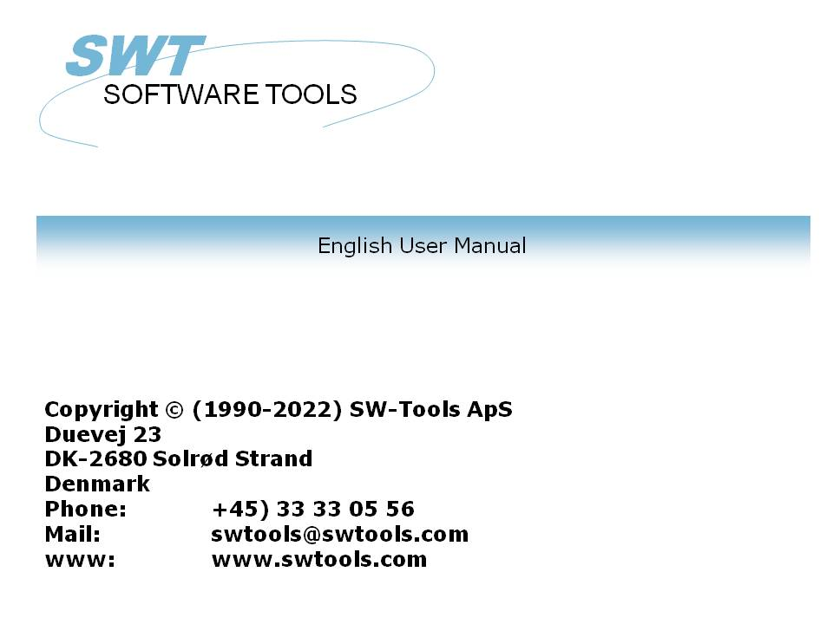

User Administation

22/11/01 / 2022-09-01 008.384

Contents
Contents 2
1. USER Administration 4
1.1. Setup 5
1.2. Creating a user 6
1.2.1. Amending the user informations 8
1.2.2. Deleting a user 9
1.3. Starting TRIO with user administation active 10
1.3.1. TRIO programs started from a Windows icon 11
1.3.2. CHAIN to another module 12
1.4. User permissions 13
1.4.1. GRANT and REVOKE access 14
1.5. REVOKE permission from a user 15
1.6. User Groups 18
1.7. GRANT permissions for a user 19
1.7.1. Function permission 20
1.7.2. Program permissions 21
1.7.2.1. CHAIN to a program 22
1.7.3. File permissions 23
1.7.4. Read/Write permissions 25
1.7.5. Create permissions 27
1.7.6. Field permissions 29
1.7.6.1. Index fields 31
1.7.6.2. File connections 32
1.7.6.3. Field write permissions 33
1.8. Using Subsystems 34
1.8.1. Permission files 36
1.8.2. The Dependency listbox 37
1.8.2.1. Module dependency 39
1.9. The users HOME path, main SYSTEM setup 40
1.10. The FDF file definition module 41
1.11. External user DLL functions 42
1.12. User defined fields in the user system file 43
1.13. USERINFO function 44
1.14. The SW-Tools ODBC Driver 45
2. Report start control and statistics 46
2.1. Summary statistic of last 100 runs 48
2.1.1. Start time, End time, Run time and Time used 49
2.1.2. Totals and Average time 50
2.2. Entry details 51
2.3. Report documentation and the display menu 52
2.3.1. Start ALL statistic 53
3. Report jobqueues 54
3.1. Defining a new queue 55
3.1.1. The default queuenumber and queue activation flag 56
3.2. The Queue and OK buttons 57
3.2.1. The job priority 59
3.3. Starting a queue 60
3.3.1. Queues of Queues 61
3.4. Deleting / Copying / Documenting a queue 62
3.5. Amending the queue entries 63
3.5.1. The STATUS field, Deleting a job 64
Figure list 65
Index 66

1. USER Administration

The user administation may be used for two different purposes:
- Restricting use of files/programs individually
- Creating different program systems without use of subsystems
By installation of TRIO a new icon will be added to the Windows desktop:

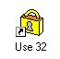

1. The user administation icon
When you select this the following menu will be shown:

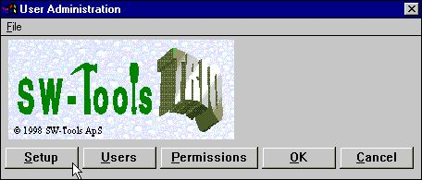

2. The user administation menu

1.1. Setup
The first thing to be done is to activate the user administation with the SETUP button:

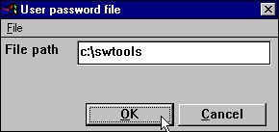

3. The user administation setup
where you should give a path for the password file (PASSWD.USE). A good suggestion could be the directory where you installed TRIO.
When this path is present the user administration is active, you may later deactivate it just by removing the path by blanking it out.
NOTE: Do not just delete the PASSWD.USE file as the system will threat this as an attempt of unauthorised access to the system and act as no users are present at all.

1.2. Creating a user
Next step is to create one or more users by selecting the USER from the menu:

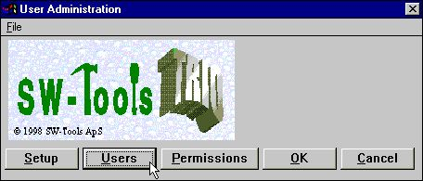

4. Selecting maintenance of users
which gives you the following dialog:

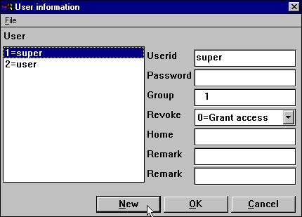

5. Maintenance of users
You notice that to users are created by installation:
super A superuser allowed to change passwords and permissions
user A sample user
The first thing to be done is to create your own user by click on the NEW button:

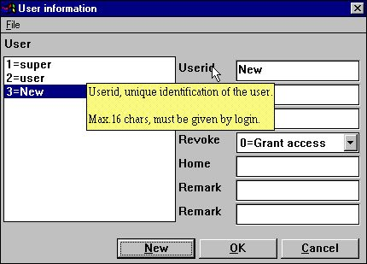

6. Creating a new user
Which gives you a new entry in the users file whereafter you may modify the user name / password informations.
Note that when you move the cursor over the leading text for the fields a short help description is shown for each field.
Try creating a user like:

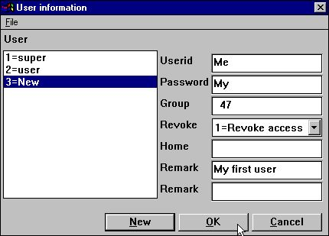

7. A sample user
click OK and leave the user administration system by OK again.
You should note that both the user name and password are case sensitive.
Be careful to remember the user/password for the superuser if you intend to change these.

1.2.1. Amending the user informations
Just select the user from the listbox, amend the informations and click OK.

1.2.2. Deleting a user
Select the user from the listbox and press the DEL or BACKSPACE key.

1.3. Starting TRIO with user administation active
Now when you starts any of the TRIO products the following dialog is active before you are let in:

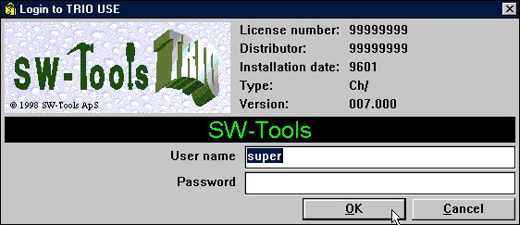

8. The logon dialog
You cannot use any TRIO program without first logging in. However for your convenience the last login user and password will be remembered by next login so you just have to click OK.
If you login with as superuser all TRIO programs will function just as before user administation was created. The superuser is allowed everything and has by default no special system setup.

1.3.1. TRIO programs started from a Windows icon
The windows icon to start report 15 in subsystem 6 may call up the program:
c:\swtools\rapwin.exe 6015
After activating the user administation you will also have to login when selecting such program. The login informations may be added to the command line:
c:\swtools\rapwin.exe 6015 -uid=Me,My

1.3.2. CHAIN to another module
If you chain one of the TRIO modules eg.RAPWIN from an IQ program, no additional login will be required by start of this.

1.4. User permissions
If you login to RAPGEN with your newly created user Me password My you will have access to all programs for example from the DEMO system. This is due to the REVOKE option we have set on the user.

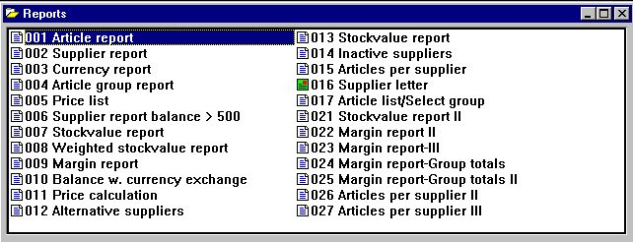

9. All reports in the DEMO system are allowed

1.4.1. GRANT and REVOKE access
There are two basically different ways of handle the users:
- GRANT: Nothing is allowed from start, permission must be given
- REVOKE: Everything is allowed, permission may be redrawn.
The easy way to administrate a user is to create with the REVOKE option as it will then be able to access all programs until it is allowed to do so. For a user created with the GRANT option he cannot use the system at all until we allow him to do so.

1.5. REVOKE permission from a user
Let us try to reduce the number of reports for our user by selecting the PERMISSION function:

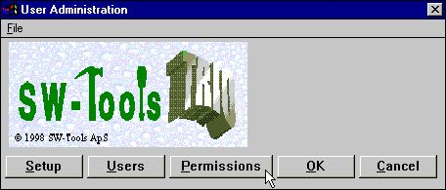

10. Selecting the PERMISSION function
which gives the following dialog:

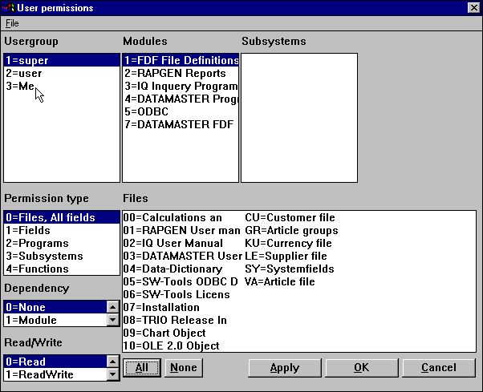

11. Permission dialog
The dialog consist of a number of listboxes corresponding to the resources we have got in the system and we should now first select the resources we want by clicking on:
Usergroup: 3 Me
Module: 2 RAPGEN reports
Permission type: 2 Programs
Programs: Select the desired programs

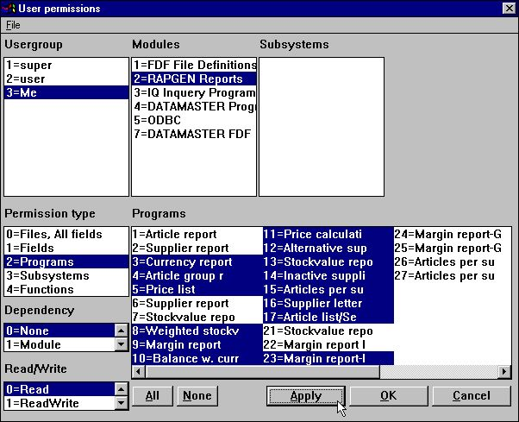

12. Revoking access from the testuser
You select a program by click on this, more consecutive programs by holding down the SHIFT key by the click, and more individual programs by use of the CTRL key.
NOTE that the permissions are unchanged until you activate the selections by click on the APPLY button.
After this we can select OK and leave the user administation and login to RAPGEN with our test user where the menu is reduced:

13. The updated RAPGEN program menu

1.6. User Groups
Note than when you select a USER from the usergroup listbox the permissions you grant or revoke are not only for the individual user but for all users created with the same group number.
This means if you create another user with groupno. 47 as the testuser Me/My he will become the same set of permissions. You must differentiate the groups to make different permissions.
Users in group 1 all becomes SUPERUSERs with permission to everything, users in group 0 has no permissions at all which may be used to temporarily disable a user without changing the permissions.

1.7. GRANT permissions for a user
If we have a look on the second user created by default:

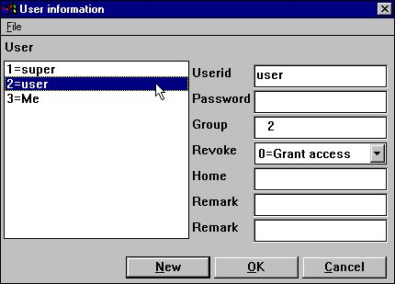

14. The default <user> created by installation.
This user is created in group 2 with GRANT access.
If you try to login to TRIO with username user and no password you will just be thrown out, permissions must be granted for everything before the user can do anything. Let us have a look on what to set up to make use of RAPGEN:

1.7.1. Function permission
We have to tell that the user may use RAPGEN by selecting:
Usergroup: 2 user
Module: 2 RAPGEN reports
Permission type: 4 Functions
Functions: 1 Module allowed

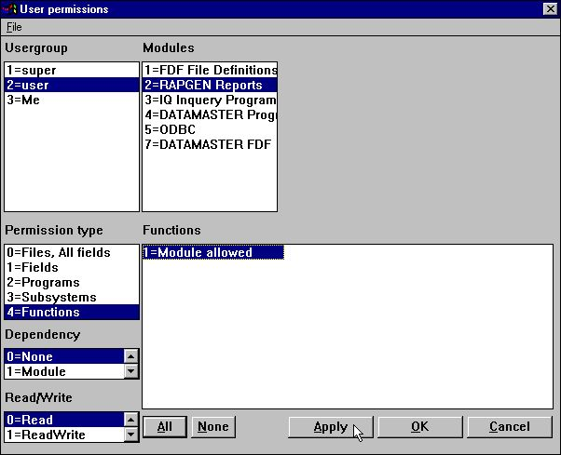

15. RAPGEN Function permission
The permission for the functions are separated in READ/WRITE/CREATE.
A user with FUNCTION-READ can start a program but cannot amend it, just as if -nl was used from the WINDOWS icon for nologo start. This may be used for REVOKE users to block all program amendments.
MODULE-WRITE causes amendments of programs to be possible but no definition of new programs. This may especially be used to block the IQ new program function.
MODULE-CREATE causes creation/deletion of programs to be possible. Preferences and subsystems are accessible only together with MODULE-CREATE.
Note that these restrictions are not implemented for the FDF module, neither in the programmer or the DATAMASTER version, as we suggest that an enduser should have absolute no access for file definitions at all.

1.7.2. Program permissions
Now the user is allowed to select RAPGEN but also some programs should be permitted:
Usergroup: 2 user
Module: 2 RAPGEN reports
Permission type: 2 Programs
Programs: The permitted programs

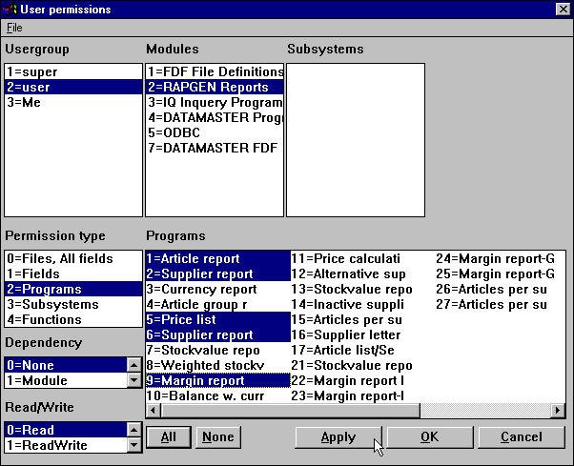

16. RAPGEN Program permissions
If we now logon as the user we get the permitted programs only.

1.7.2.1. CHAIN to a program
Any CHAIN to another program requires that the user has permission to the chained program also with one exception:
If the user are not allowed to make ANY program changes (FUNCTION-READ only) CHAIN to non-permittet programs will be allowed. This may be used to reduce the enduser menu points by removing chained programs.

1.7.3. File permissions
However, if we try to start or amend one of these we will get an error:

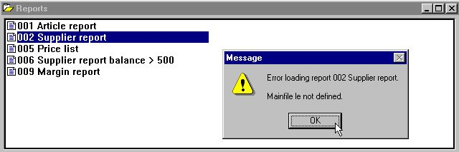

17. RAPGEN selecting a program
We have to permit access to the files involved also:
Usergroup: 2 user
Module: 2 RAPGEN reports
Permission type: 0 Files, All fields
Files: The permitted files AND the system file SY

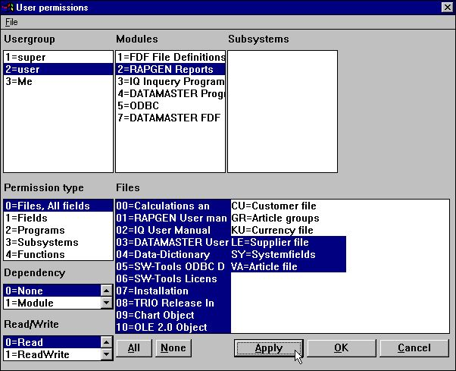

18. Permitting the necessary files
File-IDs consisting of 2-digit numbers are manual files which means you can block out these also.
You must permit access to the system file SY or at least the fields used from this (#DD,#PD and #PP = SY#1-3) as a minimum. In case of no access for these fields all report will print 0 pages (page count not allowed!)

1.7.4. Read/Write permissions
You may have noted that the user above was allowed only to start the permitted reports, the pushbuttons for all modifications are dimmed out.
If he should be allowed to amend these also you must grant WRITE access to these. Granting write access will itself grant read access.
A user may have read access to some reports and he may have write access to a part of these.
Usergroup: 2 user
Module: 2 RAPGEN reports
Permission type: 2 Programs
Read/Write: 1 ReadWrite
Programs: Select the desired programs

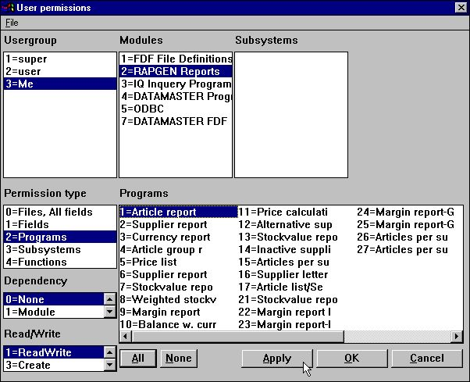

19. Granting write access for programs
The user is now able to amend report number 1 which means the amendment buttons are active when this report is selected, whereas the buttons changes to be dimmed out when one of the other permitted reports is selected.
NOTE that the user of course must have WRITE permission for the FUNCTION RAPGEN also to be allowed to change any reports.
In the user dialog when you set e.g. WRITE permission you will not in here directly be able to see that READ permission is given automatically also (WRITE allowed causes READ allowed)
This is the case but cannot be done at definition time due to the user may be REVOKE in which case the permissions must be opposite (READ forbidden causes WRITE forbidden).

1.7.5. Create permissions
Up to now we have granted some resources (reports/files) which were present in the system already. If we wants the user also to create his own reports we must grant permission for this also:
Usergroup: 2 user
Module: 2 RAPGEN reports
Permission type: 2 Programs
Read/Write: 2 Create
Programs: Select the desired unused programs

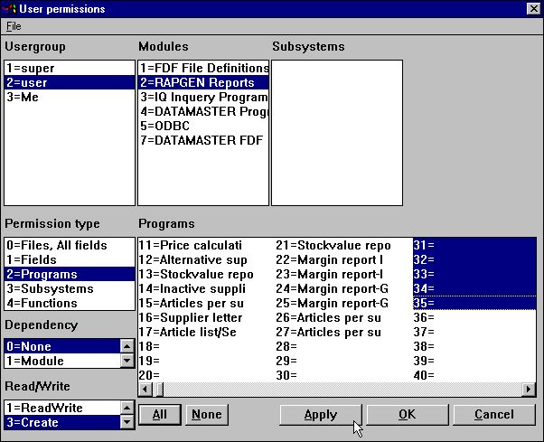

20. Granting create permission for programs
When the create option is selected, the unused reports is included in the listbox. After the marking above creation of report 31-35 is possible and the user has got read and write access to the reports also.

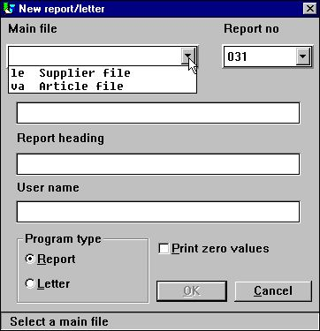

21. Defining a new report
If you login as user and try to create reports you will note that the first free report is 31, the report file becomes full when you have used the 5 reports and only the files LE and VA is available.
If you look at the Database field window, only the allowed files will be shown as will the relation between files and the graphic relation diagram will be reduced to the resources permitted.

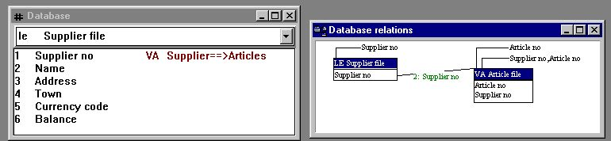

22. The reduced database window and relation diagram

1.7.6. Field permissions
Above we granted access for complete files to the user. If we first
remove the grant access for all VA-Article file
we may instead grant access on the field level by selecting:
Usergroup: 2 user
Module: 2 RAPGEN reports
Permission type: 1 Fields
Files: VA the file to specify fields for
Fields: Select the desired fields

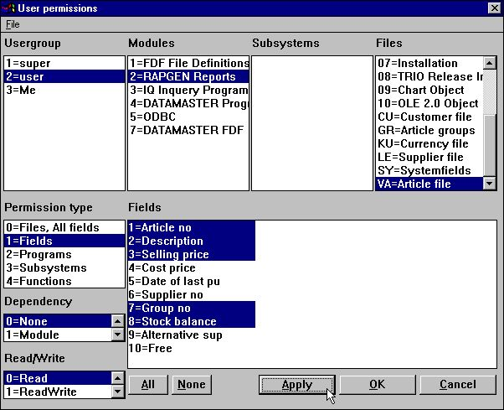

23. Reducing the fields permitted for a file
If we after this as user <user> try to run the DEMO report 1 which is already defined with all fields from the file VA we gets the result:

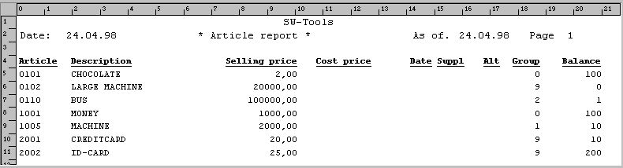

24. Trying to output all fields from VA with report 1.
which means all referenced fields which are not permitted will become the value of zero by print. No warning or error message is given on this but the forbidden information is left out.
If non-permitted fields are used in calculations an error message will be given as the calculation module does not know the field at all and cannot produce any consistent result.
If you try to amend the layout for the report it comes like:

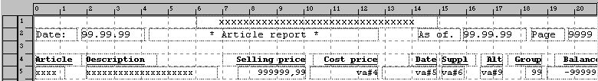

25. Amending the report layout

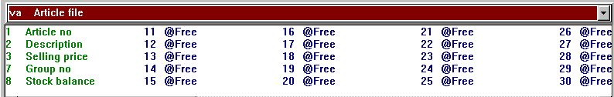

26. The database windows by amending the report layout
The non-permitted fields cannot selected from the database window as they are left out completely and should they be present anyway in the layout they are just shown as the field reference, not even the name or format are available.

1.7.6.1. Index fields
You must note that an index may not work properly if the user does not have read access for all fields which are part of the index.
In the above example there is no read access for the supplier number of the article file which is the first part of index 2. This means that starting a report using index 2 of the file will not be sorted according to the supplier number but somehow else dependent on the database interface used.

1.7.6.2. File connections
Also in case of file connections all involved fields in the connection must have been granted read access or the connection will not work.
If a program has connection to a file which has no read permission the program may not produce any output at all as all files cannot be opened.

1.7.6.3. Field write permissions
Be extremely careful if file update is used and you do grant read access but not write access to all fields in the files being updated.
In this case only the fields permitted will be written back to the file.

1.8. Using Subsystems
If you have created subsystems these will be shown in the subsystem listbox and you should select one of these:

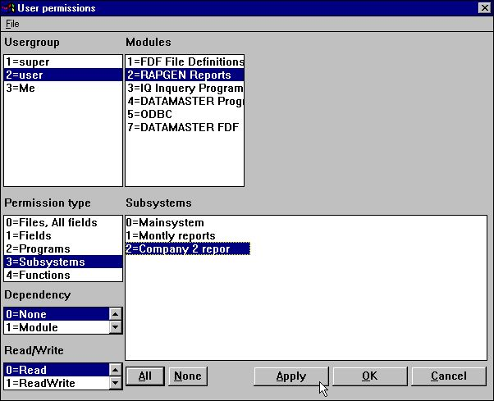

27. Subsystem selection listbox
Also you must grant permission to use the subsystem as such:
Usergroup: 2 user
Module: 2 RAPGEN reports
Permission type: 4 Subsystems
Subsystems: Select the desired subsystems

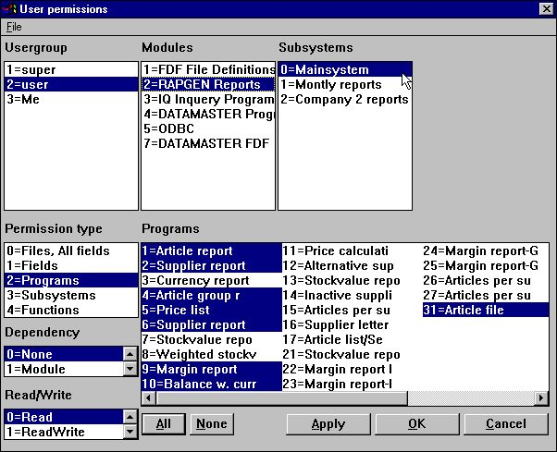

28. Subsystem permissions

1.8.1. Permission files
The permissions are stored, xxxx being the usergroup number, in:
programpath\DMxxxx.USE Report program permissions
programpath\IQxxxx.USE IQ/DATAMASTER program permissions
filedefpath\DDxxxx.USE File/Field permissions
This means in the above example where a subsystem has been created for company 2 using the same reports as the main system, just the company number is different, will give same access rights for the reports in the two subsystems.

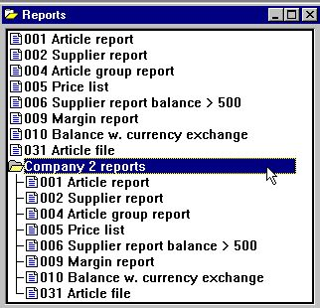

29. Equal reports permission in the two subsystems due to same USE-file

1.8.2. The Dependency listbox
In such case you may make the permissions dependent on the subsystem by use of the dependency listbox. If we want a selector like:

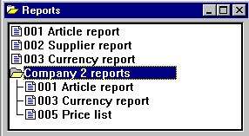

30. The report selector with individual subsystem permissions
We will first have to
remove the program permissions granted with dependency NONE
and then create the permissions for each subsystem.
Usergroup: 2 user
Module: 2 RAPGEN reports
Subsystem: 2 Company 2
Permission type: 2 Programs
Dependency: 2 Subsystem

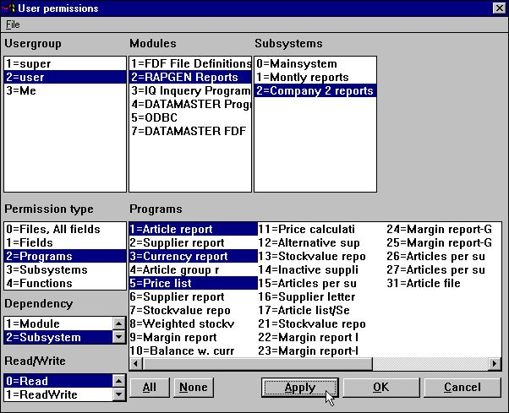

31. Program permissions dependent on subsystem selection

1.8.2.1. Module dependency
In the dependency listbox you will also find the option MODULE dependent and even the combination MODULE & SUBSYSTEM dependent.
In case of programs these are nearly born module dependent as RAPGEN and IQ/DM has quite different program selector but when it comes to files these may be common to all modules.
By selecting module dependency you may define a file to be used with read access in IQ, write access on specific fields in RAPGEN and no access in DATAMASTER.

1.9. The users HOME path, main SYSTEM setup
When you start any program in TRIO from an Windows icon the file RAP.INI containing the preferences setup is read from the path given as current working directory for the icon.
The RAP.INI file is set up with the Preference menu and will define where all other files are placed such as BASIS.SSV for the database interface definitions, FILES.SSV for the file definitions and DMSYSTEM.SSV for subsystems.
This is unchanged as long as you leave the HOME PATH in the user informations blank. But if you create a user like:

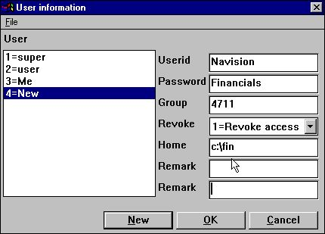

32. Specific user home path
the file c:\fin\rap.ini will be used which means this user has a complete own preference and file setup completely independent of all other implementations.

1.10. The FDF file definition module
In general you should be careful with permissions to define files which also include the DATAMASTER file definitions / redefinition module.
It is strongly recommended that users with such rights are either super users or users with REVOKE access only.
The fields / files must of cause have write access and if we took our user and opened the FDF module for the fields selected above, the display would come like:

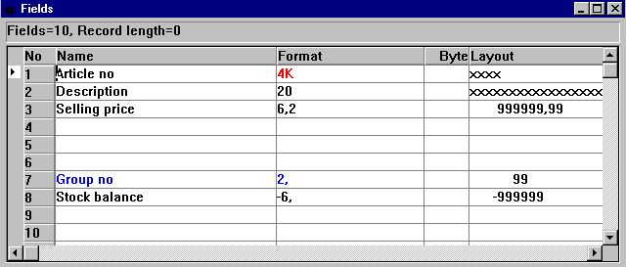

33. The FDF module for selected fields
Only the permitted fields can be read / modified and this is in sharp conflict with for example DATAMASTER redefining the complete file.

1.11. External user DLL functions
External DLL functions may be integrated into TRIO using the file definitions 00-99 and will act just as normal fields in these files.

1.12. User defined fields in the user system file
You are allowed to define field 11-17 in the system file US for individual use. When defined these will be placed in the USER creation dialog and will be reachable by the USERINFO function.

1.13. USERINFO function
A userinfo function has been implemented to allow programs to have access to all the user parameters, see description of this.

1.14. The SW-Tools ODBC Driver
When user administration is active you will have to logon to the ODBC driver as well.
The start parameters
uid=Me
pwd=My
may be used when connecting to the driver.

2. Report start control and statistics

When user administration is installed each start of a report is recorded in a logfile and displayed by start of the report:

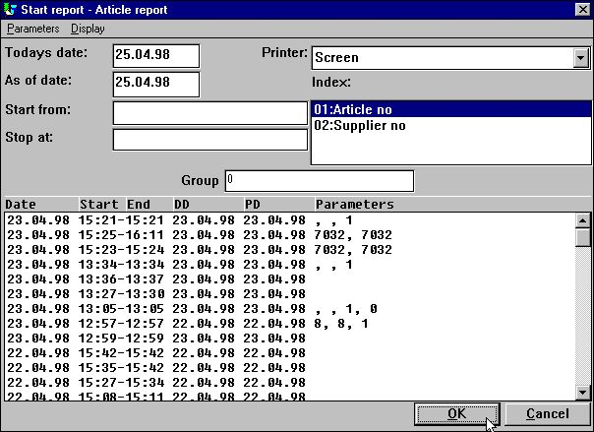

34. Report statistics by start
Each line contains start/end time and the parameters entered by start. By click on the line the parameters used for that specific start will be made ready for the current start.

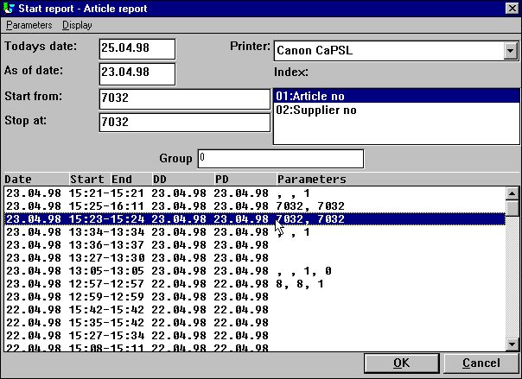

35. Repeating last start parameters by click on a line
Dependent of where on the line you make the click different actions are taken:
PARAMETERS will pick up start/stop/data, printer and total level
PD set the above but also the as as of date
DD will set todays date also

2.1. Summary statistic of last 100 runs
The logfile is stored in a textfile DM1nnn.LOG on the same directory as the report source file and is set to a maximum of 100 lines which becomes approximately 10 KB for each file. When the report is started more than 100 times the oldest entries will be dropped out from the file.
Based on these 100 entries you can get a run statistic by click on:
START/ENDTIME the summary run statistic is shown

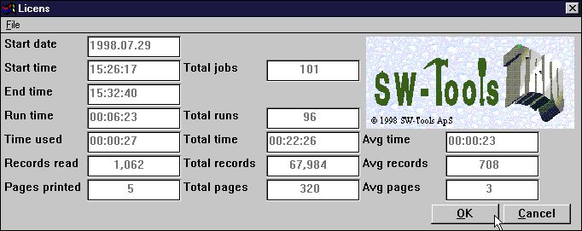

36. Summary report start statistics
Note the floating field help when you move the cursor over the field texts.

2.1.1. Start time, End time, Run time and Time used
When you click OK to start a report the START date/time is inserted, the other time fields are left blank. This timestamp is refreshed when the report is actually beginning to run, that is when the files are opened.
The END time is set when you close the report display window and the time difference from start to this is stated as RUN time.
As the system may have to wait as you are viewing the report result on screen which would give an incorrect picture of the time used, this waiting time is reduced from the run time giving the real time USED by the cpu.

2.1.2. Totals and Average time
The total JOBS on the statistics gives you the number of lines in the logfile.
The total RUNS is the number of jobs which are finished. Based on this and the real time used the average figures is calculated.

2.2. Entry details
For each entry you can get the detailed informations by click on:
STARTDATE the details are shown
.

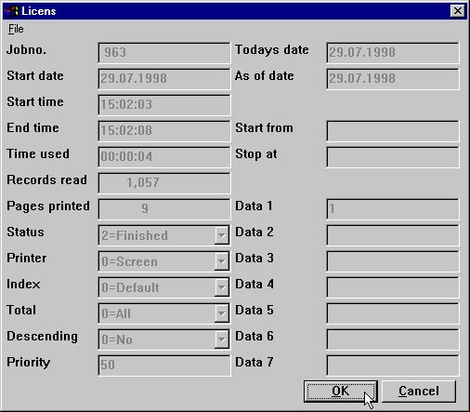

37. Details for one job
Note the floating field help when you move the cursor over the field texts.

2.3. Report documentation and the display menu
If you have entered documentation for the report this will take preference over the logfile display, however you may
Insert a first BLANK documentation line to get the log displayed
With the display menu you can toggle the display of documentation and log.

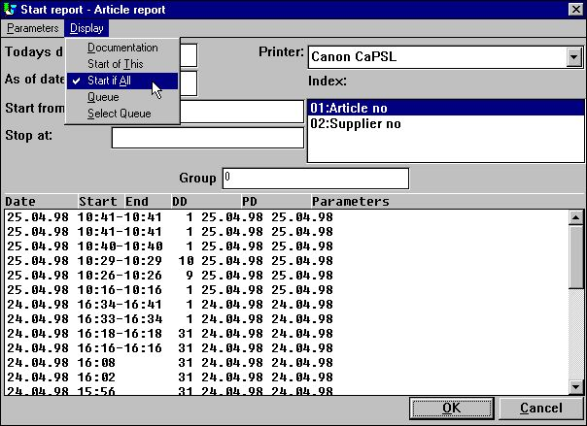

38. The extended DISPLAY menu

2.3.1. Start ALL statistic
By default only start of the selected report is shown but also the last 100 starts of any report in the selected report subsystems may be shown. This statistic is collected in a separate file named DM1000.LOG

3. Report jobqueues

RAPGEN includes a QUEUE facility which you may activate from the display menu by selecting the SELECT QUEUE menupoint which gives the following:

39. Selecting a jobqueue

3.1. Defining a new queue
When you select the NEW entry which are present in any of the displayed subsystem you will be given a queue number and prompted for a name:

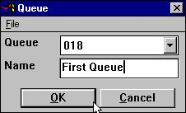

40. Defining a new jobqueue
You may have as many queues as you want.

3.1.1. The default queuenumber and queue activation flag
The last queuenumber you have used will be remember and suggested as queuenumber by next queuing attempt.
This is stored as an entry like QUEUE=18 in your RAP.INI file and when this is present the QUEUE button mentioned below will be active on the start screen.

3.2. The Queue and OK buttons
Once you have activated a queue you will get an additional QUEUE button on the start screen:

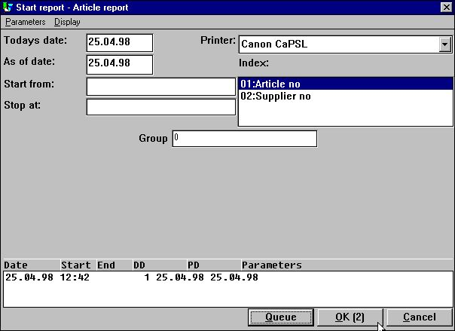

41. The Queue and OK buttons
When you click the queue button you select a queuenumber and may enter some other informations for the job to be inserted:

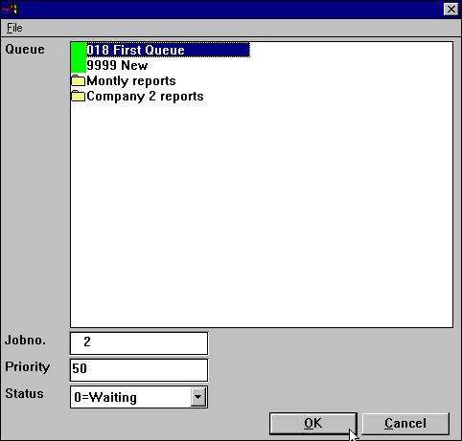

42. Inserting a job in the queue
The program is given the next free jobnumber and this will be displayed inside the OK button. This means that when you click on OK(2) the job will be inserted as job number 2.

3.2.1. The job priority
When inserting a job in the queue you may adjust the job priority field. The suggestion for a new job will always be 50, set the priority to a higher number to get the job first in the queue or lower to get is last.

3.3. Starting a queue
A queue is nothing but a normal report and you will later start execution of the queued reports just like you would start any other report.
The queue itself is of cause connected to the report and stored as the textfile DM1xxx.QUE on the report directory.

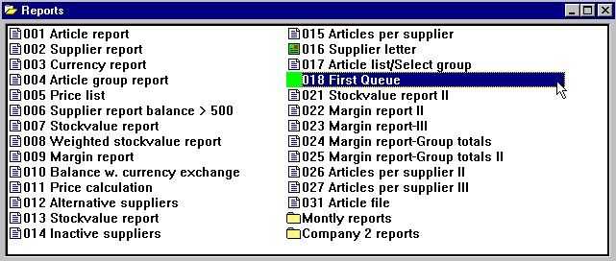

43. Starting the queue
You note that the queue is marked with a special icon on the report selector.

3.3.1. Queues of Queues
As a queue is threated just like another report you may insert a queue into another queue.

3.4. Deleting / Copying / Documenting a queue
You can delete or copy a queue just like you will do for a normal report and you may also enter documentation for this.
In a matter of fact you are able to select calculations/layout for the queue also but these will just be ignored as the queue program itself is never run.

3.5. Amending the queue entries
When you start a queue you will get the queued jobs displayed just as this was a reports start statistics and by click on the STARTDATE field on a line the details of the job will be displayed as shown in the previus chapter.

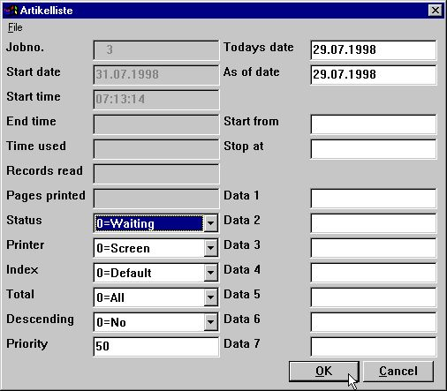

44. Amending a job in the queue
You may here amend the job start parameters, see also the help description you get when moving the mouse cursor over the fields.

3.5.1. The STATUS field, Deleting a job
With help of the STATUS field you can hold a job from execution or delete it. The field takes the following values:
0 = Waiting
1 = Running
2 = Finished
3 = Aborted
4 = Hold
5 = Deleted
Only jobs with status 0 - waiting will be executed.

Figure list
1. The user administation icon 3
2. The user administation menu 3
3. The user administation setup 4
4. Selecting maintenance of users 5
5. Maintenance of users 5
6. Creating a new user 6
7. A sample user 6
8. The logon dialog 9
9. All reports in the DEMO system are allowed 12
10. Selecting the PERMISSION function 14
11. Permission dialog 14
12. Revoking access from the testuser 15
13. The updated RAPGEN program menu 16
14. The default <user> created by installation. 18
15. RAPGEN Function permission 19
16. RAPGEN Program permissions 20
17. RAPGEN selecting a program 22
18. Permitting the necessary files 23
19. Granting write access for programs 24
20. Granting create permission for programs 26
21. Defining a new report 27
22. The reduced database window and relation diagram 27
23. Reducing the fields permitted for a file 28
24. Trying to output all fields from VA with report 1. 29
25. Amending the report layout 29
26. The database windows by amending the report layout 29
27. Subsystem selection listbox 33
28. Subsystem permissions 34
29. Equal reports permission in the two subsystems due to same USE-file 35
30. The report selector with individual subsystem permissions 36
31. Program permissions dependent on subsystem selection 37
32. Specific user home path 39
33. The FDF module for selected fields 40
34. Report statistics by start 45
35. Repeating last start parameters by click on a line 46
36. Summary report start statistics 47
37. Details for one job 50
38. The extended DISPLAY menu 51
39. Selecting a jobqueue 53
40. Defining a new jobqueue 54
41. The Queue and OK buttons 56
42. Inserting a job in the queue 57
43. Starting the queue 59
44. Amending a job in the queue 62

Index

B
BASIS 39
C
CHAIN 11;21
D
DATAMASTER 19;35;38;40
Dependency 36
DISPLAY 51;64
DLL 41
Driver 44
F
FDF 19;40;64
G
GRANT 13;18
I
Index 30
IQ 11;19;35;38
O
ODBC 44
P
Preferences 19
Q
Queue 56;64
R
RAPGEN 12;15;16;18;19;20;22;24;26;28;33;36;38;53;64
REVOKE 12;13;14;19;25;40
S
Setup 4
SSV 39
Subsystem 33;34;36;64
T
TRIO 3;4;9;10;11;18;39;41
U
Usergroup 15;19;20;22;24;26;28;33;36
USERINFO 42;43
W
WRITE 19;24;25

