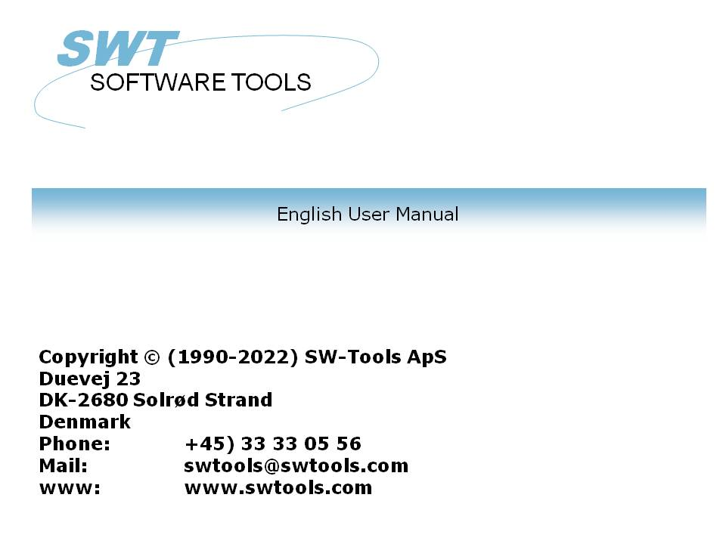

Setup Wizard - Navision Financials/Attain

22/11/01 / 2022-09-01 008.384

Contents
Contents 2
1. The Setup Wizard 3
2. Step 1 - Interface 4
2.1. Requirements 5
2.2. Multiple installations of C/FRONT 6
3. Step 2 - Identification and SW-Tools Server connection 7
3.1. Identification 8
3.2. SW-Tools Server connection 9
3.2.1. Server interface 10
3.2.2. Multiple companies 11
4. Step 3 - Database 12
4.1. Program folder 13
4.2. Connection 14
4.2.1. NT Authentication 15
4.2.2. SQL Server option 16
4.2.2.1. Database Name 17
4.3. Options for server access 18
4.3.1. Server Name 19
4.3.2. Net Type 20
4.4. Options for local access 21
4.4.1. Database Name 22
4.4.2. Commit Cache 23
4.4.3. DBMS Cache (KB) 24
4.5. User ID 25
4.6. Password 26
4.7. Company Name 27
4.8. Read Only 28
4.9. CFRONT.DLL/CFRONTSQL.DLL 29
4.10. Language id 30
4.11. File id 31
5. Step 4 - Data-Dictionary 32
6. Finnished 33
Figure list 34
Index 35

1. The Setup Wizard

The Setup Wizard provides an easy way to setup the components required for working with SW-Tools TRIO for reports, queries and data entry and for SW-Tools ODBC driver.
The wizard will guide you through the following:
- Selecting an interface (Required)
- Checking that required components such as Windows DLL's is present (Automatic)
- Setup of the interface fields (Required)
- Location of the sub system (Required)
If you require to amend an interface setup by this Wizard please refer to the 'Data-Dictionary' manual.

2. Step 1 - Interface

When the Setup Wizard is started you are required to select an interface. Normally you will only have one but several may be listed according to the interfaces known to the SW-Tools products.
You need to select the following interface as shown in this figure:

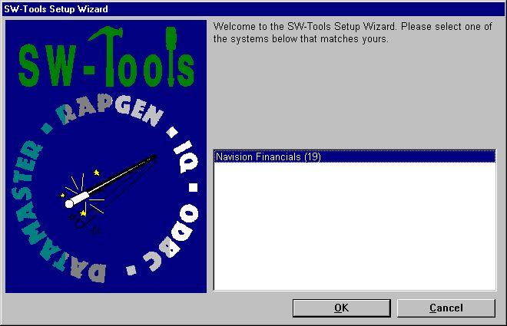

1. Selecting the Navision Financials/Attain interface

2.1. Requirements
There are some requirements which must be present in order for the SW-Tools products to access Navision Financials/Attain.
- C/FRONT must be installed and licensed

2.2. Multiple installations of C/FRONT
Multiple installations of C/FRONT on the same system may cause problems. Please refer to the warning issued by the Wizard and the 'README.TXT' file located in the C/FRONT installation directory.

3. Step 2 - Identification and SW-Tools Server connection

The Wizard will use a name and descrition to identify the setup. If any changes/extensions are made to your Navision database table/field definitions you have to go through the setup wizard again to update your TRIO dictionary.

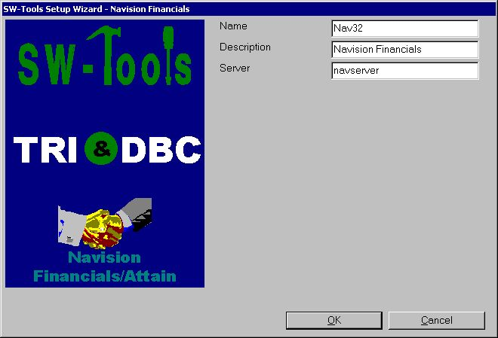

2. Identification and Server connection

3.1. Identification
The field Name and Description is by the Wizard to name the interface, subsystem and ODBC datasources with. A name is generated according to these rules:
Interface = <name>
Subsystem = <description> <name> (<company>)
System DSN = <name><company>s
User DSN = <name><company>u
File DSN = <name><company>f
The length of name is limited to 6 characters and the description to 64. The <company> is only added if using the SW-Tools Server connection.

3.2. SW-Tools Server connection
With this feature you will have the following advantages:
- C/FRONT is only required to be setup and licensed on the server
- SW-Tools IQ superindex search is optimal
- Access multiple companies in one report or query
In order to use this facility you must install the SW-Tools Windows Server on the server where the Navision database is located.
On that same server C/FRONT must be installed and licensed, and an interface prepared using the SW-Tools Setup Wizard - Navision Financials/Attain.
If you use the server connection you will NOT need step 3.

3.2.1. Server interface
When you from the client make access to the SW-Tools Server you will only be able to select one of the interfaces setup on the server using the SW-Tools Setup Wizard - Navision Financials/Attain.

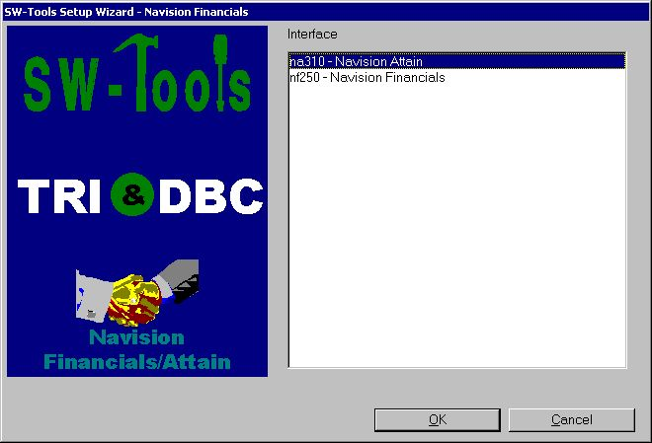

3. Selecting a server interface

3.2.2. Multiple companies
Only by using the SW-Tools Server you are able to access multiple companies at the same time.
The Wizard will provide a list of all known companies where you may select one or more. For each selected company the wizard will create a subsystem in TRIO and also an ODBC datasource.

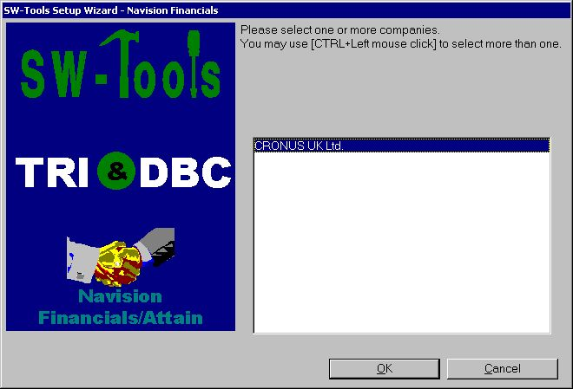

4. Selecting companies

4. Step 3 - Database

This chapter describes how to enter the fields required to setup access to Navision Financials/Attain. The fields are presented in a dialog looking like this:

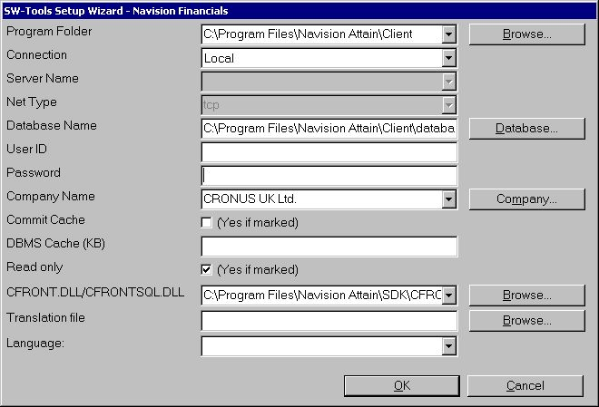

5. Setup access to Navision Financials/Attain dialog

4.1. Program folder
Enter the path of the Navision Financials/Attain installation. You may browse by selecting the field "Browse...". Browse to the relevant folder and then select OK to copy the path to the field.

4.2. Connection
If you have a locale installation of Navision Financials/Attain select the "Local" field otherwise select the "Server" field.

4.2.1. NT Authentication
If you want to use the NT Authentication select the "Server with NT Authentication" or "SQL Server with NT Authentication" field.

4.2.2. SQL Server option
If you want to use the SQL Server option select the "SQL Server" or "SQL Server with NT Authentication" field.

4.2.2.1. Database Name
Enter the name of the SQL Server database you want to open.

4.3. Options for server access
The following fields applies only if connection type is "Server".

4.3.1. Server Name
Enter the name of the server, that is, the server where the Navision Financials/Attain database is located. This is a list field which is filled with all entries the the hosts file used by Windows Networking.

4.3.2. Net Type
In a multiuser installation, enter the name of the network protocol program, that is, TCP (for TCP/IP) or NETB (for NetBios).

4.4. Options for local access
The following fields applies only if connection type is "Local".

4.4.1. Database Name
Enter the name of the database you want to connect to. You can see a list of available databases by selecting the field "Database...". Browse to the relevant folder, select the database file name, and then select Open to copy the name to the field.

4.4.2. Commit Cache
Specifies whether the commit cache should be used:

4.4.3. DBMS Cache (KB)
Enter the size of the cache (0-30,000 KB)

4.5. User ID
Enter the user ID that you use when logging in.

4.6. Password
Enter the password for the user ID. If you do not, you will have to enter an ID and password every time you want to open the database through the ODBC driver.

4.7. Company Name
Enter the company name from which you want to retrieve data. You can see a list of available company names by selecting the field "Company...". Select the company name from the opened list.

4.8. Read Only
Specifies whether access to the Navision database should be read-only.

4.9. CFRONT.DLL/CFRONTSQL.DLL
This field must be the actual location of the C/FRONT library used by TRIO to access the Navision database.
If the database is a native Navision database the location MUST include the CFRONT.DLL filename. If the database is a SQL database the filename MUST be CFRONTSQL.DLL.

4.10. Language id
This field provides a language id for the Wizard to get the required translation from the database.

4.11. File id
Normally the Setup Wizard will generate a file id for all tables automatically starting with aa, ab, ac ... ending with zz. If you require to use the unique Navision table id instead please enter minimum 2 characters in this field - both alphanumeric! When set the file id is generated as XX999, where XX is what you entered and 999 is the unique Navision table id. For example the Customer table number is 18, so if you entered IN in the field you will get IN18 as file id.

5. Step 4 - Data-Dictionary

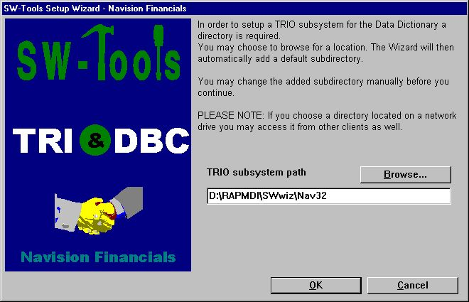

6. TRIO subsystem path

6. Finnished

When the wizard has completed it will list what has been setup:

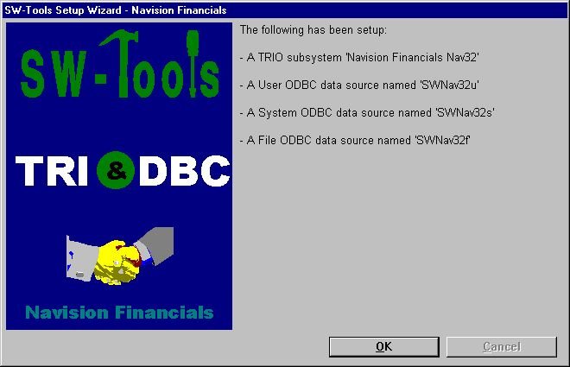

7. What has been setup
You may now work with SW-Tools TRIO and ODBC.

Figure list
1. Selecting the Navision Financials/Attain interface 4
2. Identification and Server connection 7
3. Selecting a server interface 10
4. Selecting companies 11
5. Setup access to Navision Financials/Attain dialog 12
6. TRIO subsystem path 32
7. What has been setup 33

Index

B
Browse 13;22
C
Cache 23;24
Commit 23
Company 27
D
Database 12;17;22
Data-Dictionary 3;32
DBMS 24
I
Interface 4;8
L
Local 14;21
N
NETB 20
NetBios 20
Networking 19
O
ODBC 3;8;11;26;33
P
Password 26
S
Server 7;8;9;10;11;14;15;16;17;18;19;34
T
TRIO 3;7;11;29;32;33;34

