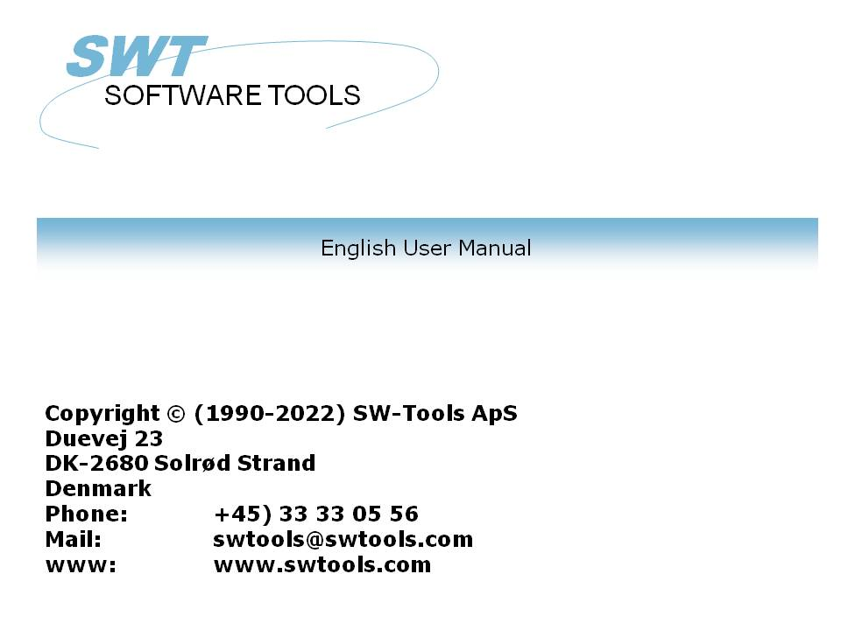

Functions for release

22/11/01 / 2022-09-01 008.384

Contents
Contents 2
1. Pre-Release functions 4
1.1. DIALOG - Function for additional input 5
1.2. FIRST - Calculate first (RAP) 6
1.3. FTP - File Transfer Processor 7
1.4. PARAMS - Function for additional report start parameters (RAP) 8
1.5. PRINT(L= - Function for additional report start parameters (RAP) 9
1.6. PRINT(LAB= - Label function 10
1.7. SCRPRT - Recall screen print (IQ) 11
1.8. USERINFO - Get information about user 12
2. Error corrections 13
2.1. Username protection by start of report was not properly implemented 14
2.2. Calculations in IQ/DM incorrectly written when source file size > 12 KB 15
2.3. G3000 files not supported on 99 files per unit systems 16
2.4. Focus lost when using chain(+999) from one DATAMASTER program to another 17
2.5. Free fields for Total records and key activated 18
2.6. GPF in IQ/DM when working with CHAIN() and EXIT 19
3. Navision Financials 20
3.1. Install Navision Financials and C/FRONT 21
3.2. Install and configure interface to Navision Financials 22
3.3. Import of table definitions 23
4. Concorde C4/C5/XAL 25
4.1. Install Concorde 26
4.2. Install and configure interface to Concorde 27
4.3. Import of table definitions 28
5. Btrieve version 5.10/6.15 29
5.1. Install and configure interface to Btrieve 30
5.2. Advanced options 31
5.2.1. Open mode 32
5.2.2. Name suffix 33
5.2.3. Name options 34
5.2.4. Parameters 35
6. Printing Labels 36
6.1. How to use in RAPGEN 37
7. Application type for controlling interfaces 38
7.1. Type 1 - Support of Informix Database table locks 39
7.2. Type 2 - Support of SAMSON system 40
7.3. Type 4 - Always perform ORDER BY 41
7.4. Type 4096 - Alpha fields may NOT be NULL 42
7.5. Type 8192 - ODBC Drivers with support of one connection per table only 43
8. New pack types 44
8.1. P1053 - Right justified fields in C-ISAM files 45
8.2. New printers in TRIO 46
8.3. Screen printer 47
9. MOF printers 48
9.0.1. Printer type 49
9.0.2. Type 1 - Text printer 50
9.0.3. Type 2 - HTML printer 51
9.0.3.1. HTML output of standard reports 52
9.0.3.2. HTML output of non-standard reports 53
9.0.4. Type 3 - RTF printer 54
9.0.5. Type 4 - TXT printer 55
9.0.6. Type 5 - SSV printer 56
10. Functions 57
10.1. New functions 58
10.2. LINE - Retrieve or set the current IQ/DM line counter 59
10.3. OBJECTGETSTRING- Get index of an objects selected item 60
10.4. GETINFO- Get additional program information (IQ/DM) 61
Figure list 62
Index 63

1. Pre-Release functions

These functions may be released.

1.1. DIALOG - Function for additional input
Number DIALOG(Fields par1)
Parameters: Par1: Fields to show in dialog
Description: The DIALOG function enables the user to pop up dialogboxes with a selected set of fields at any point of a report execution or in an IQ program for example by click on a field.
DIALOG("#1,7-8,le#3") defines a dialog with the given fields. The fields documentation is used as floating online help when the mouse cursor is moved over the leading text.
Returnvalue: Zero.
See also: PARAMS
Example: DIALOG("1-3,11") /* Make a dialog with the given fields

1.2. FIRST - Calculate first (RAP)
FIRST
Parameters: None.
Description: All following lines are calculated first.
Returnvalue: None.
See also: NORMAL, LAST, AFTER, TOTAL, SORT, INIT, ATEXIT
Example: FIRST /* Switch to first calculations

1.3. FTP - File Transfer Processor
FTP(Text par1)

Description: The FTP function has been build in to enable advanced users to transfer files for example in a report based on a SSV file containing filenames. FTP("command") executes the ftp command as:
Note that freefields may be used for the command and that the 32 bit version supports long filenames.
Returnvalue: None.
See also:sa_funny.c(099) FTP Standard
Example:
FTP("open 200.0.0.9")
FTP("user cms,mypas")
FTP("binary")
FTP("get /X.BASIC/0/AFIL c:/mydir/myfil")
FTP("quit")

1.4. PARAMS - Function for additional report start parameters (RAP)
PARAMS(Fields par1)
Parameters: Par1: Fields to show in start parameter dialog
Description: PARAMS("#1,7-8,le#3") is a variant of the dialog function where the input is done by start of the report not during report execution.
Use of PARAMS in a report will add a button <Extra parameters> to the startup screen which then activates the dialog.
Returnvalue: None.
See also: DIALOG
Example: PARAMS("1-3,11") /* Make a dialog with the given fields

1.5. PRINT(L= - Function for additional report start parameters (RAP)
PRINT(L=Text par1)
Parameters: Par1: Define lines for next print
Description: Print sets the printlines for next print.
Returnvalue: None.
See also: PRINT
Example: PRINT("L=1-3,11") /* Set next lines to print

1.6. PRINT(LAB= - Label function
PRINT(LAB=Text par1,Number par2,Number par3)
Parameters: Par1: some Par2: good Par3: param
Description: See mo.
Returnvalue: None.
See also: PRINT
Example: PRINT("LAB=1") /* Define label print

1.7. SCRPRT - Recall screen print (IQ)
SCRPRT(Filename par1)
Parameters: Par1: Filename to show using the screen printer
Description: SCRPRT("filename") calls up the screen printer with the saved print from filename. This may for example be used in IQ by click on a field.
Returnvalue: None.
See also: PRINT
Example: SCRPRT("c:/w/ab.cde") /* Show this file using the screen printer

1.8. USERINFO - Get information about user
text USERINFO(number par1)

17=User defined
Description: This function gets the requested user information.
The number in Par1 refers to the fieldnumber in the system file US where you may define field 11 to 17 individually for each installation, just be carefull if later upgrading the version of TRIO.
Returnvalue: String containing the user information.
See also:sv_use.c login
Example:
#11=USERINFO(6) /* Get the user first remark

2. Error corrections

2.1. Username protection by start of report was not properly implemented
When protecting the report with the subfunction PAS() it worked fine when working within the report generator. However, when starting the report from the windows system using command "RAPWIN.EXE <report number>" the system failed to check on the password. This has now been implemented.

2.2. Calculations in IQ/DM incorrectly written when source file size > 12 KB
In IQ/DM the calculations was damaged if the filesize exceeded 12 KB. The damage would normally appear as missing parts or incorrect characters.

2.3. G3000 files not supported on 99 files per unit systems
The search function for G3000 databases could not find any on a 99 files per unit based system. This was because the offset of the data area in a volume with 99 files per unit differed from the unit with 250 files.
The problem therefore not only applies to the search function, but also to the access of the actual data.

2.4. Focus lost when using chain(+999) from one DATAMASTER program to another
When using chain(+999) in DATAMASTER you might not get the focus in the newly activated program as expected. This is caused by that DATAMASTER actually activates the chain directly after the calculations has finnished, and hereby getting the focus in the new program. But the side effect is, because DATAMASTER is event driven, that the calling program will hereafter set the focus to the next/current input field again and therefore taking the focus away from the called program.
The problem is solved by using the rule, that DATAMASTER should only set focus on the field if the program is active and has got the focus.

2.5. Free fields for Total records and key activated
All reports defined in RAPGEN has as free field WW#51 define to gain access for the total name. Furthermore, two free fields exists, WW#50 Total number of records for total and WW#52 the total keyvalue. Both values are used internally by RAPGEN to generate the requested totalname as 99 Name xxx, but was not activated for use in calculations.

2.6. GPF in IQ/DM when working with CHAIN() and EXIT
There was an internal error in IQ/DATAMASTER which caused a GPF at some point when working with CHAIN and EXIT to shift between programs.

3. Navision Financials

This section describes how to install and use TRIO & ODBC in connection with Navision Financials. C/FRONT version 1.2 or higher is supported.

3.1. Install Navision Financials and C/FRONT
Install Navision financials and C/FRONT for example in directory e:\fin and make sure that the PATH environment variable includes the directory e:\fin. If you change the PATH variable restart the Windows system.

3.2. Install and configure interface to Navision Financials
Follow the description for installing a ODBC driver interface in TRIO. The interface for Navision is named 'Navision Financials'.
By the function 'Database-interface' you may select the installed 'Navision Financials' where the following setup will correspond to the described sample installation.

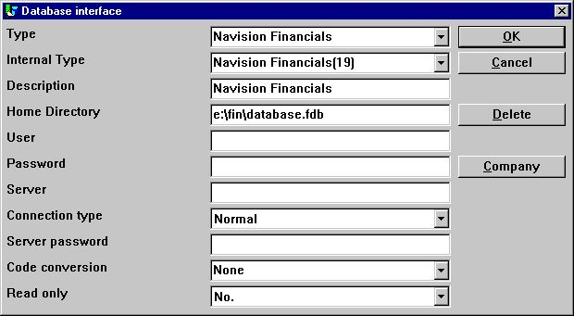

1. Sample setup of Navision Financials interface
If you use C/FRONT with TCP/NETB for server connection the field Server may be used to enter
server,type
where server is the server name and type is tcp or netb.

3.3. Import of table definitions
Before you import the Navision table definitions it is best to create a new subsystem dedicated to use with Navision. The following figure show a sample of a subsystem created from menu 'File' - 'Subsystem' - 'New...':

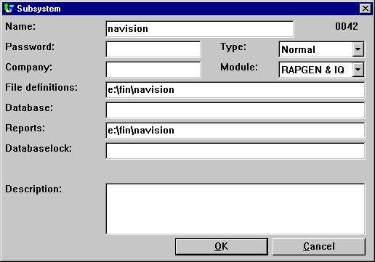

2. New subsystem for Navision table definitions
From the menu 'File' - 'Import ODBC definitions...' you may select interface 'Navision Financials' in order to import all or some of the table definitions.

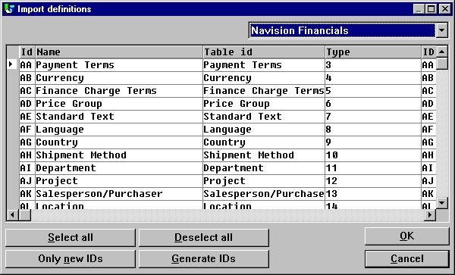

3. Import of all or some of the Navision table definitions

4. Concorde C4/C5/XAL

This section describes how to install and use TRIO & ODBC in connection with Concorde C4/C5/XAL.

4.1. Install Concorde
Install Concorde for example in directory e:\concorde and export all file definitions into a .DBD file. The export may be done by login as 'supervisor' and select the menu 'Generel' - 'Admendments' - 'Development menu'. From here you may select 'Export' - 'DBD' - 'All + Enum'. The exported file is then saved in the same directory as the Concorde installation, e.g. e:\concorde.

4.2. Install and configure interface to Concorde
Follow the description for installing a ODBC driver interface in TRIO. The interface for Navision is named 'Concorde C4' or 'Concorde C5/XAL'.
By the function 'Database-interface' you may select the installed 'Concorde' where the following setup will correspond to the described sample installation.

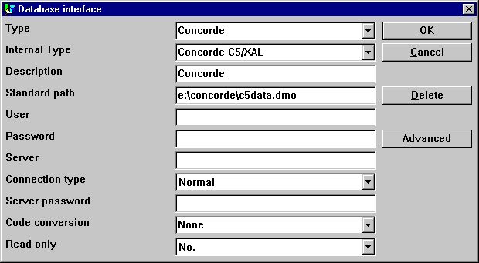

4. Sample setup of Concorde interface

4.3. Import of table definitions
Before you import the Concorde table definitions it is best to create a new subsystem dedicated to use with Concorde. The following figure show a sample of a subsystem created from menu 'File' - 'Subsystem' - 'New...':

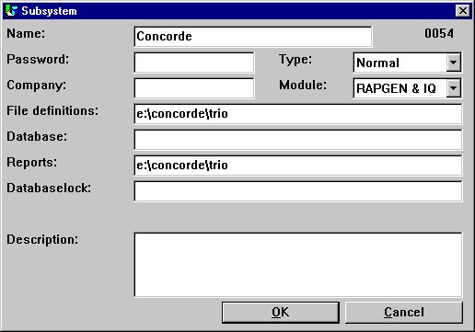

5. New subsystem for Concorde table definitions
From the menu 'File' - 'Import ODBC definitions...' you may select interface 'Concorde' in order to import all of the table definitions.
Please NOTE that a user name is required in order to import definitions. The user name is 'BASIC'.
When the user name has been entered the import will be of all tables, e.g no selection can be made. If required you may delete one or more of the imported definitions afterwards.

5. Btrieve version 5.10/6.15

Btrieve files can be accessed directly without use of ODBC. This will give a much better performance when working with TRIO.

5.1. Install and configure interface to Btrieve
Follow the description for installing a ODBC driver interface in TRIO. The interface for Btrieve is named 'Btrieve'.
By the function 'Database-interface' you may select the installed 'Btrieve' where the following setup will correspond to access of Btrieve files located in the directory 'e:\btrieve'.

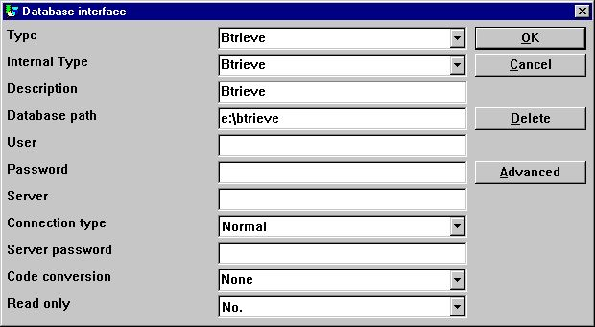

6. Sample setup of Btrieve interface

5.2. Advanced options
The Btrieve interface allows you to control how files are to be opened and how the file name should be generated.

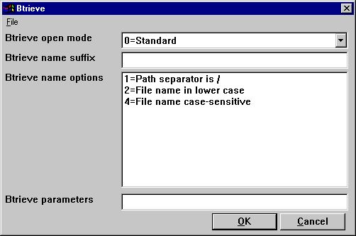

7. Advanced settings on Btrieve interface

5.2.1. Open mode
The open mode may be one of the following:
- Standard
- Exclusive
- Single Engine File Sharing (Version 6.15 only)
- Multi Engine File Sharing (Version 6.15 only)
By standard TRIO will open a Btrieve file in read-only mode unless it is a file which is to be updated on a report or in a DATAMASTER program.
I the open mode is Exclusive, no other program can gain access to the file.
The Single and Multi Engine File Sharing modes are for Btrieve version 6.15 only. Please refer to the Btrieve documentation for a detailed description of the openmodes.

5.2.2. Name suffix
The name suffix of a Btrieve file was always set to .DAT in TRIO version <= 006.008. However, Btrieve files may be without any suffix or a different one than .DAT. Therefore, it is a field you may fill yourself when installing the interface for use in TRIO.

5.2.3. Name options
These options controls how the file name of a Btrieve file is generated by TRIO. The naming options for a Btrieve may override the normal generation of the actual file location. As an example, assuming that the interface has been setup with database path
c:/btrieve/database
and a file is defined with name
customer
and the suffix is set as
dat
the actual location of the file is
c:/btrieve/database/customer.dat
Because Btrieve does NOT allow the use of / in the path the default behaviour is to replace all occurrences of / with \ giving a location as
c:\btrieve\database\customer.dat
Should this however change in newer Btrieve versions or only be dependent on the operating system used, it can be changed here.

5.2.4. Parameters
When Btrieve 5.10 is activated is is required to pass some initial parameters to the Btrieve system. The parameters are by default:
/m:48 /b:16 /f:20 /l:20 /p:4096
Please refer to the Btrieve 5.10 manual for a detailed description of the possible parameters and the meaning hereof. The parameter string has no effect when using Btrieve 6.15 or newer.

6. Printing Labels

The subfunction PRINT() can be used to produce print of labels in a very simple way. The function syntax is:
PRINT(LAB=direction columns rows width heigth copies)
The direction control how to generate the labels on the label sheet. The valid values are:
0 - No labels
1 - From left to right
2 - From top to bottom
The multiply of number of columns and rows is the actual number of labels on one sheet.
The width and height of any label on the sheet can be given in centimeters or inches by using the following syntax:
7cm equals 7 centimeters
2in equals 2 inches
Finally when printing labels you may want to print multiple copies of the same label, which can be controlled by the copies parameter.
A sample use the the PRINT(LAB=...) function could be:
PRINT(LAB=1 3 7 7cm 7cm 2)
which will produce labels printed from left to right on a label sheet with 21 labels, 3 on each row, 7 rows, where each label has the width/height of 7 centimeters. Each label is prited in 2 copies.

6.1. How to use in RAPGEN
To produce the simple print of labels a report must be defined as a letter. The main file of the report should as an example be the customer file if you want to print customer labels.
On the layout of the letter you only require to define one label in the top left part of the layout.
When the label is defined you must remember to change the Page control, which is normally set to :1,1-99 for a letter, to 1-x where x is the number of lines used to define the label.
Finally you have to add the following calculations to the report:
FIRST
PRINT(LAB=1 3 7 7cm 7cm 2)
Please remember to have the PRINT(LAB=...) in the FIRST section. Otherwise, it will reset the label control for each record read from the main file.

7. Application type for controlling interfaces

The application type can be used to control how TRIO should work with an interface. It is normally used in connection with ODBC interfaces, but may in some cases also be present for others.
When using the type for an interface, please note that one or more types may be used at the same time by adding the types together.

7.1. Type 1 - Support of Informix Database table locks
The normal use of an ODBC data source for Informix will lock any used table when connected to it. This will for example cause a problem if a user is working with IQ or RAPGEN to query or print information from the Informix database at the same time when a user wants to work with the table from another application.
It is described in the Informix database documentation that you have to execute a SQL statement
set isolation to dirty read
to avoid the problem.

7.2. Type 2 - Support of SAMSON system
The SYSTEM named SAMSON, is a financial system for DOS/Windows and UNIX, using C-ISAM as Database. In this system, all files are created with a company number as the first key part always. TRIO supports the use of company numbers on interfaces and sub systems, but normally only in connection with the file name.
This type support company number as the first key part, only for the interface C-ISAM (MASI),

7.3. Type 4 - Always perform ORDER BY
Because not all ODBC drivers support the standard given by Microsoft, you may experience SQL errors when trying to print reports with access to a table using the ODBC driver. The error will state a missing ORDER BY ... for the table.
A report that selects the fields from a customer table, where customer is the primary key will generate
SELECT customer,name,address FROM customer_table
If type 4 is set it will generate
SELECT customer,name,address FROM customer_table ORDER BY customer

7.4. Type 4096 - Alpha fields may NOT be NULL
Because some ODBC drivers / SQL Databases does NOT support aplha numeric fields with no content, e.g "" it is nessessary to inform TRIO that all alpha fields must contain some value.
This type will automatically use the field pack type 1048 on all fields, which will set the content of an empty alpha field to one space.

7.5. Type 8192 - ODBC Drivers with support of one connection per table only
Because some ODBC drivers / SQL Databases requires a unique connection for each table, where as TRIO tries to optimize table access by doing the connection to the database only once it can be nessessary to set this type.
If this type is set, TRIO will create a connection to the database for each table used. Please note, it the ODBC data source requires the user to enter a user name / password to connect to the database, it will be required to do so for each table used. To prevent this, the user name and password must be setup one for the database interface in TRIO.

8. New pack types

8.1. P1053 - Right justified fields in C-ISAM files
Because the field pack type 1043, which is used for the interface Concorde is working with an additional byte, the use hereof will fail on C-ISAM files.
By using the P1053 right justified fields will work properly.

8.2. New printers in TRIO

8.3. Screen printer
The screen setup in TRIO may now be given multiple time by setting the check mark for screen printer on an empty prtinter line in the setup dialog.

Unknown picture (g:/rapdoc/mod-eng001.jpg)

8. Additional screen printer insertion

9. MOF printers

In general TRIO now provides a number of new printers which may be setup initially as a screen printer. The button 'Setup' can now be used to set the type of printer output for the defined screen printer.

Unknown picture (g:/rapdoc/mod-eng002.jpg)

9. Setup of screen printer to MOF printer

9.0.1. Printer type
The printer type may be one of the following:
1 - Text
2 - HTML
3 - RTF
4 - TXT
5 - SSV

9.0.2. Type 1 - Text printer
Because the Window Generic text printer has its limitations and does not produce a very good and useable content, TRIO now has its own text printer. The output will be into one file, where each page is separated by a form feed (the hexadecimal character 0x0c). The printer will automatically calculate the width of any field used in the layout in order to produce an output with no overlapping fields.

9.0.3. Type 2 - HTML printer
The HTML (Hyper Text Markup Language) printer can be used to produce output directly to internet/intranet systems. This means, an output from this printer can directly be viewed in your internet/intranet browser, e.g. Netscape or Explorer.
The output may also be send as attachment to an e-mail, whereas the receiver of the mail may then view the report directly in a browser.
Because HTML does NOT support any pixel positions the printer can be used in two ways.

9.0.3.1. HTML output of standard reports
TRIO will have no problems with standard reports. The report will be converted to a HTML table, where each field corresponds to a column in the table.
Any total level or group total defined will be inserted in the same table.
All used pictures, OLE objects and charts will automatically be converted to the standard picture format GIF (Graphical Interchange Format) known to HTML.

9.0.3.2. HTML output of non-standard reports
If you have reports defined, which cannot directly be converted into a table you might experience a wrong output from the HTML printer. However, you may then setup a second HTML printer and selection the option
'Use textprinter to make fixed output'
When this printer is used instead, the report output will be correct, because it is a simple text output using a fixed font in the HTML language.
For this fixed HTML printer no pictures, OLE objects or charts will be included.

9.0.4. Type 3 - RTF printer
The RTF (Rich Text Format) printer produces output in the same way as the HTML printer. The output from here can as an example be used to include directly in a Microsoft Word document.
The only difference between the RTF and HTML printer lies in the definition file used, so please refer to the description of the HTML printer.

9.0.5. Type 4 - TXT printer

9.0.6. Type 5 - SSV printer

10. Functions

10.1. New functions

10.2. LINE - Retrieve or set the current IQ/DM line counter

10.3. OBJECTGETSTRING- Get index of an objects selected item

10.4. GETINFO- Get additional program information (IQ/DM)
number GETINFO(number par1, text par2)

Description: This function allows you to get some special information from an IQ/DM program. The type 0 and 1 will return the unique id of the window, which may be used by other functions to manipulate the window. A sample of this is present in the OLE manual.
When the type is 2 to 5 the function requires a field reference in par2. For example, to get the start column for article field number 7 par2 should equal "va#7". The coordinates of a field is here given in the actual size of the field defined in IQ/DM.
If you require the actual coordinates of a field according to the scale factor currently used, e.g. zoom in/out, use the type 6 to 9 instead.
Returnvalue: Type 0-1 returns a unique window id. The value can be held in a 9,T2 field format. Type 2-9 returns a field coordinate. The value can be held in a 9,T2 field format.
See also:
Example: GETINFO(0) /* Get the IQ program window id GETINFO(2,"va#7"); /* Get the start x coordinate of va field 7

Figure list
1. Sample setup of Navision Financials interface 21
2. New subsystem for Navision table definitions 22
3. Import of all or some of the Navision table definitions 23
4. Sample setup of Concorde interface 26
5. New subsystem for Concorde table definitions 27
6. Sample setup of Btrieve interface 29
7. Advanced settings on Btrieve interface 30
8. Additional screen printer insertion 46
9. Setup of screen printer to MOF printer 47

Index

A
ATEXIT 5
B
BASIC 6;27
Btrieve 28;29;30;31;32;33;34;61
C
Calculations 14
CHAIN 18
C-ISAM 39;44
Concorde 24;25;26;27;44;61
D
Database 21;26;29;38;39
Database-interface 21;26;29
DATAMASTER 16;18;31
DBD 25
DIALOG 4;7
F
Filename 10
Financials 19;20;21;22;61
FTP 6
G
GETINFO 60
H
HTML 48;50;51;52;53
I
Import 22;23;27;61
Informix 38
IQ 4;10;14;18;38;58;60
L
Label 9
Language 50
M
MASI 39
Microsoft 40;53
N
Navision 19;20;21;22;23;26;61
Netscape 50
O
ODBC 19;21;22;24;26;27;28;29;37;38;40;41;42
OLE 51;52;60
P
P1053 44
PARAMS 4;7
Printer 48
R
RAPGEN 17;36;38
RTF 48;53
S
SAMSON 39
SCRPRT 10
Server 21
T
TRIO 11;19;21;24;26;28;29;31;32;33;37;39;41;42;45;46;47;49;51
U
USERINFO 11

