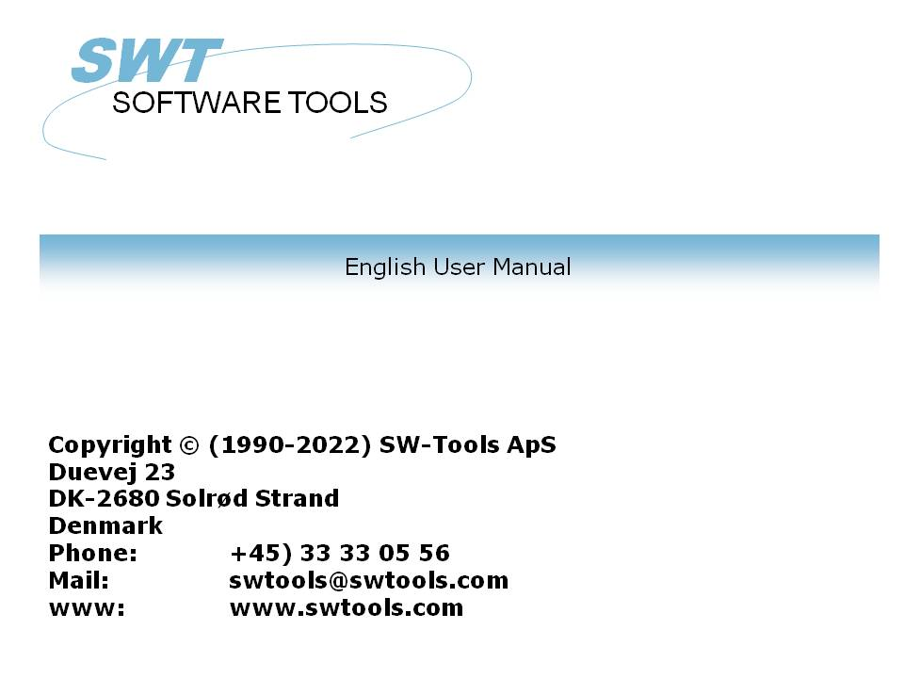

Report Generator

22/11/01 / 2022-09-01 008.384

Contents
Contents 2
1. Preface 6
1.1. Start RAPGEN 7
1.1.1. About the user interface 8
1.1.2. Functions for report definition and amendment 9
1.2. How to use this manual 10
1.3. Files used in the examples 11
1.4. Contents of the files 15
2. Define report 17
2.1. Overview 18
2.2. How to define a new report 19
2.2.1. Reportnumber 20
2.2.2. File identification 21
2.2.3. Reportname 22
2.2.4. Report heading 23
2.2.5. Print zero fields 24
2.2.6. Username/password 25
2.2.7. Report lines 26
2.2.7.1. Justify field at insertion 28
2.2.7.2. Fields from other files 29
2.2.7.3. Manuals online as helpfiles 00-08 30
2.2.7.4. Changing the start position of a field 31
2.2.7.5. Delete the last inserted field 32
2.2.7.6. Inserting text on the line 33
2.2.7.7. Ending the line 34
2.2.7.8. Blank lines (double space) 35
2.2.7.9. Start of transactions lines 36
2.2.8. Free fields 37
2.2.8.1. Heading and name 38
2.2.8.2. Field format 39
2.2.8.3. Defining field format 40
2.2.8.4. Changing free field formats in a report 41
2.2.8.5. Calculation precision 42
2.2.9. Automatic totals 43
3. Selection 44
3.1. Normal use of selections 45
3.2. Deleting selections 47
3.3. Selections not equal to 0 etc. 48
3.4. Selection on alphanumeric fields 49
3.5. Calculations in selections 50
3.6. Selections entered at the time of printing 51
3.7. Selections on parts of fields. 52
3.8. OR Selections combined with calculations 53
4. Calculations 54
4.1. Structure of the calculation function. 55
4.2. How to define calculations 56
4.3. View of translated calculations 58
4.3.1. Edit Search/Replace, Copy/Paste 59
4.4. Operands and operators 60
4.5. Percentage calculations and division 61
4.6. Part of a field 62
4.7. Alpha numeric textfields 63
4.8. Specialfields 64
4.8.1. #DD Today's date 65
4.8.2. #PD 'As of' date. 66
4.8.3. #Dx Data from #D1-#D7. 67
4.8.4. #PP Pagenumber 68
4.8.5. #OK Status after reading another file 69
4.8.6. #LEVEL Total level no 70
4.8.7. #GROUP total group numbers 71
4.9. REM Remarks 72
4.10. Remarks after calculations with /* 73
4.11. Functions 74
4.11.1. IF - Conditional calculations 75
4.11.2. Relational operators 76
4.11.3. Logical operators 77
4.11.4. WHEN, when to perform calculations 78
4.11.5. FIRST/NORMAL/LAST and AFTER calculations 79
4.11.6. TOTAL and SORT calculations 80
4.12. Wizard function helper 81
4.13. Updating files 83
4.14. Control print in calculations 84
4.14.1. Define printlines 85
4.14.2. line specifications 86
4.14.3. +xx blank lines 87
4.14.4. :xx goto line xx 88
4.14.5. PRINT (L=lines) 89
4.14.6. Conditional PRINT lines 90
4.14.7. PRINT (T=total lines) 91
4.14.8. PRINT (D=detail) READH lines 92
4.14.9. PRINT (H=heading lines) 93
4.14.10. Footer lines 94
4.14.11. PRINT - total control of report print 95
4.14.12. PRINT (x-y) print lines 96
4.14.13. Print in LAST section 97
4.14.14. PRINT(xx=yy) and PRINT(?=yy) Printer information 98
4.14.15. PRINTER(2) Fix report printer 99
4.14.16. #LIN linenumber and #LOF lines on form 100
4.15. Printing Labels 101
4.15.1. How to use in RAPGEN 102
5. Sorting and totalling 103
5.1. Sorting 104
5.1.1. Sorting on part of field 105
5.1.2. Sorting descending 106
5.1.3. Subtotal levels 107
5.1.3.1. Form feed for subtotal 108
5.1.3.2. No print of total line if only one record 109
5.1.3.3. Print number of records in subtotal 110
5.1.3.4. Print keyvalue for subtotal 111
5.1.4. Concept of sorting 112
5.1.5. Secondary sorting sequence 113
5.2. Subtotal levels without sorting 114
5.3. Weighted totals 116
5.3.1. Principles 117
5.3.2. First pass 118
5.3.3. Collecting the total value 119
5.3.4. Calculation 120
5.3.5. Weighted totals and selections 122
5.4. The report program flow 123
5.5. Calculated totals 124
5.5.1. Principles 125
5.5.2. Fundamental rules for calculated totals 126
5.5.3. Use of the WHEN command 127
5.5.4. Example of calculated totals 128
5.5.5. Technique for calculated totals 130
5.6. Fields to be totalled 131
5.6.1. Print out fields on the total line. 132
5.7. Group totals 133
5.7.1. Group field, number of codes and name 134
5.7.2. 'Undefined' group totals 135
5.7.3. Dynamic groups 136
5.7.4. Other files and calculated fields 137
5.8. Charts 138
6. Using multiple files 139
6.1. Principles in using multiple files 140
6.2. The field overview 141
6.3. READ used in calculations 143
6.3.1. Implicit READ of files 144
6.4. Relation between files 145
6.5. Continue reading of the third file 146
6.6. Files with more than one index 147
6.7. Different records from the same file 148
6.8. Maximum numbers of files 149
6.9. Conditional reading of other files 150
6.10. Reading AFTER the selections are done 151
6.11. Sum of the postings 152
6.12. Statement of account reports 153
6.13. READ(KU) Balance list with currency conversion 154
6.14. Price calculations with READ of more files 155
6.15. Price calculations without automatic connections 157
6.16. Alternative suppliers: several references in the same file 158
6.17. READ in connection with totals 160
6.18. START/NEXT/REPEAT Sum of the postings 162
6.18.1. Conditional sum with START/NEXT/REPEAT 164
6.18.2. Several loops of START/NEXT/REPEAT inside each other 165
6.18.3. Selection in connection with START/NEXT/REPEAT 166
6.18.4. END endvalue for START interval 168
6.19. READH/LINE statement of account type report. 169
6.19.1. Selection in connection with READH/LINE 170
6.19.2. Totals in connection with READH/LINE 172
6.20. SPEEDing up read of external files 173
6.21. Building files with LET 174
7. Letters and amendment of reports 175
7.1. Defining a letter 176
8. Copying, deleting and documentation 177
8.1. Copying a report 178
8.1.1. Delete a report 179
8.1.2. Documentation of report definitions 180
8.1.3. Report information 181
8.1.4. KEYS edit function 182
9. Starting a report 183
9.1. Start report function 184
9.1.1. Today's date 186
9.1.2. As of date 187
9.1.3. Start from and stop at 188
9.1.4. Selecting an index 189
9.1.4.1. Reverse sortorder 190
9.1.5. Extra data at start 191
9.1.6. Warning concerning sorting/weighted totals 192
9.1.7. Total levels 193
9.2. Printer selection 194
9.2.1. Defining a new printer 196
9.2.2. The default documentation font 197
9.2.3. Printing on an UNIX printer 198
9.2.4. Margins and page size 199
9.2.5. Screen printer 200
9.2.6. Fit page to width 201
9.2.7. Close report when finished 202
9.3. Screen printer 203
9.4. Screen printer enhancements 204
9.4.1. Saving the screen print to a file 205
9.4.1.1. SCRPRT function for IQ print recall 206
9.5. Multi Output Format printers 207
9.5.1. Printer type 208
9.6. Text printer, Printertype 1 209
9.6.1. Options 210
9.7. HTML printer, Printertype 2 211
9.7.1. HTML output of standard reports 212
9.7.2. HTML output of non-standard reports 213
9.7.3. Background, logo and browse buttons 214
9.8. RTF printer, Printertype 3 215
9.9. TXT printer, Printertype 4 216
9.10. SSV printer, Printertype 5 217
9.11. Options for printer type 2 - 5 218
9.11.1. Output to file 219
9.11.2. View output with 220
9.11.3. Definition file 221
10. Documentation and start parameters 222
10.1. Documentation 223
10.2. PARAMS function for additional report start parameters 225
10.3. Report start statistics and jobqueues 227
10.4. RAPGEN Start parameters 228
10.5. Standard reports 229
11. Compiling reports 231
11.1. Compiler - makes report 20-25% faster 232
11.1.1. Generating the program. 233
Figure list 234
Index 236

1. Preface

RAPGEN is a programming tool for users who have no programming experience. After a short introduction, all users may produce reports in a step by step dialogue with the terminal.
RAPGEN has been developed and improved over a period of 25 years and has thousands of satisfied users.
The main objective has been to create a tool so simple that everybody can use it.
Reports may be printed on any type of printer or shown on the screen.
RAPGEN is built around a DATA-DICTIONARY, defined during implementation by the installer, which contains information on all files, fields and their internal relationships.

1.1. Start RAPGEN
When you select RAPGEN, the following is displayed:

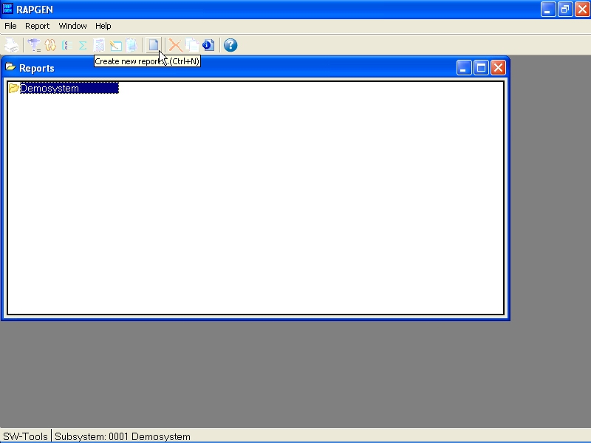

1. Report overview

1.1.1. About the user interface
RAPGEN always displays a main window with the following informations:

2. The main window
To access the functions in RAPGEN you may use the menus or the related buttons on the toolbar.

3. Accessing the functions using menus or the toolbar
Because the toolbar doesn't have room for all the functions in RAPGEN it will vary from function area to function area, as for the pulldown menus. For example you will view this toolbar when activating the layout function:

4. Other buttons on the toolbar

1.1.2. Functions for report definition and amendment
The reportgenerator has the following functions to process reports.

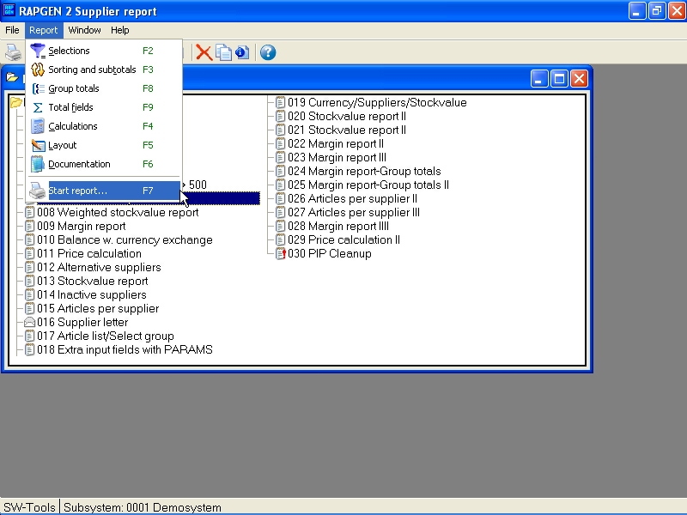

5. Functions

1.2. How to use this manual
The step by step dialogue and information texts on the screen will hopefully be sufficient guidance in most cases, but if you have a problem then use the manual as a handbook and look the main function up in the table of contents in the keyword section.
The manual includes a lot of examples, based on four simple files. The structure and contents of these files are explained in detail in the next section.

1.3. Files used in the examples
We have used 4 simple files, all created with DATAMASTER, for the examples in this manual.
In order to show you how to use RAPGEN on several files at the same time, we have based the examples on a simple article file. Each Article belongs to an article group with information on group name and a calculation factor which could be used to calculate a new sales price based on the cost price and the vendors payment currency code.
Detailed descriptions of the four files used in the examples are given overleaf, these files are:

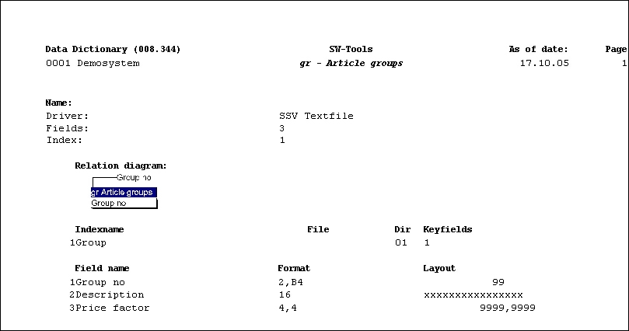

6. GR Article group file

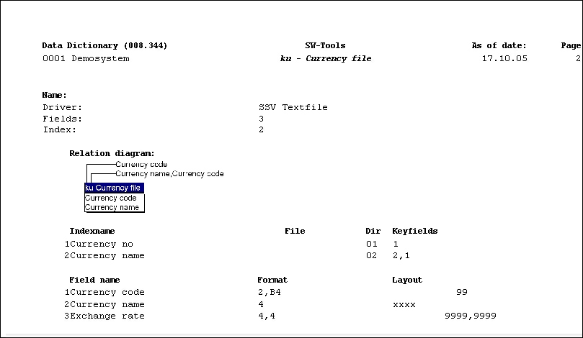

7. KU Currency file

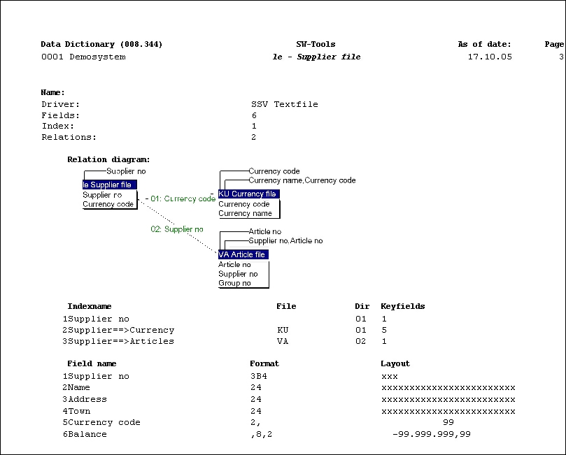

8. LE Supplier file

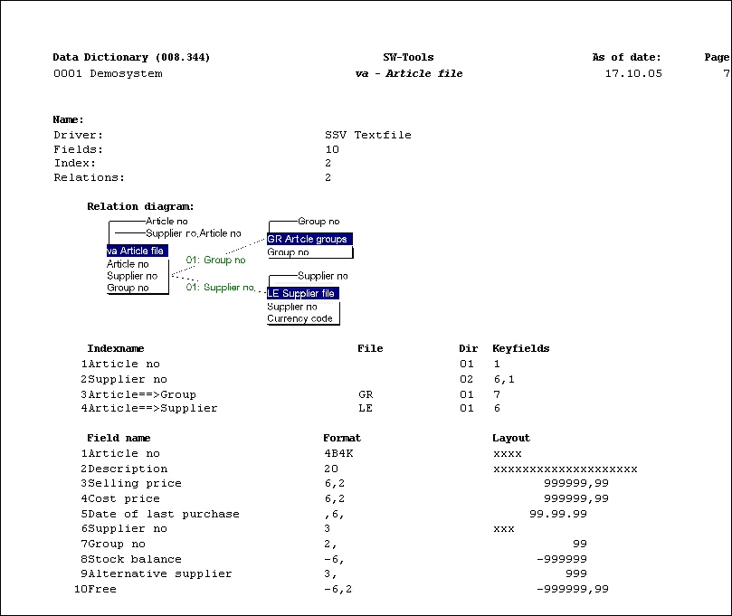

9. VA Article file

1.4. Contents of the files

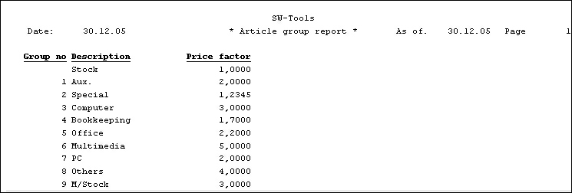

10. Contents of Article group file

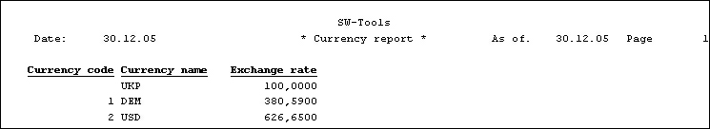

11. Contents of Currency file

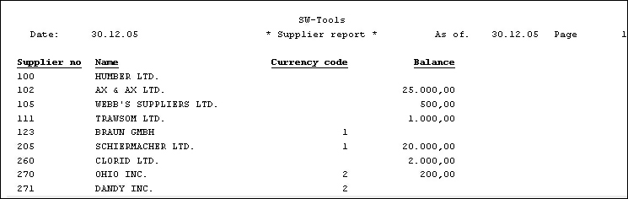

12. Contents of Supplier file

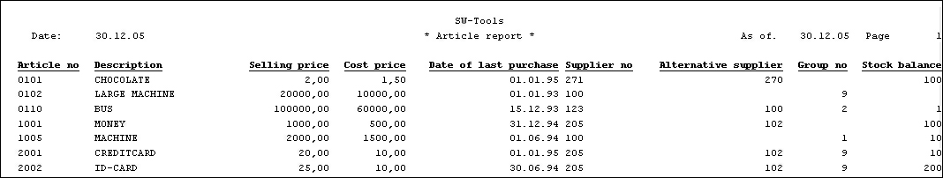

13. Contents of Article file

2. Define report

2.1. Overview
When you define a new report, just tell RAPGEN which files you want to use, give the report a number and a name and define the fields you want to be written in the report. In order to make it easier to select the fields, RAPGEN will show you the fields in the files on the screen.
From the overview of fields in the files you simply type in the number of the selected field and then RAPGEN will position the fields left or right justified on the line (alpha/numeric) with suggested headings (fieldnames).
Once you have selected the fields you want in your report, it is possible to end the function and start the report. Based on your information, RAPGEN will generate a C program.
This program may be changed either within RAPGEN or outside it and will as an option total all suitable numeric fields and print out grand totals.
If you want to improve the lay-out of your report then type in headings, alter the field positions, use multiple lines and use fields from other files. It is possible to concentrate first on the layout of your report and then later to introduce other functions, define the selections, sorting, the calculations and the totalization you want done in the report. Each function may be changed without any effect on the others.

2.2. How to define a new report
When you define a new report, the screen shows the names of all the existing reports that have been created with RAPGEN.
Here you select 'New report'.

14. Report overview and selecting new report function
RAPGEN now opens a dialog where you have to enter som main information for the report:

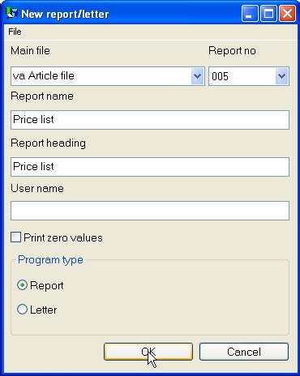

15. Define new report - pricelist

2.2.1. Reportnumber
Normally you do not enter anything here because RAPGEN automatically assigns a free reportnumber. If you want to use another number in order to group the reports just select it here.

2.2.2. File identification
Once the report number is selected, the next thing to do is to define which file one wants to use. The screen shows all files implemented for use with RAPGEN in this system.

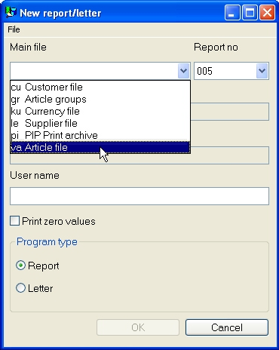

16. Implemented files
A file is identified by a short name. The file selected will be the main file, i.e. the file read through and from which references to other files are made.

2.2.3. Reportname
The name identifies a report to the user and is normally shown on the screen with 1-25 letters.

2.2.4. Report heading
If nothing is entered here the report name will be taken as the heading. The heading is automatically positioned in the center of the report, according to the number of fields in the report.

2.2.5. Print zero fields
If nothing is selected all zero fields will be suppressed.

2.2.6. Username/password
You may password protect the report by entering a username here. If entered all other functions then require input of the username, so don't forget it!
The username will NOT be displayed when entered.
Normally just ignore this to avoid protecting the report with a password.

2.2.7. Report lines
When you have ended the definition of the main information of a report the screen will show you an overview of fields in the file and additional free fields for use in calculations.

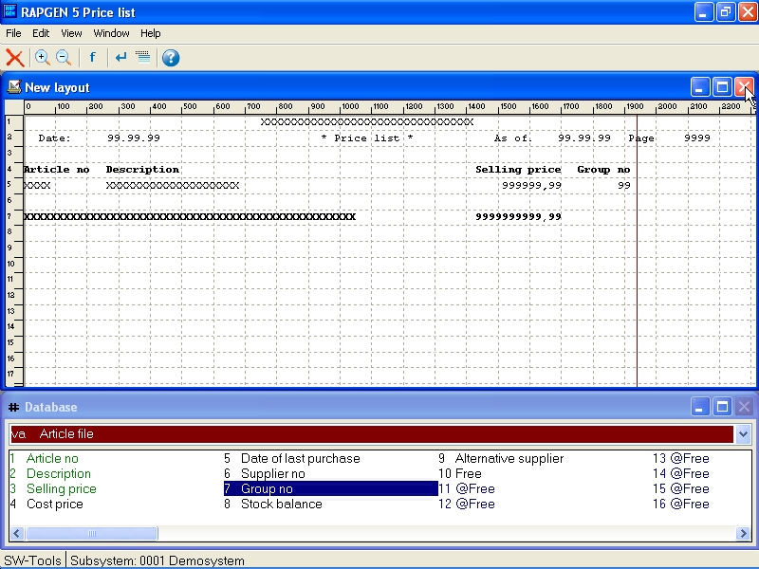

17. Reportlines and field overview
Just select the fields you wish to show in your report and the field, with the fieldname as heading, is positioned in the line according to the field format and the length of the name/heading. Alpha fields are left justified and numeric fields are right justified. When a fieldnumber is selected, the number and name are highlighted on the screen.
When all lines are defined, the function is ended by selecting the following function:

18. Ending the new report function
The example defined above is shown overleaf:

19. The report output

2.2.7.1. Justify field at insertion
If you double click on the field the standard definition may be changed before inserted on the layout. This allows you to change or completely exclude the field heading, pad with zeros etc.

2.2.7.2. Fields from other files
You may select fields from other files simply by selecting the file. When the file is selected the field overview is changed and a field from this file may be selected.
Please refer to Multiple files.

2.2.7.3. Manuals online as helpfiles 00-08
To get quick access to the manuals these are also placed as 'pseudofiles' in the database window which you have on screen whenever a report is defined.
The normal datadictionary structure is used for these files which means they comes as small textfiles which can be online even if you do not have space for the complete Windows HLP manuals.

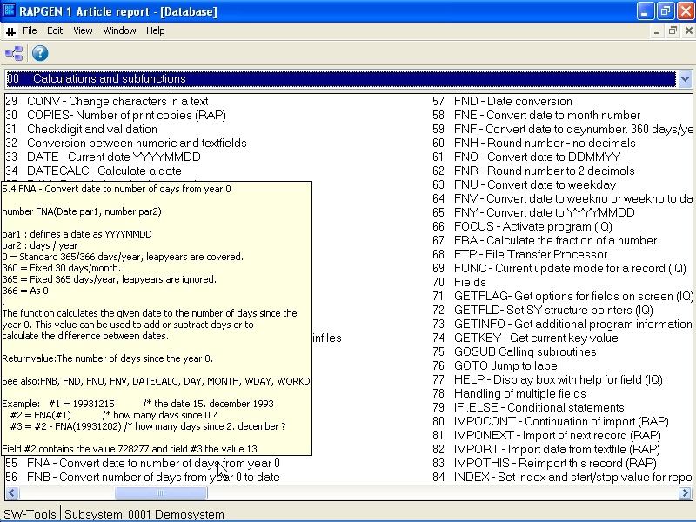

20. Function help
The sections of the manuals will appear as fields sorted by name. When you move the cursor over a field the corresponding help pops up immediately. Only the text is shown, the figures will be omitted, but if the Windows HLP manual is online you may doubleclick on a field to open this.

2.2.7.4. Changing the start position of a field
You can always see the start position of the next field. By changing this position you may add more space between the fields. To change the start position:

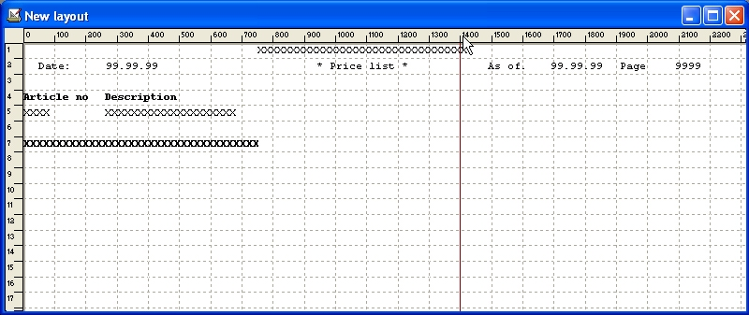

21. Changing the start position of a field

2.2.7.5. Delete the last inserted field
The function deletes the last inserted field. If you want to delete the field heading as well select the function once more.

2.2.7.6. Inserting text on the line
If you select this function you may insert text instead of a field. Text is inserted on the field line, not the heading line.

2.2.7.7. Ending the line
If you select this function you may define a new line of fields to be printed for each record read in the main file.
You may define as many lines as needed on a report.

2.2.7.8. Blank lines (double space)
Blank lines are defined by selecting the end of line function twice without inserting any fields.

2.2.7.9. Start of transactions lines
When selecting this function RAPGEN is aware of that the previously defined report lines are to be used as heading for the transaction lines.
The control of the report is the READH command, refer to Multiple files.
RAPGEN inserts a READH command, on the first external file used, in the calculations.

2.2.8. Free fields
A part from the main file fields the field overview displays free fields marked @Free. Free fields are used for calculations and are not defined in the file.

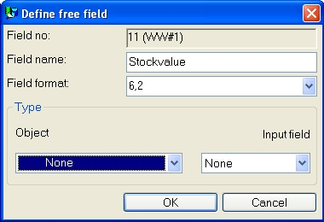

22. Defining a free field

2.2.8.1. Heading and name
When you select a free field , you are asked to give it a name which will appear as field name when you define the calculation and as heading on the layout.

2.2.8.2. Field format
RAPGEN assign a default format for each free field upon first definition. You may change this format according to the following rules:

2.2.8.3. Defining field format

1 | xx, | Number of digits - no sign
2 | xx,yy | Number of digits before decimal point and yy decimals - no sign
3 | -xx, | as 1, with sign
4 | -xx,yy | as 2, with sign
5 | ,xx,yy | as 1, with edit per 1000
6 | xx | without comma xx represent the number of characters in a textfield

23. Definition of a field format

2.2.8.4. Changing free field formats in a report
It is only the free fields in a report that you may change, fields defined in files cannot be changed in RAPGEN.

2.2.8.5. Calculation precision
When entering the format of the field RAPGEN automatically select the best fit C variable for fast calculation at the best precision.
If number of decimal digits is given for numeric fields the field will be rounded to this number of decimal digits.

2.2.9. Automatic totals
When a report is defined RAPGEN will automatically total all suitable fields as final totals. If some of the totals do not make sense or you only require some of them, you may exclude these in the total field function.
RAPGEN totals fields according to the following criteria:

24. Criteria for automatic totals

3. Selection

Selection is used to select specific records in files.

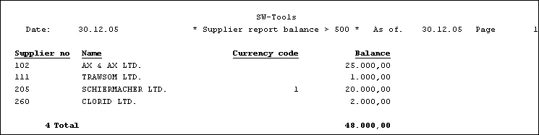

25. Supplier list, only balances over 500 are printed

3.1. Normal use of selections
When you choose this function, you may review the fields in the file on the screen, and then you may select any of these by typing in the field number:

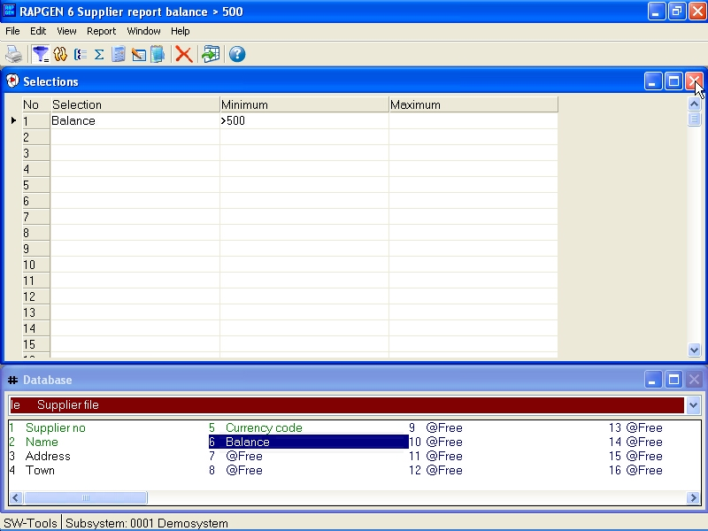

26. Defining selections
After entering the field number you may define a minimum and maximum value for the fields, so that only records in this field range will be printed.
You may simply define one of the minimum/maximum values.
After this you may type in a new field number and define combined selections on multiple fields. You should note that this would be a selection where both the first AND the second selection have to be true. For example field number 7 must contain the number 5 AND field number 15 must contain the number 1 at the same time. If you define a selection like this and field number 7 contains 5 and field number 7 contains 9, nothing at all will be printed on the report. "OR" selections must be done by calculations, as explained later.
You may select on the fields of the file, calculated fields, and fields from other files.
When you have finished the definition just end the function by:

27. Closing selections

3.2. Deleting selections
You may delete selections by selecting the following function:

Unknown picture (g:/rapdoc/rc1-eng26.jpg)

28. Deletion of selection

3.3. Selections not equal to 0 etc.
If you state a minimum/maximum, the value of the field must be within the range . In both minimum/maximum specification, you may use one of the relational operators (see Chapter 4 Calculations):
<>0
and no maximum. This will give the result that only records with the field not equal to 0 will be printed.

3.4. Selection on alphanumeric fields
RAPGEN automatically insert quotation-marks if the selection is based on an alphanumeric field, e.g. minimum value:
A
is interpreted as "A".

3.5. Calculations in selections
In both minimum and maximum fields you may enter a calculation, in this way it is possible to define, for example:

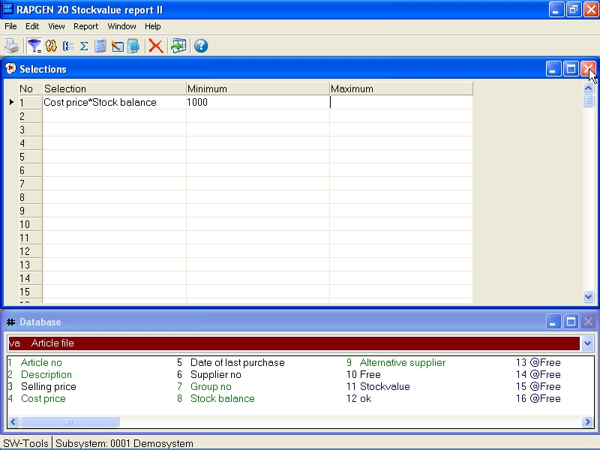

29. Calculations in selections
In using this example you have defined a selection on the condition that a total of fields must be greater than another field.

3.6. Selections entered at the time of printing
You may use data input when printing a report, as a basis for selection when the report is printed. For example, if you define two free fields as INPUT field 1 and 2 and:
MINIMUM: #47 and MAXIMUM: #48
in the selection, RAPGEN defines two input fields at start of report. Entering values in these fields will change the selection from time to time.

3.7. Selections on parts of fields.
If you want to select on the condition that the 3rd digit in a number is a given maximum or minimum, you may define #7(3,3) as a fieldnumber.

3.8. OR Selections combined with calculations
The fact that you may select on calculated fields may be used to allow more complicated selections by calculating a free field for use in selections, for example:

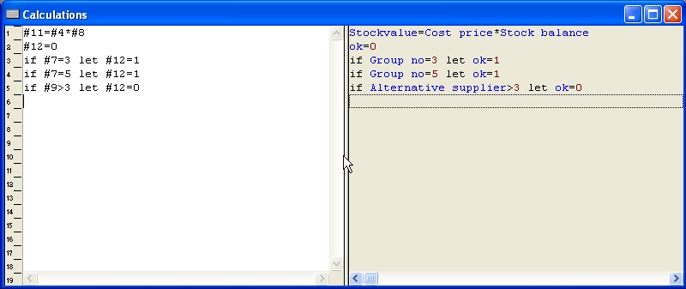

30. Selection on calculated field - OR selection
and then define a selection as follows:

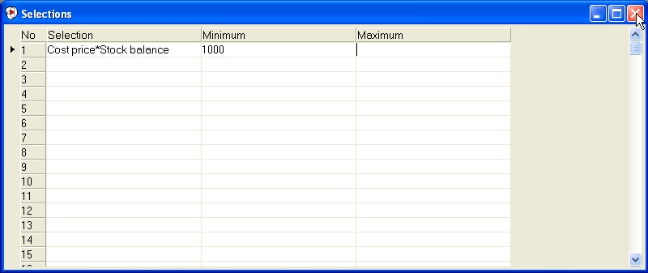

31. Selection on calculated field - OR selection
In the case you will only process records where fieldnumber 7 is either 3 or 5, but not if fieldnumber 9 is greater than 3. This method can be used to provide logical "OR" selections.

4. Calculations

4.1. Structure of the calculation function.
With this function, you may calculate results and print them in a report or use the calculation to sort a file into a new order or to select on certain conditions. The syntax is identical to normal algebra, e.g. A = B + C and you can use all the normal operators including square roots and trigonometric functions.
When calculating, it is actually BASIC lines that are used. To make it simple to use RAPGEN translates your commands into BASIC syntax and then into C language lines. Just refer to a free-fieldnumber e.g. #51 = #20 + #19 and the sum of fieldnumber 20 and fieldnumber 19 are placed in fieldnumber #51. If you wish to know fieldnumber #20 as a percentage of fieldnumber #19, just type:
#51 = #20 % #19
You may use a field from another file in the calculations by using the file shortname and a fieldnumber e.g.:
#52 = KU#12 - #20
There are also functions for rounding, e.g. to 2 decimal places, calculation of days between 2 dates, calculation of workdays, reading other files, calculation of checkdigits of fields or lines printed for optical reading (OCR).

4.2. How to define calculations
When selecting this function the following screen is displayed:

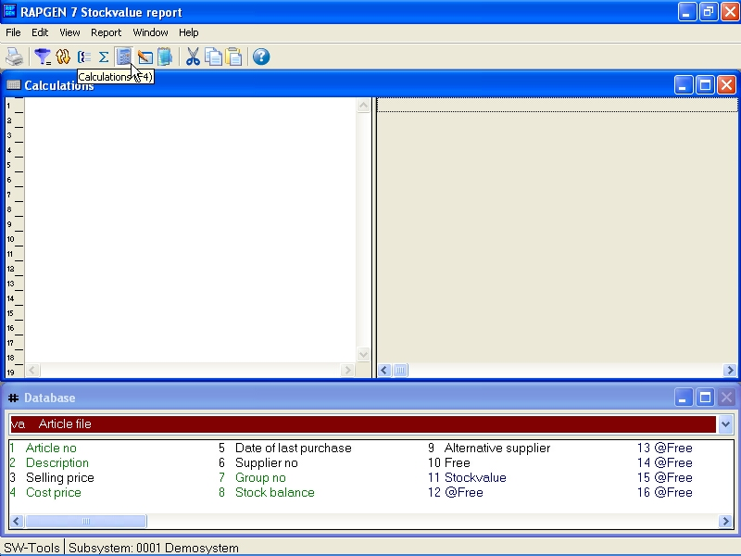

32. Calculations
In the new report function, you have edited the report and have chosen to print a free field with a related format and name. If you printed out the report before you defined the calculation, you would have had 0 in the field.
You may enter, for example:
#11 = #8 * #4
This means that Fieldnumber 11 (Stockvalue) is to be calculated as
#8 (Costprice) * #4 (Stockbalance)

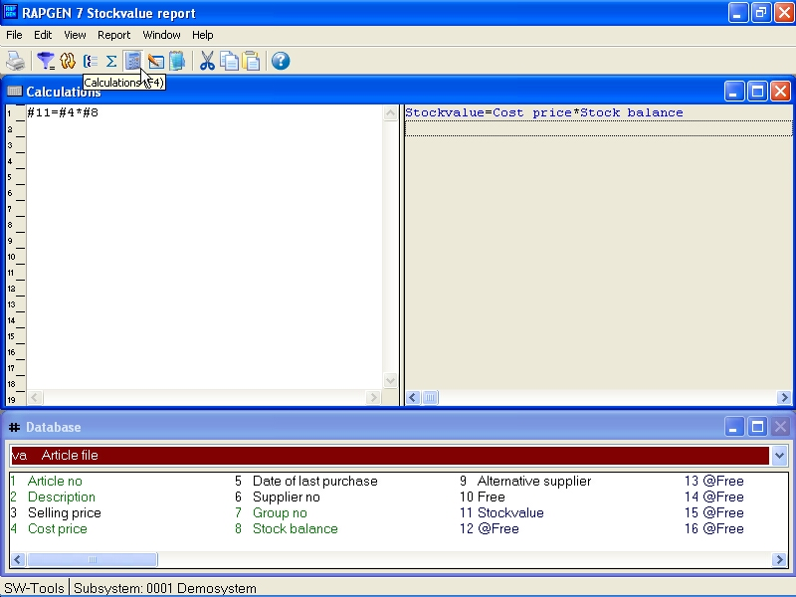

33. Calculating the stockvalue
You may see above that the field numbers used in calculations are translated into fieldnames and on the screen you will see that the result Fieldnumber 11 - Stockvalue is highlighted.
Now you may proceed with more calculations or stop and print your report.

4.3. View of translated calculations
Normally the translated calculations are displayed in colours and all field references are translated into fieldnames.
If required, in the calculations or in another function, you may change the translation mode of fields as shown here:

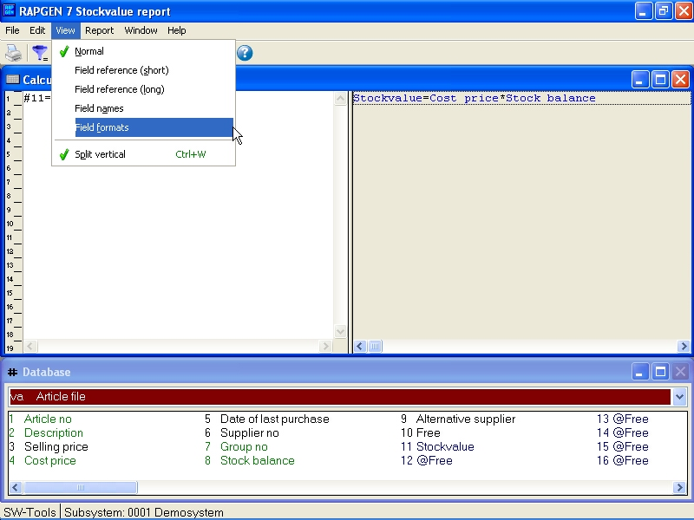

34. Changing view of translated calculations

4.3.1. Edit Search/Replace, Copy/Paste
In the edit functions for calculations, keys etc. you have got the possibility to search and eventually replace a textstring.

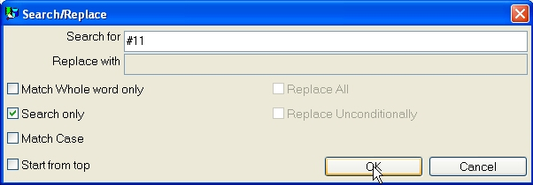

35. Searching / Replacing a string

4.4. Operands and operators
Thus the entered calculations are translated to C code the user can take advantage of coding calculations with parentheses, call to subfunctions etc. You may use the following operators:
+ = Addition
- = Subtraction
* = Multiplication
/ = Division
and these will be executed in this order:
* = Then multiplication's and divisions
+ = Then additions and subtractions
This order may be changed by the use of brackets.
As operands you may normally use field numbers, e.g. #7 means field number 7. If you wish to use fields from other files you must also enter the file shortname (2 letters). E.g. KU#15 means field number 15 in the file KU.
You may also use constants in expressions, e.g. #18 = #10 * 100. Note that decimal separator must be ENTERED AS A POINT e.g. 10.47.
The result field in a calculation will normally be stored in one of free fields in the main file.

4.5. Percentage calculations and division
As you may know, it is NOT possible to divide by 0. If you try to do this you will get unexpected results.
To avoid this, you can ensure that you do not try to divide by 0 by using the IF statement. E.g.:
#50 = 0
IF #22 <> 0 LET #50 = #21 * 100 / #22
In this example the calculation will only take place if #22 is not 0. If field #22 is 0, the result field #50 will also be 0. In this calculation, we have calculated #21 as a percentage of #22.
In order to make this very common operation easy to use RAPGEN has a % operator. Just enter:
#50 = #21 % #22
and the 2 lines shown above will be generated automatically.

4.6. Part of a field
You may need to work on selected characters or digits in a field. This may be done as follows:
#7(3,4) will give you the 3rd and 4th character/digits of fieldnumber 7.
#15(5,8) will give you the 5th to the 8th character/digits of fieldnumber 15.
You may also make calculations which depend on the contents of part of a field:
IF #7(3,3) = 5 LET ...
The calculation will only be performed if field 7's 3rd digit is 5. It is also possible to use a digit directly in a calculation:
#50 = #21 * #7(3,3) + #22

4.7. Alpha numeric textfields
When defining the calculations or selections fields differs from being numeric or alphanumeric (text). The following rules are to be used for alphanumeric fields.
If you perform calculations on alphanumeric fields RAPGEN converts the contents of this field. The field containing "123 45" will therefore have the numeric value 123 and NOT 12345!

4.8. Specialfields
We may define calculations like:
#8 = #7 * #6
#8 = #7 * KU#15
but may also use the following special fields:

4.8.1. #DD Today's date
This value is entered as the first date at the start of the program.

4.8.2. #PD 'As of' date.
This value is entered as the second date at the start of the program.

4.8.3. #Dx Data from #D1-#D7.
If you select a free field for a calculation, e.g.:
#50 = #97
and marks field #97 as an INPUT field the name becomes:
#D1currency
and RAPGEN will add this field to the start screen of the report. You are able to define up to 7 such start data fields.
Data can as an example be used to enter a currency amount using the currency of the day at start of the report, where the report makes its selections based on this data field. This is useful because the currency can vary from time to time.

4.8.4. #PP Pagenumber
You may use the pagenumbers in calculations via this variable.

4.8.5. #OK Status after reading another file
After a calculation which reads another file, for example READ(KU), you can check if the read was successful and thus control other calculations or selections.
IF #OK = 0 LET #7 = 1 /* reading OK! or
IF #OK <> 0 READ (LE) /* reading NOT OK!

4.8.6. #LEVEL Total level no
If you have defined that totals must be calculated before printing in Sorting and totals, you may make the calculations conditional on the total level number.
A normal line has #LEVEL=0. Subtotal levels run from #LEVEL=1 to #LEVEL=9. If a report has only one grand total, this will be at #LEVEL=1.
Normally the field is only used in very complicated reports.

4.8.7. #GROUP total group numbers
In connection with grouptotals, you may wish to attach a text to the group numbers. For example:
IF #GROUP = 1 LET #50 = "M/Stock"
IF #GROUP = 2 LET #50 = "Special"
If the group names are in another file you may prefer to use the READ instruction instead of the text constants in the report definitions.

4.9. REM Remarks
The REM lines help to document your calculations in normal text, so you can make use of this facility to note what you have actually done in your calculations. For example:
REM calculation of days overdue.

4.10. Remarks after calculations with /*
On each line you are allowed to enter a comment by separating it from the actual calculation, e.g.:
#15 = #3 - #4 /* calculate ...

4.11. Functions
RAPGEN has a number of built in functions for rounding, date calculations etc., which you can use in the calculations. Chapter 2 - CALCULATIONS AND SUBFUNCTIONS descripes all these.

4.11.1. IF - Conditional calculations
IF statements allows you to control the calculations, e.g. only calculate a field in a code that has a specific value or calculate the field a different way for another code. An example of an IF statement could be:
#50 = 0
IF #7 = 2 LET #50 = #21 % #22
You can combine several IF statements on one line:
IF #7 > 1 IF #7 < 5 LET #50 = #21 % #22
where both IF statements has to be corrent before the calculation will be performed. This equals the logical AND, not the OR expression.
IF statements can also be used when reading from other files. For example:
IF #7 = 2 READ(KU)
the file KU is only read if field 7 equals 2.

4.11.2. Relational operators
In selections, and in connection with the IF statement the following operators may be used:
= Equal to
> Greater than
< Less than
>= Greater than or equal to
<= Less than or equal to
<> Not equal to
You can check the field value directly, e.g.:
IF #7 LET #50 = 5
which means that if field 7 is different from 0. This conditional statement can be reversed:
IF NOT #7 LET #50 = 5
meaning that if field 7 is zero then...

4.11.3. Logical operators
You can also use the two logical operators 'AND' and 'OR', For example:
IF #7 = 1 AND #15 = 2 LET #45 = 1
IF #7 = 1 OR #7 = 3 LET #45 = 2

4.11.4. WHEN, when to perform calculations
The command WHEN is used to define when calculations may be performed, i.e. before/after sorting or accumulating totals.
You enter the WHEN command using the following syntax:

Unknown picture (g:/rapdoc/rc1-eng031.jpg)

36. WHEN, When to perform calculations
In this way, you can control calculations until a new WHEN command is entered.
The WHEN command may also be used to reduce look-up in other file during sorting.

4.11.5. FIRST/NORMAL/LAST and AFTER calculations
These commands are normally only used in very complicated reports.
The FIRST command will cause your calculations to take place before reading the files, e.g. Dimensioning of user files.
The NORMAL command is used when you wish to return to normal. Normal means of reading records, before selections, sorting and totals.
The LAST command is used when you wish to perform calculations after the last record has been read and the last total line has been printed and the last total line.
The AFTER command is used when you wish to perform calculations after selections, i.e. calculations reading other files are only performed on selected records. This might improve the speed of the reports.

4.11.6. TOTAL and SORT calculations
Using the WHEN command allows you to split NORMAL calculations so that calculations only are performed at requested times.
This may end with very complicated reports that are somewhat non-readable and unstructured.
Instead as using the AFTER command RAPGEN allows you to use the following sections:
TOTAL calculations are only performed when totals are printed and you may NOT have selected calculated totals on report thus this is default when using this command.
SORT calculations are only performed during sorting. The command also informs RAPGEN of NOT TO perform calculations in the NORMAL section.

4.12. Wizard function helper
You should select a calculation line containing any function call and then from the EDIT menu activate the wizard of simply press CTRL.Q on the line.

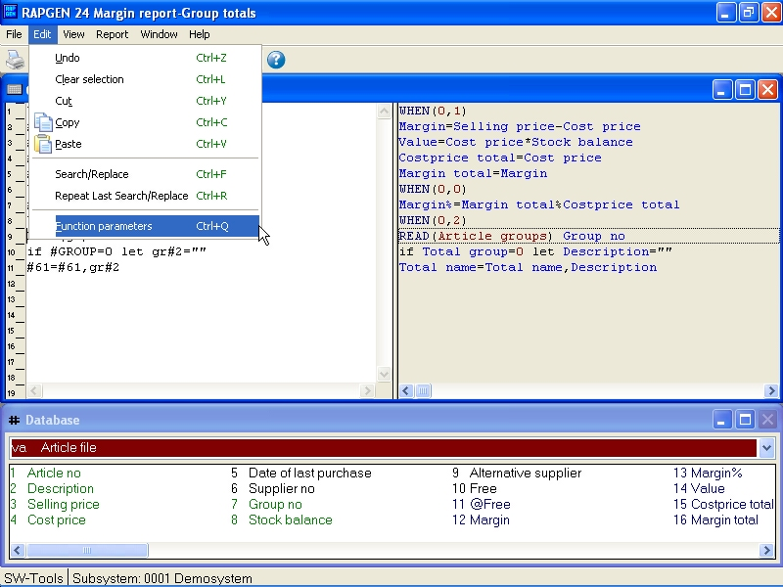

37. Activating the function wizard
The wizard now finds the nearest function name on the present line and makes an input dialog based on the help manuals.

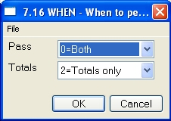

38. The function wizard for WHEN
Which means you will get the parameters shown in clear text and these can be selected from the allowed values.
If you move the mouse cursor over the fieldnames you will get the function manual documentation shown as floating help.
In case of a new calculation line to be entered you may just enter the function name, say READ followed by CTRL.Q

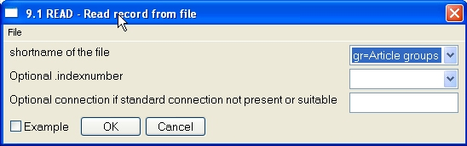
39. The function wizard for READ
The wizard also integrates to the Data Dictionary whereby it is able to let you select files and their indexes from a listbox.
If you check the EXAMPLE field the example from the manual will be included in your program, you may afterwards have to change the fieldnumbers to get a working result.
You should always see the wizard as a helping tool when defining a program but at the same time observe that some functions may have so specialised use that the wizard cannot show all the possibilities. For example with READ the use of Upper/Lowercase fileID's and forced connections will not be supported by the wizard.

4.13. Updating files
Normally the user won't be allowed to update in the database files. This is considered much to big a risk and might most likely corrupt the database.
The exception might be the files the user has created using the DRN function. These files may be updated by the user where the updating reports will be password protected.
The update of files are quite simple. The user can instead of calculating free fields calculate directly on the field from the file to be updated. For example:
UPDATE (1) /* allow update of main file
#7 = #7 + 1 /* increase counter
REWRITE (XX) /* modify record in database file

4.14. Control print in calculations
The PRINT command can be used in 3 different ways:
1. You can decide which lines to be printed the next time the report print something.
2. Take full control of the report print.
3. Print lines from the layout directly - here and now.
NOTE: Function 1 and 3 can be combined.
PRINT commands in the calculations have priority of the values entered when activating the LINE command in function 7 and overwrite/change these.

4.14.1. Define printlines
In the following calculation line is entered:
PRINT(L=7-8)
the lines 7 and 8 will be printed the next file a record is to be printed. The print doesn't directly print line 7 and 8, but is a change of the LINE defined DETAILLINE section.
L = lines are to be printed for each following record.
You can use H=, N=, T= og D= for header, new page, totals and detail (READH) print.

4.14.2. line specifications
Simply enter one line:
PRINT (L=7)
or an interval of lines:
PRINT (L=7-9)
or a combination of both:
PRINT (L=7,15-20,9,11-12)

4.14.3. +xx blank lines
You can print blank lines using the syntax +xx:
PRINT (7,+2,8)
This will print line 7, 2 blank lines and then line 8.

4.14.4. :xx goto line xx
You can jump to a specific line on the print page:
PRINT (H=:10,1-3)
The header of the report will start at line 10.
Please note that if the line jump causes a jump backwards on the page the current page will be flushed and a new page activated. The N= normally has to contain a :1 to force a pagebreak.

4.14.5. PRINT (L=lines)
You may set the print lines for following records using the calculation
PRINT (L=5-6)
which prints the lines 5 and 6 for each record read.

4.14.6. Conditional PRINT lines
PRINT is a function as all other functions mentioned in this manual. This allows you to use it in conjunction with IF statements:

40. Conditional print lines

4.14.7. PRINT (T=total lines)
The calculation
PRINT (T=17)
sets the print lines for further print of total lines.

4.14.8. PRINT (D=detail) READH lines
This function is only meaningful is the report contains a READH call in the calculations. READH is similar to the normal READ, but in addition it prints the header each time a main record is read:
PRINT (D=+2,7)
Sets the lines for this header.

4.14.9. PRINT (H=heading lines)
The report header print lines may be set using the calculation
PRINT (H=1-3)
With PRINT(H= you may set more space on top of the page by entering the following line:
PRINT (H=+3,1-4)
The header can be deactivated completely with:
PRINT (H=)

4.14.10. Footer lines
You can print some footer lines with PRINT(...). For example:
PRINT(:1003,10-11,:1,1-4)
This jumps to 3 lines from the bottom line (e.g. line 69 if page is 72 lines), then prints line 10 and 11 and then forces a pagebreak and prints line 1 to 4 on the new page.

4.14.11. PRINT - total control of report print
If you enter the command PRINT without parameters:

41. Total control of print
The PRINT command is similar to the NORMAL command, but deactivates all automatic print performed by RAPGEN. When using this command the user has to insert calculations calling the PRINT (...) to get any output at all.

4.14.12. PRINT (x-y) print lines
The calculation line:
PRINT (7)
immediately print line 7 of the report layout. The calculation:
PRINT (L=7-8)
gives the same result as the lines:
PRINT
PRINT (7-8)

4.14.13. Print in LAST section
You can use the PRINT command in the LAST section to print a trailing page.

4.14.14. PRINT(xx=yy) and PRINT(?=yy) Printer information
You may retrieve detailed printer information using the PRINT function, see the function manual.

4.14.15. PRINTER(2) Fix report printer
You may lock the report to a printer defined in the print setup.

4.14.16. #LIN linenumber and #LOF lines on form
The new system field #LIN may be used in the calculations especially compared to the value in #LOF lines on form as e.g.
IF #LIN>#LOF-5 THEN PRINT(:1,1-4) /* Force newpage

4.15. Printing Labels
The subfunction PRINT() can be used to produce print of labels in a very simple way. The function syntax is:
PRINT(LAB=direction, columns, rows, width, height, copies)
.
The direction control how to generate the labels on the label sheet. The valid values are:
0 - No labels
1 - From left to right
2 - From top to bottom
.
The multiply of number of columns and rows is the actual number of labels on one sheet.
The width and height of any label on the sheet can be given in centimetres or inches by using the following syntax:
7cm equals 7 centimetres
2in equals 2 inches
.
Finally when printing labels you may want to print multiple copies of the same label, which can be controlled by the copies parameter.
A sample use of the PRINT(LAB=...) function could be:
PRINT(LAB=1,3,7,7cm,7cm,2)
.
which will produce labels printed from left to right on a label sheet with 21 labels, 3 on each row, 7 rows, where each label has the width/height of 7 centimetres. Each label is printed in 2 copies.

4.15.1. How to use in RAPGEN
To produce the simple print of labels a report must be defined as a letter. The main file of the report should as an example be the customer file if you want to print customer labels.
On the layout of the letter you only require to define one label in the top left part of the layout.
When the label is defined you must remember to change the Page control, which is normally set to :1,1-99 for a letter, to 1-x where x is the number of lines used to define the label.
Finally you have to add the following calculations to the report:
FIRST
PRINT(LAB=1,3,7,7cm,7cm,2)
.
Please remember to have the PRINT(LAB=...) in the FIRST section. Otherwise, it will reset the label control for each record read from the main file.

5. Sorting and totalling

Sorting and totals are defined in the same function because very often totals are related to the sequence in which you may wish to process the files. Total levels occur when one or more of the characters in a file key or a sort key changes value. These levels may be defined in the structure of sort keys.

5.1. Sorting
To define a sort criteria just select a field from the field-overview:
and in this way you can combine fields or parts of fields until you have got the sort criteria you require.

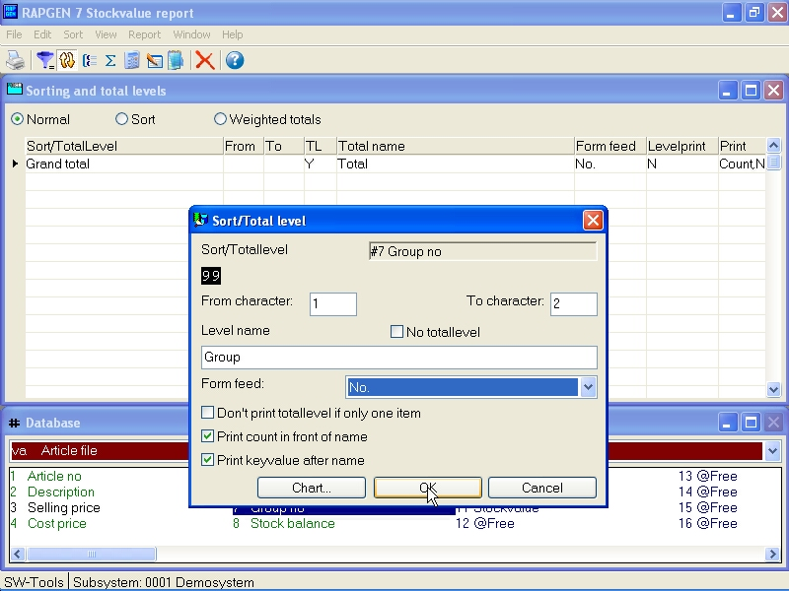

42. Building a sortkey

5.1.1. Sorting on part of field
You may build a sortkey selecting one or more fields and may for each of those choose from/to character position of the field.

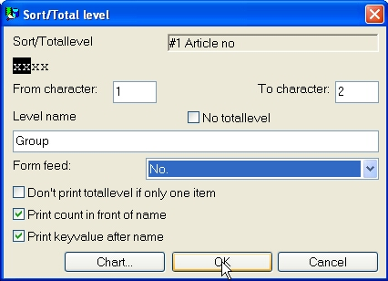

43. Sort on part of field

5.1.2. Sorting descending
When defining SORT you may select ASCending or DESCending from the menu.

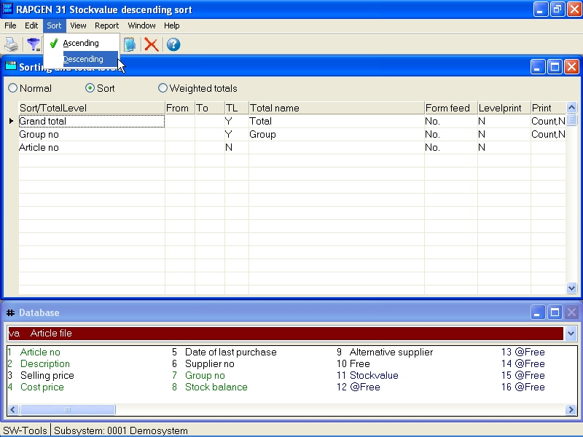

44. Sorting descending

5.1.3. Subtotal levels
As when defining af sort criteria just select the field used to define the subtotal. Then mark the definition as a subtotal.

45. Defining a subtotal
The result of the defined subtotal is shown here:

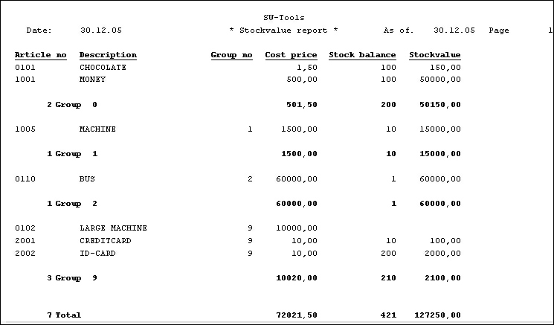

46. Sorted list with subtotals, sorted by article group

5.1.3.1. Form feed for subtotal
A subtotal is normally printed with a leading and trailing blank line. If required the total can be printed differently, for example starting on a new page.
When defining af subtotal you may control the option as shown here:

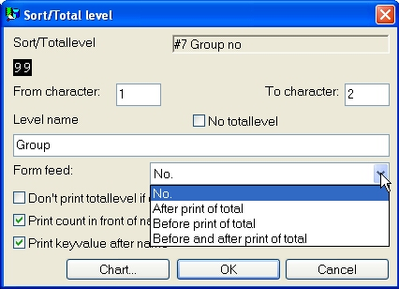

47. Form feed for subtotal

5.1.3.2. No print of total line if only one record
Choosing this option suppresses the print of the subtotal if the level only contains one record before the subtotal.

5.1.3.3. Print number of records in subtotal
Normally a print of a subtotal or grouptotal starts with a value equal to the number of records in the level, then the totalname and at last the keyvalue for the level. If you want to suppress this information please remove this option.

5.1.3.4. Print keyvalue for subtotal
If you want to suppress the printing of the key on the total line you can remove this option.

5.1.4. Concept of sorting
Sorting is done by adding an extra first pass to the report it is all records are read and a sort file is builded before print starts.
During both passes the calculations and selections is done which means you are able to sort on calculated fields - even on fields from other files.
Only records fullfilling the selections will be inserted into the sortfile.
By use of the WHEN command you can control whether a block of calculations is executed during the sort and/or the print pass of the report. For example it is poosible to omit timeconsuming reading of other files during the sort it the informations in these are not needed.

5.1.5. Secondary sorting sequence
If a suppliers list is sorted for example by currency code and nothing else, the suppliers with similar currency codes are listed in the order they where read in the first pass of the sort. The list will because of the primary index result in supplier order, but if a name index is selected at start of report the order is by name.

5.2. Subtotal levels without sorting
Even if you do not wish to sort, you may define subtotals in a similar way.
As with subtotal definitions in connection with sorting, you may define a subtotal level each time a part of the index used for this report changes, e.g. 2 first digits of an articlenumber.
You must, of course, know the structure of the indexes in order to use this function. Normally, only the primary index is used.

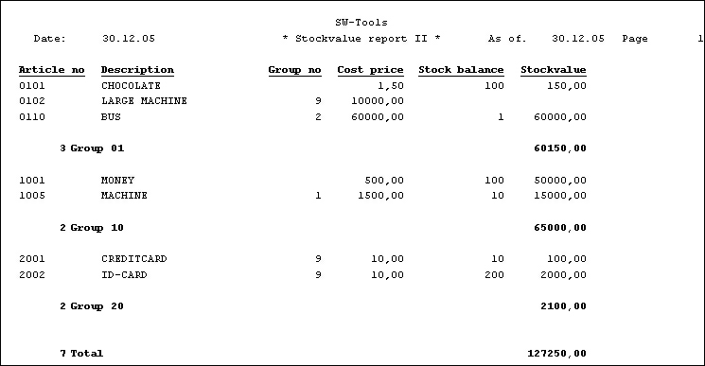

48. Report containing subtotals
When a report is started it is possible to suppress the normal print lines and only get the total lines. This is useful if the report normally prints lines for 6000 articles and what you want is the subtotals.

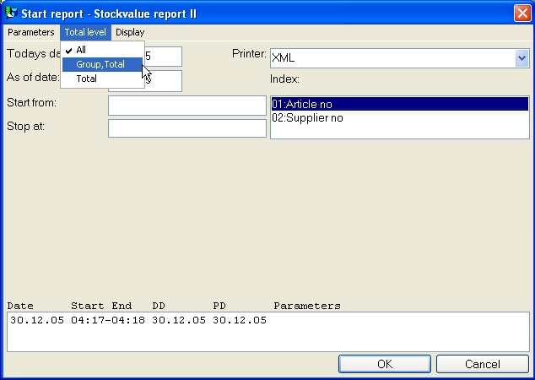

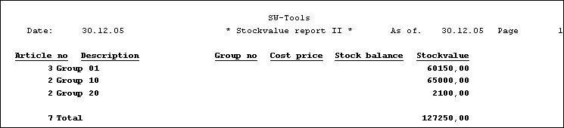

49. Report with subtotals only

5.3. Weighted totals

5.3.1. Principles
Weighted totals are detail lines weighted with a final total of the report. For example a customer list where the balance is weighted with the total of all customers balance.

5.3.2. First pass
RAPGEN has to know the final totals in order to use them in the calculation of the detail lines.
This is done by reading the file(s) or part of it/them, and then reading it/them once more performing the calculations and printout.

5.3.3. Collecting the total value
The final totals are produced by calculations using free fields. During the first pass, final totals of the selected fields are calculated. With the WHEN command, you may define if a calculation is to be performed in the first, second or both passes. E.g.:
WHEN (1,0) /* First pass only
#50 = #50 + #24 /* total balance

5.3.4. Calculation
When entering the second pass, field 50 now contains the total value of field 24 (#50 equal 100 %).
During the second pass this field, #50, is used as a constant value:
WHEN (2,0) /* second pass only
#51 = #24 % #50
In this way you calculate fieldnumber #51 equals field #24 as a percentage of fieldnumber #50. You may even use this field in selection so that only results greater than 2% are printed.

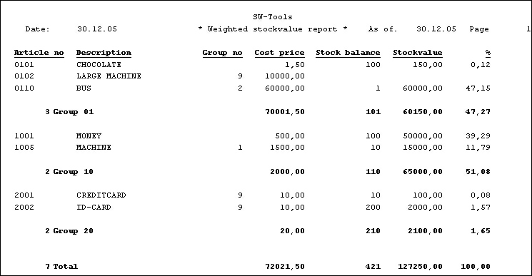

50. Report with weighted totals and subtotals
The calculations for this report is as shown here:

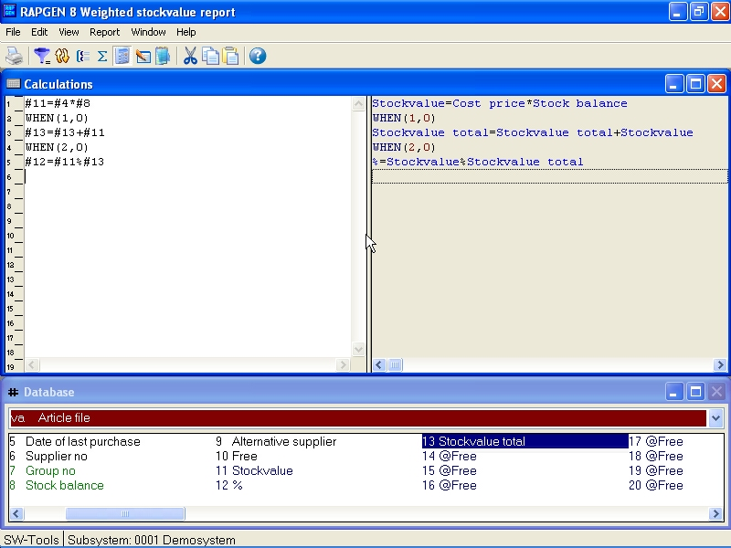

51. Calculations for weighted totals

5.3.5. Weighted totals and selections
Please note that a calculation is normally performed before a selection. If you only wish to create a report with weighted totals on a part of a file(s), then use the IF-statement in the calculation function:
WHEN (1,0) /* first pass only
IF #7 = 2 LET #50 = #50 + #24
Now fieldnumber #50 is only accumulated when fieldnumber #7 is equal to 2.

5.4. The report program flow
Before you go on, we can review the structure of the RAPGEN subroutines. The following sections explain the stages of the sequence.

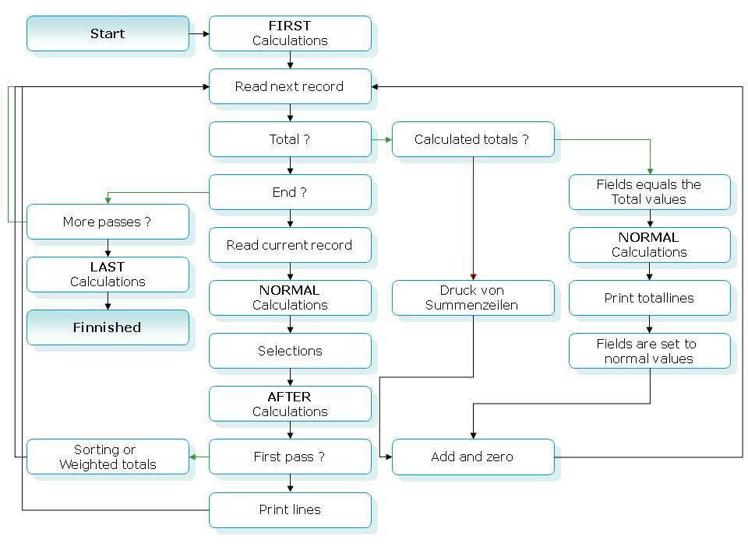

52. The report program flow

5.5. Calculated totals
Calculations on totals are normally only necessary for percentages on total lines.

5.5.1. Principles
Normally, calculations on a report will be made for each record which is read from the files, i.e. per line on the report, and the totals will be created as the sum of those fields you have asked to be totalled. This will be suitable for most reports.
If the calculations maintain percent calculations, e.g. profit margin for each article, the total will be the total of the percentages of the single lines, which is not meaningful. However, since totals may be calculated before printing out, you may make RAPGEN create percentage calculations for the total lines.
It may not be desirable to calculate all total fields, e.g. if you print out lines with a field calculated as a foreign currency amount, you will not wish calculate the total of this field, as the total foreign currency amount will be nonsense. In using the calculated totals, you will normally also use the WHEN command in connection with calculations, allowing you to state which calculations shall be made for the totals. For special reports, you may use the special fields #LEVEL and #GROUP to control different calculations for different total levels or total groups.

5.5.2. Fundamental rules for calculated totals
With calculated totals, all fields which enter into the calculations will be totalled!
If you calculate e.g.
#51 = #24 % #50
all the included fields, such as 24, 50 and 51 will be defined as totals, even though not all the fields are printed out on the report. If you do not define a total on a field, this field will be 0 from that moment when the total calculations are made, and you will not get the desired results.

5.5.3. Use of the WHEN command
With the aid of the WHEN command during calculations, (see below), you may control when calculations shall be made:
0 = Both totals and lines
1 = Only lines
2 = Only totals
e.g. currency conversion may only be made for lines, while percent calculations are be made for both lines and totals.
In the next example a report is defined, where the Stockvalue is calculated as stock * bargain price, which is a typical example of a calculated total, since (total stock) * (total bargain price), is nonsense.

5.5.4. Example of calculated totals

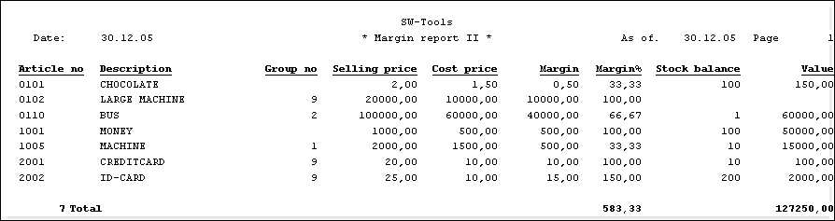

53. The report without calculated totals, margin % is wrong

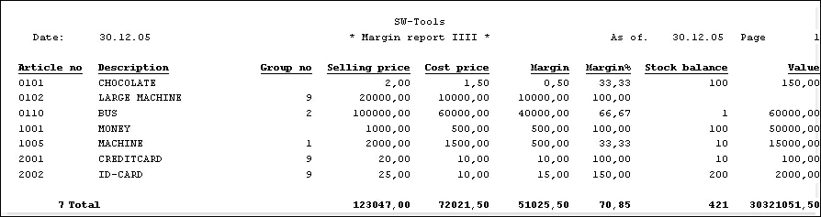

54. The report with calculated totals, total value is wrong

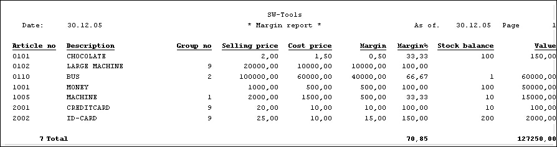

55. The report with calculated totals and WHEN calculations

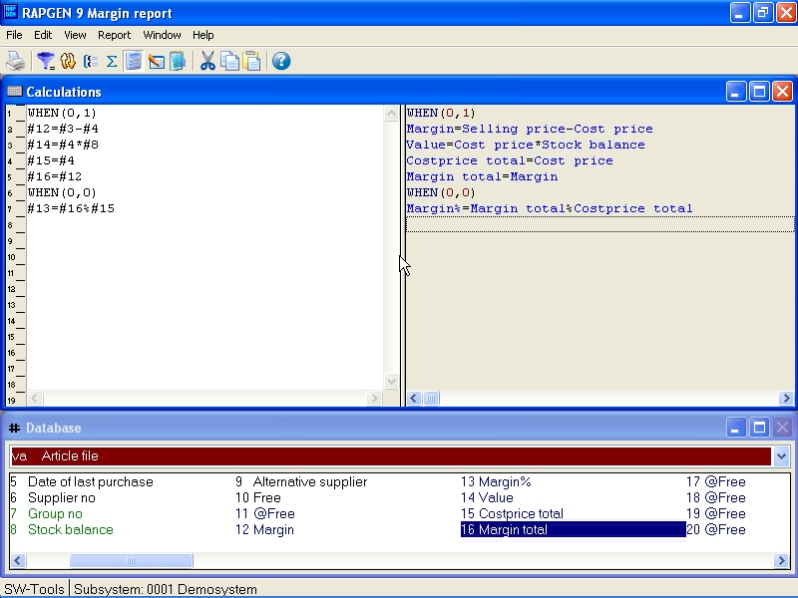

56. The report definition for calculated totals
Please notice the use of the free fields 14 and 15.
The fields 14 and 15 are written out on the list, but you don't wish totals for these.
Instead you totalize field 14 and 15, and use them in the total calculations, these fields will not be written out on the list, but will be line 4 and 11 for each line (not totals) in the calculations.

5.5.5. Technique for calculated totals
RAPGEN collects the total values for the selected fields in 'extra' free fields starting with free field 51 and onwards. Calculations like:
#20 = #3 + #4
are translated to C-code as:
WW.f9 = VA.f3 + VA.f4
If field 20 and field 3 are totalled RAPGEN generates a total function with the total fields if you define calculated totals. For example:
WW.f52 = WW.f51 + VA.f4
Here RAPGEN uses total fields for all fields to be totalled plus normal field that are totalled.

5.6. Fields to be totalled
Here you select the fields you want totalled on the report.

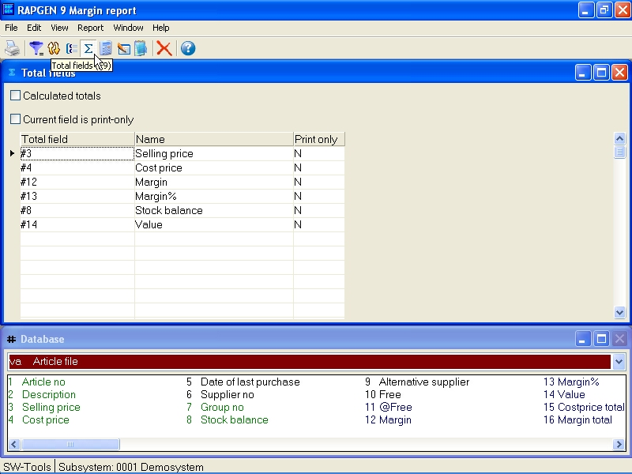

57. Definition of fields to be totalled
You may select fields from extern files, e.g. KU#24. With calculated totals all fields which are in the total calculation will be totalled. When you are finished with the total fields you insert END. You also have the possibility to define special positioning of the totals:

5.6.1. Print out fields on the total line.
If you select the field as print only it will not be totalled, but only written out on the total line ,(naturally only if it is placed on the line in the reportdefinition).
The contents of the fields will be the last value from the file, unless you have defined something else with the aid of the calculations.
The function is typically used to put a customer name down on the total line for the customer, or to write out the same of the article group on a article group total line. Such a name may either be written directly in the report with the aid of calculated totals, or read from another file.

5.7. Group totals
With the help of group totals you may at the end of the report get the totals by inserting that there e.g. are 5 customers in group 7 with total value 9000 DKK.

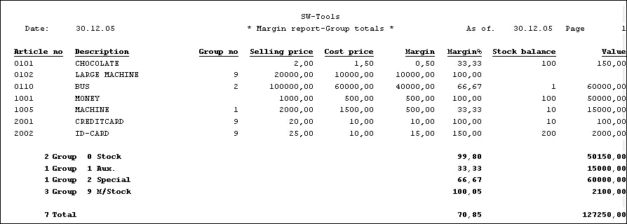

58. Example of group totals
If you have defined the report with several subtotal levels the grouptotal will normally be printed on all levels. You may control this for each group total definition.

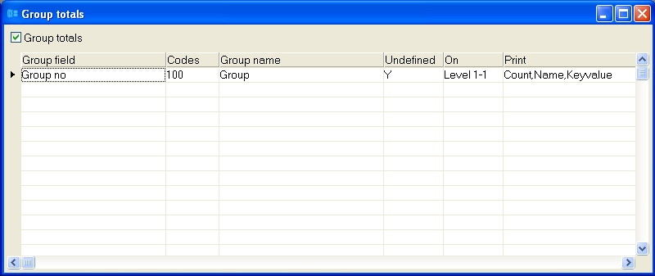

59. Definition of a group total

5.7.1. Group field, number of codes and name
Here you key in the number of the field, which may control the index of the totals, the field must be numeric (see later) and contain a code between 0 and 100.
The highest value of the field is set in number of codes, e.g. 100, and RAPGEN will make room for the codes 0-100, if the value of the field in a record is outside this range the totalling will be performed in group 0.
Please notice that there are not 100 different values, but the values 0 to 100.
The numbers of such values in a group influence the size of a report program.
At the end you can enter a groupname, which is printed out on the total line and RAPGEN returns to the question about group field number.

5.7.2. 'Undefined' group totals
You may define 'undefined' groups if the group field is a datefield or even an alphanumeric field.
RAPGEN will then build a table around the different values which are in the field when you run through the file. In number of codes, you state different numbers of values for the field, not as usual the highest value of the code.
You may in that way split up the totals, e.g. after a 4 numbered code or a date field, and specially those groups may be defined with a alpha numeric text field, e.g. the groups A,B,C... If there are more than the named numbers of values of the field, the rest will be placed in a various group.

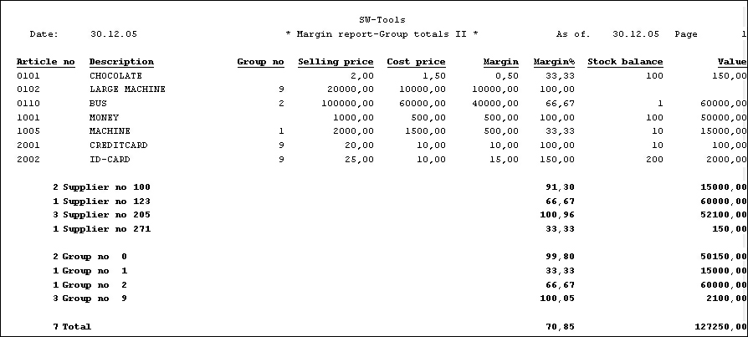

60. Example of more groups, the last group 'undefined'

5.7.3. Dynamic groups
If 100 is entered 100 groups elements only are formed. Enter 0 if the group should expand dynamically without limit.

5.7.4. Other files and calculated fields
You may use fields from other files to control the groups, e.g. KU#7. Calculated free fields may also be used to control the groups.

5.8. Charts
The chart functions provide the user with a very simple way to produce a chart for report just by checking this option on the total dialogbox. Also an IQ program may easily be extended with a chart.
Different chart forms are available as Bar, Pie, Line and XYZ point and a set of calculation functions are added for the advanced users who needs an extensive control of chart options.
The TRIO Charts manual desribes these functions in details.

6. Using multiple files

6.1. Principles in using multiple files
All reports must have a mainfile and many reports will only use one file. If you refer to datafields in a mainfile the reference will be:
#7
If you refer to a field in another file, add the 2 letter abbreviation before the fieldnumber:
KU#7
Fields in all files may be used in calculations, selections and sorting.
The relations between files may be established in two ways:
1. By the installer of the applications or
2. By the user in the calculations. Just enter: READ(KU),#1
The information will cause RAPGEN to READ a file, KU, with fieldno. 1 as a key. If the installer has defined the file relations then just enter:
READ (KU)

6.2. The field overview
The field overview is always displayed in the database window. The normal contents of the window is the fields in the main file of the report. If the list contains main file fields you will also have access to the free fields.

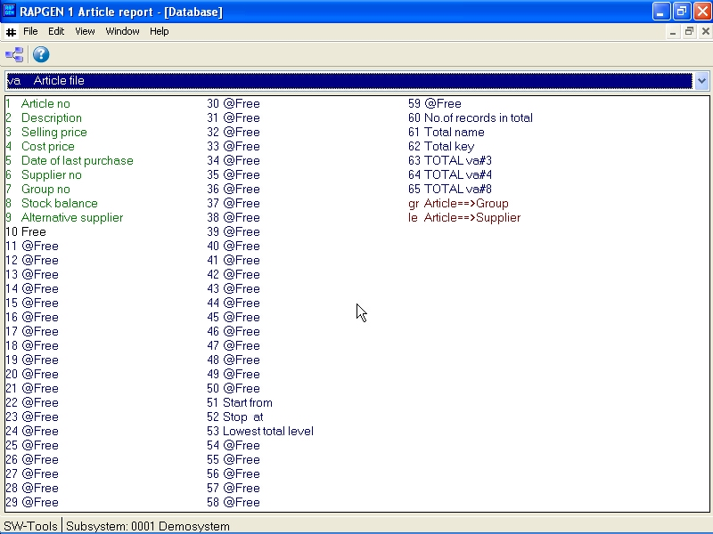

61. Field overview
To gain access to fields from other files select the following:

Unknown picture (g:/rapdoc/???)

62. Field overview from other files
When returning to the report definition the last displayed file will remain on the screen.
Using the on-line manual facility by pressing the HELP key you are able to display the extended description of a field/file. If you for example enter VA#1, the on-line manual displays the extended help for the Article files field 1 - Article no.

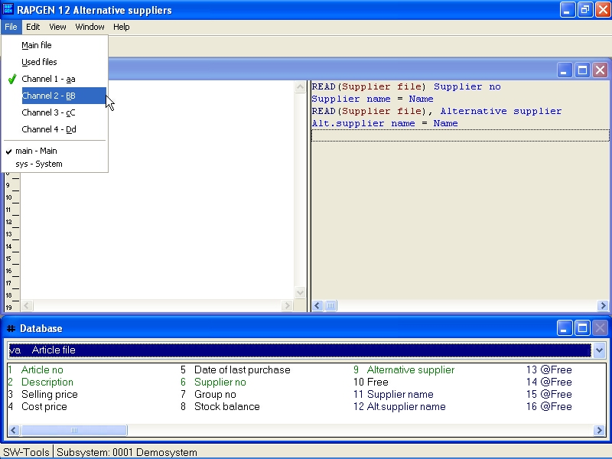

63. Field overview from another file channel

6.3. READ used in calculations
When using fields from files other than the main file, it must be defined how to READ the file, e.g. READ(KU) to read file KU.

6.3.1. Implicit READ of files
When a field from file xx is referenced RAPGEN will itself make a READ(xx) if the user do not place this in the calculations and an automatic connection to the file is present.

6.4. Relation between files
In connection with the READ, it is necessary to give information of the structure of the key. If fieldno. 15 in the mainfile is e.g. a customer. and you wish to use this as a key to the file KU, information on this may be given to RAPGEN:
The installer can define the relationship at installation time. Then you need only use the command READ(KU).
The relationship is not known! Use READ(KU),#15. I.e. READ file KU with fieldno. 15 as a key.
If no connection exists RAPGEN builds an automatic connection using the main files key definition.

6.5. Continue reading of the third file
When you have read in a file with the READ instruction, it is possible to refer to all the fields in the files when printing, e.g. KU#15, as with the fields of the main files, and to use these fields in calculations.
While the READ instruction may be understood as a calculation line itself you may continue reading more files accessed with fields in files you have already read, e.g. by inserting READ(XX),KU#7, the file XX is read using fieldnumber 7 from the file KU as the key.
In the case where an automatic connection between the different files was created during implementation, the user only has to key in READ(XX). RAPGEN itself will search through the already defined files starting with the main file, after that referencing files until a connection between a "known" file and the new file is found.

6.6. Files with more than one index
If a file has more then one index, you may refer to index 2 by e.g.
READ(KU.02),#15
With fields which may be used as a key, the programmer may specify which index should be used during installation of the file connections.

6.7. Different records from the same file
You may get into situations, where several different records from the same file need to be treated at the same time. Here you may refer to the same file KU with big or small letters, and you may use the same file definitions but different records.
The fields KU#1 and ku#1 refer to different record types in the same file, and therefore there may be both a READ(KU) and READ(ku) in the calculations. The combinations KU, ku, Ku and kU may be used, so a maximum of 4 different record types from one file may be used. Each of these references counts as an independent file in the total number of files in the report.

6.8. Maximum numbers of files
A report has no limit on used files. It is only the operating system or the database system that may have a limit.

6.9. Conditional reading of other files
By placing the READ instructions in conjunction with the calculations on the report, you will get the advantage that reading other files, as well as other calculation lines, may be made conditionally e.g.
IF #7 = 3 READ (KU),#15

6.10. Reading AFTER the selections are done
You may refer to other files after the normal selections on the report, by using the AFTER command in definition of the calculations. This may increase program speed, but can only be used if no selection is based on the fields from these files.

6.11. Sum of the postings
You may in calculations make a run through a file, e.g. the postings on a customer, to select the total posting amount into a free field.
The command START(XX), NEXT(XX) and REPEAT(XX) defined respectively an interval in the file XX, read the next record after which you may put in calculation lines to do summation, and repeat until there are no more records in the interval.

6.12. Statement of account reports
There are functions for 'statement of account' type of reports, where you print out information from a customer, followed by a row of postings and at the end a total.
Here you split up the print out definitions into respectively header and lines with the LINE command when defining the report on the posting file, and as calculation you give the command READH(KU), which will print out a header each time the customer changes.

6.13. READ(KU) Balance list with currency conversion
We wish to build up a balance list with the following format:

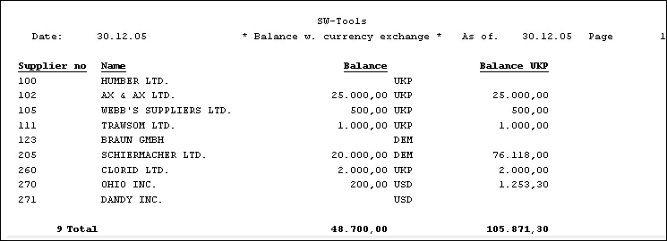

64. Supplier balance sheet with currency calculation
The supplier file, LE, is chosen as the report main file and under the definition of the report with function 1, you place the value designation from the value file KU#2 after the balance field. During calculation, the currency file may be read, after which the BALANCE in home currency may be calculated in the following way:
READ (KU),#5
#7 = FNR (#6 * KU#3 / 100)
READ (KU),#5, specified that the currency file is read using field 5 from the main file (supplier file) as key, named as the value code, converted to the correct format.
The value code in the supplier file is defined as 2 digits, and the key to the currency file is built up as 2 characters from this, with leading zeroes if the code is less than 10.

6.14. Price calculations with READ of more files
From the stock file as main file you may build up the following price calculation list:

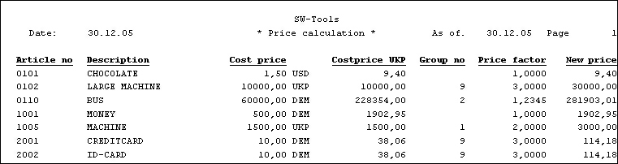

65. Calculation of new sale price from rate and price factor
with the following calculations:

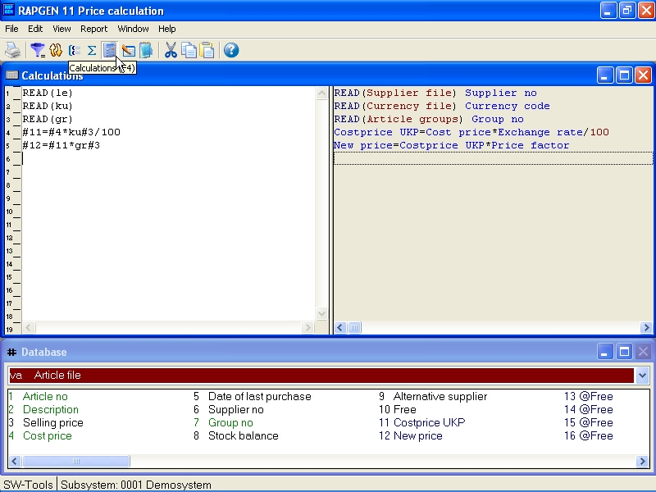

66. Price calculations with READ of more files
In this example we use all the files:
First you read the supplier file from the stock file, after which the currency code from the supplier file is known.
After that you read the currency file (with access by the suppliers currency code).
Finally, you read the Article group file (from the stock file field for the stock group).
You may now calculate a buying price in DKK using the currency rate.
New salesprice in DKK is calculated as the buying price * stockgroup price factor.
If RAPGEN has been installed with the option of rewriting in the file, you could have updated the stock price directly by putting in an extra line:
#3 = #11 /* Sales price = new sales price

6.15. Price calculations without automatic connections
In this example we assumed that the programmer has installed RAPGEN with automatic connection between the files. It is therefore not necessary to insert which fields are used as keys for the different read commands as RAPGEN itself can see that the currency file may be read from a field in the supplier file.
If these automatic connections have not been defined, the read commands would be more complicated:

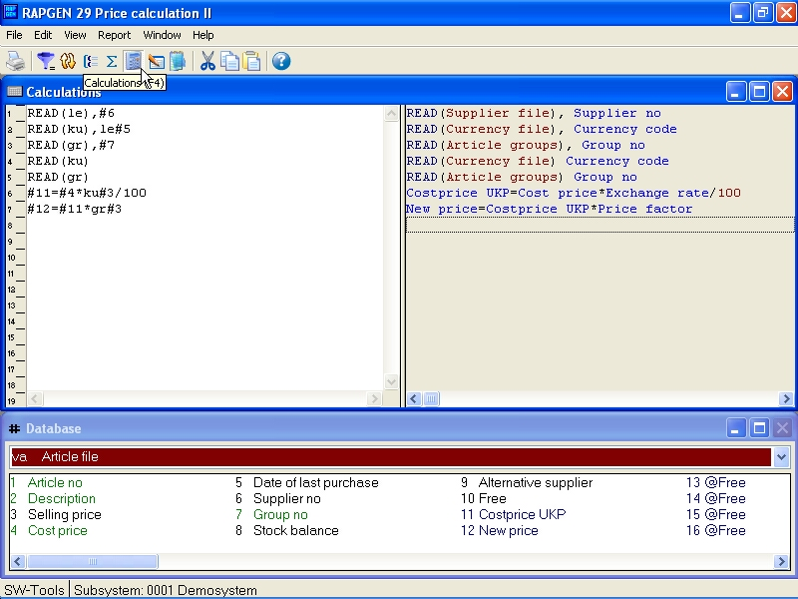

67. Price calculations without automatic connections
You may here see the great advantage of definition of automatic connections, otherwise you must know details of the keys in the file:

6.16. Alternative suppliers: several references in the same file
If you want to define a stock list, where the name of both the normal supplier and the alternative supplier may be printed out, you may read the same file several times.

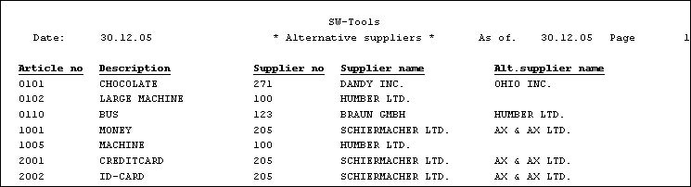

68. Reading the same file multiple times
This may be done with the calculations:
READ (LE),#6
READ (le),#9
while the second supplier is inserted with small letters. We could instead have used Le or lE, a combination of big and small letters. Each file may be included in a report in up to 4 variants.
The first reading is done with field 6, normal supplier number, as key, and the second reading with field 9, alternative supplier number, as key. Please notice that it does not matter if the field is numeric (#9) or alpha numeric (#6), RAPGEN's key building is used.
During definition of a report, you print out the first name as LE#2 and the second name as le#2. The same effect could have been reached in another way by printing out two free fields, e.g. #11 and #12, both defined as 24 characters, after the following calculations:

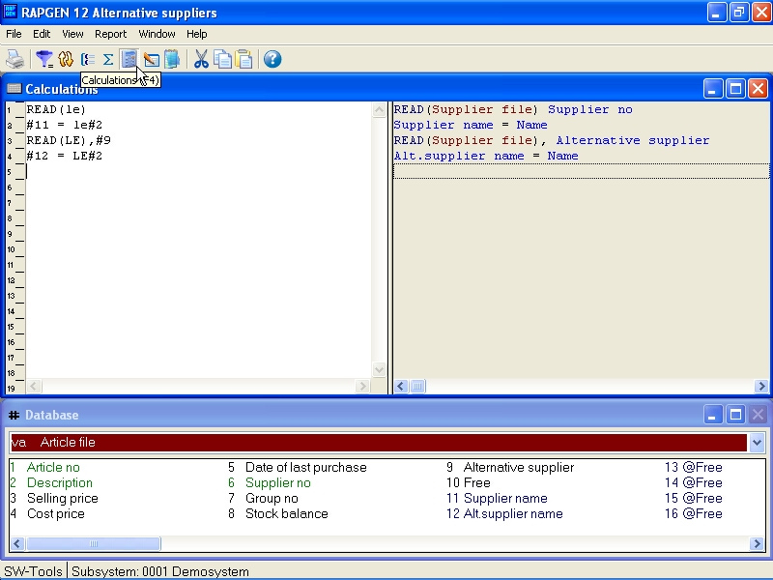

69. Alternative suppliers: several references in the same file
First you read in the normal supplier number, after which the field you want to use from this may be stored in free fields, and then the alternative supplier is read in from the same file on top of the last record, thus changing the contents of LE#2.

6.17. READ in connection with totals
The example on group totals may be improved by printing out the stock group name for each group:

70. Reading the name of group totals
This is done by defining the following calculation lines:

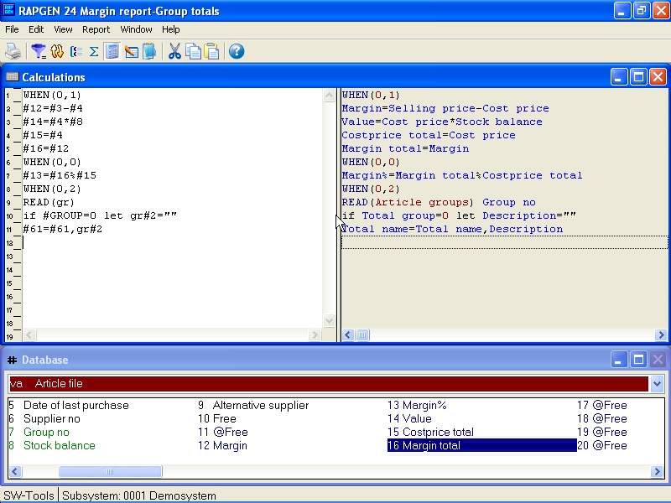

71. READ in connection with totals
When defining which fields might be totalled, insert -2, print out of field 2, the stock name, on the total line. Calculated totals may also be defined on the list.
The calculations do the following:
The lines may only be done for totals.
The stockgroup file is read with field 7 as key.
The stockname is equal to the read stockgroup name.
If GRAND TOTAL is being printed (#LEVEL=1) Stockname is set to ""
Totalname (#61) is expanded with the groupname

6.18. START/NEXT/REPEAT Sum of the postings
If we want to define a report on a file with a underlying posting file, where the postings are not to be printed out, but only their sum, this may be done with the START/NEXT/REPEAT commands.

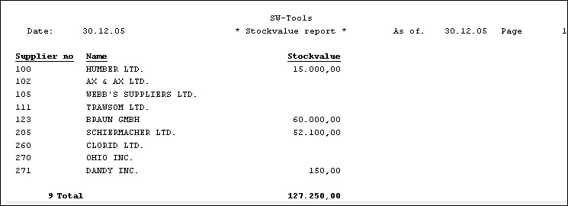

72. Total stock value collected with START/NEXT/REPEAT

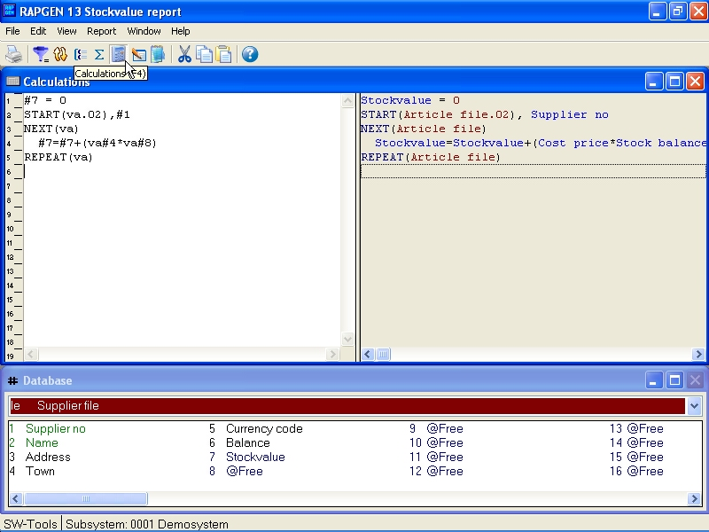

73. The report definition for collection total stock value
In the examples we have chosen to print out the supplier file and per supplier to calculate the value of supplied articles. We choose a free field #7 to contain the stock value, and this field is printed out and totalled on the report. The calculations are built up in the following way:
First you zero the total fields for the stock value:
#7 = 0
Start the addition of records in the article file, while VA.02 means that we wish to run through the file according to the 2nd index, which is the supplier number-key:
START (va.02),#1
With the command NEXT you read an article from the article file, and the next calculations are done until there are no more articles, after which RAPGEN jumps to the calculation line REPEAT:
NEXT (va.02)
Summation of stock value:
#7 = #7 + va#8 * va#4
With the command REPEAT you jump back to NEXT line after which the sum continues, until there is no more articles.
REPEAT (va)
Please note, that key building is inserted in connection with the START command, but is not necessary for the NEXT and REPEAT commands (the key may naturally also be defined). The index number must be inserted in both the START and NEXT commands, if you don't use the first index, but this is not necessary with the REPEAT command.

6.18.1. Conditional sum with START/NEXT/REPEAT
The sum of the stock value may naturally be conditional on an IF, e.g.:
IF VA#7 = 1 LET #7 = #7 + va#8 * va#4
IF VA#7 <> 1 LET #8 = #8 + va#8 * va#4
whereby you may split up the stock value for all articles in article group 1 and all other articles (Remember to zero both field 7 and field 8 before summation).

6.18.2. Several loops of START/NEXT/REPEAT inside each other
You may in a loop of START/NEXT/REPEAT have several loops of the same kind. If the system was built up so the supply of an article was in each file inserted per stock place (LA), the summation could be done with a loop over these:

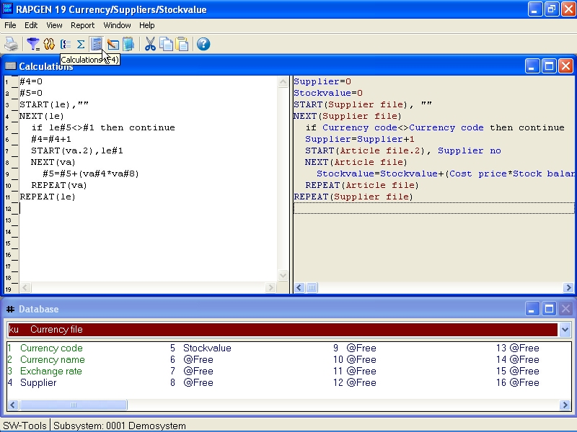

74. Several loops of START/NEXT/REPEAT inside each other
In the same way you may READ other files inside such a loop e.g. find the price factor for the articles article group.

6.18.3. Selection in connection with START/NEXT/REPEAT
Selection in connection with START/NEXT/REPEAT may typically be used for exception reports. E.g. you wish to get a list for all the suppliers, where you haven't bought articles since a keyed in date:

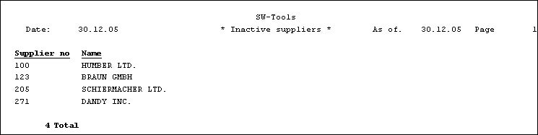

75. Suppliers not used since 31/12-1994
We use the free field #7 to control the selection and define this as only records, where #7 is equal to 1, shall be printed out. The calculations are defined as follows:

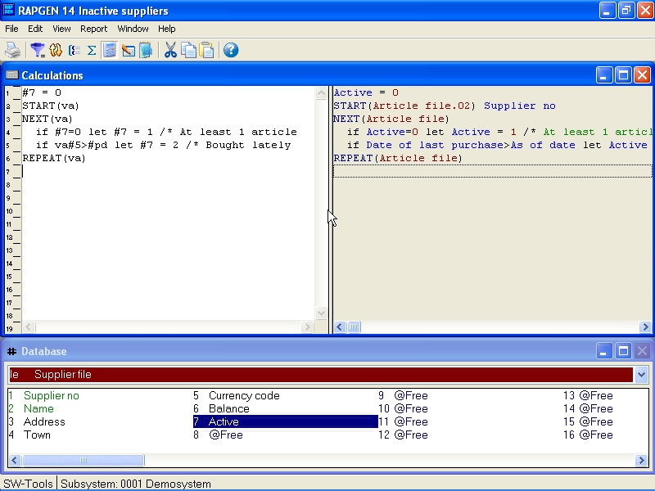

76. Selection in connection with START/NEXT/REPEAT
Field 7 will be 2 if the supplier has one or more articles where the last buying date is greater than the one inserted by start in per date, and such suppliers are not printed out.

6.18.4. END endvalue for START interval
After START (VA),#1 the NEXT(VA) read all the articles where the keyvalue equals field #1. If you insert the line END(VA),"999" right below the START() command the NEXT(VA) reads until the keyvalue equals "999".

6.19. READH/LINE statement of account type report.
If we wish to make a report, where each suppliers articles are printed out, this is defined with function 1 with the article file as main file, a "posting file".

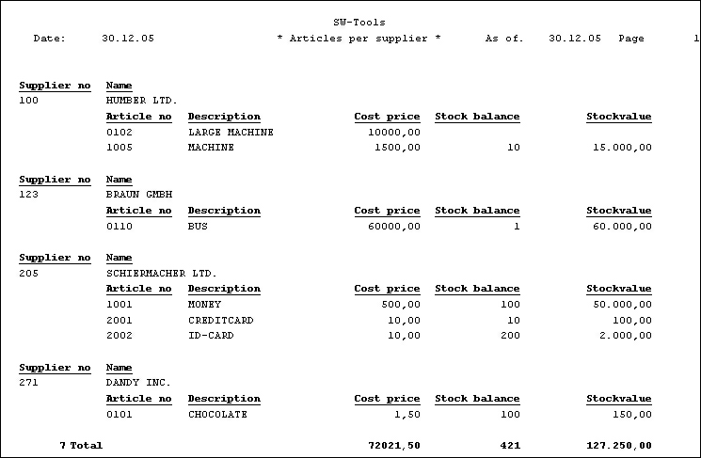

77. Articles by supplier defined with READH and LINE commands
On the first line of the report the fields LE#1 and LE#2 supplier number and name are printed out from the supplier file.
Then you select the function Detail and hereby define the previous lines as header lines, only to be printed each time the supplier changes. The next set of lines that will be defined is to be printed for each article.
The line is now defined with the fields from the article file, which you want printed out.
As calculation you may define the connection between the files:
READH (LE),#6
this command works in the same way as the normal READ command, the supplier file is read using the Article file field 6, supplier number, as key. If, and only if, you read a new supplier, the first defined lines, supplier number and name will be printed out.
To get a reasonable print out, the article file may be sorted by supplier number, so that all articles from the same supplier appear together. This may be done by using Index 2.
If the article group should have controlled the report, you would have had to sort the list, as the article group is not defined as an index in the system.

6.19.1. Selection in connection with READH/LINE
If you define a selection on the list, so that articles with article group 0 are not printed, the list will appear as follows:

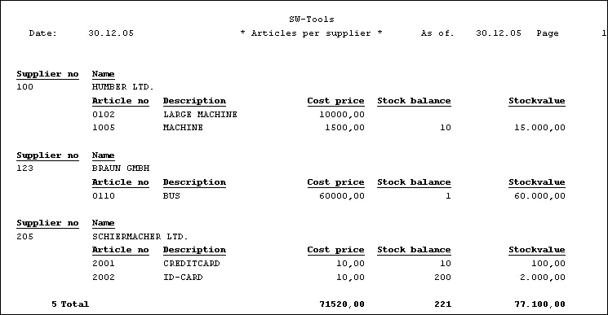

78. Selection of article group > 0
Please notice, that the supplier number 271 is printed out, because this has an article connected in the system, even if there is no articles, which shall be printed on the report due to the selection.
To avoid print out of such suppliers we have to control the head line to and change our calculation to:
IF #7 <> 0 READH (LE),#6
so that the supplier file is only read if article group is not equal to 0. The selection is thus incorporated in the read.
Another way to avoid 'zero-suppliers' is to define calculations as an AFTER calculation, that means calculation which is only done for those articles, which meet the selection criteria. This is done by inserting the command AFTER on the calculation line before reading.

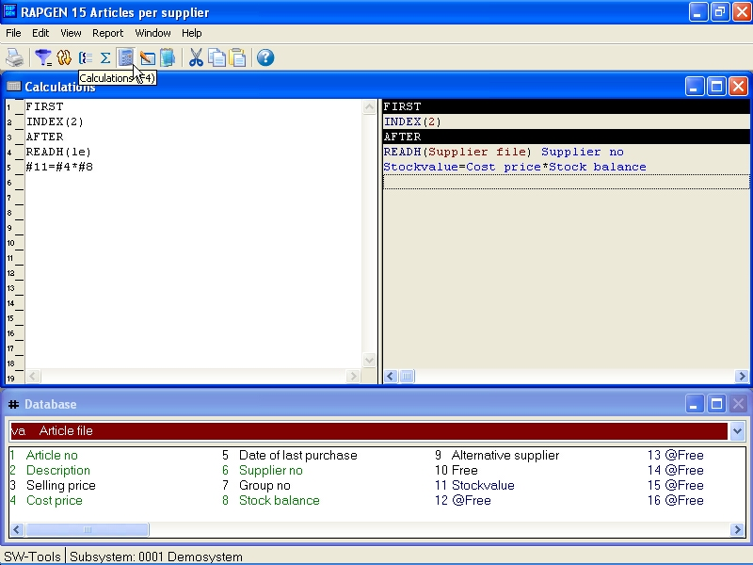

79. Selection in connection with READH/LINE

6.19.2. Totals in connection with READH/LINE
If we wish a total of the stock value per supplier:

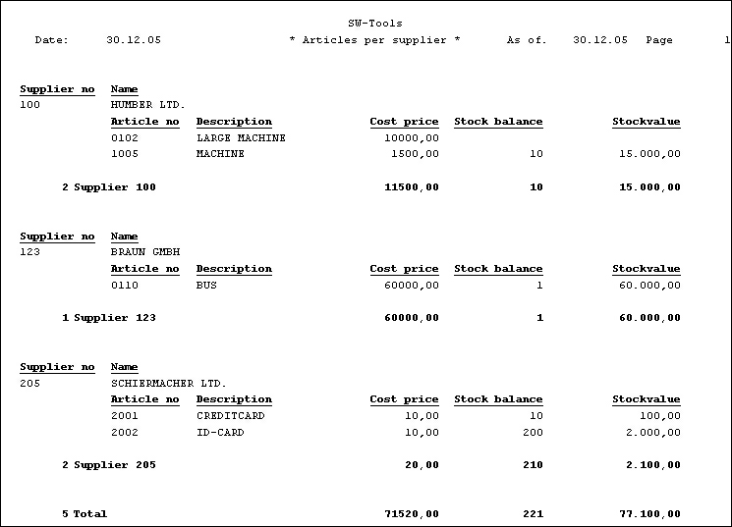

80. Totals in connection with START/NEXT/REPEAT
this may be done by defining a subtotal level for each time the first 3 digits in the Article File Key 2 change. I.e. every time the supplier number changes.

6.20. SPEEDing up read of external files
The SPEED() function may be used to optimize the read strategi on a report as a record will not be read again when the same key is given but taken from memory. You should be carefull with this on updating reports.

6.21. Building files with LET
The LET function may be used to build new files quickly based on any field in a report, calculated or from external files.
You must have a DATAMASTER license to use this function as the files are defined as DATAMASTER files and the database drivers must be installed with write access.
DATAMASTER files only can be modified this way as file data will be lost when the file is redefined. However once defined you can use all the DATAMASTER functions for extending / redefining the file.
LET (AA=#1-3) produces instantly a new file definition for the file AA with the given fields which you can see in the database field window.
If the file AA is already present you will be asked if the old definition should be overwritten. If so
A NEW EMPTY FILE WILL BE CREATED, DATA IS NOT KEPT OR CONVERTED !
The file will be created with the first field as unique key unless you state one of the key options as LET(AA=#1K,2-3,4D) or LET(AA=#1-4;2) see the examples in the function reference below.
You may state the number of records if needed and the database type after the LET(..), if not given the default is 1000 records using the first database interface which are normally the SSV driver.
LET (AA=#1-3),200 XWrt
gives you 200 records in a X-Basic file. The driver name XWRT is looked up between the driver names you have given in the BASIS file by the FDF installation.
The file itself will not be created until the report is started. If you state a negative number of records as LET (AA=#1-3),-100 the file will be new created by each start of the report.
The following will define a new access file and fill it with data:
UPDATE(1) /* Activate updating
NOPAS()
LET(AA=#1-3,15,le#1-3) access
AFTER /* After selections is done
INSERT(AA) /* Make a new record in AA

7. Letters and amendment of reports

A letter is a report where only one page is printed on screen for a file. In a letter you may define selections, sorting and calculations e.g. print letters to selected customers, sorted by postcode. Totals cannot be defined on a letter. Examples include:
Letters of all types
Labels of all types
Checks

7.1. Defining a letter
A letter is defined just as another report, you just have to check the box for letter-type of report.
In this way you can edit a letter with, for example, a name and address from a file, and a letter text and/or fields from other files.

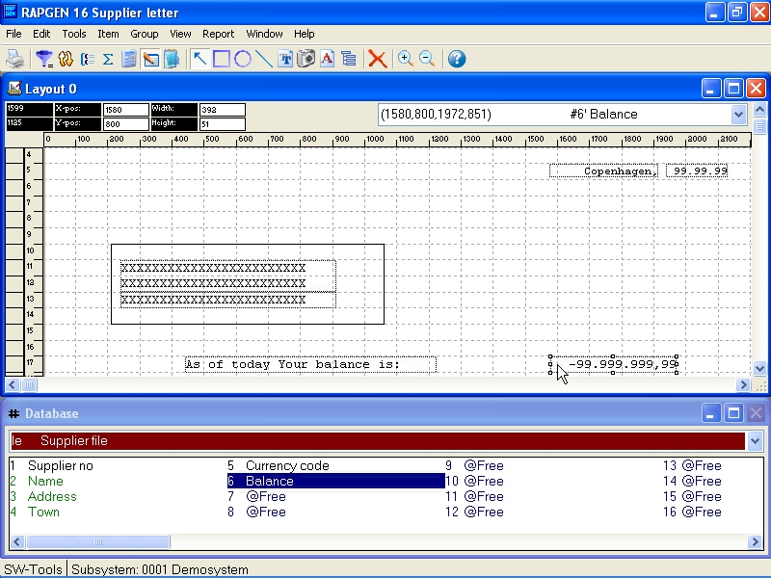

81. Definition of a supplier letter

8. Copying, deleting and documentation

8.1. Copying a report
A report may be copied by using Function 10, where you select:

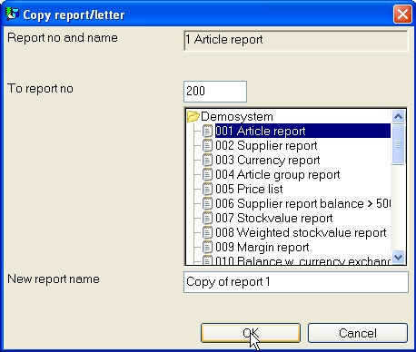

82. Copying a report
The report is then copied. The first time the new report is printed, the program will be generated. The copy function may be used to make a copy of a report which you want to extend, without changing the original. You can then extend the copy.

8.1.1. Delete a report
With the delete function you can delete a report, although you have to answer yes when the system asks you the question delete yes/no, in order to avoid deleting a report by mistake.

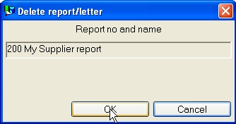

83. Deleting a report

8.1.2. Documentation of report definitions
Using this function, it is possible to print documentation of the report definitions for one or more reports.

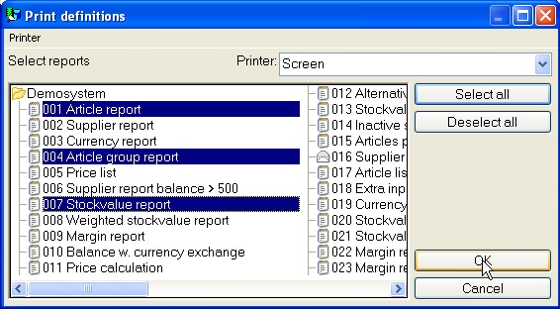

84. Print of report definitions
A print of a report definition may look like this:

Unknown picture (g:/rapdoc/rc1-eng072.jpg)

85. Report definition for supplier balance > 500

8.1.3. Report information
When editing the report informations the used files, including the main file, may be changed by click on the FILES button.

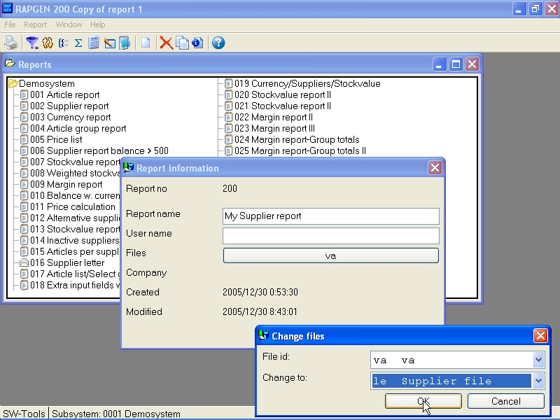

86. Report information
Note that the USER NAME is been added after the created/modified date. This username origins from your input in the LICENSE user remark for this PC and may also be used in the calculations as #UN

8.1.4. KEYS edit function
An edit function are found in the file menu to maintain the KEYS files which also may be entered using another editor like notepad.

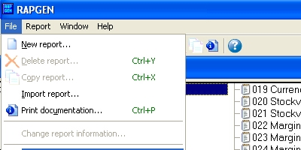

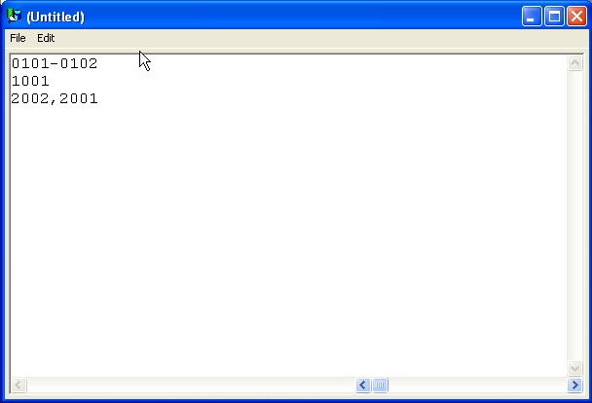

87. Keys file editor

9. Starting a report

9.1. Start report function
When you start a report the following is displayed:

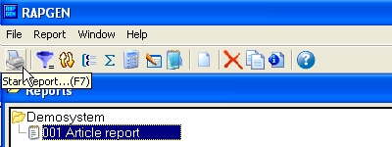

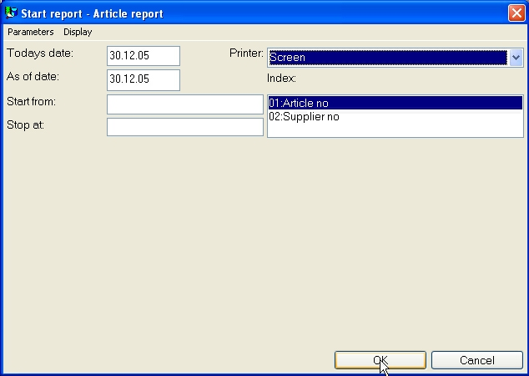

88. Start of report
Enter the start information and decide whether the report should be run on the screen or the printer.
After starting the report for the first time you will have to wait approximately 15-30 seconds, while the report generator generates and saves a program. Changing the report definitions will cause RAPGEN to delete the program and then generate it again.
During program generation, RAPGEN will test all calculation lines and also test that the syntax is correct. If you receive an error message, you must correct the definitions before the report can be started.
This control is performed by the RAPGEN interpreter.
If no lines are printed then make sure that the section of the file selected does contain your selection criteria.
The start parameters are explained below:

9.1.1. Today's date
The fields for both today's date and 'as of' date are normally written on the first heading of the report, and are not used for anything else unless you have defined calculations or selections on these.

9.1.2. As of date
This is entered as described above. 'As of' date, is typically used if you wish to define calculations or selections on a date field.

9.1.3. Start from and stop at
In the fields, Start from and Stop at, you may enter the range of records a report is to include, e.g. from supplier 1000 to 2000. If nothing is entered in these fields, the report will include all records in the file.
You may enter only part of a number, because the printout will always start from the key higher or equal to the value entered, and stop when the key of the file becomes greater than the stop value.
It is necessary to know a little about the key structure of your files before entering start and stop values. For instance, depending on whether a customer number with 5 digits contains leading zeroes or not, the start/stop function may not work correctly.

9.1.4. Selecting an index
If you are using a file with several indexes, you may select one of these. For example if you select index 2 for an article report, it will be printed supplier order, not article order.

9.1.4.1. Reverse sortorder
From the parameters menu you have the possibility to reverse the order of the printout.
This works on all sorted as well as unsorted reports if the database interface supports descending read.
Note that reverse sortorder may also be stated in the calculations as INDEX(-1)

9.1.5. Extra data at start
If one or more free fields are defined as INPUT fields you may enter a value for these fields before starting the report:

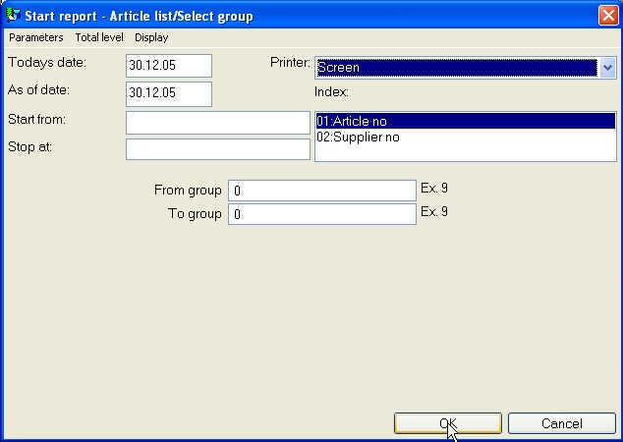

89. Data at start
This can be useful for selections what otherwise had to be changed before each start of the report.

9.1.6. Warning concerning sorting/weighted totals
If a report is sorted or uses weighted totals, a warning concerning this is given when the report is started, because it make take a while before the printout will start.

9.1.7. Total levels
Normally you will print the entire report, but you may select only to print certain total levels rather than for example 10000 lines of articles just by choosing the wanted level from the menu.

9.2. Printer selection
The PRINTER field is a listbox from which you may select one of the printers defined in the system.
When you use the PRINTER SETUP menu the printer definitions will be stored into a file (MYPRT.SSV) so you do not have to setup the same parameters each time the specific printer should be used.

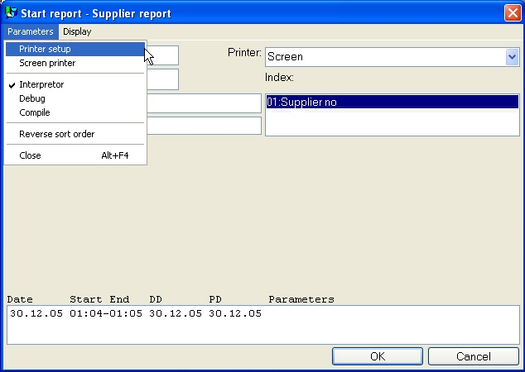

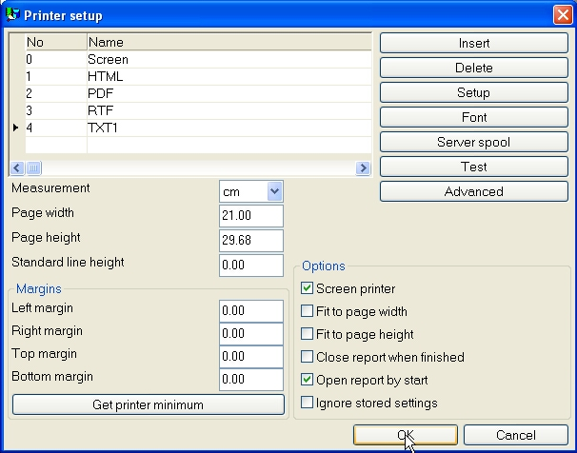

90. Printer setup
The list shows the printers defined and you may select a line by click on this. Then use the SETUP button to change the printer settings.

9.2.1. Defining a new printer
A new printer is defined just by selecting an empty line. The printer NAME may be modified to any text you want. You may use INSERT to insert printers inbetween and the DELETE button to get rid of old printers.

9.2.2. The default documentation font
The FONT button may be used to set a default font for print of report documentation. Note that this default font has no influence on the print output from a running report.

9.2.3. Printing on an UNIX printer
The SERVER SPOOL button may be used to redirect the print from a local Windows printer to the UNIX spoolsystem. Note that Windows must know the printertype of the unix printer to get the controlcharacters correct.

Unknown picture (g:/rapdoc/rc1-eng110.jpg)

91. Server spool
In the listbox of servers you get all servers known by the file definitions (basis) file. The printfile made from Windows with control characters will be send to this server and the unix spool command stated will be issued.

9.2.4. Margins and page size
You may adjust the printer margins and page size. The measurement box defines your input as cm, inch, lines or pitch. The absolute printer minimum settings is taken by click on the minimum button.

9.2.5. Screen printer
Checking this box sends the output to the screen printer.

9.2.6. Fit page to width
Checking this box will reduce the font size on reports being to wide to fit on the paper to a smaller font. Other reports will remain unchanged.

9.2.7. Close report when finished
If you check this box you do not have to press the OK button when printout is finished.

9.3. Screen printer
You may always choose to print a report on the screen rather than on the printer. The screen printer allows you to look at all pages printed.
You may use PgDw and PgUp to go to next/previous page and the down/up-arrows to scroll within a page, HOME/END to go to top/bottom on a page.
When you select PRINT from the file menu multiple pages may be printed.

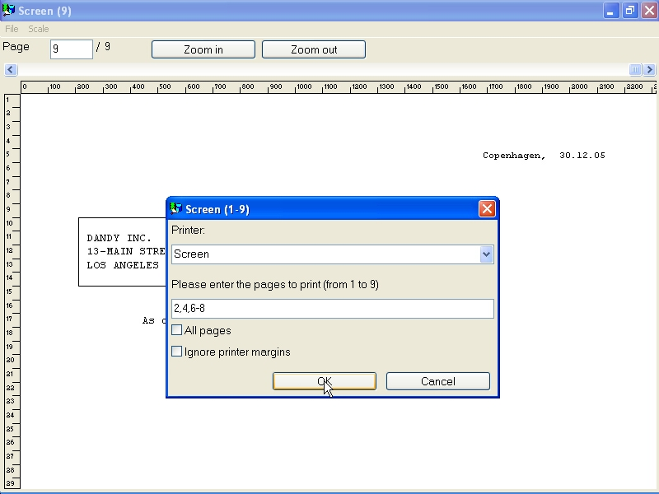

92. Screen print

9.4. Screen printer enhancements
The screen setup in TRIO may now be given multiple time by setting the check mark for screen printer on an empty printer line in the setup dialog.

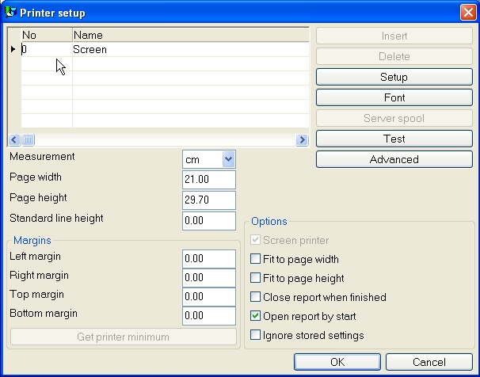

93. Additional screen printer insertion
Different screenprinters may be setup with different pagesize and as you will see below may be used for Multi Output Format to textfiles, HTML and RTF also.

9.4.1. Saving the screen print to a file
In the file menu for the screen printer display a possibility has been added to save a print to a file and to recall this later.

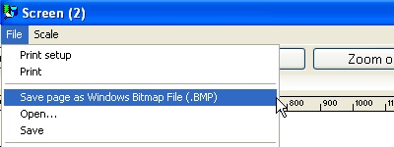

94. Saving a screen print to a file
However you should note that special print as charts and OLE linked objects will not be included into to saved print.

9.4.1.1. SCRPRT function for IQ print recall
The SCRPRT("filename") function in IQ may also be used to recall the print.

9.5. Multi Output Format printers
In general TRIO now provides a number of new printers which may be setup initially as a screen printer. The button 'Setup' can now be used to set the type of printer output for the defined screen printer.

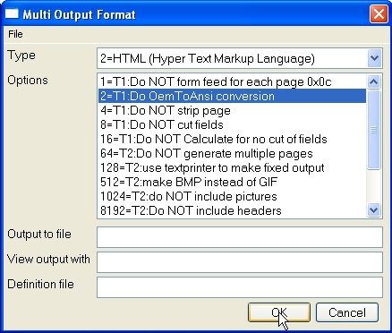

95. Setup of screen printer to Multi Output Output printer
The options possible for a Multi Output Format printer will be described separately for each printer type. One or several options may be selected for a printer. You should note that hardcopy of a screen is not possible on this type of printer as the hardcopy will always go to the Windows default printer.

9.5.1. Printer type
The printer type may be one of the following:
1 - Text
2 - HTML
3 - RTF
4 - TXT
5 - SSV
The printer output definition is stored in myprt999.ini which must be present on the installation. The following is installed with TRIO:
Type 2 - myprt002.ini
Type 3 - myprt003.ini
Type 4 - myprt004.ini
Type 5 - myprt005.ini
You may change these definition files by copying the one matching the type of printer you are using for example to
myhtml.ini
make amendments to it and setup the printer to use this definition file instead.

9.6. Text printer, Printertype 1
Because the Window Generic text printer has its limitations and does not produce a very good and useably content, TRIO now has its own text printer. The output will be into one file, where each page is separated by a form feed (the hexadecimal character 0x0c). The printer will automatically calculate the width of any field used in the layout in order to produce an output with no overlapping fields.

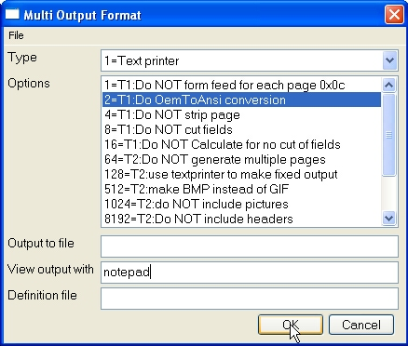

96. Sample setup of TEXT printer viewed in notepad

9.6.1. Options
The options beginning with
T1 : xxxx
is used by this printer. None of the T2 options are valid!

The printer will as standard add a form feed after each page printed. If you require to print all pages with no form feed select option 1.

TRIO will as standard convert all characters to OEM format, e.g. the format known to MS-DOS. Hereby, it is possible to use the file in MS-DOS, where all language specific characters are properly translated. The file may for example be viewed with MS-DOS EDIT. If the file is to be used in Windows the option 2 must be selected in order to get language characters correctly translated because Windows uses ANSI character set. If option 2 is set you may for example view the file in notepad, wordpad, word or others.

Internally the text printer generates a page with x columns and y lines. This page is then filled until overflow of lines is encountered. At this point, the page will normally be stripped, e.g. trailing blanks on lines and trailing blank lines are removed, which gives a small and compact file. If you want the page output with the real length of each line including all lines select option 4.

TRIO always cuts the fields width according to the field box size defined. E.g. if a text field of 30 characters is defined with a field box width only allowing approx. 20 characters only 20 characters will be printed. If required to output the entire field content disregarding the field box size select option 8. Please note the description of option 16.

As described for option 8 all use of standard windows printer drivers in TRIO will cut fields according to a box width. However, this text printer will as standard try and calculate the box width of all used fields to avoid any missing characters from fields printed. In other words, the printer tries to expand the box width of any field used. To avoid it, select option 16.

9.7. HTML printer, Printertype 2
The HTML (Hyper Text Markup Language) printer can be used to produce output directly to internet/intranet systems. This means, an output from this printer can directly be viewed in your internet/intranet browser, e.g. Netscape, Explorer or others.
The output may also be send as attachment to an e-mail, whereas the receiver of the mail may then view the report directly in a browser.
Because HTML does NOT support any pixel positions the printer can be used in two ways.

97. Sample setup of TEXT printer viewed in Netscape

9.7.1. HTML output of standard reports
TRIO will have no problems with standard reports. The report will be converted to a HTML table, where each field corresponds to a column in the table.
Any total level or group total defined will be inserted in the same table.
All used pictures, OLE objects and charts will automatically be converted to the standard picture format GIF (Graphical Interchange Format) known to HTML.

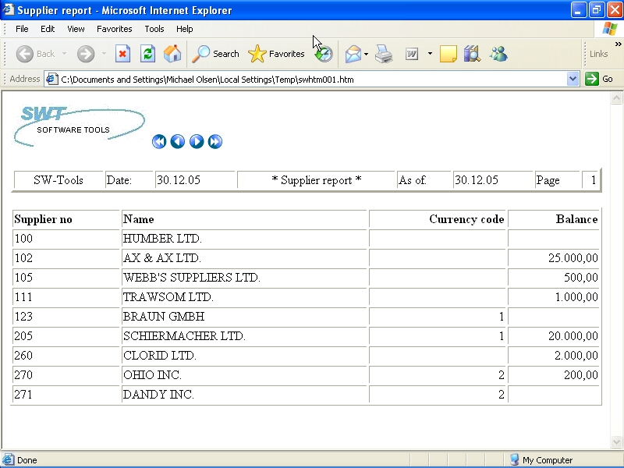

98. Sample HTML output of standard report in Netscape

9.7.2. HTML output of non-standard reports
Please refer to the description of option 128 and 2.

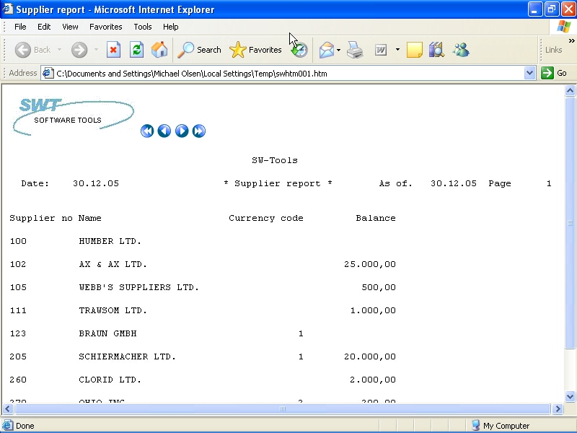

99. Sample HTML output of non-standard report in Netscape

9.7.3. Background, logo and browse buttons
When you print a report on the defined HTML printer, the definition file myprt002.ini contains a number of references for a standard logo and browse button pictures. These picture files are found in the TRIO installation directory in GIF format:
htm-bkgn.gif - Background
htm-logo.gif - Logo
htm-frst.gif - Browse to first page button
htm-next.gif - Browse to next page button
htm-prev.gif - Browse to previous page button
htm-last.gif - Browse to last page button

9.8. RTF printer, Printertype 3
The RTF (Rich Text Format) printer produces output in the same way as the HTML printer. The output from here can as an example be used to include directly in a Microsoft Word document.
The only difference between the RTF and HTML printer lies in the definition file used, so please refer to the description of the HTML printer.

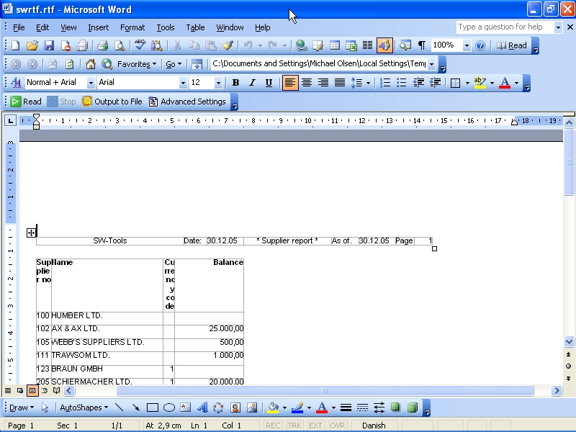

100. Sample RTF output in Microsoft Word

9.9. TXT printer, Printertype 4
The TXT printer equals the type 1 text printer, but will standard generate multiple text files, e.g. one file per page printed. This means, no form feed character is inserted in the files.

9.10. SSV printer, Printertype 5
The SSV (Semi-colon separated file) printer produces output of a standard report only (please refer to HTML output of standard reports). Each definition part of the report is written to the SSV file where each item used in the layout corresponds to a field, and each field is separated by a semi-colon.
For example, if you have defined a report with printout of the article number, description and selling price, using the standard RAPGEN heading, the output will be:
Company name;Date;98.06.07;......
Article number;Description;Selling price
0101;aaa;123.45
0102;bbb;4.567.89
2 Group 01;4.691.34
The printer will not replace any occurrence of semi-colons in text fields.

9.11. Options for printer type 2 - 5
The options beginning with
T2 : xxxx
is used by this printer. The T1 options are only valid if type is 4 or the option 128 is selected.

The printer will generate a separate file for each page, e.g. the filename will be
xxxxx999.yyy
.
where 999 is the page number. If you want the output in one file only select option 64 and the filename will be generated as
xxxxxxxx.yyy
.
Please NOTE, if using TRIO 16-bit version the filename is limited to a maximum of 8 characters xxx plus 3 characters yyy, e.g. only 5 can be used because 3 characters is used for page number.

If you have reports defined, which cannot directly be converted into a table you might experience a wrong output from the printer. However, you may select the option 128.
When the option is selected the report output will be correct, because it is a simple text output using a fixed font.
For this fixed output no pictures, OLE objects or charts will be included.

When printing in HTML format the standard picture file format is called GIF (Graphical Interchange Format) whereas when printing in RTF format the standard is BMP (BitMaP - Standard Windows picture file format). Normally you have no need of selection this option. It will automatically generate GIF files when using the HTML printer and BMP files when using the RTF printer.
If you want to use the BMP for the HTML printer instead select option 512.

These options speak for themselves. For example, if you want to output in SSV format, but only the totals defined on a report select options 1024, 8192, 16384 and 65536. Given the sample in section 'SSV printer, Printertype 5' the only line will be:
2 Group 01;4.691.34

9.11.1. Output to file
This filename may contain path and file name for output. If working with TRIO 16-bit version the name may not exceed 8 characters plus 3 characters as extension. The syntax of the file name must be
[<drive>:][<path>]<filename>.<extension>
The default drive and path is the same directory as TRIO is installed in.
The default filename is always swxxx.yyy where xxx and yyy is set according to the options on the printer:
00 = htm
04 = rtf
32 = ssv
64 = txt
which means that with no options set the default file name is
swhtm.htm
If printing to multiple files there must be enough free characters in the file name to add the file number 999, e.g. page 5 is named
swhtm005.htm
A sample of a file name could be:
c:\webfiles\swrap.htm

9.11.2. View output with
The field is used to view the output.
Assuming the output is in HTML format and you have the Netscape browser installed in directory c:\programs, you could view it by calling
c:\programs\netscape.exe <filename>
We cannot tell you exactly which application to use for viewing the output, but only show some samples
HTML: Netscape or iexplore.exe
RTF: wordpad.exe or winword.exe
TXT: wordpad.exe or notepad.exe
Please NOTE: It may be necessary to enter the program name with complete path!

9.11.3. Definition file
The default definition file for the printer type 2 is:
myprt002.ini for HTML output (Option 00)
myprt003.ini for RTF output (Option 04)
myprt005.ini for SSV output (Option 32)
myprt004.ini for TEXT output (Option 64)
You may define your own definition file by copying the default. If you do, enter the name of the new definition file here.

10. Documentation and start parameters

10.1. Documentation
With this function you may define text and example text for each of the defined start parameters, preciously defined in free fields, e.g. where the name of the free field starts with #D1 to #D7.
You may also enter a free documentation for the report here.

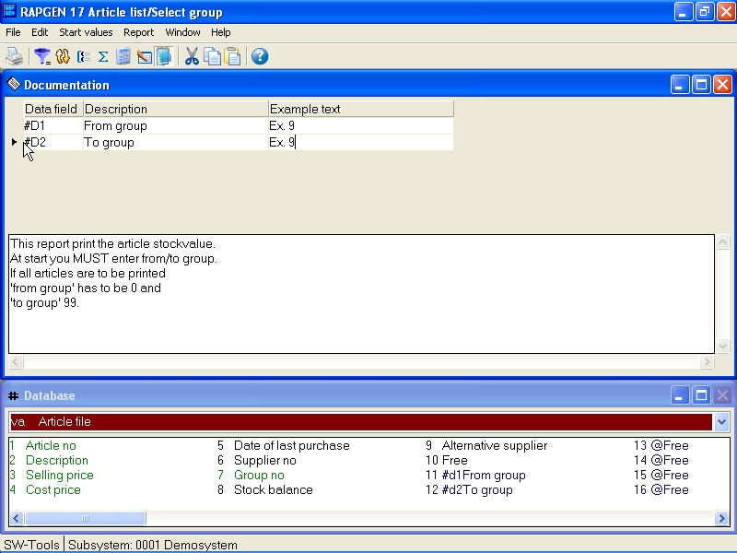

101. Documentation of report and start parameters
When the report is started the screen will appear with the documentation.

102. Documentation - amended start screen

10.2. PARAMS function for additional report start parameters
PARAMS("#1,7C,6O,le#3") is a variant of the dialog function where the input is done by start of the report not during report execution.
Use of PARAMS in a report will add a button <Extra parameters> to the startup screen which then activates the dialog.

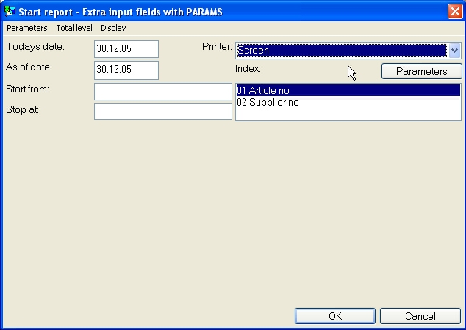

103. PARAMS("#1,7C,6O,le#3") on an article report
You may also use the DIALOG function on a report but note the difference that PARAMS takes input by report start, DIALOG when the report is actually running which means it should be placed as FIRST or under some IF control.

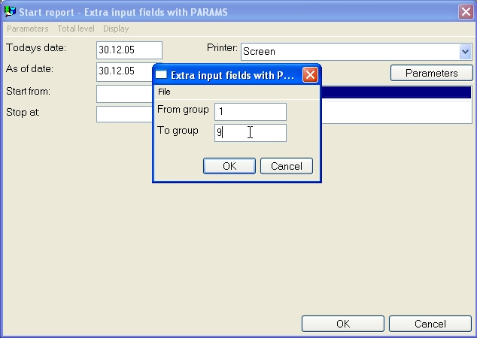

104. The input screen for PARAMS("#1,7C,6O,le#3")

10.3. Report start statistics and jobqueues
When user administration is installed each start of a report is recorded in a logfile and displayed by start of the report:
A logfile with the last 100 start informations is kept for each report and displayed by report start. The parameters may be reused for next start or an average runtime statistic may be shown just by click on an entry line.

10.4. RAPGEN Start parameters
RAPGEN may be selected from WINDOWS using the following parameters:
RAPWIN ssppp Start program ppp in subsystem ss
RAPWIN -r=ssppp As above
RAPWIN -e Exit when report has been executed
RAPWIN -nl No Logo by start, Runtime only.
Programs cannot be defined or changed
RAPWIN -ok Do display startscreen before start
RAPWIN -s7;310397;;0001;9999;... Set start parameters
7 = Printer number 7
310397 = Todays date
= As of date as default
0001 = Start key
9999 = End key
...= User defined data input
RAPWIN $ Wait until this report is executed
RAPWIN -m Always open dialog when report starts

10.5. Standard reports
When defining a new report or a new letter RAPGEN uses a standard report as basis for this. You are able to amend these standards yourself for example to define a different standard heading.
First you should setup a STANDARD subsystem as shown below and open this which gives you the available standard reports:

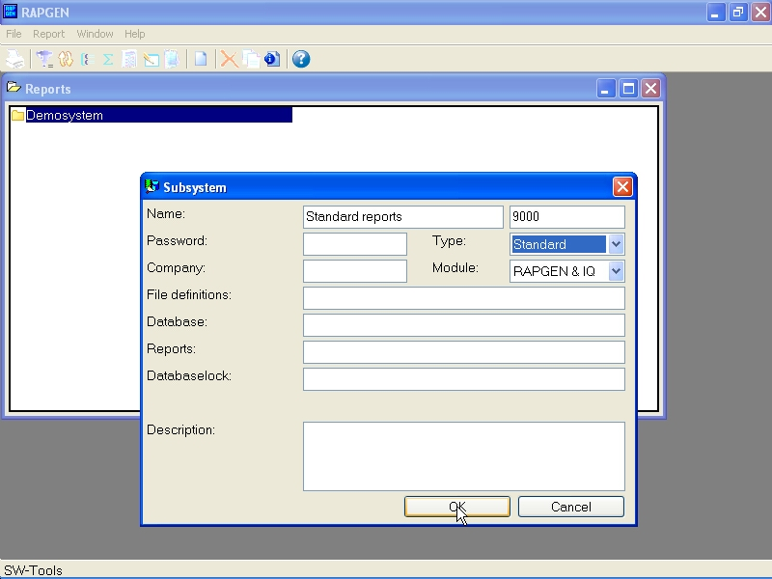

105. Setting up the STANDARD subsystem
The standard reports which comes with TRIO looks like:

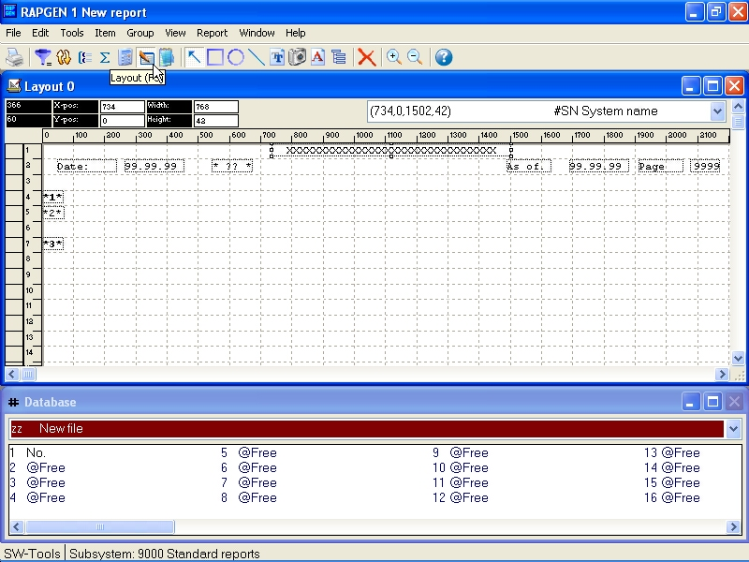

106. The standard report
The ?? will be replaced with the report heading.
The fields *1*, *2* and *3* defines the standard font and colour used for heading, fields and totals.
NOTE: If you reinstall or upgrade TRIO the standard reports must be adjusted again !
The standard reports are kept as DM1001.eng and DM1002.eng on the TRIO program directory.

11. Compiling reports

11.1. Compiler - makes report 20-25% faster
In order to use a compiler with RAPGEN an ANSI C compatiple compiler must be installed. It is only possible to use this function if such a C compiler is installed and RAPGEN is bougth with licens for compiling.
If a compiler is installed all reports generated can be compiled and linked. This process demands a bit more time when the report is started the first time but the generated program is in general appr.x. 20-25% faster.
In compiled reports you may also use all functions avaiable in the standard C/Windows libraries.
c: if (#17>3) return(7);
By typing c: in front of a calculation line all syntax check of RAPGEN is deactivated exept from the field translation and handled solely by the compiler.

11.1.1. Generating the program.
The first time the report is started RAPGEN generates and compiles a C program. This program will be stored on the system and called the next time the report is started, provided that the user hasn't made any changes in the report.

Figure list
1. Report overview 4
2. The main window 5
3. Accessing the functions using menus or the toolbar 5
4. Other buttons on the toolbar 5
5. Functions 6
6. GR Article group file 8
7. KU Currency file 9
8. LE Supplier file 10
9. VA Article file 11
10. Contents of Article group file 12
11. Contents of Currency file 12
12. Contents of Supplier file 12
13. Contents of Article file 13
14. Report overview and selecting new report function 16
15. Define new report - pricelist 16
16. Implemented files 18
17. Reportlines and field overview 23
18. Ending the new report function 24
19. The report output 24
20. Function help 27
21. Changing the start position of a field 28
22. Defining a free field 34
23. Definition of a field format 37
24. Criteria for automatic totals 40
25. Supplier list, only balances over 500 are printed 41
26. Defining selections 42
27. Closing selections 43
28. Deletion of selection 44
29. Calculations in selections 47
30. Selection on calculated field - OR selection 50
31. Selection on calculated field - OR selection 50
32. Calculations 53
33. Calculating the stockvalue 54
34. Changing view of translated calculations 55
35. Searching / Replacing a string 56
36. WHEN, When to perform calculations 75
37. Activating the function wizard 78
38. The function wizard for WHEN 78
40. Conditional print lines 87
41. Total control of print 92
42. Building a sortkey 101
43. Sort on part of field 102
44. Sorting descending 103
45. Defining a subtotal 104
46. Sorted list with subtotals, sorted by article group 104
47. Form feed for subtotal 105
48. Report containing subtotals 111
49. Report with subtotals only 112
50. Report with weighted totals and subtotals 117
51. Calculations for weighted totals 118
52. The report program flow 120
53. The report without calculated totals, margin % is wrong 125
54. The report with calculated totals, total value is wrong 125
55. The report with calculated totals and WHEN calculations 125
56. The report definition for calculated totals 126
57. Definition of fields to be totalled 128
58. Example of group totals 130
59. Definition of a group total 130
60. Example of more groups, the last group 'undefined' 132
61. Field overview 138
62. Field overview from other files 138
63. Field overview from another file channel 139
64. Supplier balance sheet with currency calculation 151
65. Calculation of new sale price from rate and price factor 152
66. Price calculations with READ of more files 152
67. Price calculations without automatic connections 154
68. Reading the same file multiple times 155
69. Alternative suppliers: several references in the same file 156
70. Reading the name of group totals 157
71. READ in connection with totals 158
72. Total stock value collected with START/NEXT/REPEAT 159
73. The report definition for collection total stock value 160
74. Several loops of START/NEXT/REPEAT inside each other 162
75. Suppliers not used since 31/12-1994 163
76. Selection in connection with START/NEXT/REPEAT 164
77. Articles by supplier defined with READH and LINE commands 166
78. Selection of article group > 0 167
79. Selection in connection with READH/LINE 168
80. Totals in connection with START/NEXT/REPEAT 169
81. Definition of a supplier letter 173
82. Copying a report 175
83. Deleting a report 176
84. Print of report definitions 177
85. Report definition for supplier balance > 500 177
86. Report information 178
87. Keys file editor 179
88. Start of report 181
89. Data at start 188
90. Printer setup 192
91. Server spool 195
92. Screen print 200
93. Additional screen printer insertion 201
94. Saving a screen print to a file 202
95. Setup of screen printer to Multi Output Output printer 204
96. Sample setup of TEXT printer viewed in notepad 206
97. Sample setup of TEXT printer viewed in Netscape 208
98. Sample HTML output of standard report in Netscape 209
99. Sample HTML output of non-standard report in Netscape 210
100. Sample RTF output in Microsoft Word 212
101. Documentation of report and start parameters 220
102. Documentation - amended start screen 221
103. PARAMS("#1,7C,6O,le#3") on an article report 222
104. The input screen for PARAMS("#1,7C,6O,le#3") 223
105. Setting up the STANDARD subsystem 226
106. The standard report 227

Index

A
Addition 57
AFTER 76;77;148;167;171
AND 42;71;72;74
ANSI 207;229
B
BASIC 52
C
Calculations 45;47;51;53;118;121;127;231
C-code 127
Checks 172
Compiler 229
Compiling 228
Copying 174;175;232
D
DATA-DICTIONARY 3
DATAMASTER 8;171
Deleting 44;176;232
Division 57
Documentation 177;219;220;221;232
E
END 128;165;200
F
Fieldnumber 53;54
FIRST 76;99;222
FNR 151
Footer 91
G
Generator 1
Group 130;131;214;215
I
IF 58;59;66;68;72;73;74;87;97;119;147;161;167;222
IF-statement 119
L
Labels 98;172
LAST 76;94
LET 58;59;66;68;72;73;74;119;161;171
M
MAXIMUM 48
MINIMUM 48
Multiplication 57
N
NEXT 149;159;160;161;162;163;164;165;169;232
NORMAL 76;77;92
NOT 22;58;60;66;73;77;171;208
O
OCR 52
Operands 57
OR 42;50;72;74;171;231
P
Pagenumber 65
PRINT 81;82;83;84;85;86;87;88;89;90;91;92;93;94;95;97;98;99;200
Printer 95;191;192;205;225;232
Printing 98;195
R
RAPGEN 3;4;5;8;15;16;17;18;33;36;38;39;40;46;48;52;58;60;64;71;77;92;99;115;120;122;127;131;132;137;141;142;143;153;154;155;160;181;182;214;225;226;229;230
READ 66;68;72;79;89;137;140;141;142;143;144;145;147;151;152;155;157;158;162;166;232
READH 33;82;89;150;166;167;168;169;232
REM 69
REPEAT 149;159;160;161;162;163;164;169;232
Reportname 19
Reportnumber 17
REWRITE 80
S
Selection 41;46;50;163;164;167;168;231;232
Sort 102;231
SORT 77;103
Sorting 67;100;101;102;103;109;231
Specialfields 61
START 149;159;160;161;162;163;164;165;169;232
Starting 180
SUBFUNCTIONS 71
Subtotal 67;104;111
Subtraction 57
Summation 160
T
Total 67;92;100;159;190;231;232
TOTAL 77;158
Totalname 158
U
UPDATE 80;171
Username 22
W
Weighted 113;114;119
WHEN 75;77;78;109;116;117;119;122;124;125;231;232

