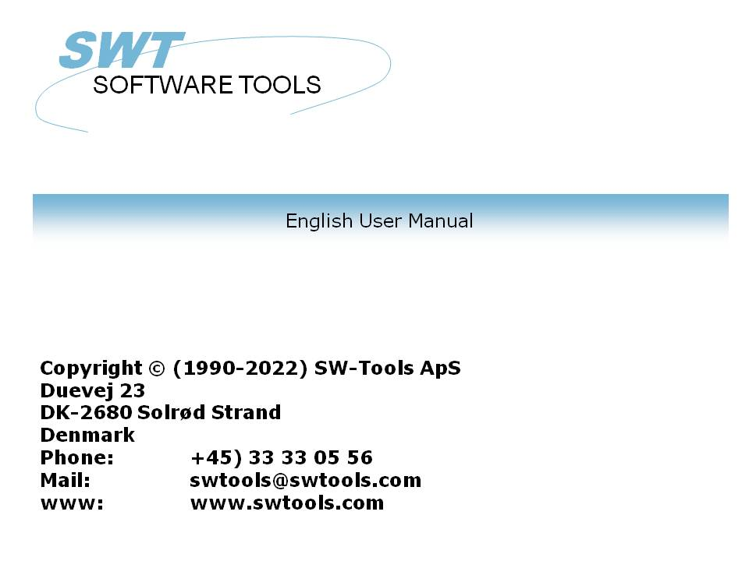

TRIO Release Information (008.000)

22/11/01 / 2022-09-01 008.384

Contents
Contents 2
1. Introduction 5
2. Start and installation of TRIO 6
2.1. Start of TRIO 7
2.1.1. User login 8
2.1.2. Logo 9
2.1.3. User maintenance 10
2.1.3.1. Creating the users 11
2.1.3.2. Upgrading with real user administration license 12
2.2. Installation and upgrading 13
2.3. Manuals 16
3. Printing from TRIO 17
3.1. Printer setup 18
3.1.1. The TEST button 19
3.1.2. The ADVANCED Button 20
3.2. Forms 21
3.2.1. Creation of forms 22
3.2.2. Controlling the form print from the calculations 23
3.2.3. Handling of forms during the layout definition 24
3.3. PIP Print archiving 25
3.3.1. Screen printer display when using PIP 26
3.3.1.1. Screen printer display without using PIP 27
3.3.2. Recalling an archived print 28
3.3.3. Report start statistics 29
3.3.3.1. Use of the report start statistics 30
3.3.4. Structure of the PIP files 31
3.3.5. The SSV Printindex file 32
3.3.5.1. Defining the printindex for individual print recall 33
3.3.5.2. Calculations in IQ for individual print recall 34
3.3.5.3. The IQ programme for PIP print recall 35
3.3.5.4. Calculations in IQ to ease searching 36
3.3.6. PIP Print archiving controlled from within the calculations 37
3.3.7. Cleanup of old print 38
3.3.8. PIP Locking and error handling 39
4. Report layout definition and tuning 40
4.1. The layout function 41
4.1.1. New layout when report is defined 42
4.1.2. Autosize of fields 43
4.1.3. Alignment 44
4.1.4. Auto scroll when moving, inserting items in layout 45
4.2. Layout preferences 46
4.2.1. Display options 47
4.2.1.1. Grid 48
4.2.1.2. Page frame 49
4.2.1.3. Use line height instead of font height 50
4.2.2. Vertical position step 51
4.2.3. Horizontal/vertical measurement, ruler and alignment 52
4.3. Additional picture formats 53
4.3.1. Scaling of pictures 54
4.3.2. Animation of pictures 55
4.4. The database window, display and search 56
4.4.1. The display and sort of the database window 57
4.4.2. Searching the database 58
4.4.3. Display of used files only 59
4.4.4. Actions by click on a field in the database window 60
4.4.5. The function parameter wizard help 61
5. IQ 62
5.1. GRID listboxes 63
5.2. DGRID for simple data selection 65
5.3. SCROLLBAR object 66
6. The datadictionary 68
6.1. Long datadictionary file ID 69
6.2. Datadictionary fieldnumbers 70
6.3. Datadictionary standard field formats 71
6.3.1. The standard FORMAT file 72
6.3.2. Defining a file using the standard formats 73
6.4. Integration between different database systems 74
6.4.1. The database system IDs 75
6.4.1.1. Creation of database identifications 76
6.4.1.2. The database window when BASID is activated 77
6.4.1.3. The fixed database ID's MAIN and SYS 78
6.4.2. File connections spanning over different databases 79
6.5. Datadictionary calculations / Stored procedures 80
6.6. User definable subfunctions 82
6.6.1. Selecting the function definitions 83
6.6.2. Creation of new functions 84
6.6.3. How it works 85
7. External packages and runtime licences 86
7.1. Packages 87
7.1.1. Package numbers 88
7.2. TRIO Runtime licenses 89
7.3. Activating a package in TRIO 90
7.3.1. How TRIO handles a package 91
7.3.1.1. Package licenses 92
7.4. The license input program 93
7.4.1. The distributors license file 94
7.4.2. Entering the distributor license 95
7.4.2.1. DISK input and output of license files 96
7.5. Preparing a package on the distributor site 97
7.5.1. The licensing package 98
7.5.2. Making the package ZIP file 99
7.5.2.1. Contents of the package ZIP file 100
7.5.3. Issuing a license for the package 101
7.5.4. Copying the package to the customer side 102
8. Other amendments and enhancements 103
8.1. Limits 104
8.2. Memory and optimization 105
8.3. SW-Tools ODBC Driver 106
8.4. UNIX server SWTUSOCK 107
8.4.1. LINUX server 108
8.5. Descending index definition 109
8.6. EXPORT Append to file 110
8.7. Japanese kanji codetables 111
8.8. Network pathnames 112
8.9. User administration 113
9. Subfunctions 114
9.1. The ZIP and UNZIP functions 115
9.1.1. UNZIP - Unpack files 116
9.1.2. ZIP - Zip file compression 117
9.2. PRINT functions 118
9.2.1. PIP - Print archiving 119
9.2.2. SCRPRT - Recall screen print (IQ) 120
9.2.3. PRINT - Print formula 121
9.2.4. PRINT(LAB= - Label function (RAP) 122
9.3. The GRID Functions for IQ 123
9.3.1. DGRID - Dialog Database Grid (IQ) 124
9.3.2. GRIDHDR - Set header for grid (IQ) 125
9.3.3. GRIDFLD - Set fields values into grid row (IQ) 126
Figure list 127
Index 129

1. Introduction

The release 008 of TRIO contains the following enhancements:
Users
- User maintenance and login (also without user administration)
- Report start statistics (also without user administration)
.
Print
- PIP Print archiving
- Formulary print on reports
- Support of different picture formats (GIF/TIF/PCX etc)
.
Runtime
- ZIP and UNZIP functions for packed file handling
- RUNTIME package and license handling
.
IQ
- GRID listboxes
- DGRID data selection input listboxes
- Scrollbar type objects
.
Datadictionary
- Search facilities on files and fields
- Extension of file ID from 2 to 8 characters
- Extension of fieldnumbers from maximum 999 to 999999999
- Raising of different limits (fieldlength/recordlength etc)
- Integration of different database definitions in one program
- Datadictionary calculations
- Datadictionary standard field formats (like AMOUNT and DATE)
.
Languages and installation
- Language support of French, Spanish, Swedish
- Installation programme updated to 32 bits long pathnames
.
Manuals
- Now online on the CD together with a print program
.
For customers with maintenance contract the additional functions will be free of charge, these customers will receive an update when the test period has ended.

2. Start and installation of TRIO

2.1. Start of TRIO
The startscreen for TRIO has been changed as follows:

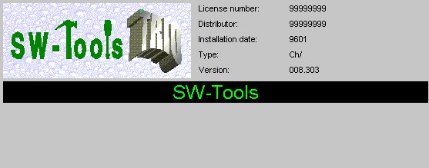

1. Start of TRIO

2.1.1. User login
TRIO without user administration has been opened to start with a username in order to take advantage of the HOMEPATH, which may be given for each user.

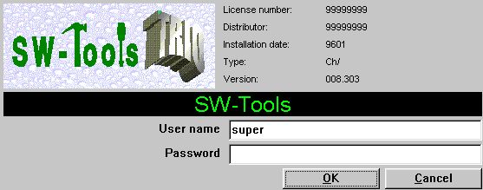

2. Start of TRIO when more users are activated

2.1.2. Logo
You may design your own logo, store this in the file SWTRIOLL.BMP which will display as:

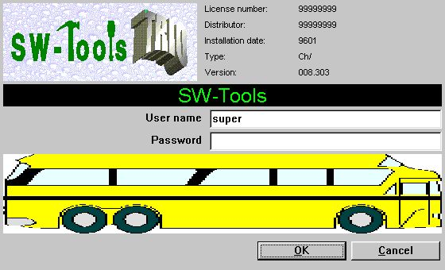

3. Start of TRIO with own logo activated

2.1.3. User maintenance
Users may be defined even if the user administration is not activated, however no individual user privileges can be made.
This means the User administration may be selected and setup, but the definition screen is without the privilege definitions:

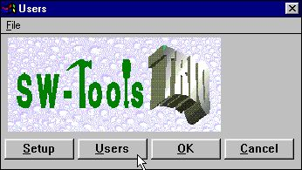

4. The reduced user menu

2.1.3.1. Creating the users
On the user maintenance screen the fields for user group and grant/revoke are omitted as all users becomes superusers when the user administration license is not present.

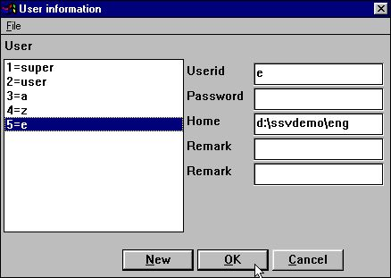

5. The reduced user maintenance screen
Apart from these reductions the user maintenance follows the procedure as described in the user administration manual, and you gain the advantage of the HOMEPATH enabling you to split different applications on one system dependent on login instead of using subsystems or different Windows icons.

2.1.3.2. Upgrading with real user administration license
Without the module user administration is present on the license, the main user SUPER will be created as superuser (usergroup 1-Revoke), all other users as USER (usergroup 2-Grant), but all threaded as superusers with all rights including right to create other users.
If user administration later is added to the license, even without being X-Marked for the specific PC, the treatment of all users as superusers is terminated, and the first user (SUPER) only may create other users.
For security reasons, a user password file created with user administration license activated, cannot be used directly on a PC without this license, as this would violate the protection system.

2.2. Installation and upgrading
Due to support of more languages the installation screen has been changed to:

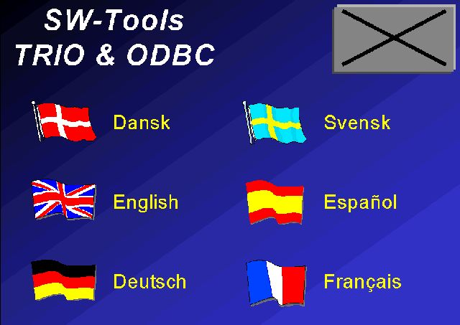

6. The language screen

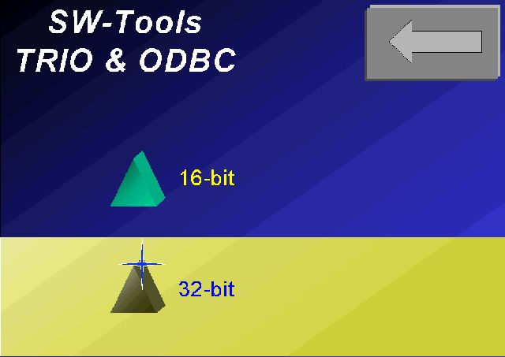

7. The 16/32 bit screen

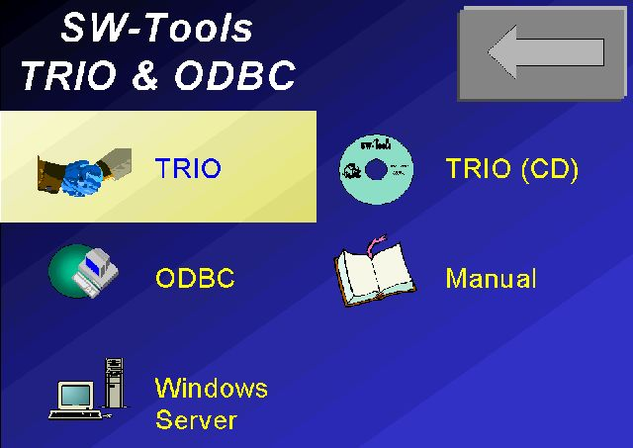

8. The product screen
The installation programme for the 32 bit version is now running 32 bits, which allows the use of long filenames already by installation. TRIO version 008 if fully compatible with version 007, but you should note that the opposite is not the case. If you use fileID's of more than 2 characters no reverse compatibility is possible, file definitions cannot be exported to previous versions or to the VIEW basic report generator.
Also the use of database interaction, external packages, GRID functions or PIP print collection will not be moveable to TRIO versions below 008.
By upgrading, it is possible to use any persistent 007 server module, but we recommend upgrading the server to version 008, which will be able to service a mix of clients on newest or older versions. It is not possible to use long fileIDs, fieldnumber modifications or the like with a 007 server.

2.3. Manuals
Manuals will from version 008 be distributed on CD only, together with a programme enabling the user himself to print as many copies as needed:

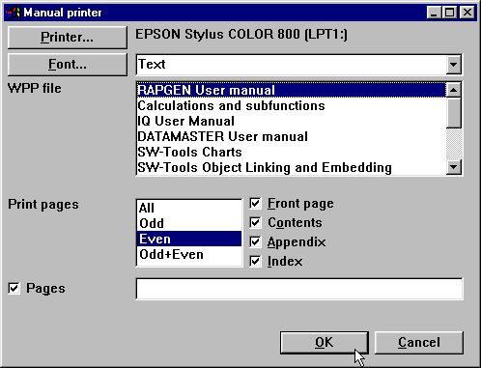

9. Printout of manuals

3. Printing from TRIO

In order to make easy distribution of reports in package form, where change of printers is most likely when the package is installed, field boxes in the layout will now be set to automatic resizing by default, as has some of the printroutines been reworked.
However you should note that when inserting a field in a report, the selected font may be a PRINTER font, which varies with the printer used. Note when developing reports to be used on different printers use a general font only, such as times new roman or the like, and force the printer driver in windows to download TrueType fonts, not using any hardwired fonts in the printer.
Also new facilities for print archiving and form print have been added.

3.1. Printer setup
The printer setup has been extended with a TEST and an ADVANCED button:

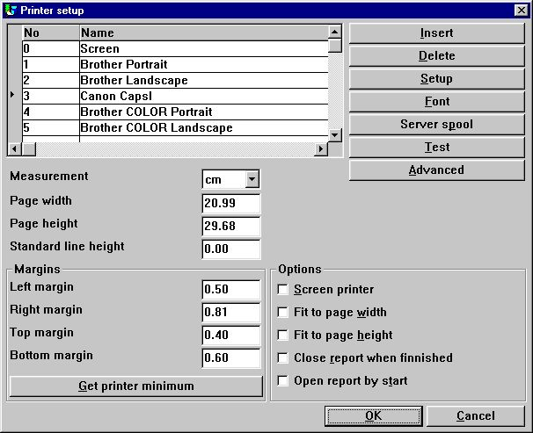

10. The printer setup

3.1.1. The TEST button
When TEST is pressed one page is printed on the selected printer showing the margins and resolution used.
The corners on this testprint are marked with a grid where the margins should be shown as a solid line. As printers seems to behave differently you should check the following before trusting the driver settings:

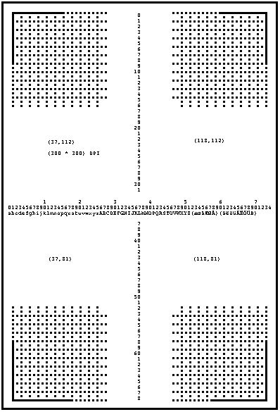

11. Test button, CAVE before trusting printer

3.1.2. The ADVANCED Button
The ADVANCED button is used to setup the new facilities for form print and print archiving.

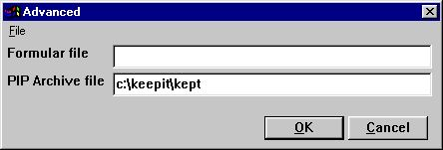

12. The advanced button in the printer setup

3.2. Forms
The formula file should contain a picture in WMF format, which then will be extended to full paper size (without respect of margins and with the image stretched to fit in both directions) and printed transparent behind all other texts on all pages.
For example: you may try to enter one of the picture files from the TRIO demo system, which may be stored as
c:\swtools\demo\wmf\0101.wmf
You should note, that the form is output to the printer for each page, and this may considerably reduce the speed of printing on some printers.
If possible, for production runs, use any macro language for the printer to download the form fixed into the printer memory as described in the individual printer drivers manuals.

3.2.1. Creation of forms
To create a form you may use any picture programme which is able to save in WMF format, e.g. Microsoft PowerPoint.
The reason for using the WMF format is because it is based on vectors, e.g. the drawing may be scaled without loosing its resolution. However, it is also possible to use any of the other supported pictures format, such as BMP, GIF, JPG etc.

3.2.2. Controlling the form print from the calculations
It is also possible to control the form printout from the calculations. This means a report may use different forms on the pages printed.
PRINT(FORM=c:/swtools/demo/wmf/0101.wmf)
will change the form to be taken from the WMF filename given.
The PRINT(FORM= should be placed in the FIRST section if the form is to be used from the very start. If placed in the NORMAL section, the form change will take effect, when the first line on the following page is printed.

3.2.3. Handling of forms during the layout definition
As soon as a form has been setup for a printer you may select this printer in the layout function which will then show the form in background according to the printer page size.

3.3. PIP Print archiving
Setting a PIP (Print zIP) archive filename causes all printouts to be archived into filename.zip and a printoverview file filename.ssv to be builded. An example may be:
c:\keepit\kept
If the directory c:\keepit is not present, this will be created. Note that the first character of the filename must be a letter. You should omit the file extension as this is set to zip/ssv
If you omit the path from the filename, the database path from the setup preferences will be used.
If the filename is 4 characters or less, YYMM will be added when archiving to keep filesizes low and ease deletion of old print. The above example will produce the files
c:\keepit\kept9908.zip
c:\keepit\kept9909.zip
c:\keepit\kept.ssv
The print archiving may also be controlled from within the calculations of a report without defining this on the printer setup. (see the PIP function later)
Print archiving may be defined for a screen printer also, so a physical print is produced only as a reprint from the archive.

3.3.1. Screen printer display when using PIP
When you are using PIP print archiving for a report printout, the VIEW button will be activated even if the output is not printed on a screenprinter, as the screenprinter files have to be made anyway for the print archiving.
This means you get the double function of printing and viewing the output on screen at the same time

3.3.1.1. Screen printer display without using PIP
You may specify the making of screen printer files for a printer without actually archiving the print by entering the
PIP Filename as just -
the print is not archived but you get the VIEW possibility.

3.3.2. Recalling an archived print
The report statistics startlog will show start-endtime for a run, if print has been collected the - is replaced by + as start+endtime, by clicking at the endtime you will get the print on screen and may reprint all or selected pages. The reprint may be done on a different printer type as the print will then be resized, but please observe that differences in page setup and field scaling may heavyly influence the print.
Note that the + mark indicates only that a print was collected, and not necessarily that the print is still present: Somebody may have made a periodically cleanup of the zipfile in which case the print of course cannot be displayed.
As the startlog holds the last 100 starts only the recall possibility will be pushed out after more than this number. This recall is restricted to report start and not other print such as data dictionary definitions.
However you may define the SSV file made by the print archiving for an IQ program, use this for searching a specific print and display it with the calculation function SCRPRT, see later.

3.3.3. Report start statistics
The report start statistics are now included as a part of TRIO without the necessity of a licence for user administration to be present. For a full description you should refer to the last chapter in the user administration manual.

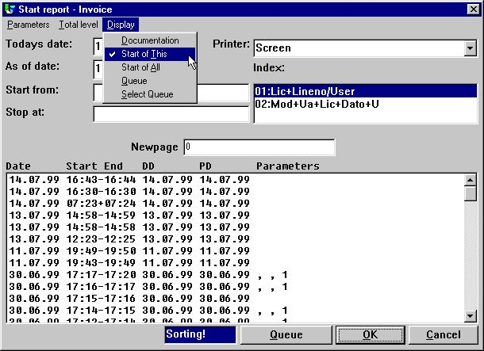

13. Start of a report showing the report statistics

3.3.3.1. Use of the report start statistics
By clicking at one of the statistic lines, different functions are achieved depending on where the click is made:
- Startdate gives details of this report
- Starttime gives run statistics for this start
- Endtime displays the archived print if present (marked with a +)
- Anywhere else duplicates the parameters with or without the dates
The PIP print archive file/number is shown on the report detail information you get by click at the date field:

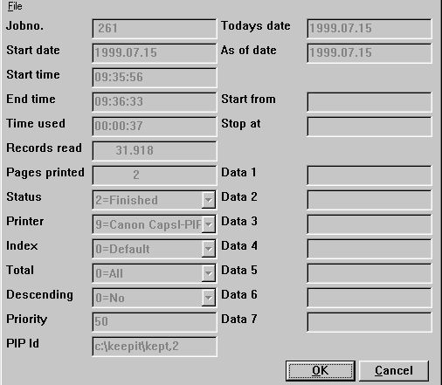

14. Display of report details with the PIP id

3.3.4. Structure of the PIP files
The print will be stored in the same way as the screen printers output in one or more compressed ZIP-files. Each print session is numbered by taking the next free number from the zipfile, the printsession number nnnnn may range from 00000 to 32000.
Each printpage will be stored as a file nnnnn-NN.NNN in the zipfile, nnnnn being the printsession number, NN.NNN being the print page number within the printsession. These filenames are 16/32 bit compatible.
Any chart on the report will be also included in the print archiving, but you must note, that pictures and OLE objects may be stored as references to an external file, and not packed into the print archive itself.
To get a proper display of the archived print, such external files must be accessible, also when the print is recalled. However to enable moving of the print archive files between different machines, when no file is present, TRIO will search the following paths:
- The database path as given in the preferences
- The TMP path
- The current path given when the programme was started
- The report definition path
- The path of the TRIO programs itself
If not found, the display will just be left out without warning.

3.3.5. The SSV Printindex file
A printindex SSV textfile will be built with one line for each printsession and the following fields:
- Printsession number within the zipfile
- Date printed
- Report number
- Report name
- Additional user-controlled informations given in calculations
( as customer number, name, invoice number, date)
For example the ssv file could contain:
SW-Tools
1;19990715;dm1001;Article report
2;19990715;dm1008;Invoice

3.3.5.1. Defining the printindex for individual print recall
If you want to use such a printindex file for searching and display with IQ, you must first make a file definition like:

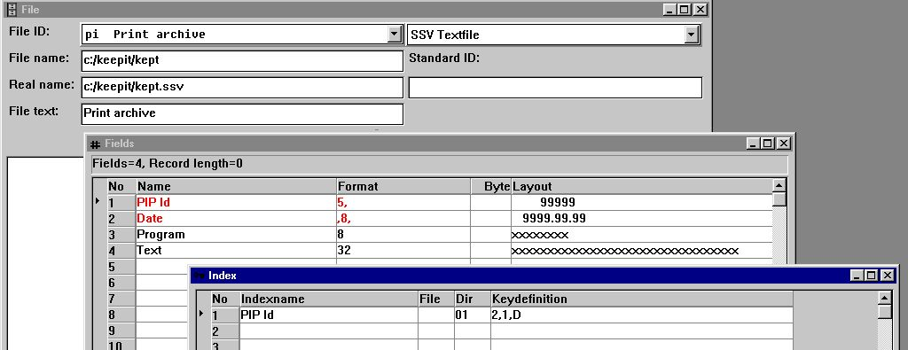

15. A standard definition for a PIP file
Note the index definition of 2,1,D causes the print to come in date order, the newest print first.

3.3.5.2. Calculations in IQ for individual print recall
Define an IQ programme on this file as pi#1-99L on listform and add the following calculations:

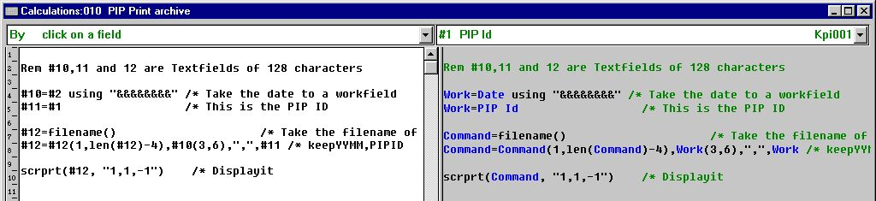

16. Calculations for PIP print recall
The SCRPRT function gets the first parameter as PIP id
c:/keepit/kept9908,1
and the second parameter controlling the display (see functions later) as:
1 = Start display on page 1
1 = Display in window
-1 = Zoom factor (zoom out once to reduce size)
which gives the result:

3.3.5.3. The IQ programme for PIP print recall

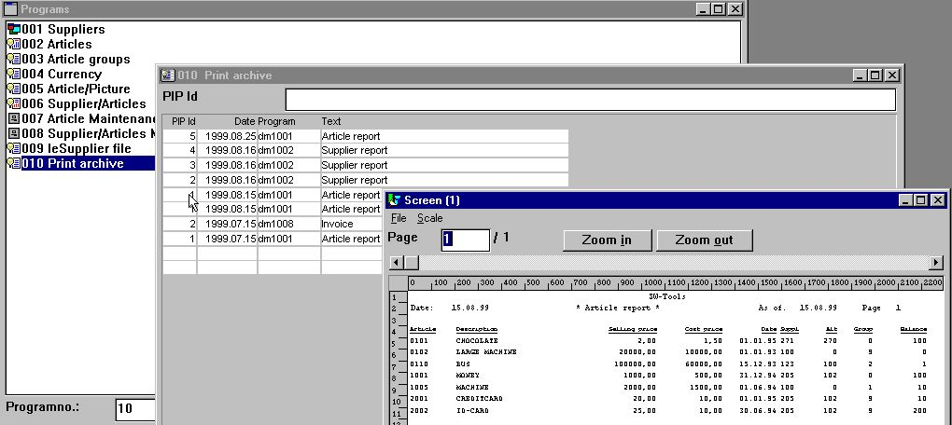

17. The IQ programme for PIP print recall

3.3.5.4. Calculations in IQ to ease searching
You may add the following lines to the IQ program

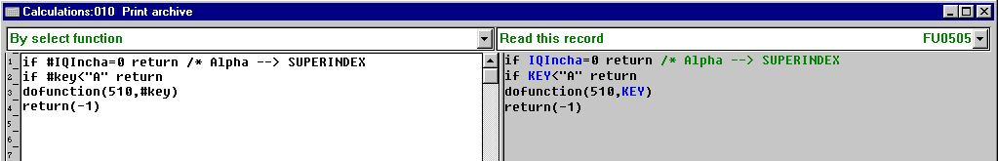

18. Calculations in IQ programme for PIP print recall
IQ will switch to SUPERINDEX automatically when a letter is entered as searchkey, whereas a number input goes to index search. Such routine generally may be used in IQ programs.

3.3.6. PIP Print archiving controlled from within the calculations
The calculation function PIP for print archiving has been introduced as:
PIP ( fields, filename [,optional pages] )
In a report you may use this function to switch on the print archiving for a report instead of for a printer. The PIP filename does not have to be set on the printer, if set, the calculation specification will overrule this. For example:
LAST
PIP("#1-3", "c:/keepit/kept")
will archive the print and place the contents of field 1,2 and 3 in the printindex file (kept.ssv).
The first field in the printindex file will always be the PIPID or printsession number as to retrieve the print. If the filename given is 4 characters or less so that YYMM is added, the date YYYYMMDD is inserted as the next field. After this follows the fields you state for the PIP function or, if nothing stated, the report number and name.
The PIP function may be used in the NORMAL section of a report to archive all pages printed since the last call of PIP. This means you may call PIP after finishing printing an invoice to get the invoices separated in the print index by searching with the print recall.
The last PAGES parameter of the PIP function may be used for further control of what to archive, could be totals only from a huge report, but should normally be left blank. See the PIP function description for details of this.
If a report results in more separate entries in the print archive, like one for each invoice, the last one of these will be displayed by clicking on the endtime in the start log.

3.3.7. Cleanup of old print
In our example above the zipfiles were named keptYYMM.zip. If you need space quickly just delete the unnecessary old files from the disk.
However the correct method of course is to make a report on the printindex file deleting all old records and at the same time removing these from the print archive ZIP file. For this we need the ZIP function which we pass the zip filename and PIPID, together with the mode -d for delete and -q for quiet operation to ignore all error messages:

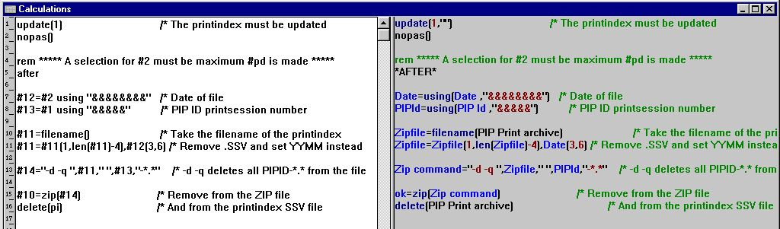

19. Calculations for a PIP cleanup report
The freefields 11,12,13 and 14 used above are all textfields of 128 chars. The field #10 will be 0 if the zip entry was deleted or 1 if not deleted.

3.3.8. PIP Locking and error handling
During the print archiving the printindex SSV file is of course locked. If more users try to archive at the same time to the same file the last one will receive a warning and will have to wait until the first is completed.
To speed up the archiving, control is not handled back to Windows during the ZIP packing which may cause a short pause during the archiving.
The ZIP function itself may give error messages as disk full or report problems with the zip file.

4. Report layout definition and tuning

4.1. The layout function
The layout function has been modified at several levels. Of most importance, the rulers and alignments now support use of centimetres, inches and points.

4.1.1. New layout when report is defined
In previous versions it was almost impossible to select the same starting position of a field on the next line as on the line previously defined. This problem is now solved.
The box size calculated by the new report layout will now match the box size calculated later on in the layout function.
Please refer to the new preference for further details.

4.1.2. Autosize of fields
All TRIO standard reports will as standard insert fields with the option 'Autosize box' width and height (both included).

4.1.3. Alignment
When inserting or moving fields in the layout it is automatically aligned horizontally. If this is not required the checkmark of the new option in menu
File, Edit, Align to column
may be removed.

4.1.4. Auto scroll when moving, inserting items in layout
The layout function will automatically scroll the layout when the mouse cursor reaches the edges of the layout window during the movement or insertion of items.

4.2. Layout preferences
The layout function contains a preference dialog. It is activated through the menu
File, Preferences...
and allows you to setup how you need to work with the layout. The changed settings will be saved individually on each report.

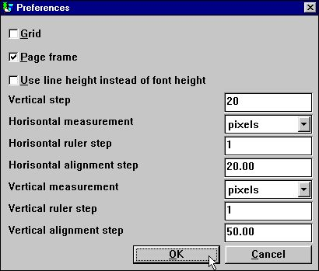

20. The preferences in the layout function

4.2.1. Display options

4.2.1.1. Grid
The layout grid is provided as a guideline. This option may be turned on or off. How the lines are displayed depends on the horizontal and vertical ruler step.

4.2.1.2. Page frame
The page frame is provided as a guideline. It will display the size of the page depending on the printer currently selected in the layout. It will NOT limit you from exceeding the page when inserting and moving items.

4.2.1.3. Use line height instead of font height
This option is only used in connection with a report. Normally, inserting a field uses the standard font height to set the box size of the field. However, if you want to use the normal line height of a report you may turn this option on.

4.2.2. Vertical position step
The vertical step is only used in connection with the layout of a new report. When you create a new report and click on the horizontal measurement bar you change the starting position of the next field to be inserted. This position will be aligned according to the vertical position step. Doing this makes it easier to keep the same starting position of fields when creating reports with more than one print line.

4.2.3. Horizontal/vertical measurement, ruler and alignment
The measurement may selected as
- pixels
- cm
- in
- points
The preference dialog will automatically convert the existing alignment value according to the selected measurement.
The alignment value is used when inserting and moving items within the layout. An item will be aligned according to the value setup here.
BE AWARE that changing the vertical ruler and alignment step to anything other than pixels/50 may cause you to insert or move items to positions that DO NOT correspond to the correct print line used by the report generator.

4.3. Additional picture formats
TRIO supports display and print of the following picture formats
BMP - Microsoft Windows bitmaps
CUT - Dr. Halo
DIB - Microsoft Windows Device Independent Bitmaps
GIF - Compuserve Graphics Interchange Format
IFF - Interchange File Format (Amiga Electronic Arts Deluxe Paint)
IMG - GEM Raster files (Digital Research)
JPG/JPE/JPEG - Joint Photograpics Experts Group
LBM - Interchange File Format (Amiga Electronic Arts Deluxe Paint)
MAC - Macintosh Paint
MSP - Microsoft Paint
PCX - ZSoft PC Paintbrush
PIC - Pictor PC Paint
RAS - Sun Raster files
TGA - Targa TrueVision Files
TIF - Tagged Image File Format
WMF - Windows Meta-files
However as there may be different variants of these picture formats, it is impossible to test and support all formats in all variants, especially with respect to different types of compression. In case you experience problems with any type it may be necessary to convert into one of the other types or save with different compression level.
You should note that display of pictures may be faster and of better quality in the 32 bit version than in the 16 bit version.

4.3.1. Scaling of pictures
Pictures may be displayed in two ways:
A. Filling out the box given in the layout (the picture is stretched in both directions)
B. Sizing inside the box as much as possible, but keeping the aspect ratio of the image, this may cause either the left side or the bottom of the box to be left blank.

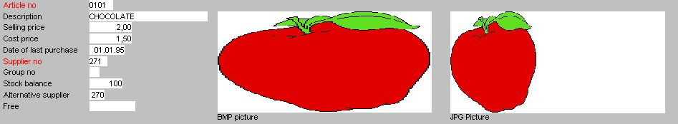

21. Picture displayed with or without maintainance of the aspect ratio
For the time being, the WMF is always displayed according to way A, all other according to A or B.

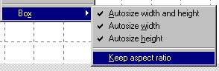

22. Keeping aspect ratio

4.3.2. Animation of pictures
You may create an animated picture in IQ just by displaying the same picture field multiple times with different contents. N.B. This requires a fast PC.
The DISP function to redisplay one or more fields as DISP(#30) ensures that a field is redisplayed after the calculations are done, before any change of input is made. For picture animation you will have to add the U option as DISP(#30U) to get the screen updated immediately without waiting until the next input.

4.4. The database window, display and search
The database window include settings how to sort and display information within the window. Furthermore, it is possible to search the entire data dictionary for fields or tables.

4.4.1. The display and sort of the database window
The options you may setup for the database window is found in the menu
View - Options...
when the database window is active.

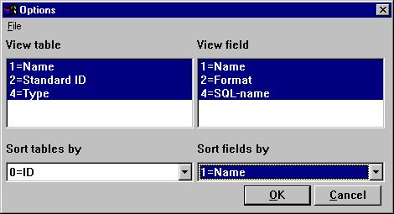

23. View and sort options of the database window
Apart from always including the table id, the view/and sort of tables include
- Name
- Text
- Standard ID
Field always includes field numbers, but may also view and sort
- Name
- Format
- SQL name
If the option of viewing fields includes field format, the database window will display the following:

24. Database window including field format

4.4.2. Searching the database
When searching the database definitions, it is possible to find tables and/or fields. The search option is selected when the database window is active in the menu
Edit - Search

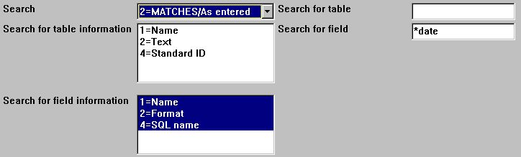

25. Entering the search criteria
The search is performed according to the search method selected, which may be
- As entered
- Case-sensitive
- MATCHES/As entered
- MATCHES/Case-sensitive
The MATCHES allows you to work with part of the text following a specific syntax. The syntax is based on the use of some special characters
* = any text
? = any one character
For example, the database definitions may have several tables, where fields are defined as dates. However, only searching after the text
date
will not find a field in upper case if the method is as entered. It will not find a field
date of last purchase
If using the method MATCHES/As entered and searching for
*date*
it will find any field having date within the field name, e.g. any text followed by the text date and ending with any text.

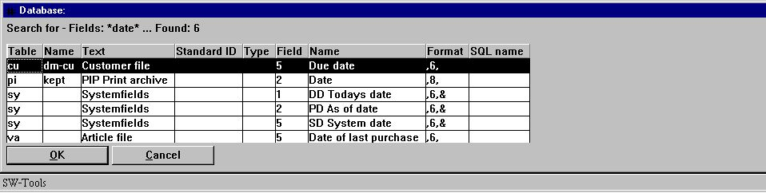

26. The search result shown in the database window

4.4.3. Display of used files only
This option is activated from the file menu when the database window is active.
You may select to show used files only for the programme in order to get the overview of needed files as short as possible.

4.4.4. Actions by click on a field in the database window
When defining selections or calculations you may click on any field in the database window to get the full field definition shown. By selections the field will be inserted in the current selected box on screen also.

4.4.5. The function parameter wizard help
By using the function parameter wizard by calculations (ctrl.Q), you may go directly to the windows manual section for this function by selecting HELP (F1).

5. IQ

5.1. GRID listboxes
The GRIDHDR and GRIDFLD function has been added.

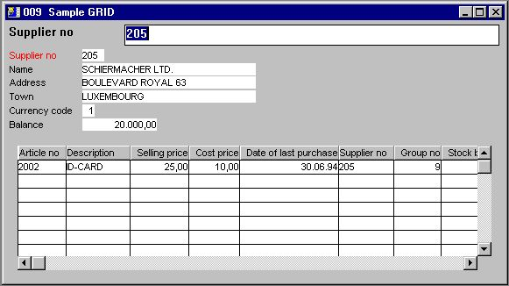

27. Sample use of GRID

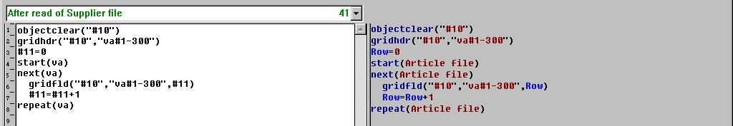

28. The GRID calculations

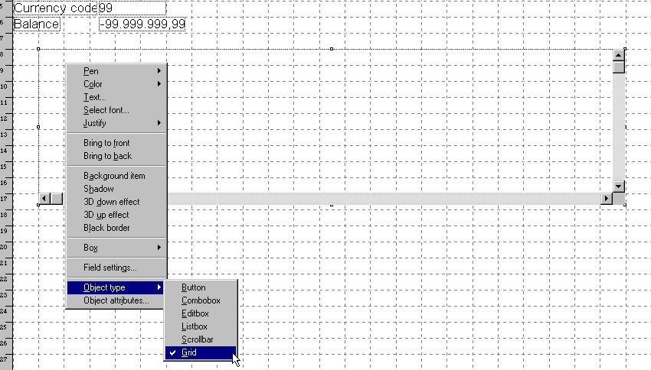

29. The GRID field in the layout

5.2. DGRID for simple data selection
The subfunction DGRID may be used to select a record from a dialog box which will block the current application until selection has been made.
For example, by entering the following calculation by click on a field in a IQ query
DGRID("va!1!1-2,6!0!Select an article",#50)
will read records from the article file 'va' which are sorted according to the index number '1' and display the fields '1-3'.
The function will return the value of the displayed field '0', e.g. field number 1 because

 | Displayed field | Field
 | 0 | 1
 | 1 | 2
 | 2 | 6

which is stored in field #50.
Finally the dialog title is set to 'Select an article'.

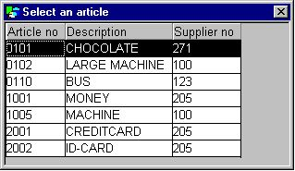

30. DGRID dialog
For more information please refer to the DGRID subfunction.

5.3. SCROLLBAR object
The scrollbar object may be used to display numeric values from 0 to 32767.
To make a scrollbar field you may define a work field named 'Scrollbar' with format '6,' and change the object type in the IQ form to 'Scrollbar' when inserted.

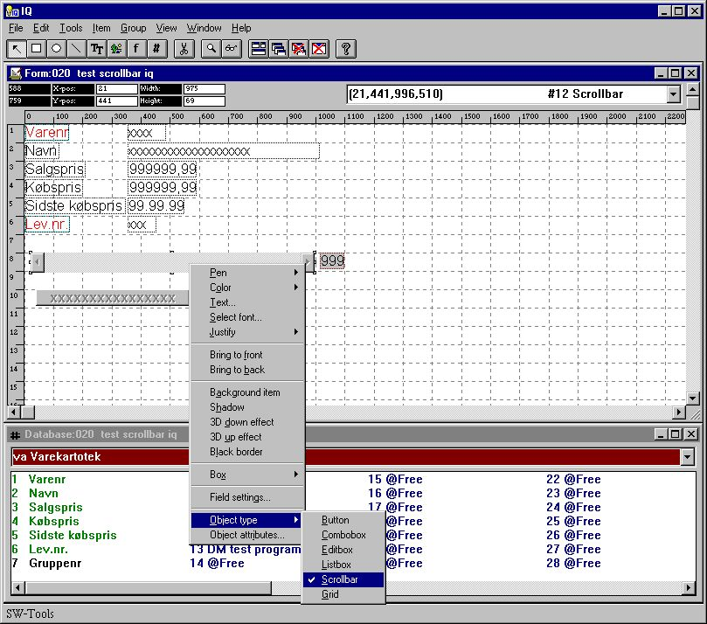

31. Scrollbar inserted in a IQ/DM form
When using a scrollbar in IQ the following calculations are required:
- Setting the maximum value using ObjectAddString()
- Getting the current position of the scrollbar using ObjectGetString()
For example: You may define the work field #12 as 'Scrollbar' with format '3,' and add the following calculation by start of program
ObjectAddString("#12","100","")
which will set the maximum position of the scrollbar to 100. Then a calculation by clicking on field #12
#12=ObjectGetString("#12")
in order to retrieve the current scroll position.
When using the scrollbar object in DATAMASTER you do not require to use the ObjectGetString() to retrieve the current position, because DATAMASTER does this automatically by setting the value into field #12.

6. The datadictionary

6.1. Long datadictionary file ID
The 2 character file ID has been extended to a maximum of 8 characters.

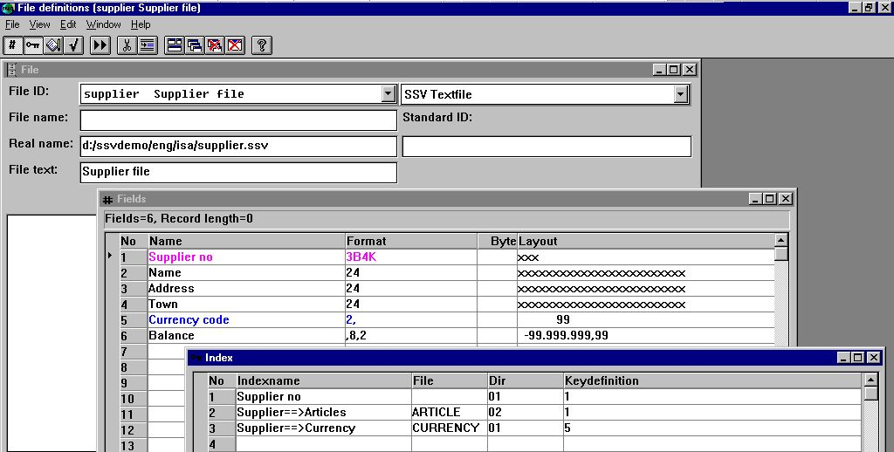

32. The demo supplier file with long file ID
Note that connections, READ(....) and all file/field access in general are extended in this way, and use of fileIDs longer than 2 characters is in no way backward compatible with previous versions, also in respect to any Unix server.
In calculations you may then give fields as:
va#47=1
customer#47=1
invoice#47=1
invoice#statcode=1
The use of upper/lower case letters for the same file multiple times in a single programme is limited to the 2 first characters only, (auftrag/AUFTRAG/Auftrag/aUFTRAG), more than 4 times the same file is not considered relevant.
On 32 bit systems you may even create fileIDs with up to 32 characters, but this is not recommended as all the compatibility with the 16 bit version will be lost.
A conflict with old TRIO programs and long filenames exists in the syntax in read of files, where the connection is stated explicitly, as READ(va.le), the old syntax READ(vale) without point is still supported unless a long fileID 'vale' really is present.

6.2. Datadictionary fieldnumbers
Each fieldnumber in a file may be stated separately independent of the real sequence, as a new column in the FDF has been added for user-defined fieldnumbers:

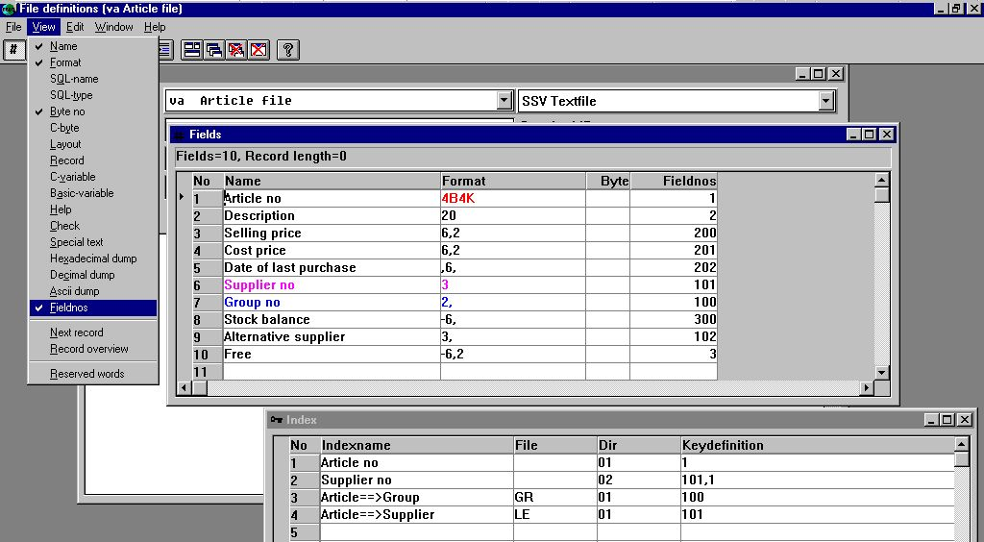

33. Amending the fieldnumbers in the datadictionary
In the database window the fields are shown sorted by the new sequence and all references go to the new fieldnumber, for example should the db now be calculated as #310=#201-#200

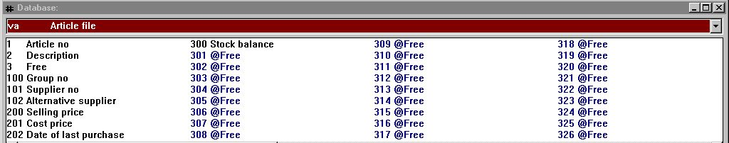

34. The database window after fieldnumbers has been amended
Note that workfields are numbered as usual after the last used field in the file.
The maximum number of fields in one file is still 999, but fieldnumbers may be up to 2.000.000.000 in the 32 bit version. The 16 bit version is restricted to a maximum of 65000.

6.3. Datadictionary standard field formats
A field format may be stated as AMOUNT, the real format will be taken from the file FORMAT if present by searching for a fieldname Amount.

6.3.1. The standard FORMAT file
To activate the standard field formats, just create a file named FORMAT in your datadictionary e.g.:

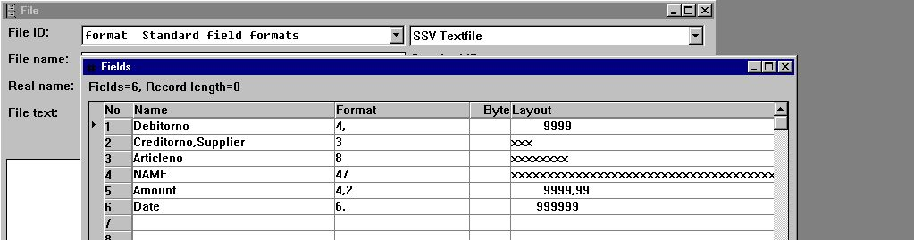

35. Creating the FORMAT file with standard formats
The fieldnames given here will be the standard formats, these must be alphanumeric without special characters, upper/lower case does not matter. You may state synonyms by separating these by comma as shown for supplier.
The field formats may contain bytenumbers, packtypes and other options just like a normal field format.

6.3.2. Defining a file using the standard formats
You may use these standard formats when defining a file like:

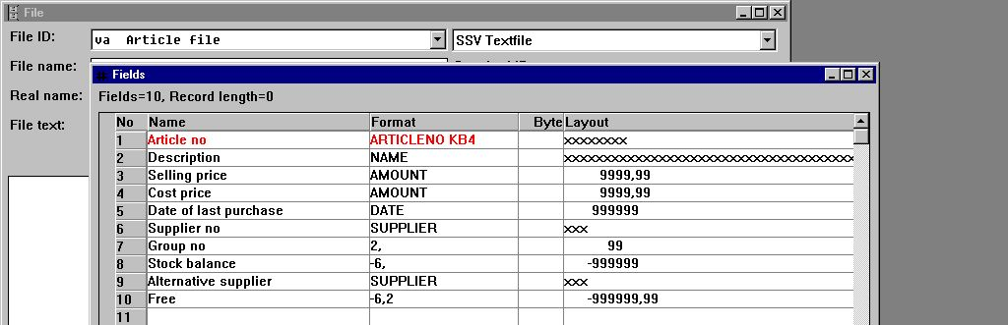

36. The demo article file using standard formats
The standard format is used when a field format starts with an alphabetic character. The standard format name goes up to the first space met. After this, you may state additional options for the field as shown for the first field with the K=Key and B4=Bytenumber 4 options added.

6.4. Integration between different database systems
As it is being more common to have different database systems in the same equipment, it is possible to define these completely separate but still access and mix these from within the calculations.
A qualifier stating the ID of the database followed by underscore may be stated in front of any fileID as:
comet_invoice = Filedefinitions COMET, file INVOICE
alx_customer = Filedefinitions ALX, file CUSTOMER
Which may be used in calculations as:
alx_customer#47=1
READ(comet_invoice),alx_customer#47
comet_invoice#statcode=1 .

6.4.1. The database system IDs
A file containing the database systems ID (BASID.SSV) states the connection from a fileID like 'comet_xxxxx' to a directory with the file definitions (FILES.SSV/xxxxx.SSD and BASIS.SSV) for the database 'comet'.
The BASID.SSV file must always be placed in the same directory, as where the BASIS.SSV file with the drivers are found for this database.

6.4.1.1. Creation of database identifications
You reach the database ID's from the FDF subsystem menu:

37. Selection of maintenance of the database ID's
wherefrom you get the following screen:

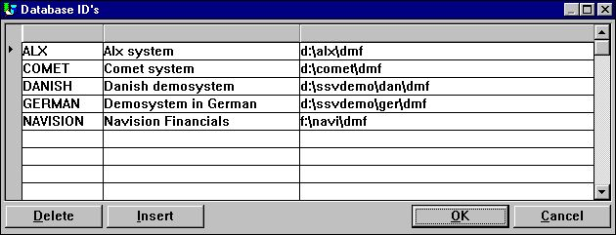

38. Maintenance of the database ID's
Note that the database ID is alphabetic and uppercase (A-Z) only, you cannot use digits or special characters.

6.4.1.2. The database window when BASID is activated
When more database ID's are present in the system these will show as menu items in the file menu for the database window:

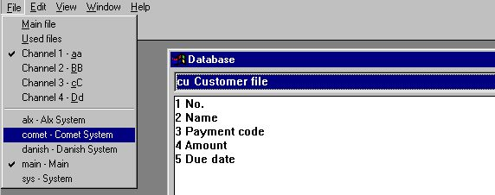

39. The database window file and database selection
When you select for example the COMET database, you will get this as:

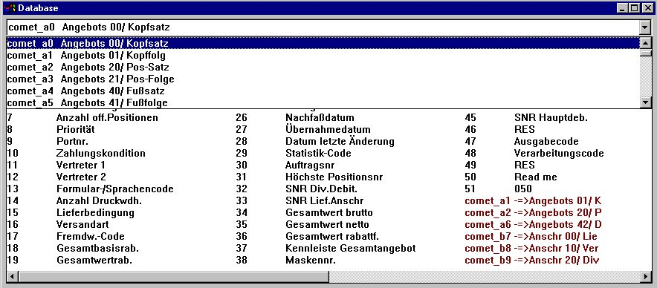

40. The file, field and connection selection in the database window

6.4.1.3. The fixed database ID's MAIN and SYS
TRIO will always add two ID's:
- MAIN
- SYS
MAIN you may use to return from a selected database to the original.
SYS is more for programmer's use, where special system fields may be added. This is also used internally by TRIO itself.

6.4.2. File connections spanning over different databases
In the FDF standard file connections may be defined to other database systems, as seen above in the database window the connected file is just stated as BASID_FILEID to get another database.

6.5. Datadictionary calculations / Stored procedures
Each file or field definition may be associated with one or more calculation blocks held in the datadictionary itself. These stored procedures are defined by:

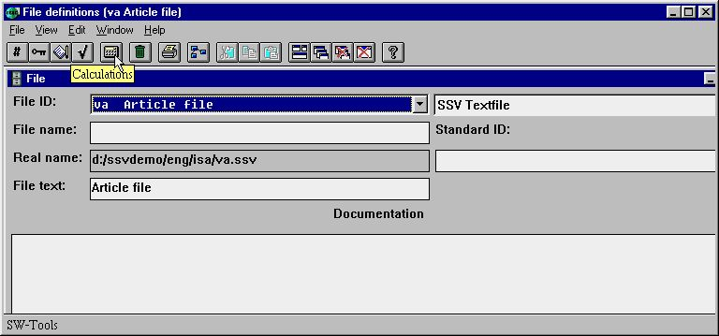

41. The new calculation icon in the data dictionary
Like the present IQ calculations, the calculation block name decides, when the specific calculations should be executed, e.g. by READ or by WRITE of the file.

42. Selecting where to calculate for a file definition
When the calculation block is selected, you may select a single field also:

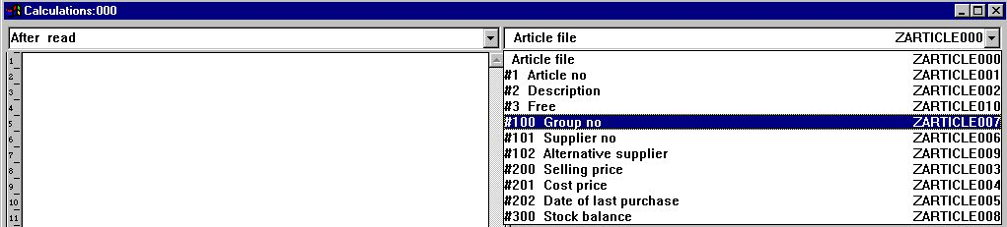

43. Selecting calculations for a single field or the complete file

6.6. User definable subfunctions
Common blocks of calculations may be defined as a subfunction like the function descriptions which come with TRIO in the files 00-99.
These files are made like normal file definitions, but may hold function definitions and documentation of internal TRIO functions and external DLL functions which may be made by other programmers.
From version 008 you may now also define your own set of functions as common calculations, which may be modified and parametered when loaded.

6.6.1. Selecting the function definitions
You reach the function definition files when the FDF programme is switched into the SYSTEM FILES mode:

44. Selecting the SYSTEM FILES mode in the FDF
which enables you to maintain / create file definitions starting with a digit, which is normally blocked in the FDF.
You should change/create filedefinitions in the range 50-59 only, thus avoiding conflict with this and future TRIO releases.

6.6.2. Creation of new functions
First the functions are created just as fields in the datadictionary, the fieldname becomes the function name and the field format states how the return value is given:

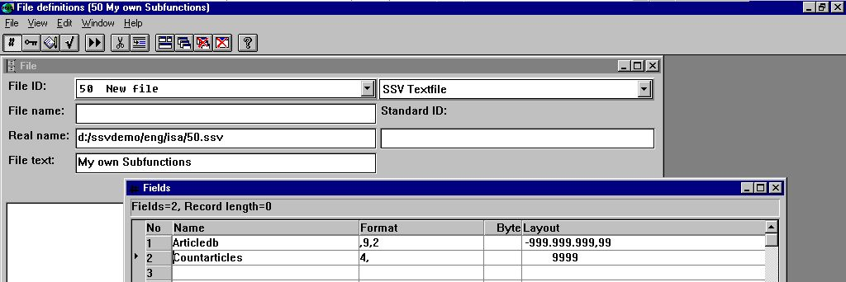

45. Creating new functions in the subfunction definition 50
The function- (field-) name must be plain alphabetic, no spaces or special characters is allowed. Upper/lowercase does not matter.
The calculations for the functions are then entered as the datadictionary field calculations:

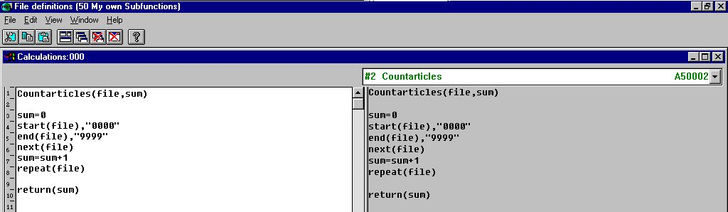

46. Entering the function calculation lines
The function is now installed and may be used in other datadictionary calculations or IQ as:

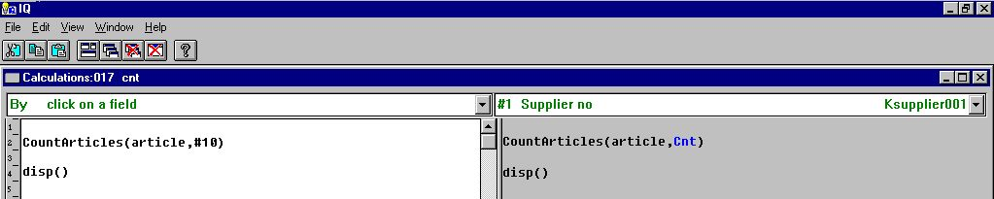

47. Using the homemade function

6.6.3. How it works
The first line of the function definition contains
functionname(par1,par2,...) .
When the function is to be calculated, the code is loaded into the program and any occurrence of par1 is replaced by the first given parameter, par2 with the next, and so on, whereafter the code is executed just as it was entered in the programme itself.
In the above example the first lines becomes by load:
#10=0
start(article),"0000"
end(article)
:
:

7. External packages and runtime licences

A package consisting of a set of TRIO programs may be made and licensed individually by a certified TRIO distributor.

7.1. Packages
A package consists of one ZIP file named ddddllll.zip containing all necessary files, dddd being the distributor number, llll a package number.
The ZIP file may contain report definitions, IQ programme definitions, file definitions, SSV files for parameters and pictures.

7.1.1. Package numbers
When the package number llll is in the range from 3000 to 3999, the ZIPfile will be crypted and can only be used by customers having a valid license for the product llll (3000-3999) issued by distributor dddd.
If llll is in the range 3000-3499 the license procedure for user ID registration is not necessary, 3500-3999 requires a final license to be issued for each PC user ID within 3 months just like the TRIO package.
If llll is any other number the ZIPfile is not crypted and usable by any TRIO customers with a full license, not just runtime, and the package does not have to be licensed separately.

7.2. TRIO Runtime licenses
TRIO may be delivered with a RUNTIME license, in which case it is not possible to create/amend programs at all, only start of premade programs within a licensed package is possible.
The FDF module will however be fully available also with just a runtime license, as the installation may require individual file setup.

7.3. Activating a package in TRIO
If a package 3002 is made by distributor 4003 the ZIP filename for this becomes 40033002.ZIP
This zipfile must be copied to the customer system, for example to the directory DEMO as \DEMO\40033002.ZIP
You may now set any report/IQ/FDF or database path in TRIO to point to this zipfile, either by a user homepath or creating a subsystem as shown:

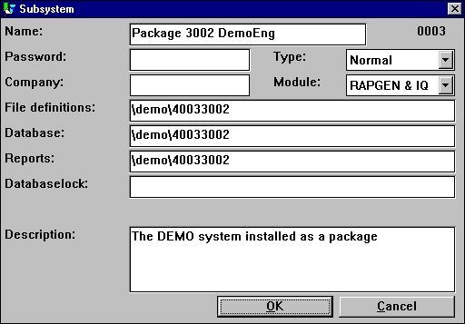

48. Setting up a package subsystem
Above the file definitions are also to be taken from the package. You may however set these to be taken from the customers own definitions outside the package just by changing the path.

7.3.1. How TRIO handles a package
TRIO will for the above subsystem try to open a file for, say report number 777, like \DEMO\40033002\dm1777.src. If this file is not present and the directory stated is 8 digits, TRIO will check if the package file \DEMO\40033002.ZIP is present. If so, the license is checked and the requested file is unzipped and encrypted from here without the user noticing this at all.
If the report is then amended and saved, the directory 40033002 will be created and the real file \DEMO\40033002\dm1777.src will be written. As the file is now present, all further access will go to the amended file and the original file in the package is ignored. The one programme has now been moved out from the package and modified for individual use.
This means by later upgrading with a new version of the programs inside the package by replacing the ZIPfile, all individual amendments will be kept unless such files are removed. Also the package may contain a set of standard file definitions. If any file on the customer requires individual setup, it will just be moved out from the package ZIPfile when modified.

7.3.1.1. Package licenses
The distributor 4003 may issue a RUNTIME (or READONLY, which is the same) license for the package, in which case only the start of the programs is possible, TRIO will never, as described above, allow amendments and move a programme out of the package. File definitions however may be amended.
The distributor 4003 may also choose to issue a FULL license. In this case the programs may be modified freely if the customer also has got a full TRIO license.
Note that package numbers 3000-3499 do not require user registrations. Maximum number is the same as for the TRIO license, 3500-3999 do, and all other numbers do not require a separate license at all and are always for full usage.

7.4. The license input program
A package license is considered completely separate from the TRIO license, and for this purpose the license programme has been extended with a menu for selection of distributor:

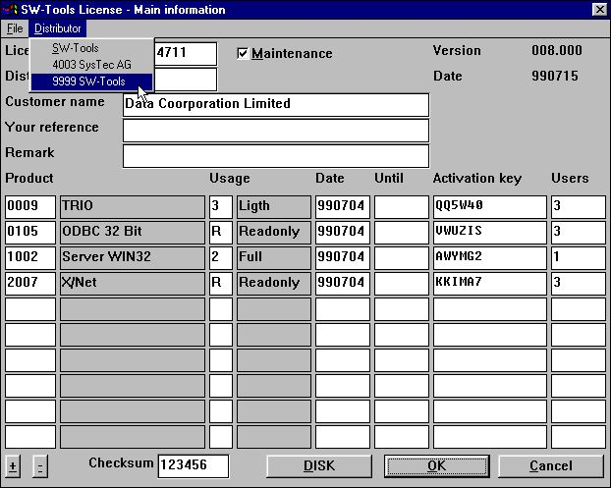

49. Selection of package distributor in the license program
The first menupoint SW-Tools will be present always for the TRIO license, the additional distributors are shown if a distributor license file is present.

7.4.1. The distributors license file
A distributor must identify each package with a package number and a name.
For TRIO itself the license programme takes this information from the file LICENSPR.ENG on the TRIO installation directory, ENG being the language suffix (ENG is also the default if the used language is not present)
The file LI4003PR.ENG must be made by the distributor 4003 and placed together with the LICENSPR.ENG file on the customer system before the package licenses can be entered. This file could contain:
SysTec AG
3001;Danish Package
3002;English Demosystem
3003;German Package
A002;Voll
A005;Runtime
A00R;Nur lesen
The first line being the distributor name to be displayed in the license program, followed by the package numbers and names, and finally the usage codes.

7.4.2. Entering the distributor license
When a distributor is selected the license from this may the be entered as:

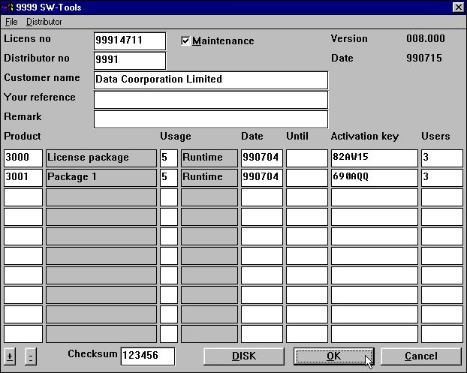

50. Two licensed packages from an external distributor

7.4.2.1. DISK input and output of license files
Like TRIO, it is possible to forward license files on disk. For distributor packages the .LIC and .PLS files will get the same name as for TRIO, but have a header line with the distributor number.
By DISK input of the .LIC file in the license programme the correct distributor will be selected automatically. The customer does not have to use the menu first.
By DISK output of the .PLS file this information must of course be forwarded to the correct distributor by the customer.

7.5. Preparing a package on the distributor site
The package should normally be contained as source in one complete TRIO subsystem so the thing to do is to zip the files together with the proper cryptation key and ship the zipfile.

7.5.1. The licensing package
A licensing package containing all necessary programs to enter and issue package licenses will be released for distributors, who needs to create their own packages.
This set of TRIO programs contains all elements necessary to enter and issue the distributor licenses together with the package helpprograms.

7.5.2. Making the package ZIP file
In the distributor license package there is a report for this, scanning through the input files and calling the ZIP functions, which will deliver the proper cryptation key for the package number.

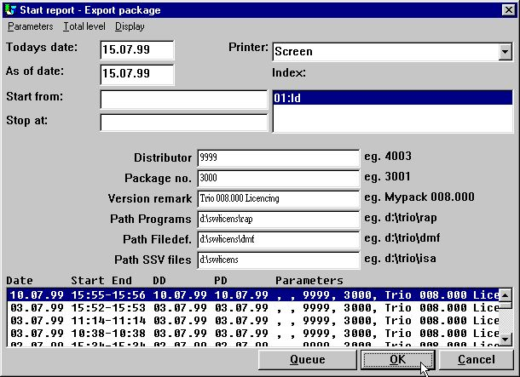

51. Starting the package report on distributor site

7.5.2.1. Contents of the package ZIP file
In the package ZIP file you may place any programme definition DMxxxx.SRC / IQxxxx.SRC, programme overviews DMREPORT.SSV / IQREPORT.SSV, file definitions xx.SSD and overview FILES.SSV.
Also, pictures such as LOGOs may be inserted.
For distributors making compiled reports, the DMxxxx.EXE compiled program may also be zipped, in which case the customer does not need a compiler to run this.

7.5.3. Issuing a license for the package
For the time being the license request must be forwarded to SW-Tools and the license registered here in a separate system until the license package programs are finally released and documented.
A distributor license with own logo may look like:

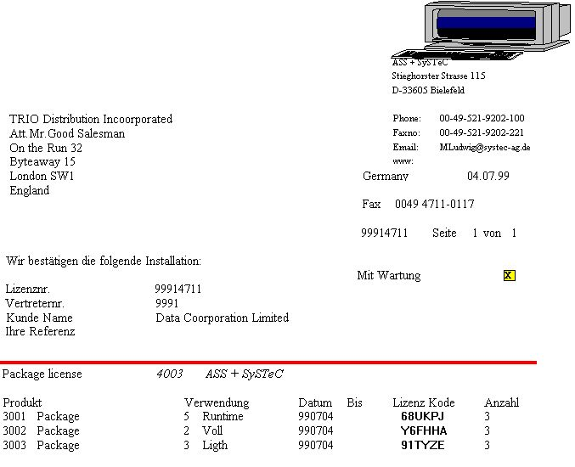

52. A printed distributor package license
The logo printed is taken from the dddd.WMF file, here 4003.WMF.
The signature printed is taken from the XX.BMP file, XX being the first 2 letters of the user name entered in the license for the current PC.

7.5.4. Copying the package to the customer side
You will have to place the following files on the customer system:
- ddddllll.ZIP The package ZIP file
- LIddddPR.ENG The distributor license file
- nnnnnnnn.LIC The customer license file if possible

8. Other amendments and enhancements

8.1. Limits
The following numbers, which previously have been a maximum 32.000 bytes, have been increased to 65.000 bytes on the 16 Bit, 2.000.000.000 on the 32 Bit version.
- Recordlength of a file
- Length of one single alpha field and (from,to) specification
- Number of fields in one group (Tablefields)
- Total size of a report definition (DM1001.src)

8.2. Memory and optimization
The memory usage allows access from external DLL functions both on the 16 bit and 32 bit version to TRIO internal structures.
In general the modules were previously optimized mostly with respect to the 16 bit versions, now optimizations goes toward the 32 bit versions.

8.3. SW-Tools ODBC Driver
The ODBC driver has been extended to support long fileIDs, datadictionary calculations, and also external package file definitions also.

8.4. UNIX server SWTUSOCK
The default startup of the Unix server now uses the -x option causing each client to get his own process, which highly improves both performance and stability. To avoid using the -x option you may use -X (uppercase) to turn it off.

8.4.1. LINUX server
A version of SWTUSOCK for LINUX is available.

8.5. Descending index definition
The D options on field in index definitions may be used for the SSV and BASIC drivers and will be threaded exactly as I (invert all bits)

8.6. EXPORT Append to file
If a + is added to the export filename (as c:/tmp/ud+), data will be appended to the file instead of overwriting the file.

8.7. Japanese kanji codetables
The Japanese kanji codetables has been tuned, thanks to SNI Japan.

8.8. Network pathnames
It is now possible to use network computer names in the pathnames as
\\computername\sharename\directory .

8.9. User administration
At the time of this documentation the full user administration has not been updated for long fileIDs, basisIDs and fieldnumber modifications.

9. Subfunctions

The wellknown ZIP and UNZIP functions for file compression have been built in and are the basis for PIP print archiving and, together with cryptation, separate licensed packages.
For printing, PIP and FORM has been added for archiving and forms.
GRID functions for list/combobox handling in IQ has been added.

9.1. The ZIP and UNZIP functions

9.1.1. UNZIP - Unpack files
Number UNZIP(Text par1, Text par2, Text par3, Number par4)

Par4: Max length of par 3

The UNZIP function takes input from a ZIP compressed file made with the ZIP function or another product like PKZIP or WINZIP.

where the available options are:
-d restore/create Directory structure stored in .ZIP file
-f Freshen files in destination directory
-n extract only Newer files
-o Overwrite previously existing files
-s[pwd] Decrypt with password

See also: ZIP
Example:
UNZIP("-d c:/tmp/zipfile")
UNZIP("d:/work/packfile","j:/tmp",#11,512)

9.1.2. ZIP - Zip file compression
Number ZIP(Text par1)

The ZIP function compresses one or more files into a zipfile, which may later be unpacked using the UNZIP functions or other programs like PKZIP or WINZIP.

where the available options are:
-a Add files
-b[drive] create temp zipfile on alternative drive
-c"comment" set comment for all files
-d Delete files
-e[x,n,f,s,0] use [eXtra|Normal (default)|Fast|Super fast|NO compression]
-f Freshen files
-i add files with archive Attribute set (don't turn attribute off)
-m[f,u] Move files [with Freshen | with Update]
-o set .ZIP file date to the latest file in .ZIP file
-p|P store Pathnames|p=recursed into|P=specified & recursed into
-q Quiet mode
-r Recurse subdirectories
-s[pwd] Scramble with password
-t[date] take files NEWER than or EQUAL to date (default=today)
-T[date] take files OLDER than date (default=today)
-u Update files
-w|W<h,s> include|exclude <Hidden, System> files (default=Whs)
-x<file> eXclude specified file
-z"comment" set .ZIP file header comment

See also: UNZIP,PIP
Example:
ZIP("d:/work/files*.*")

9.2. PRINT functions

9.2.1. PIP - Print archiving
PIP(Fields par1,Filename par2,Text par3)

Description: PIP enables you to control the print archiving for each report instead of for a printer in general.
Par1 should contain the fields to form the printindex file for search and display of printoverview, as invoice number, customer name or the like.
Par2 contains the print archive filename, first char must be a letter. If no path is given the database path from the preference setup is used. If only 4 characters or less is given, YYMM is added to the filename and the date is inserted as 2.field in the printindex file.
Par3 can normally be omitted, in which case the print archives all pages printed since the last PIP function call. You may however state:
* All pages printed
- No pages, Just add entry to the SSV printindex
1-3,7 These pages
0 Current (Last) page only

0=OK, x=Failed.
See also: PRINT,ZIP
Example:
PIP("#1-3","kept") /* Archive into keptYYMM with field 1-3 in printindex

9.2.2. SCRPRT - Recall screen print (IQ)
SCRPRT(Filename par1, Text par2^)

Description: SCRPRT("filename") calls up the screen printer with the saved print from filename. This may for example be used in IQ by click on a field.
For the PIP Print archiving SCRPRT("filename,PIPID") is used, causing all files with the given PIPID to be unpacked from the filename.zip archive.
The second parameter may be used to tune the display on screen, it consist of a textstring with 5 values separated by commas:
Par2: "a,b,c,d,e"
a: 1 = Start display on page 1
b: 1 = Display in window,
0 = Full screen
c: -1 = Zoom factor, zoom out once to reduce size
d: 4 = If given, print on myprt 4, close after this is done
e: 3-4 = If d given, page range to print these pages only may be set
Returnvalue: None.
See also: PRINT,PIP
Example:
SCRPRT("c:/w/ab.cde") /* Show this file using the screen printer
SCRPRT("c:/keepit/kept9908,7","1,1,-1") /* PIPID 7, page1 in window zoomed -1

9.2.3. PRINT - Print formula
PRINT(FORM=Text par1)
Parameters: Par1: Filename,WMF file for form

PRINT(FORM=c:/swtools/wmf/0101.wmf) defines a WMF picture file which will be used as background form when next page is printed.
Returnvalue: None.
See also: PRINT,PIP
Example:
PRINT(FORM=c:/swtools/wmf/0101.wmf) /* Select this form

9.2.4. PRINT(LAB= - Label function (RAP)
PRINT(LAB=Text par1, Text par2, Text par3, Text par4, Text par5, Text par6)

par6 : Copies
Description: The width and height of any label on the sheet can be given in centimetres or inches by using the following syntax:
7cm equals 7 centimetres
2in equals 2 inches
The below sample produces labels printed from left to right on a label sheet with 21 labels, 3 on each row, 7 rows, where each label has the width/height of 7 centimetres. Each label is printed in 2 copies.
Returnvalue: None.
See also: PRINT
Example:
FIRST
PRINT(LAB=1,3,7,7cm,7cm,2) /* Define label print
NORMAL

9.3. The GRID Functions for IQ

9.3.1. DGRID - Dialog Database Grid (IQ)
DGRID(text par1, text par2)

Description: This function may be used to generate a dialog of records from a selected table. The dialog will display the records according to an existing index and the fields requested. THIS FUNCTION CANNOT BE CANCELLED!
The syntax of the definition in par1 is:
A!B!C!D!E!F!G!H!I!J!K
where each parameter is separated by the character "!".
A - File id
B - Index
C - Fields to display
D - Column to return value from (Origin 0)
E - Dialog header
F - Selections (Optional - Refer to EXEC)
G - Reserved
H - Reserved
I - Reserved
J - Screen x position (optional)
K - Screen y position (optional)
Please note the returnvalue is set to origin 0 of the fields requested to be displayed. For example, if defined
va!1!1-6!0!Select an article
table va is opened using index 1 and display of fields 1-6. If a row is selected the returned value will be the value of display field 0, e.g. field 1 (Article number).
If defined
va!2!1,2,6!2!Select an article
table va is opened using index 2 and display of fields 1, 2 and 6. If a row is selected the returned value will be the value of display field 2, e.g. field 6 because
Display field 0 = field 1
Display field 1 = field 2
Display field 2 = field 6
If required to control which records are to be displayed, it may be required to perform selections. As TRIO already supports the command EXEC, it is possible to use a parameter F for this:
va!1!1-6!0!Articles in group 9!va#7==9
This will only include articles within article group 9.
Returnvalue: 0=Ok, row selected x=No row selected, Dialog closed
Example: DGRID("va!1!1-6!0!Select an article",#50) /* User may select an article

9.3.2. GRIDHDR - Set header for grid (IQ)
GRIDHDR(fields par1, fields par2, Bitflag par3)

32768 = Line pointer active
Description: The heading may be set by reference to fields whereas the field names will be used. For example,
va#1-6
will generate a heading as
Article no . Name . Selling price .......
The format of each field will determine if the column is left or right justified, but may be changed with an option after the field reference. Also, a field may be inserted into the grid without being displayed or scrolled. The following options may be used:
l - left justified
r - right justified
h - hidden
s - no scroll
i - no input
A definition such as
va#1s,2,6h,7l
will display field 1 as a no scroll field, field 2, field 6 will not be displayed and field 7 will be left justified.
Returnvalue: None.
See also: GRIDFLD
Example: GRIDHDR("#50","va#1-10") /* This defined the grid header as field 1-10 from the article table

9.3.3. GRIDFLD - Set fields values into grid row (IQ)
GRIDFLD(fields par1, fields par2, number par3)

par3 : Row number
Description: The function inserts the value of fields in par2 into the grid. Please remember manually to calculate the row number for par3 which starts from 0.
Returnvalue: None.
See also: GRIDHDR
Example: GRIDFLD("#50","va#1-10",0) /* Insert fields values in first row

Figure list
1. Start of TRIO 5
2. Start of TRIO when more users are activated 6
3. Start of TRIO with own logo activated 7
4. The reduced user menu 8
5. The reduced user maintenance screen 9
6. The language screen 11
7. The 16/32 bit screen 12
8. The product screen 13
9. Printout of manuals 14
10. The printer setup 16
11. Test button, CAVE before trusting printer 17
12. The advanced button in the printer setup 18
13. Start of a report showing the report statistics 27
14. Display of report details with the PIP id 28
15. A standard definition for a PIP file 31
16. Calculations for PIP print recall 32
17. The IQ programme for PIP print recall 33
18. Calculations in IQ programme for PIP print recall 34
19. Calculations for a PIP cleanup report 36
20. The preferences in the layout function 44
21. Picture displayed with or without maintainance of the aspect ratio 52
22. Keeping aspect ratio 52
23. View and sort options of the database window 55
24. Database window including field format 55
25. Entering the search criteria 56
26. The search result shown in the database window 56
27. Sample use of GRID 61
28. The GRID calculations 61
29. The GRID field in the layout 62
30. DGRID dialog 63
31. Scrollbar inserted in a IQ/DM form 64
32. The demo supplier file with long file ID 67
33. Amending the fieldnumbers in the datadictionary 68
34. The database window after fieldnumbers has been amended 68
35. Creating the FORMAT file with standard formats 70
36. The demo article file using standard formats 71
37. Selection of maintenance of the database ID's 74
38. Maintenance of the database ID's 74
39. The database window file and database selection 75
40. The file, field and connection selection in the database window 75
41. The new calculation icon in the data dictionary 78
42. Selecting where to calculate for a file definition 78
43. Selecting calculations for a single field or the complete file 79
44. Selecting the SYSTEM FILES mode in the FDF 81
45. Creating new functions in the subfunction definition 50 82
46. Entering the function calculation lines 82
47. Using the homemade function 82
48. Setting up a package subsystem 88
49. Selection of package distributor in the license program 91
50. Two licensed packages from an external distributor 93
51. Starting the package report on distributor site 97
52. A printed distributor package license 99

Index

A
Align 42
ALX 72
Animation 53
Autosize 41
B
BASID 73;75;77
BASIS 73
BMP 7;20;51;99
Button 18
C
Cleanup 36
D
Datadictionary 3;68;69;78
DATAMASTER 65
Device 51
DISP 53
DLL 80;103
Driver 104
E
EXEC 122
EXPORT 108
F
FDF 68;74;77;81;87;88;125
G
GIF 3;20;51
H
HELP 59
I
Installation 3;11
IQ 3;26;31;32;33;34;53;60;63;64;78;82;85;88;112;118;121;122;123;124;125
J
JPG 20;51
L
LINUX 106
Locking 37
O
ODBC 104
OLE 29
P
Package 86;90;92
Picture 52;125
PIP 3;13;23;24;25;28;29;31;32;33;34;35;36;37;112;115;117;118;119;125
Preferences 44
PRINT 21;116;117;118;119;120
Printindex 30
R
Recordlength 102
Runtime 3;87;92
S
Scaling 52
Search 3;56
SQL 55
SSV 26;30;37;73;85;98;107;117
SUPER 10
SUPERINDEX 34
SWTUSOCK 105;106
T
TRIO 1;3;4;5;6;7;13;15;19;27;29;41;51;67;76;80;81;84;86;87;88;89;90;91;92;94;95;96;103;122;125
U
UNIX 105
UNZIP 3;112;113;114;115
User 3;6;8;80;111;122
V
VIEW 13;24;25
W
WRITE 78
Z
ZIP 3;29;36;37;85;88;89;97;98;100;112;113;114;115;117

