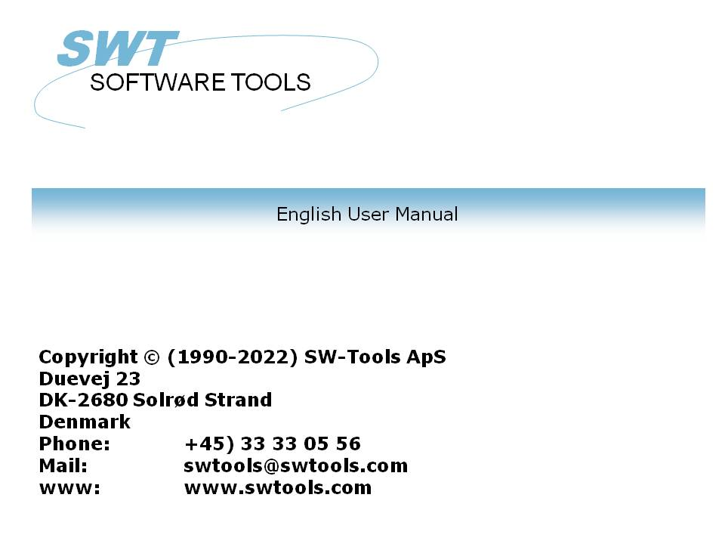

TRIO Release Information (006.000)

22/11/01 / 2022-09-01 008.384

Contents
Contents 2
1. Overview 6
1.1. New functionality 7
1.1.1. RAPGEN Report generator 8
1.1.2. FDF Data dictionary 9
1.1.3. IQ Inquiry system 10
1.1.4. DATAMASTER Database system 11
1.1.5. SW-Tools ODBC driver 12
1.1.6. LICENSE system 13
1.1.7. Installation 14
1.2. Error corrections 15
1.2.1. RAPGEN Report generator 16
1.2.2. IQ Inquiry system 17
1.2.3. DATAMASTER Database system 18
1.2.4. SW-Tools ODBC driver 19
2. RAPGEN extensions 20
2.1. Start report 21
2.1.1. Printer selection 22
2.1.1.1. Defining a new printer 23
2.1.1.2. The default documentation font 24
2.1.1.3. Printing on an UNIX printer 25
2.1.1.4. Margins and page size 26
2.1.1.5. Screen printer 27
2.1.1.6. Fit page to width 28
2.1.1.7. Close report when finished 29
2.1.2. Screen printer 30
2.1.3. Reverse sortorder 31
2.1.4. Sort cancel and speed increase 32
2.2. KEYS edit function 33
2.3. Edit Search/Replace, Copy/Paste 34
2.4. Report information 35
2.5. Manuals online as helpfiles 00-08 36
2.6. FREE field definitions 37
2.7. Printer control in the calculations 38
2.7.1. #LIN linenumber and #LOF lines on form 39
2.7.2. PRINT(xx=yy) and PRINT(?=yy) 40
2.7.3. PRINTER(2) 41
2.7.4. COPIES(2) and different PRINTERs 42
2.8. Sorting descending 43
2.9. Basic like calculations 44
2.9.1. T2$,S9$ and other Basic variables 45
2.9.2. SIZE, DELAY dummy functions 46
2.10. Group totals 47
2.11. RAPGEN Start parameters 48
2.12. Standard reports 49
2.13. Implicit READ of files and SPEED 50
2.14. Building files with LET 51
3. FDF extensions 52
3.1. Preferences 53
3.2. Import ODBC definitions 54
3.3. Codetables 55
3.3.1. Codetable numbers 56
3.3.2. The SORT codetable 57
3.3.3. Contents of the codetables 58
3.4. Company filename search 59
3.4.1. DOS filenames for BASIC files 60
3.5. Amending DATAMASTER files using the FDF module 61
3.5.1. DATAMASTER file conversion from BASIC to ODBC 62
3.6. File connections 63
3.7. ODBC driver setup 64
3.7.1. Application type 65
3.8. Format ,6,0 amount editing 66
3.9. Record overview Control record and Error messages 67
3.10. Print options menu 68
3.10.1. Printing table of contents 69
3.11. FDF Start parameters 70
3.12. New BCD packtypes 71
3.13. Multiple constants in index definitions 72
3.14. X* Fixed parameter file connections 73
3.15. System files 74
4. IQ Extensions 75
4.1. Defining a new program options 76
4.2. Amending a program without file access 77
4.3. Search strategy improved 78
4.3.1. Interrupting SUPERINDEX 79
4.4. Help and check on fields 80
4.4.1. Field documentation 81
4.4.2. Valid values 82
4.5. Layout editing 83
4.5.1. Part of fields and tablefields 84
4.5.2. Blocks of lines 85
4.5.3. Field options on right mouse button 86
4.5.3.1. Box sizing and field flags 87
4.5.3.2. Object type and attributes 88
4.6. DEBUG in the calculations 89
4.7. Calculation areas 90
4.7.1. Before DISPLAY of a field 91
4.7.2. OWN routines 92
4.7.3. Before TRANSMIT to other programs 93
4.7.4. By select of a FUNCTION 94
4.7.4.1. DOFUNCTION messages 95
4.7.5. By read of mainfile 96
4.8. Interprogram communication 97
4.8.1. Program number 98
4.8.2. Fields from other programs 99
4.8.3. GOSUB common subroutines 100
4.8.4. GLOBAL variables A1,A2,... 101
4.9. IQ Start parameters 102
4.10. Standard programs 103
4.11. Hardcopy function 104
5. DATAMASTER Extensions 105
5.1. OK/CANCEL buttons 106
5.1.1. Button shortcuts 107
5.2. Calculations areas 108
5.2.1. By change of input sequence 109
5.2.1.1. Specifying the input sequences 110
6. SW-Tools ODBC driver 111
6.1. WRITE released 112
6.2. W95B setup 113
7. Unix Server updates 114
8. The LICENSE module 115
9. Installation 116
10. Function description 117
10.1. New system fields 118
10.1.1. #UN User name 119
10.1.2. #LIN linenumber and #LOF lines on form 120
10.1.3. #IQxxxx IQ system fields 121
10.2. New or extended functions 122
10.2.1. ACCESS("filename") - Check if file exists 123
10.2.2. CHAIN("program","key") - Chain program or external command 124
10.2.3. CHAINR(report) - Chain program or external command directly 125
10.2.4. CLRFLAG("fields",option,type) - Set options for fields 126
10.2.5. COPIES(n,printer) Number of print copies 127
10.2.6. DEBUG(mode) - Switch on debug window 128
10.2.7. DELAY() - Dummy function for BASIC compatibility 129
10.2.8. DISABLE(program) - Disable input for a program 130
10.2.9. DISP("Fields") - Refresh screen display 131
10.2.10. DOFUNCTION(functionno,"key",program) - Execute external function 132
10.2.11. ENABLE(program) - Enable input for a program 133
10.2.12. EXEC("expression",program) - Execute text as calculation line 134
10.2.13. EXPORT("CLOSE") - Close export file 135
10.2.14. EXIT(program) - Close program or window 136
10.2.15. FOCUS(program) - Activate program 137
10.2.16. GETFLAG("fields",option,type) - Get options for fields 138
10.2.17. GETFLD("Field") 139
10.2.18. HELP("field") - Display box with help for field 140
10.2.19. INDEX(indexnumber) - Lock index on report 141
10.2.20. INSTALL("xxxxxx.dll","funcname","3,[sCCC]","myname") External functions 142
10.2.21. ISACTIVE(program) - Ask if program is active 143
10.2.22. KEYON(0/1) - Switch key input field ON/OFF 144
10.2.23. LET (Fields=...) - Assign values to fields 145
10.2.24. LET (id=fields) Creating new files 146
10.2.25. NEXTFLD("field") - Jump to input field 147
10.2.26. NEXTFLDSEQ(sequence,fieldnumber) - Jump to input field in sequence 148
10.2.27. MENUCH("menunumbers") - Flip menu checked flag 149
10.2.28. MENUUPD(menuno,function,"&text") - Add/Control menu 150
10.2.29. OBJECTADDSTRING (field,text,key) - Add string to object 151
10.2.30. OBJECTCLEAR (fields) - Clear contents of object 152
10.2.31. OPEN("id","-") - Temporary close of files 153
10.2.32. PLSNEXT(mode,"key",inputflag) - Prepare and read mainfile 154
10.2.33. PRINT (#11) - Print lines 155
10.2.34. PRINT (options=value) - Print output control 156
10.2.35. PRINT (?=option) - Printer characteristics inquiry 157
10.2.36. PRINT (>n) switching to second printer 158
10.2.37. PRINTER (printerno) - Printer selection 159
10.2.38. PRINTER (n,printerid) multiple printer output 160
10.2.39. SPEED() - Optimizing read strategi 161
10.2.40. SUPER(file),key - Prepare superindex search 162
10.2.41. SETFLAG("fields",option,type) - Set options for fields 163
10.2.42. TRANSMIT(prio,progid,connection) - Update other IQ program 164
10.2.43. TRANSSEL("input",inputflag) - Define IQ transaction selections 165
10.2.44. UPDATE(mode,"Fields") - Allow update on files 166
10.2.45. VALID(number,"Values",mode) - Valid values 167
10.2.46. WAIT(program) - Wait for program to finish 168
10.2.47. WIF("text") Testprint of text 169
10.2.48. WIFS("fields") Testprint of fields 170
Figure list 171
Index 172

1. Overview

This manual describes modifications from release (005.xxx) to (006.xxx) of the SW-Tools TRIO RAPGEN,IQ and DATAMASTER products.
This script will be translated and included into the next release of the manuals for the single products after the final release.

1.1. New functionality

1.1.1. RAPGEN Report generator
- Improved help for functions and manual reference
- Printer setup selection of font / scaling implemented
- Printer setup is stored in a file and can be reselected
- PRINT command in RAPGEN extended with margin/font settings
- Edit of calculations, Search/Replace functions added
- Standard program now accessible to the user in RAPGEN/IQ and DM
- SORT heavily optimised and CANCEL function added
- KEYS files can now be edited without use of external editor
- EXEC function to execute a calculation in a textfield
- Automatic READ of files if not given as calculation
- LET(xx= file definition
- COPIES and PRINTER functions for multiprint handling
- INSTALL function for external DLL functions
- SPEED optimize control of READ

1.1.2. FDF Data dictionary
- Codetable structure improved
- Database interface installation dialogues extended
- Automatic file lu search on BASIC files
- Error messages from database interfaces improved
- Open-Basic filesystem now supported
- SYStem file definitions released
- Multiconstant index definitions using "20,22-29,40"
- X* fixed connections to parameterfiles
- Crossconsult ISAM BCD packing now supported
- SQL access reading ODBC databases optimized
- Owner structure of Informix/Oracle database improved

1.1.3. IQ Inquiry system
- CANCEL of superindex or other searching by ESC now possible
- Calculation entries by selection of menu functions
- Calculation entries for control of reading mainfile
- Calculation entries for control of transmitting/receiving records
- Functions for intertask program communication
- Install function for communication with external DLL functions
- Layout, blocks of fields can now be moved/sized
- System fields for programming access implemented
- Hardcopy now delivers a bitmap picture instead of textprint

1.1.4. DATAMASTER Database system
- OK/CANCEL buttons added to datamaster programs
- Shortcuts for workfield buttons (&OK) may be defined
- Definition of individual (workfield) help and check

1.1.5. SW-Tools ODBC driver
- WRITE has been released
- W95B use of ODBC 3.0 installation in Office 97 supported

1.1.6. LICENSE system
- Email transfer errors of license codes are handled better
- Will now be supported in different languages

1.1.7. Installation
- 4 disk are now used for the TRIO products
- Checkboxes for which products to installed is placed up front in the installation

1.2. Error corrections

1.2.1. RAPGEN Report generator
- Printing on high resolution printers (>=600 dpi) could drop lines
- LET function on workfields did not address the fields correctly
- READ(xx.00),#45,N Relative recordnumber read did not calculate correct
- PRINT required an non-empty calculation line to follow
- SELECTIONs on maximum 0 did not work
- SORT, codetable implemented
- LAST - PRINT produced an empty page due to GRANDE TOTAL newpage
- TOTALS, Subtotals without GRANDE total now working
- TOTALS, 4, fields now being totalled
- TOTALS, Subtotal levels with more keyparts now ok
- Created/Modified date, MM/DD was turned around
- Concurrent start of sorted reports now possible
- NEXT/REPEAT failed for the fileid IF and OR

1.2.2. IQ Inquiry system
- Windows NT, IQ input field failed
- READ(xx.00),#45,N Relative recordnumber read did not calculate correct
- Relative recordnumber connections could not be used between different IQ windows

1.2.3. DATAMASTER Database system
- Date validations could fail

1.2.4. SW-Tools ODBC driver
- WHERE selection on recordnumber could read thru all file if small recordnumber given
- Amendment for MS-Word which does not split SQL lines with correct syntax
- SELECT name,balance+3 ORDER BY 2 DESC
Ascending sort was always performed if sortitem was calculated

2. RAPGEN extensions

2.1. Start report
The printer selection has been reworked and reverse sort order added:

2.1.1. Printer selection
The PRINTER field has been changed to a listbox from which you may select one of the printers defined in the system.
When you use the PRINTER SETUP menu the printer definitions will be stored into a file (MYPRT.SSV) so you do not have to setup the same parameters each time the specific printer should be used.

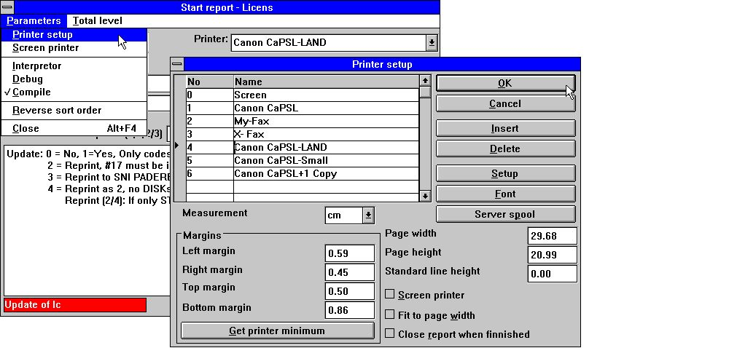

1. Printer setup
The list shows the printers defined and you may select a line by click on this. Then use the SETUP button to change the printer settings.

2.1.1.1. Defining a new printer
A new printer is defined just by selecting an empty line. The printer NAME may be modified to any text you want. You may use INSERT to insert printers inbetween and the DELETE button to get rid of old printers.

2.1.1.2. The default documentation font
The FONT button may be used to set a default font for print of report documentation. Note that this default font has no influence on the print output from a running report.

2.1.1.3. Printing on an UNIX printer
The SERVER SPOOL button may be used to redirect the print from a local Windows printer to the UNIX spoolsystem. Note that Windows must know the printertype of the unix printer to get the controlcharacters correct.

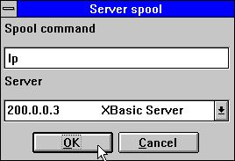

2. Server spool
In the listbox of servers you get all servers known by the file definitions (basis) file. The printfile made from Windows with control characters will be send to this server and the unix spool command stated will be issued.

2.1.1.4. Margins and page size
You may adjust the printer margins and page size. The measurement box defines your input as cm, inch, lines or pitch. The absolute printer minimum settings is taken by click on the minimum button.

2.1.1.5. Screen printer
Checking this box sends the output to the screen printer.

2.1.1.6. Fit page to width
Checking this box will reduce the font size on reports being to wide to fit on the paper to a smaller font. Other reports will remain unchanged.

2.1.1.7. Close report when finished
If you check this box you do not have to press the OK button when printout is finished.

2.1.2. Screen printer
The screen printer input of pageno has been slightly changed as CR. is required after pagenumber is entered. You may use PgDw and PgUp to go to next/previous page and the down/up-arrows to scroll within a page, HOME/END to go to top/bottom on a page.
When you select PRINT from the file menu multiple pages may be printed.

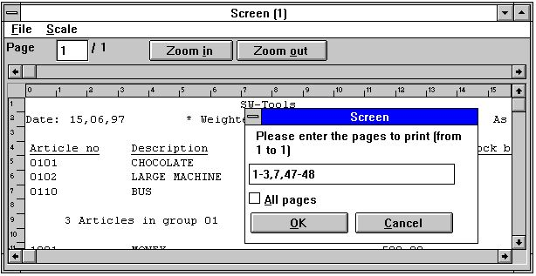

3. Screen print

2.1.3. Reverse sortorder
On the startmenu you have the possibility to reverse the order of the printout.
This works on all sorted reports and on unsorted reports if the database interface supports descending read (It is not on CTRAS defined files).
Note that reverse sortorder may also be stated in the calculations as INDEX(-1)

2.1.4. Sort cancel and speed increase
During the sort you now have the possibility to press the CANCEL button. The sort speed has been serious improved.

2.2. KEYS edit function
An edit function has been added to the file menu to maintain the KEYS files which before had to be entered using another editor like notepad.

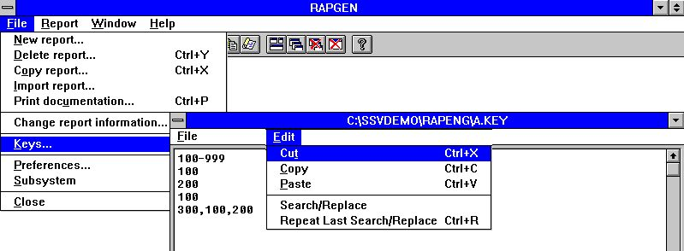

4. Keys file editor

2.3. Edit Search/Replace, Copy/Paste
In the edit functions for calculations, keys etc. you have now got the possibility to search and eventually replace a textstring.

5. Searching / Replacing a string

2.4. Report information
When editing the report informations the used files, including the main file, may be changed by click on the FILES button.

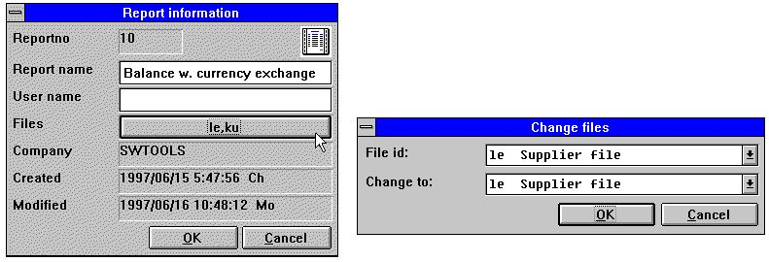

6. Report information
Note that the USER NAME has been added after the created/modified date. This username origins from your input in the LICENSE user remark for this PC and may also be used in the calculations as #UN
Unfortunately in some older versions the DATE created/modified was not always turned correctly. This is now corrected but may still influence the display for previous created reports as DD/MM is reversed.

2.5. Manuals online as helpfiles 00-08
To get quick access to the manuals these are now also places as 'pseudofiles' in the database window which you hove on screen whenever a report is defined. The normal datadictionary structure is used for these files which means they comes as small textfiles which can be online even if you do not have space for the complete Windows HLP manuals. The following are available:
00 = Calculations and subfunctions
01 = Report generator manual
02 = IQ manual
03 = DATAMASTER manual
04 = Data dictionary
05 = SW-Tools ODBC driver
06 = License
07 = Installation notes
08 = Release information

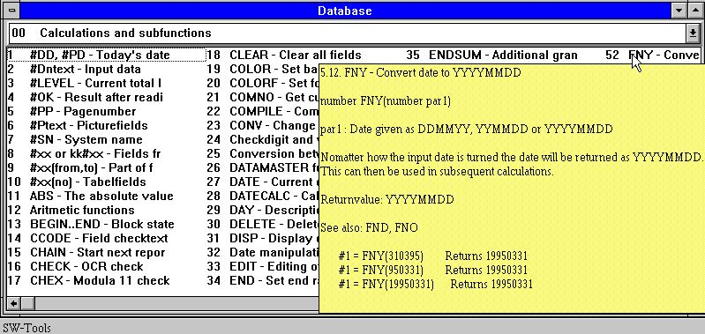

7. Function help
The sections of the manuals will appear as fields sorted by name. When you move the cursor over a field the corresponding help pops up immediately. Only the text is shown, the figures will be omitted, but if the Windows HLP manual is online you may doubleclick on a field to open this.

2.6. FREE field definitions
Defining start INPUT fields and PICTURE fields required the field name to be entered as #D1name or #Pname which could be a little confusing.
Instead you may now select the input fieldnumber from a listbox or just mark the picture checkbox.

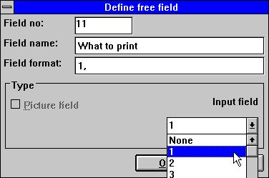

8. Defining input data or picture fields

2.7. Printer control in the calculations

2.7.1. #LIN linenumber and #LOF lines on form
The new system field #LIN may be used in the calculations especially compared to the value in #LOF lines on form as e.g.
IF #LIN>#LOF-5 THEN PRINT(:1,1-4) /* Force newpage

2.7.2. PRINT(xx=yy) and PRINT(?=yy)
You may retrieve detailed printer information using the PRINT function, see the function description.

2.7.3. PRINTER(2)
You may lock the report to a printer defined in the print setup, see above.

2.7.4. COPIES(2) and different PRINTERs
The COPIES function may now be used to produce additional copies of the printout even on different printers and the PRINTER function to produce simultanius lists on same or different printer.
You should note that the space on TEMP directory must be sufficient to hold the number of printouts you specify in the same time.

2.8. Sorting descending
When defining SORT you may now select ASCending or DESCending from the menu.

2.9. Basic like calculations
To ease conversion from VIEW reports some additional system fields has been defined:

2.9.1. T2$,S9$ and other Basic variables
The following basic variables may be used, see VIEW manual.
T1$,T2$,T9$,S9$,R$,R4,T1,T3,P2,X2,X,P6,P8,X0,R1$,R2$
However R$=key has only got a contents after GETKEY function is used.

2.9.2. SIZE, DELAY dummy functions
(RAP) These functions does not perform anything but may be entered.

2.10. Group totals
When defining GROUP totals the number of codes in a group was not at all used as the group was always extended dynamically.

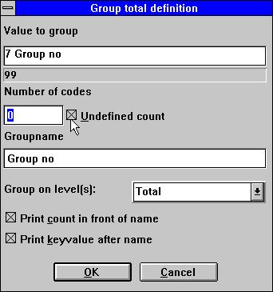

9. Group totals
Now if 100 is entered 100 groups elements only are formed. Enter 0 if the group should expand dynamically without limit.

2.11. RAPGEN Start parameters
RAPGEN may be selected from WINDOWS using the following parameters:
RAPWIN ssppp Start program ppp in subsystem ss
RAPWIN -r=ssppp As above
RAPWIN -e Exit when report has been executed
RAPWIN -nl No Logo by start, Runtime only.
Programs cannot be defined or changed
RAPWIN -ok Do display startscreen before start
RAPWIN -s7;310397;;0001;9999;... Set start parameters
7 = Printer number 7
310397 = Todays date
= As of date as default
0001 = Start key
9999 = End key
...= User defined data input
RAPWIN $ Wait until this report is executed

2.12. Standard reports
When defining a new report or a new letter RAPGEN uses a standard report as basis for this. Now you are able to amend these standards yourself for example to define a different standard heading.
First you should setup a STANDARD subsystem as shown below and open this which gives you the available standard reports:

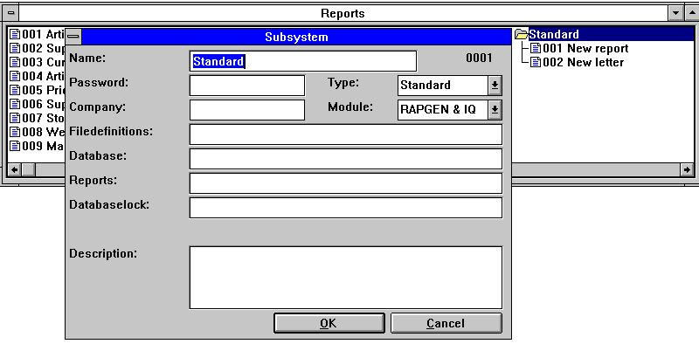

10. Setting up the STANDARD subsystem
The standard reports which comes with TRIO looks like:

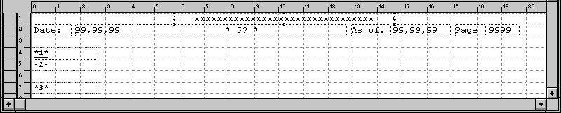

11. The standard report
The ?? will be replaced with the report heading.
The fields *1*, *2* and *3* defines the standard font and colour used for heading, fields and totals.
NOTE: If you reinstall or upgrade TRIO the standard reports must be adjusted again !
The standard reports are kept as DM1001.eng and DM1002.eng on the TRIO program directory.

2.13. Implicit READ of files and SPEED
When a field from file xx is referenced RAPGEN will now itself make a READ(xx) if the user do not place this in the calculations and an automatic connection to the file is present.
The SPEED() function may be used to optimize the read strategi on a report as a record will not be read again when the same key is given but taken from memory. You should be carefull with this on updating reports.

2.14. Building files with LET
The LET function may be used to build new files quickly based on any field in a report, calculated or from external files.
You must have a DATAMASTER license to use this function as the files are defined as DATAMASTER files and the database drivers must be installed with write access.
DATAMASTER files only can be modified this way as file data will be lost when the file is redefined. However once defined you can use all the DATAMASTER functions for extending / redefining the file.
LET (AA=#1-3) produces instantly a new file definition for the file AA with the given fields which you can see in the database field window.
If the file AA is already present you will be asked if the old definition should be overwritten. If so
A NEW EMPTY FILE WILL BE CREATED, DATA IS NOT KEPT OR CONVERTED !
The file will be created with the first field as unique key unless you state one of the key options as LET(AA=#1K,2-3,4D) or LET(AA=#1-4;2) see the examples in the function reference below.
You may state the number of records if needed and the database type after the LET(..), if not given the default is 1000 records using the first database interface which are normally the SSV driver.
LET (AA=#1-3),200 XWrt
gives you 200 records in a X-Basic file. The driver name XWRT is looked up between the driver names you have given in the BASIS file by the FDF installation.
The file itself will not be created until the report is started. If you state a negative number of records as LET (AA=#1-3),-100 the file will be new created by each start of the report.
The following will define a new access file and fill it with data:
UPDATE(1) /* Activate updating
NOPAS()
LET(AA=#1-3,15,le#1-3) access
AFTER /* After selections is done
INSERT(AA) /* Make a new record in AA

3. FDF extensions

3.1. Preferences
The path for BASIS.SSV has been added to the preference setup.

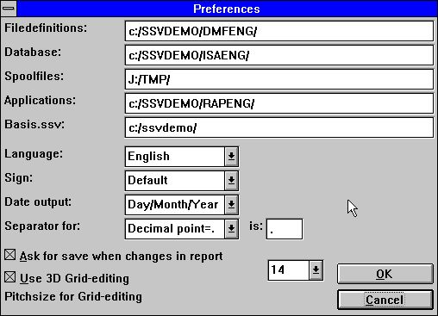

12. Preferences

3.2. Import ODBC definitions
Progress is shown and you have the possibility to cancel the job.

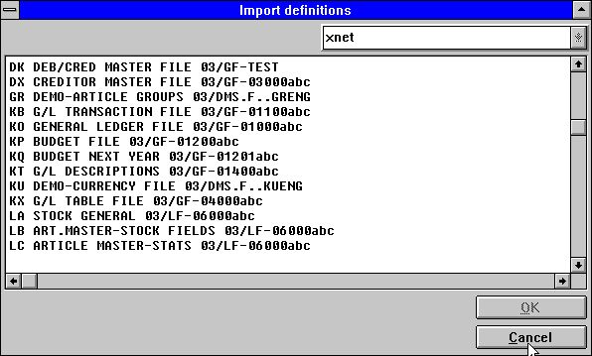

13. Import ODBC definitions
Error messages during file load will also be shown in this window.

3.3. Codetables
Up to now the BASIC string data was first masked for parity and then passed through the selected code table. This caused troubles with some special characters defined in the BASIC codetables without parity.
From version (006.xxx) the parity is included in the codetables itself and the buildin tables avoided if possible. This means the tables 1 and 2 (Danish and German buildin) now automatically uses the tables 045 and 049.

3.3.1. Codetable numbers
The codetables has been named using the country code numbers.
001 Danish UNIX Buildin
002 German UNIX Buildin
003 ODBC OemToAnsi Buildin
004 Parity plain 1:1 Buildin
010 ISO8850
011 DATAFLEX index
012 EBCDIC
013 ODBC OemToAnsi
044 English Basic parity
045 Danish Basic parity
046 Swedish Basic parity
049 German Basic parity
099 Sort multilingual

3.3.2. The SORT codetable
Sorting using RAPGEN or the SW-Tools ODBC driver now uses the SORT codetable to sort language specific characters correctly (äü last) and accents together with the appropriate character.

3.3.3. Contents of the codetables
If a character should not be converted it may be left blank in the codetable which gives a much better overview:

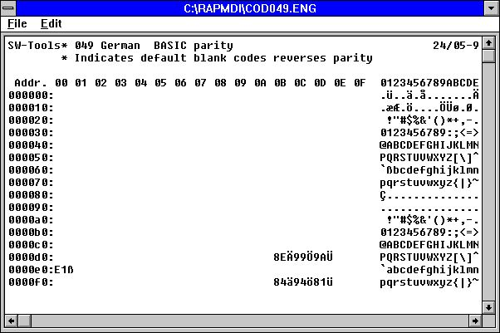

14. Codetable for reading BASIC files
To obtain this for BASIC codetables also an * mark just after SW-Tools in the first line reverses parity for all characters. The real character may be stated as a remark after the hexadecimal code or the hexadecimal code may itself be replaced with the character.

3.4. Company filename search
When installing different company on BASIC systems you have the possibility to search all LU's for the files by pressing the SEARCH button:

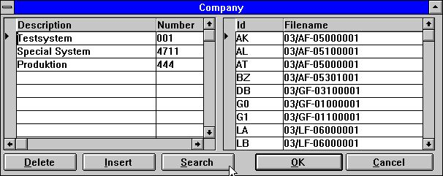

15. Company file search
All BASIC files entered as 2-digit lu + filename, e.g. 90/GF-03000abc, will be checked if present on lu 00-99 in the selected company. When found and if the lu differs from the stated lu the file is inserted in the company filename table.
NOTE: Server version (006.003) minimum is required for this function.

3.4.1. DOS filenames for BASIC files
Working offline the server with X-Basic systems causes problems with the length of the filenames. It is now defined that if a basic file is not found on a DOS system a filename will be made as
1. All points are removed
2. If more than 8 characters a point is placed after position 8
3. The name is cut down to 8.3 characters
This enables you to have a server file GF-03000001 local as GF-03000.001

3.5. Amending DATAMASTER files using the FDF module
When you amend a DATAMASTER file using the FDF module the file itself may be kept unchanged while the definition is changed (careful!) as you are asked:

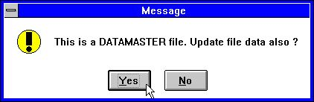

16. Confirmation of DATAMASTER file copy

3.5.1. DATAMASTER file conversion from BASIC to ODBC
When a BASIC file is copied to ODBC using DATAMASTER the informations of Packtype, Bytenumbers and Stopcharacter will now be removed as these would have bad influence on the resulting ODBC table.

3.6. File connections
Unfortunately the file connection using BASIC relative record number direct read had failed is previous versions (AS->JH.00 using #45,N)
File connections dependent on the key length #3(1,-2) has been implemented, #3(1,-2) meaning field 3 from character 1 to the keylength-2 characters.

3.7. ODBC driver setup
As some ODBC drivers are requiring special information which cannot be retrieved or trusted from the driver itself the ADVANCED setup for ODBC drivers has been extended with the following:

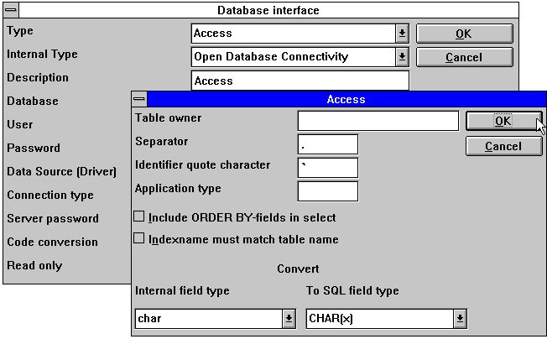

17. Setting up an ODBC driver
You should refer to the actual documentation for your driver before changing these fields.

3.7.1. Application type
The application type defines special use of items in an application package. For the time being the following are available:
1 ALX using table owner as company
2 SAMSON using first part of index as company

3.8. Format ,6,0 amount editing
The layout of date fields ,6, and ,8, did block for amount fields edited by 1000 points with length 6 or 8. These may now be defined using ,6,0 or ,8,0

3.9. Record overview Control record and Error messages
When displaying records from a BASIC file the control record will now be show in the FDF module as data from this may be defined.

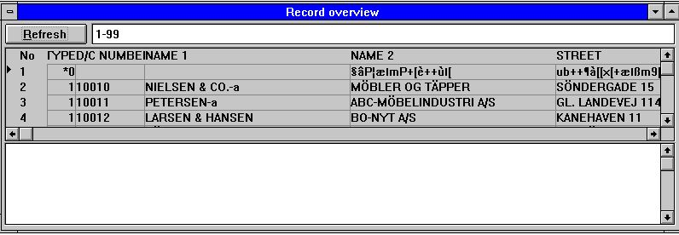

18. Record overview
A subwindow is now shown which will contain eventual error messages during open or read.

3.10. Print options menu
The print options menu has been changed to an input dialogue as the functionality grows:

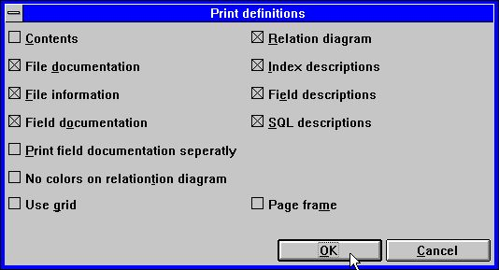

19. The print options menu

3.10.1. Printing table of contents
You may now get a table of contents printed together with the file definitions.

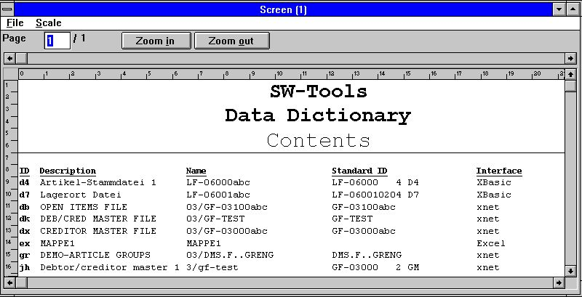

20. Table of contents

3.11. FDF Start parameters
The FDF module may be selected from WINDOWS using the following parameters:
RAPFDF -d Files will be defined as DATAMASTER files
RAPFDF -d7 Datamaster default filetype will be no.7

3.12. New BCD packtypes
The following packtypes has been implemented:
P1201 = Sign + Exponent + 1 BCD digit
P1202 = Sign + Exponent + 2 BCD digits (1 byte)
:
P1219 = Sign + Exponent + 19 BCD digits
P1201-P1219 = Sign + Exponent + 1-19 BCD digits (Crossconsult)
P1221-P1239 = 1-19 BCD digits + Exponent + Sign
P1241-P1259 = 1-19 BCD digits without any sign or exponent

3.13. Multiple constants in index definitions
Files defined with fixed constant recordstypes in index as "00",#1,P may now be extended to "00,20-29,40",#1,P
The selection will then retreive all records with one of these constants.

3.14. X* Fixed parameter file connections
A parameter file which should read a fixed record always may now define a connection which are used by all READ(pa) when no other connection is given.
Definition may be done as a connection from PA to file X* index 0 recordnumber 5

3.15. System files
The menu subsystem contains an entry system files in all products. When you from a selected subsystem switches to the system files the file definitions for among others basis.ssv and files.ssv is avaiable and reports / IQ programs can be made on these.

4. IQ Extensions

4.1. Defining a new program options
Together with the fields when defining an IQ program the following new options may be used:
va#1-7,c=0 Set check flag
0 = No check, just display field
1 = Combobox
2 = Display field check as text
3 = Display field value + checktext

va#1-7l,n=10 Limit fieldnames to max 10 characters

4.2. Amending a program without file access
When IQ cannot open all files properly you now may now continue after the error message by choosing Yes below:

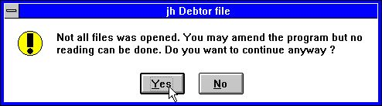

21. Not all files could be opened in an IQ program

4.3. Search strategy improved
The IQ searching has been improved on the following points:
A leading blank is now allowed in a searchkey
Quotes ".." may be given around a searchkey to allow trailing blanks
If a matchcode is entered but no found with match on this code, IQ will shift to the matchcode index anyway.
If no records are found after input, CR will give next record after the entered key. Selecting SUPERINDEX will search for the input key without having to type this again.
Check on fieldtypes to determine index priority has been extended with treatment of packed fields as strict numeric.

4.3.1. Interrupting SUPERINDEX
During the search for records the ESCAPE cursor is shown

22. The ESCAPE cursor
and you may interrupt the search by pressing escape (maybe a couple of times).

4.4. Help and check on fields
In the VIEW menu you finds the possibilities to switch on more or less help display for the database fields on screen. When you are moving the mouse over a field with helptext and the help option is on this text will be displayed.

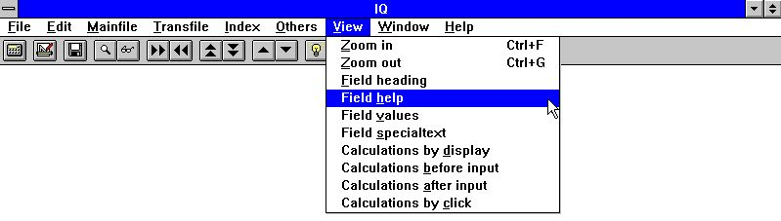

23. The VIEW menu

4.4.1. Field documentation
In the EDIT menu you will find a new entry point for writing documentation for each field on the screen.

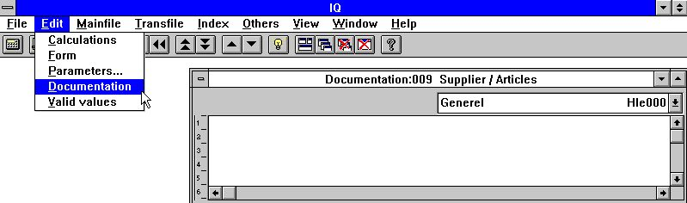

24. Field documentation
This enables you to document the workfields in a program just like a fixed database field or to extend the database documentation with specific points on this program.

4.4.2. Valid values
As with documentation you may define valid values on workfields also.

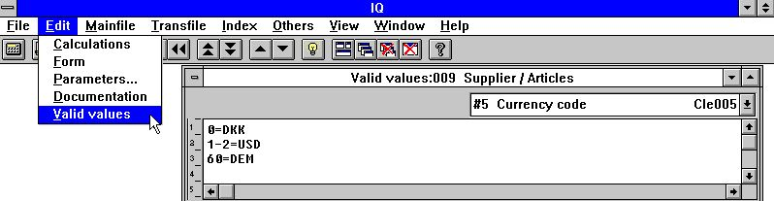

25. Valid values
You must follow the syntax: <values> = Text where values may be single values or ranges.

4.5. Layout editing

4.5.1. Part of fields and tablefields
Part of fields #5(2,13) and tablefields #7(2) may now be included directly in layout for an IQ program.

4.5.2. Blocks of lines
When lines are defined on a query the complete line block may now be moved or resized by dragging the markers in the left margin.

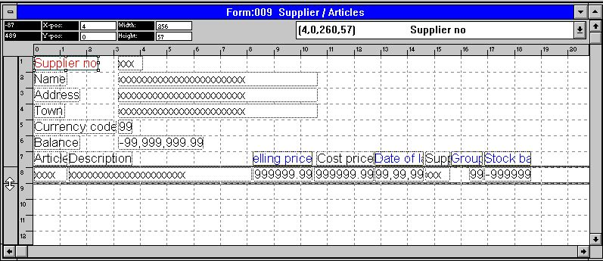

26. Editing the layout of a transaction query

4.5.3. Field options on right mouse button
Using the right mouse button you reach the field options as shown below.

4.5.3.1. Box sizing and field flags
The new BOX entry may be used to size the field boxes automatically and the new FIELD SETTINGS may be used in DATAMASTER to control field input, see also the SETFLAG and CLRFLAG functions.

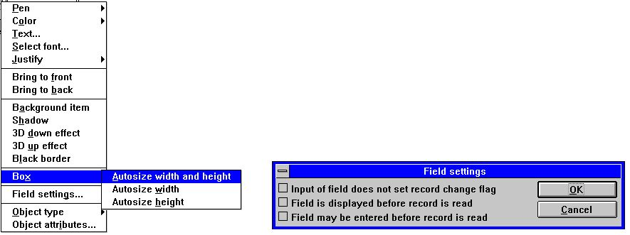

27. Edit Box size and Field settings

4.5.3.2. Object type and attributes
You can control the field behaviour with the object type and attribute entries:

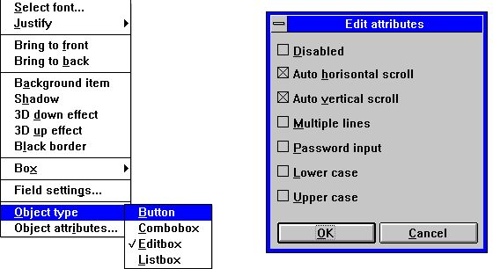

28. Object type and attributes

4.6. DEBUG in the calculations
As the number of possibilities to make calculations in IQ/DATAMASTER grows the possibility to make mistakes grows also.
You may now switch on a DEBUG window by placing a calculation line
DEBUG(1)
which when executed will open a debug window which shows like:

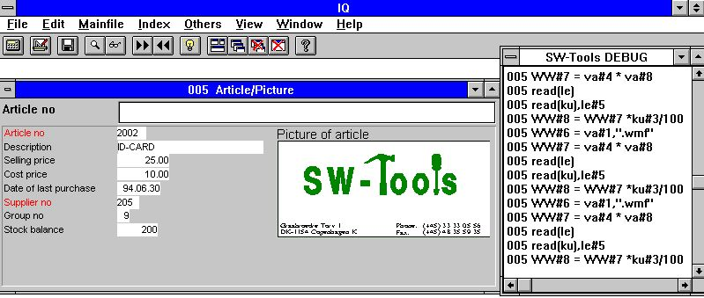

29. The DEBUG window
When opened the DEBUG window displays informations of all calculations being done in all programs. All sections of all open programs will be shown in this but any flow control such as IF...THEN will display only the expression itself.
The debug window remains open until you close IQ or a DEBUG(0) is met.

4.7. Calculation areas
The entry points where you may stick in calculations has been extended to fit some user requests:

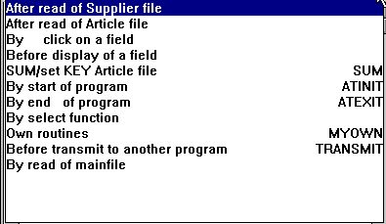

30. Calculation areas in an IQ transaction program

4.7.1. Before DISPLAY of a field
The calculations placed here are carried out just before a field is displayed the first time.

4.7.2. OWN routines
A subroutine may be placed in any calculation area using first RETURN and then LABEL: calculations RETURN
The area of MYOWN calculations is just a good place for such common routines.

4.7.3. Before TRANSMIT to other programs
When this program decides to update other programs it will first call the before transmit calculations. Here you can read the programnumber which will be updated and information about this:
#IQSendto = This program number will be updated
#IQSendsub = The program is placed in this subsystem number
#IQSendfile = This is the ID of the programs mainfile
Update will carry on if you return 0 and will be skipped by a RETURN(-1)

4.7.4. By select of a FUNCTION
When a function is selected IQ will make the corresponding action to this. But before this is done you have the possibility to check if the function is allowed at the given place.

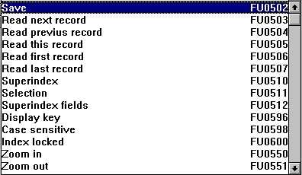

31. Function calculations
All the menu functions can be found here and you will note that the calculation LABEL is named as FUnnnn, nnnn being the function number as 551 for ZOOM OUT.

4.7.4.1. DOFUNCTION messages
What Windows does when a function is selected is to send a MESSAGE to the given program with the function number (e.g. 551 for ZOOM OUT) whereafter the program takes action on this.
With DOFUNCTION(551) you can send such a message yourself and this will be threaten exactly as if the user had activated the ZOOM OUT button.
You may even tell the DOFUNCTION to send the message to another active program and you may pass a key also, for example will
DOFUNCTION(505,#1,20)
ask program number 20 to read the record with the key given in field 1.

4.7.5. By read of mainfile
With these calculations you can influence the reading of the mainfile.

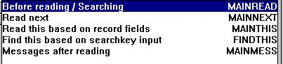

32. Mainfile calculations
Each of the calculations may set #OK and RETURN(-1) to tell the file is read. You may build your own searchroutine here but some programming knowledge would be required for this.

4.8. Interprogram communication
Above the DOFUNCTION could be used to send a message to another open program. This is one way of communicating between two programs.

4.8.1. Program number
In general functions using program number as parameter accepts one of the following:
<program> parameter for IQ functions may be given as 47 or 1047.
47 means the first instance of the running program number 47 whereas
1047 means the first instance of the running program number 47 in subsystem 1.
0 means the current program number.

4.8.2. Fields from other programs
By use of the LET command you may read/modify variables in another program:
LET (20.#1-3=#1-3) Sets field 1-3 for program 20 = this program #1-3
LET (#1-3=20.#4-6) Sets field 1-3 in this program to #4-6 from program 20
LET (#10=#3.4) Sets field 10 equal to field 3 from line 4

4.8.3. GOSUB common subroutines
A label for GOSUB may be preceded by the program number as
GOSUB 20longjump
which causes the routine LONGJUMP in the open program 20 to be executed.

4.8.4. GLOBAL variables A1,A2,...
The Basic-like variables A1,A2,... you may use as global data for all programs as setting A1=#1 in one program and reading this value in another. Also A$,B$,... may be used.

4.9. IQ Start parameters
IQ may be selected from WINDOWS using the following parameters:
IQWIN ssppp Start program ppp in subsystem ss
IQWIN -e EXIT IQ when the current program finishes
IQWIN -M... Restrict menu, see the MENUS function
IQWIN -D DATAMASTER maintenance programs may be defined
IQWIN -nl No Logo by start, Runtime only.
Programs cannot be defined or changed

4.10. Standard programs
In the standard subsystem (see RAPGEN) you will find the standards for the IQ and DATAMASTER programs. When a new program is made not only the layout but also the parameters and calculations are taken from here so any changes done to these are reflected in all new programs.

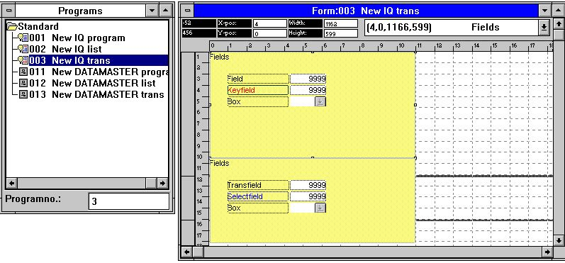

33. A standard program for IQ
In the layout for the transaction program above you note two blocks, one for the main file and one for the transactions. Both the attributes for the fields and their leading text may be changed.
Note that the DISTANCE between the fields defines the line distance in the new program.
NOTE: If you reinstall or upgrade TRIO the standard programs must be adjusted again !

4.11. Hardcopy function
Due to problems with the text hardcopy font on different printers IQ will now deliver a bitmap hardcopy of the screen instead if possible.
The menu has been extended with a hardcopy function for the active window only or for the full screen.

5. DATAMASTER Extensions

DATAMASTER has of cause got all the new functionality as IQ and:

5.1. OK/CANCEL buttons
When a DATAMASTER program is defined these buttons will be added to ease the use:

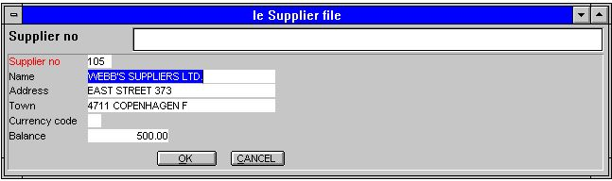

34. OK/CANCEL buttons
The OK/CANCEL buttons are examples of the use of DOFUNCTION as these invokes DOFUNCTION(998) and (997) causing the corresponding action to be taken.

5.1.1. Button shortcuts
When you define a button the name of the field is shown inside this. You may enter a freefield name as:
PRESS &ME
whereas the character just after & becomes a shortcut for this button which then may be activated by ALT+M

5.2. Calculations areas
Again all the IQ extensions are available and:

5.2.1. By change of input sequence
The PARAMETERS page defines input sequences and whenever the user enters or leaves such sequence a calculation is invoked

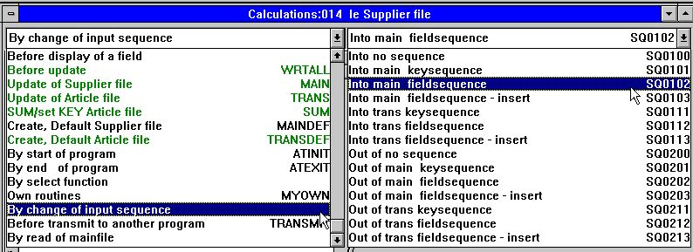

35. Calculations by change of sequence
These may e.g. be used to check/read a file when the key sequence is left.

5.2.1.1. Specifying the input sequences
When a new program is builded the sequences will be stated something like:
le#2-6[?]
which means the actual sequence used is le#2-6 the [?] marks that DATAMASTER is allowed to update this if you add new fields to the screen layout. If you want to control the sequence yourself you should remove the [?] and just state le#2-6

6. SW-Tools ODBC driver

The ODBC driver has proved to be very stable both in the 16 and 32 bit version and is extended only in the following points.

6.1. WRITE released
Using the UPDATE facility with the ODBC driver enables foreign products as ACCESS to update directly in X-Basic files.
NOTE: Every single update should be tested carefully before trusted
As the datadictionary contains all informations of the key structures changing a field will update all index this field is part of. As well may an insert or delete be reflected in the maximum of 15 indexes in a BASIC file.
To activate write you must check the following
- LICENSE for ODBC driver must allow Write and marked for this PC
- LICENSE for CTRAS must be present, allow Write and marked
- FDF CTRAS (X-Basic library) must be activated for WRITE
- The files you want to update must use this, not just X-Basic
- The ODBC driver must be setup and marked for Update
- If using MSQuery the update should be activated from its menu
We strongly recommend the use of server version (006.003) as this has been updated for the new codetable structure.
A special routine had to be implemented for the 6 digit dates in BASIC files (,6, fields) as these by read are converted to the ODBC standard DATE structure. By write such field is converted back and will always be written as YYMMDD.

6.2. W95B setup
Windows 95B together with Office 97 takes advantage of facilities in ODBC 3.0 whereas the driver setup has been moved partly away from the ODBC Administrator and is instead done online when a connection is made.
This procedure is now supported as the parameters from the online setup will be correctly stored in the new .DSN files.

7. Unix Server updates

Previous versions of TRIO will run with the new server as well will the new release run with old servers. However we recommend the versions matches.
Codetables are now transferred from the client PC to the server and used when multiindex update takes place in a BASIC file. Note that in case of old applications doing so the server uses the codetables placed with the SERVER itself.
The server has been extended to scan for BASIC filenames. If you do not upgrade the server module the SEARCH facility in the FDF module will run but without returning any filenames.

8. The LICENSE module

The license module did always deliver the file LICENS.PLS which could be confusing for us. This file is now named as 12345678.PLS using the licensnumber.
E-Mails had a tendency to convert especially CR/LF to something else causing codes mailed from us to fail. The program is now icecold for how CR/LF is placed.

9. Installation

By installation you now have a possibility to select which products to install / upgrade at advance:

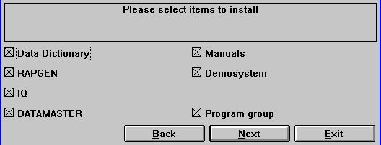

36. The installation selection

10. Function description

This section describes the new functions and updates for existing.
The IQ programming functionality and entry points has been heavily extended as system developers has wanted to stick in own routines on merely every point.
This causes many new functions together with a more detailed structure of the calculations blocks. A more distinct split between RAPGEN and IQ functions as the purpose of these gets more specialised.
Also the system fields has been extended to allow access to flags / control variables.

10.1. New system fields

10.1.1. #UN User name
You may use #UN to get the user name for this PC entered by the LICENSE module.

10.1.2. #LIN linenumber and #LOF lines on form
#LIN contains the current printline, #LOF the actual number of lines on form.

10.1.3. #IQxxxx IQ system fields
A number of IQ control fields has been added, see the SY file.

10.2. New or extended functions

10.2.1. ACCESS("filename") - Check if file exists
(IQ) Check if the given file is present, returns 0 if file is found.

10.2.2. CHAIN("program","key") - Chain program or external command
(IQ) Activate a program number or a windows command string.
CHAIN ("20") starts program 20.
CHAIN ("+5") starts program 5 and activates this.
CHAIN (">5") starts program 5, the current record will not be transmitted
CHAIN ("$5") starts program 5, activates it and waits until this finishes.
CHAIN ("+5",#1) starts program 5 which will read a record using #1

#20="notepad"
#20="command.com /C edit myfile.txt"
CHAIN(#20) starts the specified windows program
CHAIN("rapwin &") & as last character lets IQ continue
while the newstarted program is running.

10.2.3. CHAINR(report) - Chain program or external command directly
(RAP) The CHAIN command will always be placed LAST it is the next program will be started after this is finished.
Use CHAINR instead of CHAIN to interrupt this program and call-up another program immediately.

10.2.4. CLRFLAG("fields",option,type) - Set options for fields
(IQ) Each screenfield is associated with parameters (bits) defining the use. The SETFLAG function may be used to set these flags, CLRFLAG to clear them. See SETFLAG.
CLRFLAG("#12,44",7,0)

10.2.5. COPIES(n,printer) Number of print copies
(RAP) COPIES(1) gives one additional copy of the print output. A maximum of 30 copies can be stated and the must be room for all Windows spoolfiles.
COPIES(1,7) produces one additional copy on the printer defined as no.7 in the printer setup. Note however that unexpected pageshift will occur if the copyprinter has a smaller form than the original.

10.2.6. DEBUG(mode) - Switch on debug window
(IQ) DEBUG(1) will open a window which lists all calculated expressions and their program number/label when these are carried out.
The DEBUG window is closed when IQ is closed.

10.2.7. DELAY() - Dummy function for BASIC compatibility
This function is just implemented to allow BASIC report syntax.

10.2.8. DISABLE(program) - Disable input for a program
(IQ) Disables all input for the given program number.

10.2.9. DISP("Fields") - Refresh screen display
(IQ) The DISP() command displaying all fields is extended to possibility of stating just selected fields as DISP("#1,4")

10.2.10. DOFUNCTION(functionno,"key",program) - Execute external function
(IQ) DOFUNCTION sends the message <functionno> to the running IQ-Program or to the open <program>. A key may be passed to the READ functions.
The list of valid function numbers is found in the calculations listbox for 'Calculations by selection of function'. For example will
DOFUNCTION(505,#1,20) ask program 20 to read a record using key #1
DOFUNCTION(550) Zooms the current screen

10.2.11. ENABLE(program) - Enable input for a program
(IQ) Enables all input for the given program number, see DISABLE.

10.2.12. EXEC("expression",program) - Execute text as calculation line
#20="#2=17"
EXEC(#20)
executes the textstring stored in field 20 as a calculation.
When using freefields in the EXEC function you must use the WW#nn references which you may obtain from a print of the program definitions.
In general the string passed to the EXEC function is not pretranslated and checked as normal calculation lines. This has especially importance when used in RAPGEN where the C-Syntax of the calculations must be followed. We strongly advise non-programmes to keep the use of EXEC in RAPGEN simple without involving function calls. Invalid function parameters may lead to general protection faults.
One point should be especially noticed for RAPGEN: #15=2 sets field 15 equal to 2 ALSO when used as IF #15=2 LET #16=3. You must double the equal sign in such a statement following the C-Syntax giving: IF (#15==2) LET #16=3
IQ: EXEC(#20,15) switches to the active program 15 and executes the given calculation.

10.2.13. EXPORT("CLOSE") - Close export file
(RAP) The export file may now be closed using EXPORT("CLOSE"). This may be useful if you want to CHAIN notepad to view the file.

10.2.14. EXIT(program) - Close program or window
(IQ) EXIT(0) closes the current IQ program.
EXIT(20) closes program 20 if this is open, 1020 gives subsystem 1.
EXIT(-1) closes the program selection window.
EXIT(-2) closes the field selection window.
EXIT(-3) closes and exits all IQ.

10.2.15. FOCUS(program) - Activate program
(IQ) Activates input and sets focus to the given program number.

10.2.16. GETFLAG("fields",option,type) - Get options for fields
(IQ) Each screenfield is associated with parameters (bits) defining the use. The SETFLAG function may be used to set these flags, CLRFLAG to clear them. The GETFLAG function may be used to read these flags. See also SETFLAG.
GETFLAG("#12,44",7,0)

10.2.17. GETFLD("Field")
(IQ) This function sets system variables (SY#..) to point to the definition of the given field. The field definition may then be read/changed. Special and programmers use only.

10.2.18. HELP("field") - Display box with help for field
(IQ) HELP(#31) displays a messagebox with help for the given field

10.2.19. INDEX(indexnumber) - Lock index on report
(RAP) INDEX(-2) locks the report to use index 2 but in descending order. The database driver must support descending read.

10.2.20. INSTALL("xxxxxx.dll","funcname","3,[sCCC]","myname") External functions
(IQ/RAP) Programmers knowing function definitions from other DLL's may now include these as IQ functions.
INSTALL("a.dll","b","3,[ss]")
activates #20=B(#21) from a.dll, #20 and #21 being short variables

INSTALL("some.dll","aname","3,[sCl]","FUNNY")
activates #30=FUNNY(#31,#32) as function aname from some.dll
return value #30 short, parameters #31 as char pointer, #32 as long.
NOTE: Improper use of this function may cause system breakdown.

10.2.21. ISACTIVE(program) - Ask if program is active
(IQ) Returns 1 if <program> is active, 0 else.

10.2.22. KEYON(0/1) - Switch key input field ON/OFF
(IQ) KEYON(0) removes the key input field, (1) reactivates this.

10.2.23. LET (Fields=...) - Assign values to fields
(IQ) The LET assignment of multiple fields has been extended to work with multiprograms and between lines in list/transaction programs.
LET (20.#1-3=#1-3) Sets field 1-3 for program 20 = this program #1-3
LET (#1-3=20.#4-6) Sets field 1-3 in this program to #4-6 from program 20
LET (#10=#3.4) Sets field 10 equal to field 3 from line 4

10.2.24. LET (id=fields) Creating new files
(RAP) The LET function may be used to build new files.
LET (aa=#1-3,87,le#2) Define file aa, key=aa#1, type=1.database driver
LET (aa=#1-3,6K,15D) Keys aa#4 and aa#5 (duplicates)
LET (aa=#1-3,6,15;2,NP) Keys aa#2 and rel.recno (duplicates)
LET (aa=#1-3),12000 12000 records (default is 1000 if needed)
LET (aa=#1-3),-1 File should be builded eachtime
LET (aa=#1-3),1000,xnet File is a XNET file
LET (aa=#1-3) -acc File is an access file, build always
LET (07/aa=#1-3),25 Lu may be given for basic files

10.2.25. NEXTFLD("field") - Jump to input field
(IQ) use of the NEXTFLD function extended:
NEXTFLD("#10") sets next input field to field 10.
NEXTFLD("#10.2") jumps to field 10 on line 2
NEXTFLD("5.#10") jumps to program 5 field 10

10.2.26. NEXTFLDSEQ(sequence,fieldnumber) - Jump to input field in sequence
(IQ) Jump to a distinct field in one of the field sequences.
NEXTFLDSEQ(2,1) Jumps to the first field given in input sequence 2.

10.2.27. MENUCH("menunumbers") - Flip menu checked flag
(IQ) Flip checkflag on the given menu numbers (see MENUS) and update the according internal flag for program control.

10.2.28. MENUUPD(menuno,function,"&text") - Add/Control menu
(IQ) Add / Control menu manually.
MENUUPD(1,2000,"My &Own menu") Adds function 2000 to menu number 1.
By selection of this new menupoint the user calculations labelled FU2000: in the function section will be performed.

10.2.29. OBJECTADDSTRING (field,text,key) - Add string to object
(IQ) OBJECTADDSTRING(fields par1, text par2, text par3)

Description The function inserts a text in an object. The function result varies depending on the object type. In order to use the function correctly, please have the following rules in mind:

 | Object | Meaning
 | BUTTON | The function sets the text displayed for the button
 | COMBOBOX | The function adds a new element to the list
 | EDITBOX | The function set the text in the editbox. If the flag for multiple
 |  | edit lines has been set the text will be added to the previous text
 | LISTBOX | The function adds a new element to the list

Parameter par3 is only used if the object type is COMBOBOX or LISTBOX. The parameter must contain the normal value of the field.
Returnvalue None.
See also OBJECTCLEAR

10.2.30. OBJECTCLEAR (fields) - Clear contents of object
(IQ) OBJECTCLEAR(fields par1)

Description The function clears the contents of an object.
Returnvalue None.
See also OBJECTADDSTRING

OBJECTCLEAR("va#7") /* clear all previous values
START(gr),"" /* read all values from Article group table
NEXT(gr)
OBJECTADDSTRING("va#7",gr#2,gr#1) /* Display name and use no. as index
REPEAT(gr)

10.2.31. OPEN("id","-") - Temporary close of files
Files may now be closed to allow CHAINED programs to access these
OPEN("ku","-") will temporary close file to allow
CHAIN("command.com /c edit c:\\windows\\system\\ku.ssv")

OPEN("ku","+") will reopen file again
NOTE that the MAIN file must not be closed in this way.

10.2.32. PLSNEXT(mode,"key",inputflag) - Prepare and read mainfile
(IQ) Prepare and perform read of mainfile according to the given mode. Used by the menus and by page down/up etc. If inputflag is set, key is used, otherwise read is next/prior/direct.
PLSNEXT(0,#1,1) reads the next record using #1 as key
Mode = 0 Read next record
1 Read previous record
2 Read this record
4 Read first record
5 Read last record
8 Superindex
16 Use key from fields in mainfile record

10.2.33. PRINT (#11) - Print lines
(RAP) Note that a textfield may be used in the printcommand as
#11="1-4,15"
PRINT(#11)

10.2.34. PRINT (options=value) - Print output control
(RAP) The PRINT command is expanded with the command syntax PRINT(xx=value yy), where xx,value and yy can be one of the following:
xx= ml Left margin
mr Right margin
mt Top margin
mb Bottom margin
eh Empty line height
ce Close report windows on exit
fh Standard font height for all lines
cd Close printer document and start new

yy= cm Centimetre
in Inches
pt Points
lpi Lines per inch
<none> Device pixels

10.2.35. PRINT (?=option) - Printer characteristics inquiry
(RAP) The PRINT command is also expanded with a query function in order to receive some information from the internal print handler. With the syntax yy=PRINT(?=xx), where xx can be:
xx= 0 get current y position on page
1 get current page number
2 get printer x resolution
3 get printer y resolution
4 get default font height
5 get printer device context (Internal use only!)
6 get page width
7 get empty line height
8 get report buffer (Internal use only!)
9 get printer window handle (Internal use only!)
10 get page height
11 get left margin
12 get right margin
13 get top margin
14 get bottom margin
15 get internal page number
16 get job number
17 get usable page height (exclusive top/bottom margin)
The return value yy is reported in pixels except when xx is 5, 8, 9, 15 or 16.

10.2.36. PRINT (>n) switching to second printer
(RAP) PRINT(>2) switches to printer 2, see PRINTER.

10.2.37. PRINTER (printerno) - Printer selection
(RAP) This function is used in connection with the printer dialogue. In order to set the default printer for a report the following line can be added in the calculations:
PRINTER(7) /* default printer for this report is printer 7

10.2.38. PRINTER (n,printerid) multiple printer output
(RAP) PRINTER(2,7) will open a secondary printer defined as printer number 7 in the printer setup. No output is printed on this until a
PRINT(>2)
is found in the calculations whereafter all print goes to this printer. PRINT(>1) switches back to the default printer.
Each printer has its own pagenumbers and may differ in paper size. A maximum of 30 concurrent printers or copies can be used.

10.2.39. SPEED() - Optimizing read strategi
(RAP) The SPEED() function may be used to optimize the read strategi on a report as a record will not be read again when the same key is given but taken from memory. You should be carefull with this on updating reports.

10.2.40. SUPER(file),key - Prepare superindex search
(IQ) The SUPER function initialises the NEXT read for use of superindex
SUPER(va),#21 NEXT uses superindex search for the text in #21
NEXT(va) Must be follow to actually read the record
SUPER(va) Superindex is switched off
SUPER(va),"#1-3" Superindex fields is set to field 1-3

10.2.41. SETFLAG("fields",option,type) - Set options for fields
(IQ) Each screenfield is associated with parameters (bits) defining the use. The SETFLAG function may be used to set these flags, CLRFLAG to clear them.
SETFLAG("#12,44",7,0)
1 Input of field does not set record change flag
2 Field is displayed before record is read
4 Field may be entered before record is read
8 Field is part of main key and may be entered/changed as such
For the type parameter 0 only should be used:
0 User definable flags as described above
1 Field changed / State flags during input/update
2 Fixed flags defining field handling
3 Fixed flags defining field screen handling

10.2.42. TRANSMIT(prio,progid,connection) - Update other IQ program
(IQ) Transmit the current records to one or more programs using the automatic connections or if given the connection stated.
TRANSMIT(0,"","") Updates all other programs using auto connections
Prio = 0 Normal, used when a normal read is done
1 High, used when user clicks on a field
2 Transmit even this program transmitmenu is deactivated
4 Transmit even if receiving program do not want so
8 Skip calling the normal TRANSMIT calculations
16 Superpriority, step read number and send to all.

Progid="" Send to all other
"20" Just update program 20 if active
"le" Send to all programs using the file le as mainfile

Connection = "" Use automatic connections between files
"1,2P" Use field 1 and 2 packed as connection
"va.01.6" Use va as transmitting file to the other program
Read the other mainfile index 1 using field 6.

10.2.43. TRANSSEL("input",inputflag) - Define IQ transaction selections
(IQ) Scan the given input if any and define transaction selections if input contains formulas as #15>0. Used by arrows in the keyfield

10.2.44. UPDATE(mode,"Fields") - Allow update on files
The update command has been extended with specification of fields to update.
UPDATE(1,"va#6") causes the program to update field 6 in va only.
UPDATE(1,"le#3-4") when more files are involved each file must be separate
UPDATE(0) can now be used in DATAMASTER to switch all update off

10.2.45. VALID(number,"Values",mode) - Valid values
The VALID function has been extended with a mode 0 or 1.
VALID(15,"1-3,8-12") is unchanged, returns 0 if 15 is not one of the ranges.
#20="1-3,8-12"
VALID(15,#20,1)
will change the value of the range field #20 by inserting 15 so #20 becomes: "1-3,8-12,15"

10.2.46. WAIT(program) - Wait for program to finish
(IQ) Wait for given program to finish (see EXIT). Calculations will continue when the program window is closed.

10.2.47. WIF("text") Testprint of text
(IQ/RAP) WIF gives testprint without disturbing the screenlayout to the file c:/wif

10.2.48. WIFS("fields") Testprint of fields
(IQ) WIFS gives testprint of the given field values to the file c:/wif

Figure list
1. Printer setup 19
2. Server spool 22
3. Screen print 27
4. Keys file editor 30
5. Searching / Replacing a string 31
6. Report information 32
7. Function help 33
8. Defining input data or picture fields 34
9. Group totals 44
10. Setting up the STANDARD subsystem 46
11. The standard report 46
12. Preferences 50
13. Import ODBC definitions 51
14. Codetable for reading BASIC files 55
15. Company file search 56
16. Confirmation of DATAMASTER file copy 58
17. Setting up an ODBC driver 61
18. Record overview 64
19. The print options menu 65
20. Table of contents 66
21. Not all files could be opened in an IQ program 74
22. The ESCAPE cursor 76
23. The VIEW menu 77
24. Field documentation 78
25. Valid values 79
26. Editing the layout of a transaction query 82
27. Edit Box size and Field settings 84
28. Object type and attributes 85
29. The DEBUG window 86
30. Calculation areas in an IQ transaction program 87
31. Function calculations 91
32. Mainfile calculations 93
33. A standard program for IQ 100
34. OK/CANCEL buttons 103
35. Calculations by change of sequence 106
36. The installation selection 113

Index

A
ALX 62
Ascending 16
B
Basic 41;42;53;98
BASIS 48;50
BCD 6;68
Button 104
C
CANCEL 5;7;8;29;103;168
Centimetre 153
CHAIN 121;122;132;150
CHAINR 122
CLOSE 132
CLRFLAG 84;123;135;160
Codetable 6;53;55;168
Combobox 73
COPIES 5;39;124
C-Syntax 131
CTRAS 28;109
D
DATAFLEX 53
DATAMASTER 3;8;15;33;48;58;59;67;84;86;99;100;102;103;107;163;168
DEBUG 86;125;168
DELAY 43;126
DELETE 20
DESCending 40
Device 153
DISABLE 127;130
DISP 128
DISPLAY 88
DLL 5;7;139
DOFUNCTION 92;94;103;129
DSN 110
E
EBCDIC 53
Email 10
ENABLE 130
ESCAPE 76;168
EXEC 5;131
EXIT 99;133;165
EXPORT 132
F
FDF 6;48;49;58;64;67;109;111
FOCUS 134
G
GETFLAG 135
GETFLD 136
GETKEY 42
GLOBAL 98
GOSUB 97
H
Hardcopy 7;101
HELP 137
I
INDEX 28;138
Informix 6
INSERT 20;48
INSTALL 5;139
Installation 11;33;113
IQ 3;5;7;14;33;71;72;73;74;75;81;86;87;91;95;99;100;101;102;105;114;118;120;121;123;125;127;128;129;130;131;133;134;135;136;137;139;140;141;142;144;145;146;147;148;149;151;159;160;161;162;165;166;167;168
ISACTIVE 140
ISAM 6
ISO8850 53
K
KEYON 141
KEYS 5;30
L
LET 5;13;48;96;131;142;143
License 33
LONGJUMP 97
LU 56
M
MENUCH 146
MENUS 99;146
MENUUPD 147
MESSAGE 92
MSQuery 109
MS-Word 16
Multiconstant 6
MYPRT 19
N
NEXTFLD 144
NEXTFLDSEQ 145
NT 14
O
Object 85;148;168
OBJECTADDSTRING 148;149
OBJECTCLEAR 148;149
ODBC 6;9;16;33;51;53;54;59;61;108;109;110;168
OemToAnsi 53
Office 9;110
OPEN 150
Open-Basic 6
Oracle 6
Owner 6
P
Packtype 59
Parity 53
PLSNEXT 151
Preferences 50;168
PRINT 5;13;27;36;37;152;153;154;155;157
PRINTER 5;19;38;39;155;156;157
R
RAPGEN 3;5;13;17;45;46;47;54;100;114;131
S
Server 22;56;111;168
SETFLAG 84;123;135;160
SIZE 43
Sort 29;53
SPEED 5;47;158
SQL 6;16
SSV 19;48;50
Subtotal 13
SUPER 159
SUPERINDEX 75;76
T
TEMP 39
TRANSMIT 90;161
TRANSSEL 162
TRIO 1;3;11;46;100;111
U
UNIX 22;53
UPDATE 48;109;163
V
VALID 164
VIEW 41;42;77;168
W
W95B 9;110
WAIT 165
WIF 166
WIFS 167
WRITE 9;109
X
X-Basic 48;57;109
XNET 143

