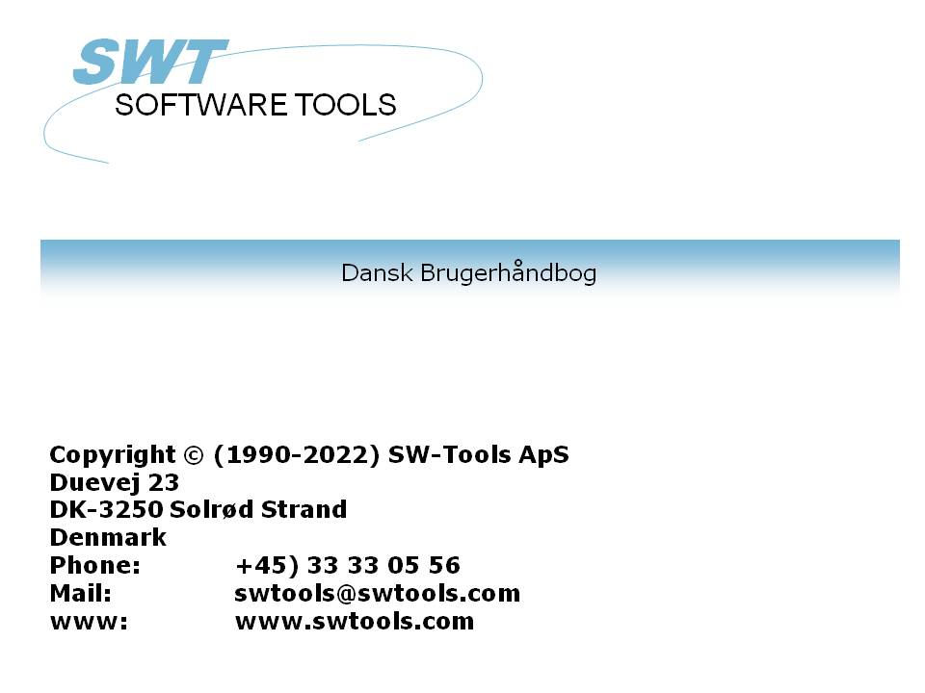

ODBC Driver

22/11/01 / 2022-09-01 008.384

Contents
Contents 2
1. Installation 3
1.1. Installation of the 16 bit driver 4
1.2. Installation of a new version of the driver 7
1.2.1. Deleting an old driver 8
1.3. The README file on the installation disk 9
1.4. Installation of the 32 bit driver 10
1.5. Selecting the 16 or 32 bit driver 11
1.5.1. Using 16 bit applications with the 32 bit driver 12
1.5.2. Using 32 bit applications with 16 bit drivers 13
2. Setting up the ODBC driver 14
2.1. Version number 15
2.2. Name and description 16
2.3. Paths, Fixed basis and Company number 17
2.4. Behaviour against the application 18
2.4.1. Qualifier and Owner 19
2.4.2. Table name and remark 20
2.4.3. Max name length and Uppercase 21
2.4.4. Sort columns by field numbers 22
2.5. Internal test 23
2.6. Updating tables via the ODBC driver 24
2.6.1. Activating WRITE 25
2.7. W95B setup 26
3. Activating systems other than the testsystem. 27
3.1. The Data Dictionary preferences 28
3.2. Creating a new Data Source Name 29
3.3. The Data dictionary driver setup 30
4. Notes and hints on different applications using ODBC. 31
4.1. MSOffice. 32
4.1.1. MSQuery 33
4.1.2. Access 34
4.1.3. Word 35
4.1.4. Excel 36
4.2. Impromptu 37
5. Notes on different database interfaces 38
5.1. CTras Quattro interface 39
Figure list 40
Index 41

1. Installation

1.1. Installation of the 16 bit driver
To install the driver insert the disk and select from Windows FILE menu - RUN - A:\SETUP. Do not use the ODBC Administrator function ADD DRIVER as this function is obsolete.
After the welcome screen you will get a list of available drivers:

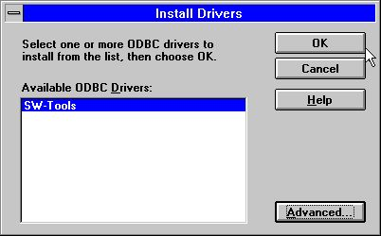

1. Available drivers on the installation disk
You should mark the SW-Tools ODBC Driver for installation and choose OK.
The ADVANCED options as shown below controls version checking and should normally not be adjusted. However you may read the version number of the driver:

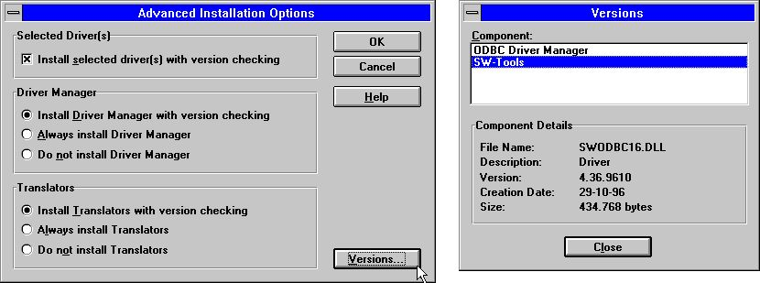

2. Advanced options and version number by installation
The ODBC driver is now copied from the disk to Windows System directory together with some small test tables and you will get a list of available data sources.
The ODBC driver manager supplied on the disk originates from Microsoft ODBC SDK 2.10 and will be installed/upgraded unless you have deselected this in the advanced options above.

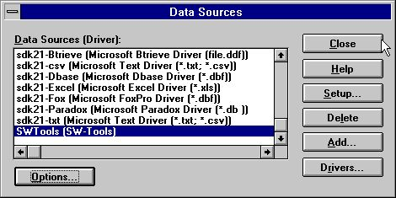

3. List of data sources after installation
If you just select CLOSE from this menu, the driver is installed with a default SETUP for the test files and you can change this later after the first test using the test files. It is not required to adjust the options menu as this is for test logging only:

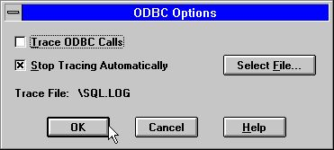

4. The options menu
Now select your favourite ODBC database program as MS-Query, Access or some other and make a quick check that the SW-Tools ODBC driver is available and the test tables are useable.

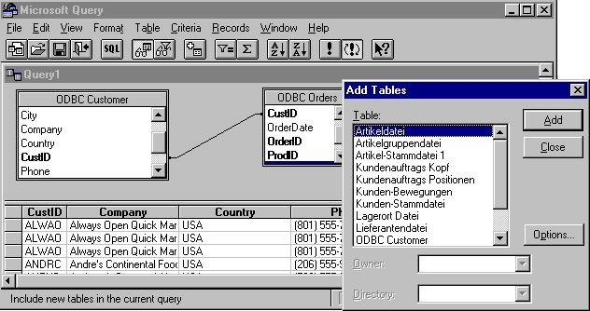

5. MS-Query example using the test files

1.2. Installation of a new version of the driver
You should just follow the steps described above. It is not necessary to delete the old version before you upgrade. Your setup information for the different Data Sources using the driver will be kept with exception of the DEMO system (Data Source Name SWTOOLS or SWTOOLS-32) where you must reinput any changes done to these.

1.2.1. Deleting an old driver
Deleting a driver causes all setup for all data sources using the driver to be lost!
The deletion removes the driver itself (SWODBC16.DLL or SWODBC32.DLL) but not the small testsystem included.

1.3. The README file on the installation disk
The README file contains more technical information on the ODBC driver and some SQL examples. The file is a plain text file and may be edited and printed.

1.4. Installation of the 32 bit driver
The 32 bit driver requires a 32 bit operating system, i.e. Windows 95, NT or Windows 3.11 with WIN32s installed.
The 32 bit driver is installed exactly in the same way as the 16 bit driver described above. The driver has "32 bit" as part of its name.

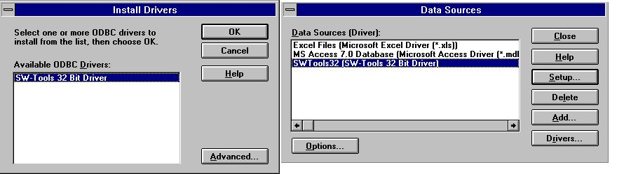

6. Installation of the 32 bit version

1.5. Selecting the 16 or 32 bit driver
If you are working with Windows for Workgroups 3.11 you should normally select the 16 bit driver.
If using Windows 95 or NT the 32 bit driver should be preferred unless your application is 16 bit. Note that long filenames are supported in the 32 bit driver only.
On the 32 bit operating systems there are separate ODBC driver managers for 16 and 32 bit drivers so both may be installed.

1.5.1. Using 16 bit applications with the 32 bit driver
The 32 bit driver contains generic thunking libraries which enable 16 bit applications to use the 32 bit driver. When the 32 bit driver is installed it becomes available for both the 32 and 16 bit ODBC administrator and can be set up separately from each of these.
If the 32 bit driver is not shown in the 16 bit applications you may have an old version of the ODBC driver manager where the 32 bit driver must be activated as SYSTEM DSN driver before it can be used as 16 bit.

1.5.2. Using 32 bit applications with 16 bit drivers
This is not possible.

2. Setting up the ODBC driver

When you install the driver for the first time is it automatically set up for use with the testsystem shipped with the driver:

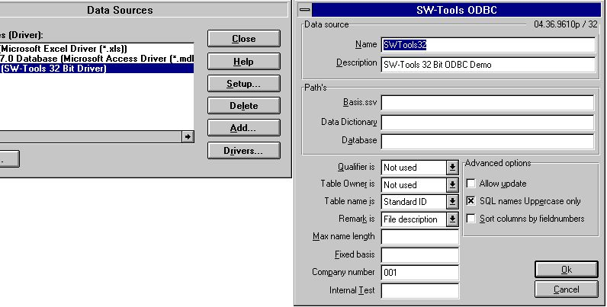

7. The default setup for the 32 bit version

2.1. Version number
On the top right of the screen you note 04.36.9610p/32 which indicates major version 04, minor version 36, release month 9610, for Production and 32 bit.

2.2. Name and description
The name is used when an application connects to the driver (DSN=DataSourceName). One ODBC driver can be installed many times with different names and setup.
The description is a free text for your information.

2.3. Paths, Fixed basis and Company number
These identify the database definitions, servers and filenames, see below.

2.4. Behaviour against the application
These parameters controls how names are returned to the application used. In general you should not change these after you have defined applications programs using the driver as table names and field names may change causing the programs to stop working.

2.4.1. Qualifier and Owner
These should be set as NOT USED. It is possible to have either the file ID or the database interface name here as information returned.

2.4.2. Table name and remark
These defines how the table names are used in the SQL calls. The table name which is shown in, for example MSQuery may be the real filename, the file description text or the separate StandardId for the file.
The table description may then be set to give a further description of the table but is not shown in applications such as MSQuery.

2.4.3. Max name length and Uppercase
If needed the SQL field name length may be limited, and the name made case sensitive.

2.4.4. Sort columns by field numbers
By default the fields will be sorted on the field name. If you rather prefer to have the fields sorted by field numbers as entered in the datadictionary set this option on.

2.5. Internal test
Always leave this field blank unless otherwise told by the support staff. Each character of this field switches on different levels of test prints which goes to the file C:\WIF. It is useful for diagnosing problems but slows down the system and may fill up the disk if set accidentally.

2.6. Updating tables via the ODBC driver
To do this you must have a licence which allows updates.
The abilities to do updates is activated by setting the Allow Update option ON and also in the Data Dictionary setting the database interface (Server) to allow updates for the specific table.
When update is activated you may use applications as Access or MSQuery to amend, create and delete rows. Note that all programs updating files should be carefully tested before use, and done on your own responsibility.

2.6.1. Activating WRITE
Using the UPDATE facility with the ODBC driver enables foreign products as ACCESS to update directly in X-Basic files.
NOTE: Every single update should be tested carefully before trusted
As the datadictionary contains all informations of the key structures changing a field will update all index this field is part of. As well may an insert or delete be reflected in the maximum of 15 indexes in a BASIC file.
To activate write you must check the following
- LICENSE for ODBC driver must allow Write and marked for this PC
- LICENSE for CTRAS must be present, allow Write and marked
- FDF CTRAS (X-Basis library) must be activated for WRITE
- The files you want to update must use this, not just X-Basic
- The ODBC driver must be setup and marked for Update
- If using MSQuery the update should be activated from its menu
We strongly recommend the use of server version (006.003) as this has been updated for the new codetable structure.
A special routine had to be implemented for the 6 digit dates in BASIC files (,6, fields) as these by read are converted to the ODBC standard DATE structure. By write such field is converted back and will always be written as YYMMDD.

2.7. W95B setup
Windows 95B together with Office 97 takes advantage of facilities in ODBC 3.0 whereas the driver setup has been moved partly away from the ODBC Administrator and is instead done online when a connection is made.
This procedure is now supported as the parameters from the online setup will be correctly stored in the new .DSN files.

3. Activating systems other than the testsystem.

The ODBC driver uses the same Data Dictionary as the TRIO package and such a Data Dictionary must be defined before the driver can be used. Each table and field needed must be described in it together with the database servers. Definitions may be imported from the database. For details refer to the Data Dictionary Manual.
When such definitions are present and useable in TRIO you will not have to change these to use the ODBC driver. All that is needed to be done is to make the ODBC driver point correctly to them.

3.1. The Data Dictionary preferences
As an example when TRIO is installed with the standard directories the Preferences looks like:

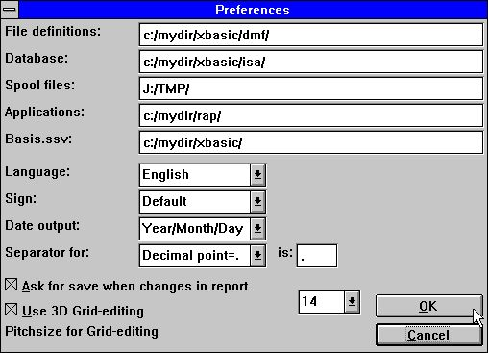

8. The preferences in the Data Dictionary Definition

3.2. Creating a new Data Source Name
You create a copy of the ODBC data source by ADD in the Administrator, by default the name is TRIO, but this may be changed, and set the PATHS to point to the used paths.

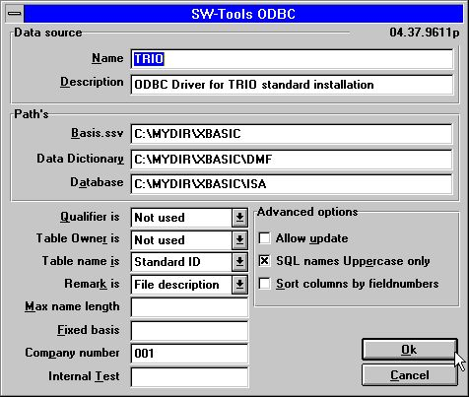

9. The ODBC driver setup for this installation
Note that also the Company Number must be set correctly and the field Fixed Basis should be left blank.

3.3. The Data dictionary driver setup
The Data Dictionary installation details for a file could look like:

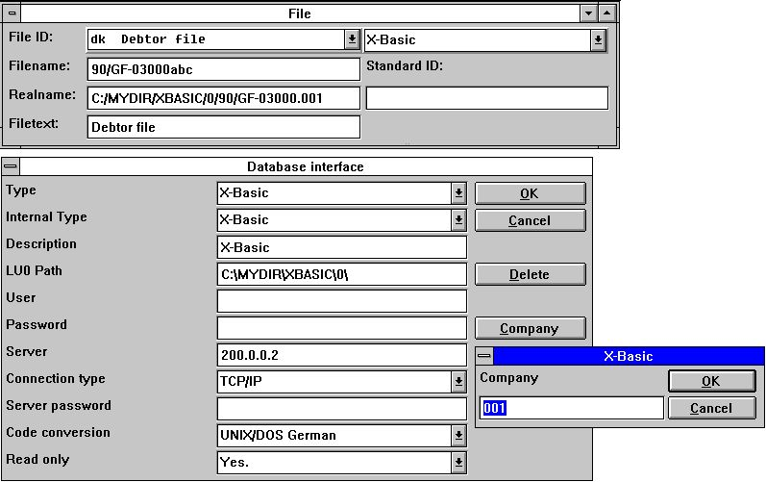

10. The Data Dictionary information for the X-Basic driver

4. Notes and hints on different applications using ODBC.

ODBC stands for Open DataBase Connectivity and is a standard which can be used by a lot of applications.
However the single product/version may have specific behaviour, requirements or limitations why we in the following will make a short list of the products which has passed our eyes and our notes on these.
If you are using other applications we would like to here your experience and hints about these.

4.1. MSOffice.
Note that when you install MSOffice you should explicitly state that MSQuery must be installed to get ODBC access in Word, Access and Excel.
MSOffice version 4.2(16 bit/W311) and 7.00(32 bit/W95,NT) is tested.

4.1.1. MSQuery
Tested with MSQuery version 1.00(16 bit/W311) and 2.00(32 bit/W95,NT) is tested.
Has a limitation of 65535 rows in the 16 bit version.

4.1.2. Access
Tested with Access version 2.00(16 bit/W311) and 7.00(32 bit/W95,NT) is tested.

4.1.3. Word
Tested with Word version 6.00(16 bit/W311) and 7.00(32 bit/W95,NT) is tested.

4.1.4. Excel
Tested with Excel version 5.00(16 bit/W311) and 7.00(32 bit/W95,NT) is tested.
Has a limitation to 16384 rows both for 16 and 32 bit versions.

4.2. Impromptu
Known to be working.

5. Notes on different database interfaces

5.1. CTras Quattro interface
This is supplied in a 16 bit version only. It may be used together with LAN, direct ALM or Windows sockets. If you are using Windows Sockets ensure that the latest version of CTRASQ.DLL is installed.

Figure list
1. Available drivers on the installation disk 4
2. Advanced options and version number by installation 4
3. List of data sources after installation 5
4. The options menu 5
5. MS-Query example using the test files 6
6. Installation of the 32 bit version 10
7. The default setup for the 32 bit version 14
8. The preferences in the Data Dictionary Definition 28
9. The ODBC driver setup for this installation 29
10. The Data Dictionary information for the X-Basic driver 30

Index

A
Administrator 4;26;29
ALM 39
B
BASIC 25
Basis 25;29
C
CLOSE 5
Company 17;29
CTRAS 25
CTRASQ 39
D
DataSourceName 16
DEMO 7
DLL 8;39
DRIVER 4
DSN 12;16;26
F
FDF 25
I
Impromptu 37
L
LAN 39
M
MSOffice 32
MSQuery 20;24;25;32;33
N
NT 10;11;32;33;34;35;36
O
Office 26
P
Paths 17
Preferences 28
Q
Qualifier 19
Quattro 39
R
README 9
S
SDK 4
Server 24
Sockets 39
SQL 9;20;21
StandardId 20
SWODBC16 8
SWODBC32 8
T
TRIO 27;28;29
U
UPDATE 25
W
W311 32;33;34;35;36
W95 32;33;34;35;36
W95B 26
WIN32s 10
WRITE 25
X
X-Basic 25;30;40

