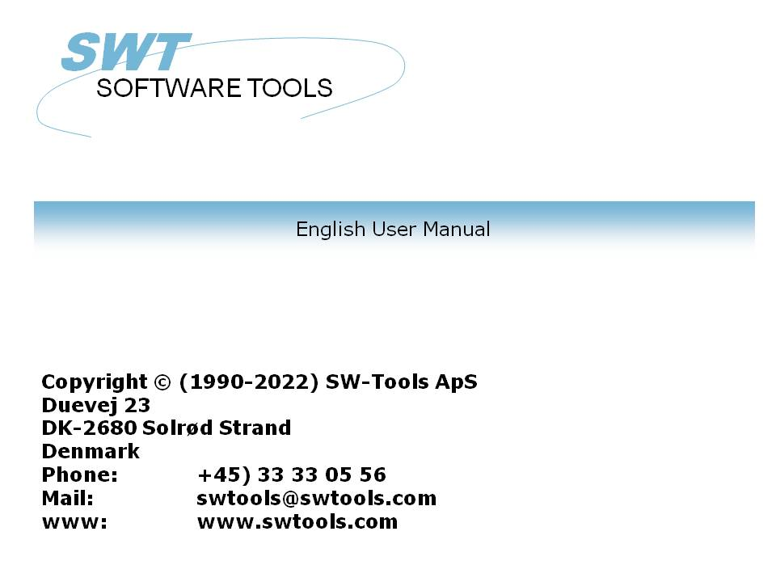

Licensing

22/11/01 / 2022-09-01 008.384

Contents
Contents 2
1. Licensing 3
1.1. Overview 4
1.2. Structure 5
1.2.1. Products 6
1.2.2. Product usage 7
1.2.2.1. DEMO versions 8
1.2.2.2. LIGHT versions 9
1.2.3. UserID 10
1.2.4. Main license 11
1.2.5. User license 12
1.3. Ordering 13
1.3.1. The main license code 14
1.4. Producing an order disk 17
1.5. The user license 18
1.5.1. Input from a disk file 19
1.6. Checksum 21
1.6.1. Ordering new products or more users 22
1.6.2. The remark fields 23
1.7. Dates 24
1.8. Missing or invalid license code 25
1.9. The start screen 26
2. Licens codes 27
2.1. Products 28
2.2. Usage of each product 29
Figure list 30
Index 31

1. Licensing

The licensing system ensures that the products are installed according to the agreed license and that update of systems with maintenance contracts is done smoothly.

1.1. Overview
1. A license code is requested using the order form for a number of users of each product
2. The license main code is issued and forwarded on disk or fax/E-Mail
3. Each client is activated for usage of individual products
4. This client information is returned to SW-Tools within 3 months on disk/E-Mail
5. SW-Tools returns a disk or fax/E-Mail with activation keys for each user
6. Each client is now released for use for more than 3 months
7. Futher clients may be added following point 3-6 above.

1.2. Structure
Each product requires a main license to work and this license must be activated for the actual user.

1.2.1. Products
A MODULE is one of RAPGEN, IQ, DATAMASTER, ODBC16 or ODBC32. Together RAPGEN,IQ and DATAMASTER forms TRIO.
A module may use one or more database DRIVER or SERVER programs which also must have an active license code.
License for any one module automatically opens for the FDF (Data Dictionary) module and the drivers for SSV (Semicolon Separated Varying length textfiles) and ODBC access for database systems.
Modules, drivers and servers together are called PRODUCTS. A product is identified by a 4 digit product number and entered as a line in the licencing system.
TRIO 32 bit requires own license codes.
User administration requires special license code.
Without maintenance you will need an upgrade version code to use TRIO 007.xxx if installation is before 01/08-1998.
A licensecode issued for TRIO version 007 may be used with version 006 also. You may have to update the product table contained in the textfile LICENSPR.SSV as all product codes must be known to the license program.

1.2.2. Product usage
Usage of a module may be DEMO, FULL or LIGHT (1,2 or 3). Usage of a driver may be READ-ONLY or READ/WRITE (R or W).

1.2.2.1. DEMO versions
DEMO versions are restricted as no more than 10 programs/reports can be saved at any time, for DATAMASTER only 5 tables can be defined. A demo version will normally be valid only for a limited period of time.

1.2.2.2. LIGHT versions
Only IQ is available in a light version which is restricted for use of 2 files only in one enquiry session.

1.2.3. UserID
Each client PC is uniquely named with its own USERID. This userid is not known until the license program is activated on the PC which means the final activation for the specific client cannot be done when placing order for the main license.
This userid is hardware dependent and will change if the CPU or Main disk is changed, in which case a new license code must be required.

1.2.4. Main license
The main license consists of a number of products activated with a specific usage from a given date for a maximum number of USERS.
Each product line on the main license must have a valid activation key to work. Lines without activation keys may be entered as ORDER lines for new products.
Additional users are entered as new lines; the already issued license is not changed. This means that the same product may occur several times on the main license and the sum of users for the product lines is the maximum licensed.

1.2.5. User license
The user license consists of a copy of the main license information where each product line is activated for the distinct users by marking these in the check box. No activation key has to be given.
The marked products will be actived for the user for a period of 3 months. After that an activation key must be entered for each product line.

1.3. Ordering
To order the main license you fill out your order form and forward this to us.
You may also call up the licensing program, fill in the details and forward the disk created.

1.3.1. The main license code
As your order is registated by us we will forward a fax (or disk/E-Mail) of the form:

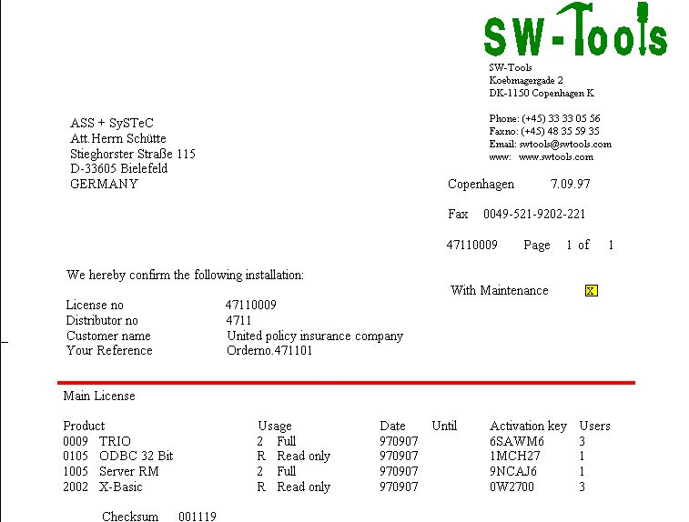

1. The main license code returned
This contents of this must be entered by selecting the license program

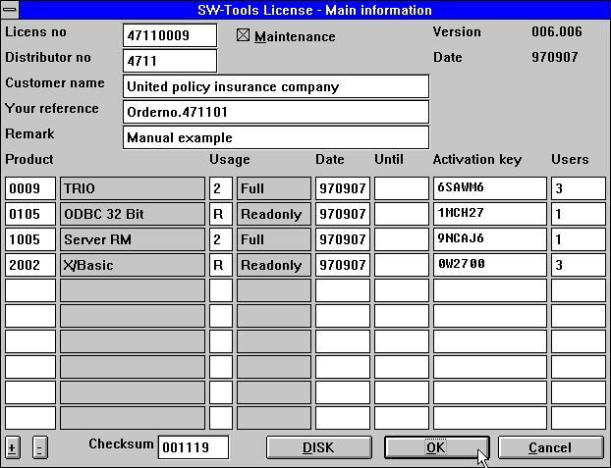

2. Entering the main license code
If you have got more than 10 product lines use the +/- buttons at the lower right for scrolling. When you choose OK the user license screen is showed and you should mark the right hand checkboxes for the products designated for this user.

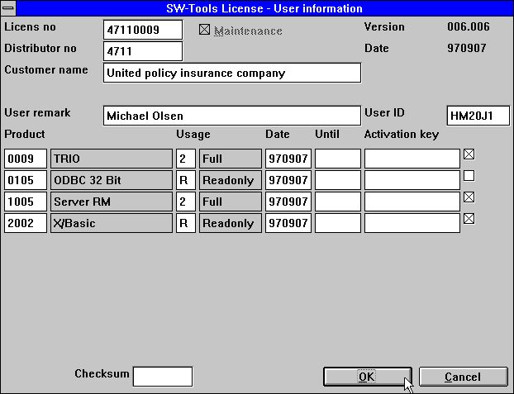

3. Marking the specific users products
This user will now have access to the marked products for 3 months from the date you have placed the mark or until the UNTIL expiry date whatever comes first.

1.4. Producing an order disk
When you click OK, if you have marked some products for this user you will have the option to produce a disk (or file) for the final user license code:

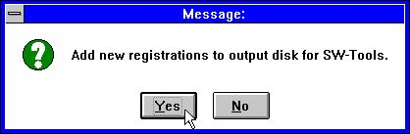

4. Making an order disk
Answering YES on this question gives a filename dialog box with the default filename A:LICENSENO.PLS, e.g. 47110009.PLS.

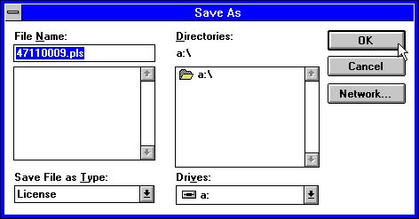

5. Output to the license file
The information will be added to this file which means the disk can be used to collect registations from multiple clients. If you add the same user information again the latest will be used.

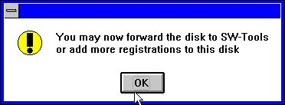

6. License file now ready

1.5. The user license
When you forward to us the registation disk or a piece of paper with the userid's and required products within 3 months the final license code will be returned by fax, disk or E-Mail.

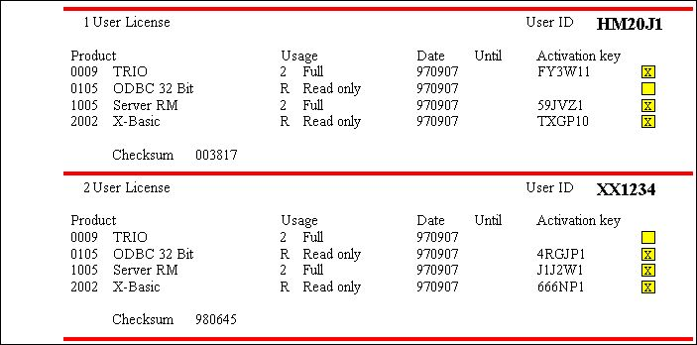

7. Final user license on fax

1.5.1. Input from a disk file
These codes must be entered in the license program on the corresponding client PC's.
If you have received a disk or a file from us, the license is updated by activating the DISK button on the first license page. You will then get a file dialog:

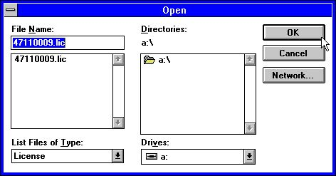

8. Getting the codes from disk
The file is named LICENSENO.LIC and may contain informations for all users. When the disk is read just click OK both for the main license and the user license page.

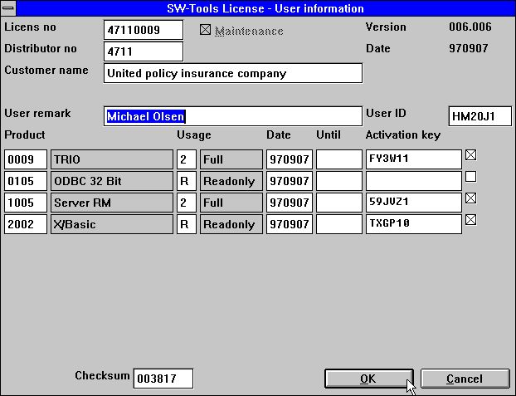

9. The updated code for the user license

1.6. Checksum
The checksum on the bottom line of the license screen ensures that all information is entered as expected. You will get an error messages as:

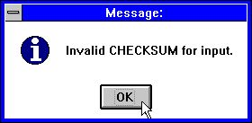

10. Invalid checksum for input
and will have to correct the information or use CANCEL before the license program lets you out.

1.6.1. Ordering new products or more users
You may add lines to the main license page without entering any activation key. Such lines will not be activated and will not be included in the checksum.
The products can be marked for client use just as normal and an order disk produced for both the main and the client license.

1.6.2. The remark fields
All information except for the remark fields is included in the checksum. You may change the remarks as you like.
The remark on the user license information may be used as the client name and referred as #UN (User Name) in the programs.

1.7. Dates
Note that the issued code is not valid BEFORE the given date and only valid TO the given until date.
The 3 months given for a client PC is calculated from the date the mark was first activated.

1.8. Missing or invalid license code
If a license code is missing you will get a message like:

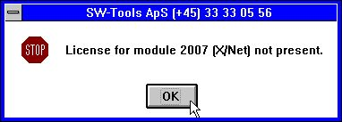

11. Trying to start without valid license
Please check that you have marked the selected product for use on the actual client and the dates are valid.

1.9. The start screen
When you start a module the license information will be shown:

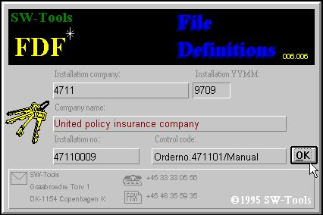

12. The start screen for the FDF module
The information is also shown in the status line and on the HELP-ABOUT page:

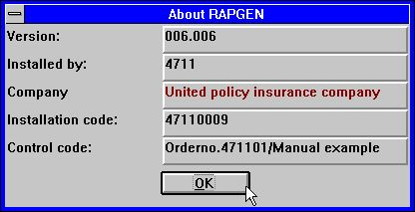

13. The ABOUT screen from the HELP menu in RAPGEN

2. Licens codes

2.1. Products
0001 - FDF Data Dictionary (Automatically enabled)
0002 - RAPGEN
0003 - IQ
0004 - DATAMASTER
0005 - ODBC 16 Bit
0009 - TRIO
0010 - Rapgen compiler
0011 - User Administation
0012 - Version upgrade
0101 - FDF Data Dictionary 32 Bit
0102 - RAPGEN 32 Bit
0103 - IQ 32 Bit
0104 - DATAMASTER 32 Bit
0105 - ODBC 32 Bit
0109 - TRIO 32 Bit
0110 - Rapgen compiler 32 Bit
0111 - User Administation 32 Bit
0112 - Version upgrade 32 Bit
1001 - Server WINDOWS 16 Bit
1002 - Server WINDOWS 32 Bit
1003 - Server OS/2
1004 - Server SCO
1005 - Server RM
1006 - Server RISC
1008 - Server HP9000
1009 - Server ICL
1010 - Server RISC-2
2000 - CSV (Automatically enabled)
2001 - ISAM Library
2002 - X/Basic
2003 - Dataflex
2005 - Btrieve
2006 - ODBC (Automatically enabled)
2007 - X/Net
2008 - Concorde XAL
2009 - Concorde C5
2010 - Isam
2011 - Unibasic
2012 - Scala
2013 - Ctras
2014 - Netbasic
2015 - Concorde C4
2017 - GSM Global 3000
2018 - Open-Basic
2019 - Navision
2022 - Global 2000
2023 - Quattro FTP

2.2. Usage of each product
1 - Demo
2 - Full
3 - Light
4 - Distributor
R - Readonly
W - Read/Write

Figure list
1. The main license code returned 14
2. Entering the main license code 15
3. Marking the specific users products 16
4. Making an order disk 17
5. Output to the license file 17
6. License file now ready 17
7. Final user license on fax 18
8. Getting the codes from disk 19
9. The updated code for the user license 20
10. Invalid checksum for input 21
11. Trying to start without valid license 25
12. The start screen for the FDF module 26
13. The ABOUT screen from the HELP menu in RAPGEN 26

Index

B
Basic 28
Btrieve 28
C
C4 28
C5 28
Checksum 21
Concorde 28
CPU 10
CSV 28
Ctras 28
D
Dataflex 28
DATAMASTER 6;8;28
DEMO 7;8
Distributor 29
DRIVER 6
E
E-Mail 4;14;18
F
FDF 6;26;28;30
FULL 7
G
GSM 28
H
HELP-ABOUT 26
HP9000 28
I
ICL 28
IQ 6;9;28
ISAM 28
L
LIC 19
LICENSENO 17;19
LIGHT 7;9
M
MODULE 6
N
Netbasic 28
O
ODBC 6;28
ODBC16 6
ODBC32 6
Open-Basic 28
P
PLS 17
PRODUCTS 6
R
RAPGEN 6;26;28;30
READ-ONLY 7
RISC 28
RISC-2 28
RM 28
S
Scala 28
SCO 28
SERVER 6
SSV 6
T
TRIO 6;28
U
Unibasic 28
UNTIL 16
Usage 7;29
USERID 10
USERS 11
W
WRITE 7
X
XAL 28

