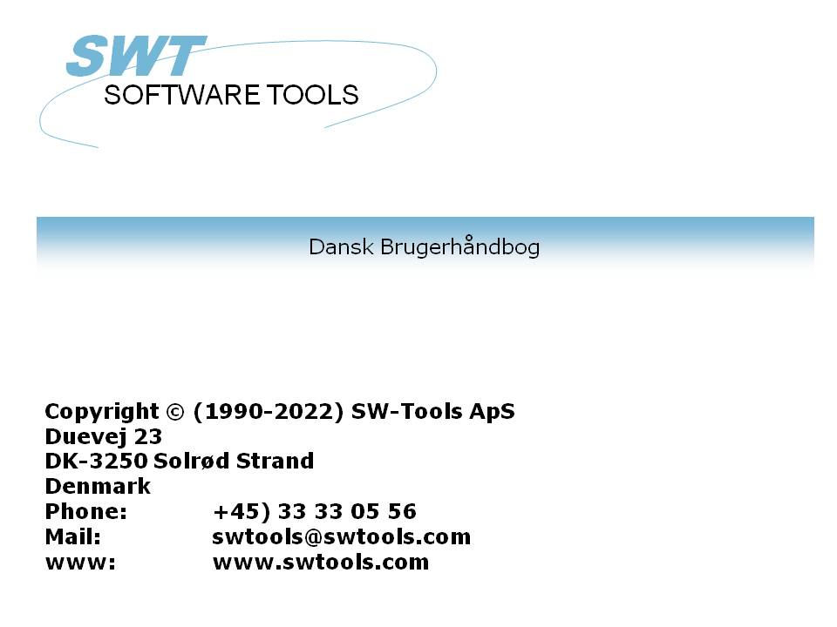

Global 2000

22/11/01 / 2022-09-01 008.384

Contents
Contents 2
1. Support 3
1.1. Scope 4
2. Setup 5
2.1. Creating a new subsystem 6
2.2. Installing the driver for Global-2000 8
2.3. Global-2000 interface adjustments 10
2.3.1. Initial changes to the interface 11
2.3.2. Creating the unit table 12
2.3.2.1. Changing units and the unit assignment file 13
2.3.2.2. Use of the unit-table during loading of copybooks 14
3. Import of the copybooks to SW-Tools Dictionary 15
3.1. Filename 17
3.2. Standard ID 18
3.3. Keyfields 19
3.3.1. RSAM file indexes 20
3.3.2. DMAM file indexes 21
3.3.3. DMAM file indexes and the ODBC driver 22
3.4. Field packtypes 23
4. Scanning of the copybook 24
4.1. Multiple copybooks 25
4.2. A copybook example 26
4.3. Filename 27
4.4. Filetext 28
4.5. Record type 29
4.6. Numeric fields 30
4.7. Date fields 31
4.7.1. Year 2000 32
4.8. Field occurences 33
4.9. Remarks as help text 34
4.10. Copying definitions 35
4.11. Redefinitions 36
4.12. Example of Date, Occurs and Redefines loading 37
Figure list 39
Index 40

1. Support

Whilst this product is supported under the normal TIS Software terms and conditions, a sufficient level of knowledge in the importing applications is required. The Global support department will only deal with problems with the TRIO software, and do not provide support for the host products (Microsoft Excel etc.).

1.1. Scope
The system supports the following Global-2000 filetypes stored in .SVL files:
RSAM Relative Sequential (Non-Indexed) files
ISAM Indexed files (1 index only)
DMAM Indexed files

2. Setup

After TRIO and the ODBC driver have been installed you must setup the following:
- A subsystem containing the Data dictionary for Global
- A driver for the Global-2000 file system
The setup is made using the 'Data Dictionary', which can be started from the program group SWTOOLS.

2.1. Creating a new subsystem
The subsystem is created by selecting the following function from the menu 'File':

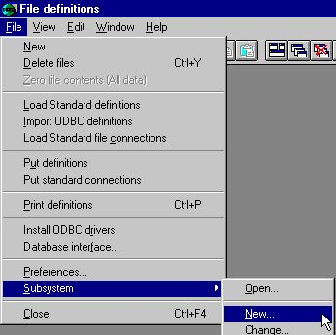

1. Creating a new subsystem
The most important information for the subsystem is the fields
- file definitions
- reports
These fields must be a path, local or on a network, where the data dictionary can be saved. If a non-existent path is entered it will automatically be created.

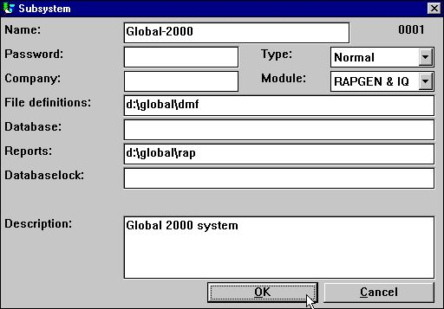

2. Important information on the subsystem
The field 'name' is used to give the system a logical and understandable name. The 'description' is free text. It will only be displayed when the mouse cursor is moved over the system name in the other TRIO applications. You may want to set up several subsystems for example one for live data and one for a test database.

2.2. Installing the driver for Global-2000
The driver may be installed using the application 'Data Dictionary'. The function to select is on the menu 'File':

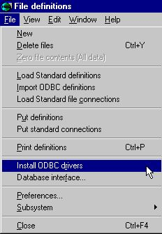

3. Installing the Global-2000 driver
The function consists of a dialog window. This initially displays information on the driver type 'SSV Textfile'. To change the installed Global-2000 interface, select the type 'Global 2000' from the first combo box.

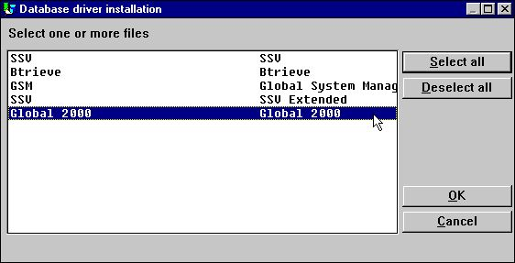

4. Selecting the driver for Global-2000
Select the Global-2000 driver and click OK.
The application will restart itself, and the Global-2000 file system will be installed. However, it is necessary for the driver to know which database to access on which unit.

2.3. Global-2000 interface adjustments
The database interface (driver) can be changed from the menu 'File' by selecting the function:

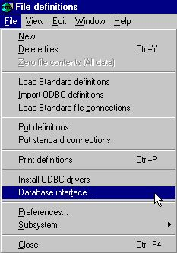

5. Changing the Global-2000 interface

2.3.1. Initial changes to the interface
Start by changing the 'Description' to a logical and understandable name. This allows the interface to be installed multiple times for different databases in the Global system.
Set the 'Read only' to 'Yes.'. The driver only supports reading the Global-2000 files - NO updates.

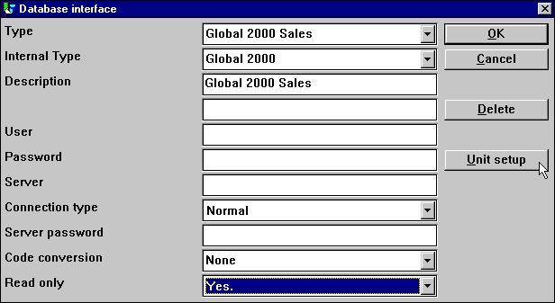

6. Initial interface changes

2.3.2. Creating the unit table
Now select the button 'Unit Setup'. This will activate a new dialog with the actual database information for the Global system.

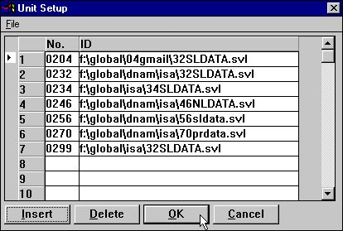

7. Setting up the unit table
A UNIT table must be created connecting units to actual SVL files. This unit table is placed together with the BASIS.SSV file, named as eg.
c:\swtools\unit0002.ssv
where 0002 is the driver number from basis.ssv. The file contains lines like
0234;i:\globalcd\g2000\34SLDATA.SVL
assigning unit 234 to the stated SVL file.
Please remember to enter the unit number as 4 digits, e.g. 234 must be entered as 0234.

2.3.2.1. Changing units and the unit assignment file
You may at any time change the unit assignment file moving complete units to another SVL file. You may also move individual files to another unit by changing the physical filename.

2.3.2.2. Use of the unit-table during loading of copybooks
Note that you should setup a correct unit table before loading the copybooks as filename and index informations are taken from the real files during this.
You may of course enter these informations manually or amend the unit table and reload the definitions if required.

3. Import of the copybooks to SW-Tools Dictionary

The Global-2000 system has no own data dictionary which means the only way to get the file definitions is from the COPYBOOK used for system generation.
The copybook must be placed beforehand in textform on the same path as where the SW-Tools file definitions are to be stored (DMF path) and named as G2000.TXT, eg.
c:\swtools\dmf\g2000.txt
Due to the varying structure of the copybooks you may find it convenient to make minor adjustments to the G2000.TXT file before loading. Several copybooks may also be combined into this file for loading in one go.
The import may then be performed from the following menu:

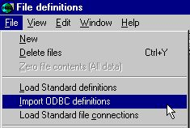

8. Importing a copybook from the Global-2000 system to the Data-Dictionary
Before the file descriptions for the database can be imported, the newly installed interface must be selected. This is done in the upper right corner where the function normally has the selection 'SSV Textfile'.

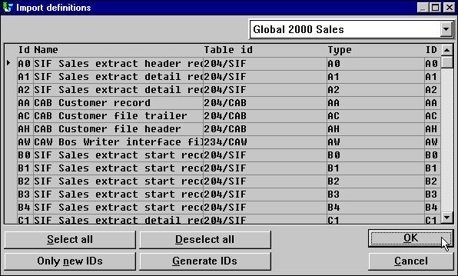

9. List of files in database
The files will by default be imported with the same file id's as known in the Global-2000 system, e.g. recordtype VP for Sales analysis detail records.
By selecting 'OK' all file descriptions will be imported.

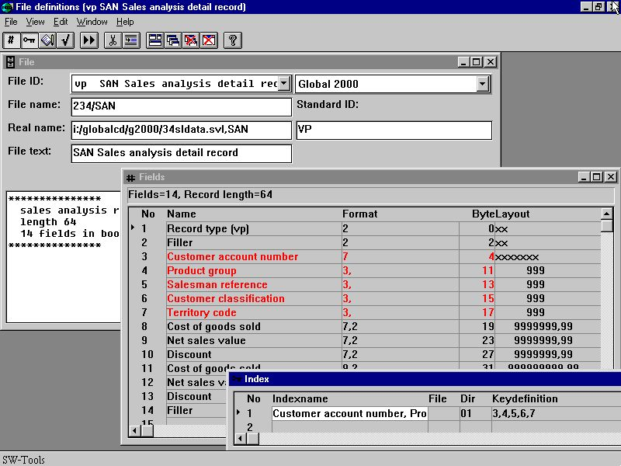

10. Example of a loaded table

3.1. Filename
During the load the files will be searched in all SVL files mentioned in the unit table and assinged a unit from here. The CAB file may be found on unit 234 whereas the filename will be loaded as 234/CAB.

3.2. Standard ID
The STANDARD ID will be set to the recordtype of the file and will be used to select only records of this type by read. You should note that where you may choose the file ID freely then the standard ID will have to correspond to the real recordtype stored in the file.

3.3. Keyfields
The SVL file header will be read during import of definitions while the unit table must have been setup before this.
The unitnumber is inserted for the file as 234/CAB and the keylength is used to define all fields as keys when these has a byte displacement between 4 and 4+keylength (byte 0-3 are reserved for recordtype and link always).

3.3.1. RSAM file indexes
As the RSAM relative sequential files have no index these will cause a problem when working with Microsoft ACCESS as an unique key is required here.
Due to this an extra field will be added to a RSAM file definition as
RECORDNUMBER 8,W
and this field will be setup as index keyfield fooling ACCESS to believe an index is present.

3.3.2. DMAM file indexes
Due to the structure used in DMAM the following index options will be common in the key definetions:
D = Descending index, all bits in the field are inverted
S = No inversion on sign bit in numeric field
Set when more numeric fields are included into one DMAM keypart
as DMAM will flip the signbit on the first field only.
Cx = Compression using translation table
x is stated as the DMAM used length of the compressed key
M = Multiple keys, set as documentation only for non-unique keys
.

3.3.3. DMAM file indexes and the ODBC driver
The ODBC knows which index to use from the WHERE clause in the SQL, the ANSI SQL standard specifies how this should be done and you may find some samples also in the README textfile on the ODBC driver disk.
WHERE Salesman>1
will go thru all defined index of the file looking for an index with the first field being 'Salesman' using this if present.
If no such index is found the first index is used and the file may be read in complete.

3.4. Field packtypes
The same packtypes as for Global 3000 are used by default:
1112 PT_GSM1 x bytes, Alphanumeric
1113 PT_GSM2 1 byte, Integer <=2 digits
1114 PT_GSM3 2 bytes, Integer <=4 digits
1115 PT_GSM4 3 bytes, Integer <=6 digits
1116 PT_GSM5 4 bytes, Integer <=9 digits
1117 PT_GSM6 1-8 bytes, Floating point if decimals or more than 9 digits

4. Scanning of the copybook

You must be fully aware that the loading of definitions from the copybooks should be considered as guidelines for the file definitions only and should not be taken without control as the loading can never be better than the original copybook.
Amendments of the file definitions after loading will be usual as the copybooks does not state all details and does not always follow any fixed syntax. It may be more convenient to amend the G2000.TXT copy of the copybook before loading to make this follow a more general syntax.

4.1. Multiple copybooks
In case of multiple copybooks to be loaded into the same FDF system you may select to join these into the G2000.TXT file. By import of the 2.copybook the fileID's cannot be the reused and the defaulting to the file recordtypes cannot always be done.
You may also install the Global 2000 database interface multiple times in the same system. If you change the 'Description' field when 'Amending database interface' to something other than 'Global 2000' next 'Install odbc drivers' will give you a second instance.
Each of these has there own unit table, say UNIT0002.SSV for the first UNIT0003.SSV for the second. By 'Import odbc definitions' you select the appropriate driver for the files giving you the associated unit table.
The copybook G2000.TXT must be overwritten between each such import.

4.2. A copybook example
A file definition from the Global-2000 copybook may look like:
:
RECORD VP SAN Sales analysis detail record
:
.BOOK VP
****************
* SALES ANALYSIS RECORD
* LENGTH 64 KEY 15
* 14 FIELDS IN BOOK
****************
02 &&TYPE PIC X(2) * RECORD TYPE (VP)
02 FILLER PIC X(2)
02 &&ACNO PIC X(7) * CUSTOMER ACCOUNT NUMBER
02 &&PGRP PIC 9(3) COMP * PRODUCT GROUP
02 &&SMAN PIC 9(3) COMP * SALESMAN REFERENCE
02 &&CUCL PIC 9(3) COMP * CUSTOMER CLASSIFICATION
02 &&TYCD PIC 9(3) COMP * TERRITORY CODE
*
* SALES STATISTICS FOR THE PERIOD
*
02 &&PCGS PIC 9(7,2) COMP * COST OF GOODS SOLD
02 &&PNET PIC 9(7,2) COMP * NET SALES VALUE
02 &&PDIS PIC 9(7,2) COMP * DISCOUNT
*
* SALES STATISTICS YEAR TO DATE
*
02 &&YCGS PIC 9(9,2) COMP * COST OF GOODS SOLD
02 &&YNET PIC 9(9,2) COMP * NET SALES VALUE
02 &&YDIS PIC 9(9,2) COMP * DISCOUNT
02 FILLER PIC X(18)
.END
:

4.3. Filename
The filename is taken from the RECORD sentense, in this case SAN:
RECORD VP SAN Sales analysis detail record
if just a BOOK section is present as
.BOOK AA * File CAB SL customer record (IS)
:
:
.END
the file definition will be loaded but the filename cannot be taken from the comment here and Unit-information and indexdefinitions will not be supplied.

4.4. Filetext
The filetext is taken from the RECORD sentense also
RECORD VP SAN Sales analysis detail record
and if no RECORD sentense is present from the comment on the .BOOK line.

4.5. Record type
All files will have a record type which are taken from the comment line of the first field named TYP or RTYP
02 &&TYPE PIC X(2) * RECORD TYPE (VP)
02 &&RTYP PIC X(2) * RECORD TYPE = DH
A field named 'Record type (VP)' is defined as a 2 alphanumeric field and the STANDARD ID for the file is set to VP causing all read to check this type.
The first &&TYP or &&RTYP is taken, record type is set to (xx) or to the two last alphanumeric characters on the line.
If no recordtype can be found this way the file shortname from the .BOOK sentense will be used.

4.6. Numeric fields
Numeric fields are stored in different length. Depending on the COBOL PIC specified the proper packtype (fieldlength) will be selected for the FDF (see above)
02 &&PGRP PIC 9(3) COMP * PRODUCT GROUP
02 &&PCGS PIC 9(7,2) COMP * COST OF GOODS SOLD

4.7. Date fields
Whenever a numeric field of 6 digits with DATE occurring in the remark is met (independent of case) this will be loaded as a datefield.
02 &&LAD PIC 9(6) COMP * LAST AMENDMENT DATE
02 &&EXPD PIC DATE * Expiry date
The first defines a field named 'Last amendment date' will be defined as a ,6, date field.

4.7.1. Year 2000
Date fields are assumed to be in the format YYMMDD as 980901 for 1998.09.01. Year 2000 dates are stored as 1YYMMDD as 1000331 for 2000.03.31.

4.8. Field occurences
The COBOL OCCURS clause defines a table of fields:
02 &&FPPB OCCURS 4 PIC S9(7,2) COMP * PAST PERIOD BALANCE O.
A field named 'Past period balance o' will be defined 4 times in the FDF. The table facility in the FDF as a ,7,2(003) is not used as an ODBC/SQL application is better of when all fields in the table is explicitly named and can be selected directly instead of using a the table syntax:
SELECT AA.'Account number',
AA.'Past period balance o',
AA.'Past period balance o'(1) FROM AA AA
.

4.9. Remarks as help text
Any comment lines following a field definition is placed as field help text.
* THE CURRENT PERIOD BALANCE IS A TOTAL OF ALL

4.10. Copying definitions
A .BOOK section may include other .BOOK definitions as for
COPY DX SUBSTITUTING "DD"
The file definition for DX is copied, recordtype DX will be substituted by DD.

4.11. Redefinitions
The COBOL language often uses the redefines clause as:
01 &&CONF REDEFINES &&CO
Such redefinition causes Bxxx byte number of the field format to be set which means both the orginal definition and any following redefinitions will be loaded as fields in the FDF

4.12. Example of Date, Occurs and Redefines loading
The file AH may be defined in the copybook as:
.BOOK AH * File CAB SL header record
*******************
* HEADER RECORD IN CAB FILE - RECORD LENGTH = 352
*******************
02 &&TYP PIC X(2) * RECORD TYPE (AH)
02 FILLER PIC X(2)
*
* RECORD KEY
*
02 &&ACC PIC X(7) * ACCOUNT NUMBER (ZEROES)
*
* FILE VERSION NUMBER
*
02 &&VER PIC 9(2,2) COMP
*
* PERIOD END DATES
*
02 &&PDTS
03 &&CPD PIC 9(6) COMP * CURRENT PERIOD DATE
03 &&PPDS * PAST PERIOD DATES
05 &&P1D PIC 9(6) COMP * PAST PERIOD 1 DATE
05 &&P2D PIC 9(6) COMP * PAST PERIOD 2 DATE
05 &&P3D PIC 9(6) COMP * PAST PERIOD 3 DATE
05 &&P4D PIC 9(6) COMP * PAST PERIOD 4 DATE
*
02 &&CPUD PIC 9 COMP * 0=no updates in close period
* 1=CAB/SLT files updated in
* close period
02 FILLER PIC X(323) * RECORD LENGTH = 352
*
01 FILLER REDEFINES &&PPDS
02 &&PPD OCCURS 4 PIC 9(6) COMP
.END
:
and will load as:

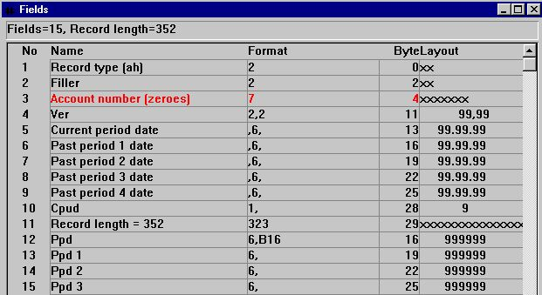

11. Example of Date, Occurs and Redefines loading

Figure list
1. Creating a new subsystem 6
2. Important information on the subsystem 7
3. Installing the Global-2000 driver 8
4. Selecting the driver for Global-2000 8
5. Changing the Global-2000 interface 10
6. Initial interface changes 11
7. Setting up the unit table 12
8. Importing a copybook from the Global-2000 system to the Data-Dictionary 15
9. List of files in database 16
10. Example of a loaded table 16
11. Example of Date, Occurs and Redefines loading 38

Index

A
ACCESS 20
C
COBOL 30;33;36
D
Date 31;32;37;38;39
Dictionary 5;8;15;39
DMAM 4;21;22
G
Global 1;3;4;5;8;9;10;11;12;15;16;23;25;26;39
I
ISAM 4
O
Occurs 37;38;39
ODBC 5;22;33
R
Redefines 37;38;39
RSAM 4;20
S
Setup 5;12
T
TRIO 3;5;7
U
Unit 12;27

