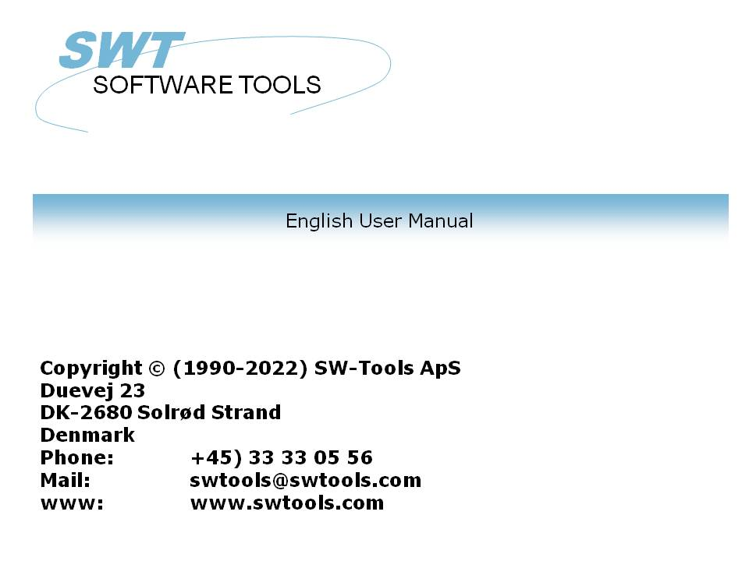

DATAMASTER User manual

22/11/01 / 2022-09-01 008.384

Contents
Contents 2
1. Introduction 4
1.1. Starting DATAMASTER 5
1.1.1. Licence information 6
1.2. Principle of operation 7
1.2.1. Defining / redefining tables 8
1.2.2. Making dataentry programs 9
1.2.3. Database (ODBC) interface driver/ file type. 10
2. Defining a new table 11
2.1. About the user interface 12
2.2. Creating a new table 14
2.2.1. Table ID 15
2.2.2. File name 16
2.2.3. Database interface (File type) 17
2.2.3.1. Real filename 18
2.2.3.2. Disk (lu) 19
2.2.3.3. Number of records 20
2.3. Entering the fields 21
2.3.1. Field name 22
2.3.1.1. Field SQL name 23
2.3.2. Field format 24
2.3.2.1. Editing of numeric fields 25
2.4. Ending the definition 26
3. Entering data into the table 27
3.1. DATAMASTER and IQ 28
3.2. The DATAMASTER functions 29
3.2.1. Create a new record 30
3.2.1.1. Input validation and date fields 31
3.2.2. Amending a record 32
3.2.3. Deleting a record 33
3.3. Dataentry on list form 34
3.3.1. Create a new record 35
3.3.2. Amending a record 36
3.3.3. Deleting a record 37
4. Altering and extending a table definition 38
4.1. Changing the database interface (file type) 39
4.2. Modifying the field informations. 40
4.2.1. Field name 41
4.2.2. Field format 42
4.2.3. Inserting/deleting fields 43
4.2.3.1. Free field numbers 44
4.2.4. Marking fields as index fields 45
4.2.4.1. K mark for unique Key fields 46
4.2.4.2. D mark for Duplicates allowed 47
4.3. Index definitions 48
4.3.1. Name 49
4.3.2. Fileid 50
4.3.3. Directory (Index number) 51
4.3.4. Keydefinition 52
4.4. Table and field documentation (Helptext) 53
4.4.1. Entering the fielddocumentation 54
4.4.2. Floating on-line field help 55
4.5. Field checkcodes 56
4.5.1. Defining the check 57
4.5.2. Field validation 58
4.6. The view menu 59
4.7. Ending the redefinition 60
5. Copying, deleting and printing the definitions 62
5.1. Copying a table 63
5.1.1. Copying a definition only 64
5.1.2. Data conversion between systems 65
5.1.3. Using RAPGEN to copy data 66
5.2. Deleting tables 67
5.2.1. Zero file contents (All data) 68
5.3. Printing documentation 69
5.3.1. Options 70
5.3.2. Printer 71
6. Working with multiple tables 72
6.1. Defining relations between tables 73
6.2. Database relations inquiry 74
6.3. Dataentry programs using multiple files 75
6.4. Transaction registration programs 76
7. Saving and modifying the dataentry program 77
7.1. OK/CANCEL buttons 78
7.1.1. Button shortcuts 79
7.2. The simple dataentry program 80
7.2.1. Field sequence parameters 81
7.2.1.1. Specifying the input sequences 82
7.2.2. Calculation entry points 83
7.2.2.1. Before update 84
7.2.2.1.1. The MESS function 85
7.2.2.1.2. The GOSUB statement 86
7.2.2.2. Update of main file 87
7.2.2.2.1. The FUNC function 88
7.2.2.2.2. The ON statement 89
7.2.2.2.3. REWRITE, INSERT and DELETE functions 90
7.2.2.3. Create, Default record 91
7.2.2.4. Calculations after input 92
7.2.2.4.1. The DISP function 93
7.2.2.5. Calculations before input 94
7.2.2.5.1. The NEXTFLD function 95
7.2.2.6. By change of input sequence 96
7.3. The list dataentry program 97
7.3.1. The LOOP function 98
7.4. The transaction registration program 99
7.4.1. Calculation entry points 100
7.4.1.1. Before update 101
7.4.1.2. Transaction update 102
7.4.2. SUM of transactions 103
7.4.3. Set KEY on transaction file (SUM) 104
7.4.3.1. The SETUPD function 105
7.5. Other calculation functions 106
7.5.1. The SEQ function 107
7.5.2. The MENUS function 108
Figure list 109
Index 111

1. Introduction

SW-Tools DATAMASTER is a tool which allows the user - without any previous experience in programming - to define tables/files, maintain them and expand their contents and size.
A table defined with DATAMASTER is automatically installed into our other products:
- RAPGEN can be used to produce printouts / batch update programs and
- IQ can be used to define inquiry programs immediately.

1.1. Starting DATAMASTER
DATAMASTER consist of two parts which shows as two different icons in Windows:

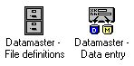

1. DATAMASTER icons
The file definition program is used to maintain the Data Dictionary, create new tables, amend/extend/delete existing tables and print database documentation.
The file maintenance program is used to define dataentry programs where you can create new records in the table, amend existing records or delete these.

1.1.1. Licence information
DATAMASTER is copyrighted SW-Tools and your licence information is shown briefly whenever the program is started.

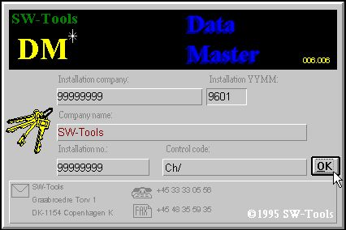

2. Licence screen
You are of course only allowed to use DATAMASTER according to your license agreement.

1.2. Principle of operation
The first part of DATAMASTER derives from the Data Dictionary module used for RAPGEN/IQ, this module has the facility to describe tables and has for DATAMASTER also the possibility to create the table itself. Apart from this every function described in the comprehensive Data Dictionary installation manual may be used but only a small subset of these is normally needed by the DATAMASTER user.
The second part of DATAMASTER is an extension of the IQ inquiry system enabling you also to make dataentry. This combination offers you the possibility to use all the search facilities in IQ together with your dataentry system.

1.2.1. Defining / redefining tables
A table is identified in the system by a ID consisting to letters or a letter and a digit. Whenever you want to use the table the ID must be given. The two table ID's SY and WW are reserved for special use, SY being SYSTEM FIELDS as today's date, WW being work fields for calculations in a program, each program will have is own work fields.
When you define a new table you just have to select a table ID, enter a name for the table and then for each field a name and a format, which determines the field length and layout. Each field is given a field number which are used to identify the field later on.
By ending the definitions DATAMASTER will install your new table definition in the data dictionary and create the table itself.
When you amend an existing table you can add new fields to the end of the table of change the name/format of existing fields. When finished DATAMASTER builds a new table and makes and runs a conversion program reading the records in the old and writing the new. When the conversion is successfully completed the old table is deleted and the new table activated.
You may insert/delete fields during this but note that fields are copied by field number as well as reports/programs may refer the table fields using the numbers. Each field may also be associated with check of valid values and an extensive documentation if so desired.

1.2.2. Making dataentry programs
As IQ, DATAMASTER enables you to make 3 different sort of programs:
- One record maintenance
- List of records
- Transaction registration
A program is defined just by entering the fields you want on the screen and may then be saved. The saved program contains the standard DATAMASTER screen layout and the calculations needed for reading/updating the tables involved.
You can freely amend such a saved program designing you own screen layout and tailoring the calculations to read/update any number of files you desire.
Calculations are parted into sections for e.g. making DEFAULT record by create, action upon input/click on a field and update of files so the standard program made by DATAMASTER is easy modified to meet your special requirements.

1.2.3. Database (ODBC) interface driver/ file type.
When defining a table you choose a file type among the installed database drivers Which driver you select depends on the future use of your tables.
Changing the file type during redefinition of a table causes DATAMASTER to CONVERT the file from one database system to another. The functionality of your programs is independent of which database systems are used unless the database itself has restrictions. The database driver must of course be able to insert/modify records in the tables.
The standard SSV (Semicolon Separated Variable length textfile) can be used for most DATAMASTER files, as this gives the smallest, fastest and most flexible file and may be imported into many other applications.
The ODBC drivers can be selected if you want to create files directly for a specific database system such as EXCEL, DBase, ACCESS, Informix, INGRESS or like. As these systems uses the far more complex SQL language you may experience that these are not as fast as the SSV files.
With the X-Basic driver using either the UNIX libraries or the CTRAS functions you can make basic indexed files directly.

2. Defining a new table

The Data Dictionary part of DATAMASTER enables you to define/redefine tables.
In this chapter we will create a simple customer table and just the functions necessary for doing this will be mentioned. Next chapter will describe how you puts data into this file.

2.1. About the user interface
The Data-Dictionary always displays a main window with the following informations:

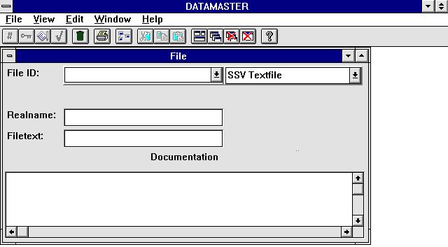

3. The main window
To access the functions in the Data-Dictionary you may use the menus or the related buttons on the toolbar.

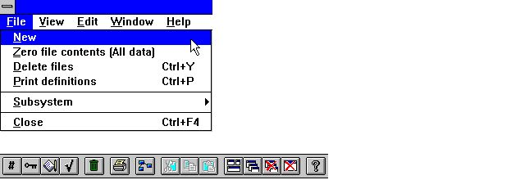

4. Accessing the functions using menus or the toolbar
Because the toolbar does not have room for all the functions in the Data-Dictionary it will vary from function area to function area, as for the pulldown menus. For example you will view this toolbar when activating the field function:

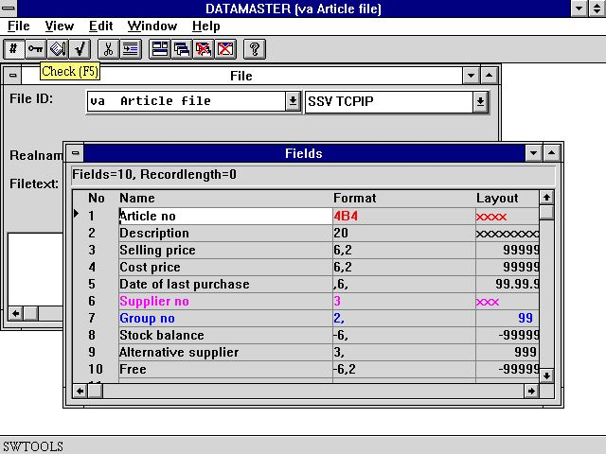

5. The toolbar during field input
Even though the menus and toolbar buttons changes between functions the Data-Dictionary have some general functions attached on the toolbar. It is functions to place Windows, closing the active window and access to the on-line manual. Because these functions are attached to the toolbar they will of course also be accessible from the pulldown menus:

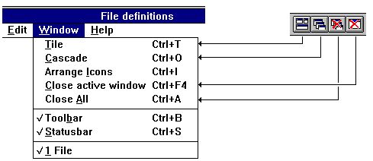

6. Generel menus and buttons

2.2. Creating a new table
To create a new table you select the function NEW from the FILE menu.

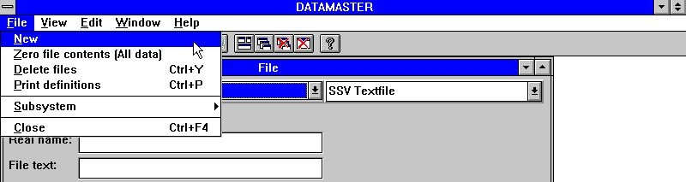

7. Defining a new table

2.2.1. Table ID
You will be asked to enter a TABLE ID consisting of two letters or a letter followed by a digit:

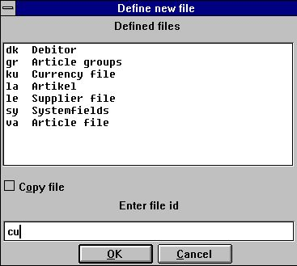

8. ID of new table
The ID's SY and WW are reserved for system use.
The listbox contains all tables used in the system - not only DATAMASTER tables. You must choose an ID which is not in use.

2.2.2. File name
After entering the ID the table name is defaulted to 'new file' and you should replace this with your desired name.
If you use TAB to move to next field the FIELD WINDOW will open allowing you to enter informations for each field.

2.2.3. Database interface (File type)
In case you have more database drivers installed you can select between these using the combobox:

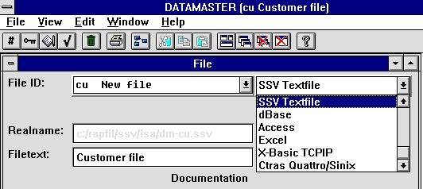

9. Database interface (File type) selection
The chosen interface must be able to build and update tables in the database if not DATAMASTER will reject to create your table later on. Pls. refer to the discussion about which interface to choose in the introduction.

2.2.3.1. Real filename
Based on which database driver you have chosen a real filename will be generated by DATAMASTER and shown for your information. This may be a database table name, a DOS or UNIX filename or a BASIC filename.

2.2.3.2. Disk (lu)
If you have chosen a BASIC interface this field will be activated and you may place the file on any other disk instead of the default lu 0.

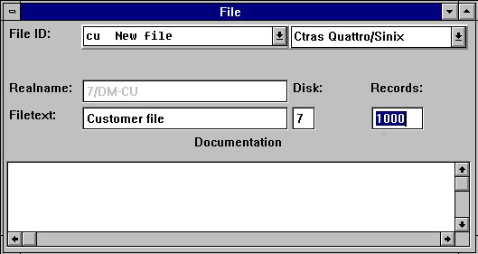

10. Disk (lu) and number of records

2.2.3.3. Number of records
Also for a BASIC interface you must specify the maximum number of records you want the file created with. The default is 1000.

2.3. Entering the fields
A table can consist of 1 to maximum 499 fields.

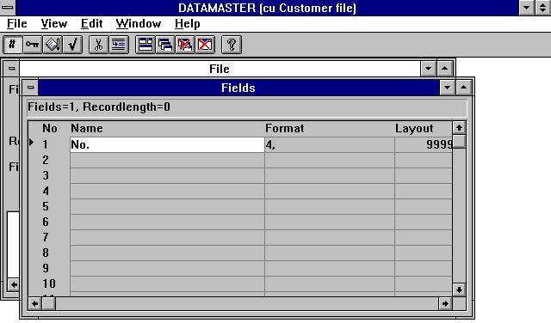

11. The field window
For each field you must enter a name and a format defining the length and type of the field. From the format specification DATAMASTER retrieves all information about the field needed for the selected database driver such as field pack type byte number if needed etc.

2.3.1. Field name
You can enter a free text of max. 256 characters and you may use special characters, language dependent letters and blanks as you desire.
We normally recommend to keep the field names short and clear as these are used as headings for screen programs and reports later on the ideal field name has the same length as the field itself.

2.3.1.1. Field SQL name
If the database driver you selected are using SQL DATAMASTER makes an unique and valid name from your free-text name. You do not have to worry about this.

2.3.2. Field format
The field defines how the values are retrieved and stored in the table. It also defines how the field has to be printed or displayed.
The format can define:
- An alphanumeric field
- A numeric field
- A date field
An alphanumeric field may contain text of any kind and is only limited by a maximal length. Therefore the field can be defined as:

 | Format | Description
 | 10 | The field is limited to 10 characters
 | 20 | The field is limited to 20 characters

A numeric field contain only numeric values but may be defined with or without a decimal part. The following examples describes the syntax:

 | Format | Description
 | 2, | The field may contain a value from 0 to 99
 | -2, | The field may contain a value from -99 to 99
 | 5, | The field may contain a value from 0 to 99999
 | -7,2 | The field may be negative and have a maximum of 7 digits and 2 decimals
 | 9,3 | The field have a maximum of 9 digits and 3 decimals

A date field may be one of the following:

 | Format | Description
 | ,6, | Contains the date as YYMMDD, where YY=Year, MM=Month, DD=Day
 | ,8, | Contains the date as YYYYMMDD, where YYYY=Year, MM=Month, DD=Day

2.3.2.1. Editing of numeric fields
A numeric field value can also be edited. If the values has to be printed or displayed with a comma or dot for each 1000 of the integer part just insert a leading comma in the format
,9,2
The value 123456789.12 will be displayed as
123,456,789.12
Please note that date fields with the format ,6, and ,8, cannot be used for other values than dates.
A field defined with leading comma will always support negative values as if defined with leading sign, e.g.
-,9,2 equals ,9,2
The character used to edit the field, in this example a comma, may be changed with the Preferences function.
Leading zeros or stars is also an option for numeric fields. If the field format contains the character &, e.g.
9,2&
the value 12345.12 is displayed as
000012345.12
or if the format is defined with the character *, e.g.
9,2*
the value 12345.12 is displayed as
****12345.12

2.4. Ending the definition
When you close the file definition [ALT+F4] or choose another file you will be asked if your definition should be kept.

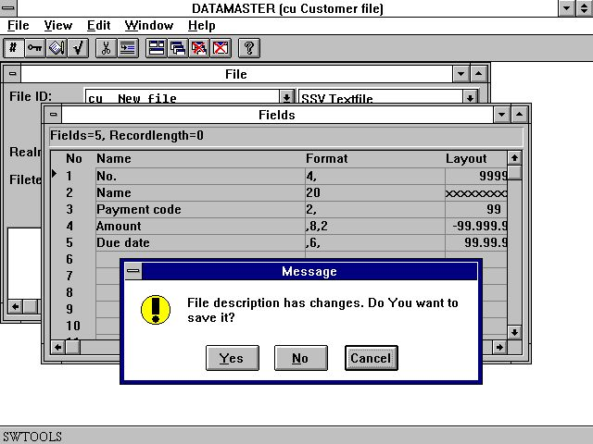

12. Ending the definition
When you answer YES the definition is stored and the file itself will be build and initialised according to the database driver you have selected.

3. Entering data into the table

Defining a dataentry program with DATAMASTER is just like defining a query in IQ but you will be able to make input to the fields.

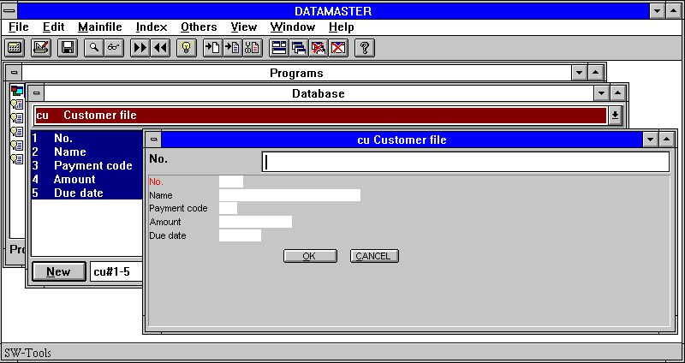

13. The first dataentry program
The newly created table (cu) is present in the Data Dictionary and you can just define a query program consisting of all fields cu#1-5. As you have selected DATAMASTER this becomes a dataentry program.
The first field (no.) is marked in red. DATAMASTER has made this field to the main index keyfield as you have not told anything else.

3.1. DATAMASTER and IQ
If you have bought and have a licence code for IQ also you may use all the functions described in the IQ manual on your new file.
Without a IQ licence you can only make programs involving you own DATAMASTER files. You will be able to enter data into your file(s), make programs with calculations and reading of other DATAMASTER files but you cannot use the IQ extensive search facilities:
- First / Last / Previous record
- First / Last / Previous / Reverse order of transactions
- Superindex
- Selections
- Index selection lock
- Display key
- Case dependent search
- Inter-program communication
In the rest of this manual we will assume that you have IQ active so no restrictions in use occurs.

3.2. The DATAMASTER functions
A DATAMASTER program is extended with the functions for create/amend/delete a record in the main file, each function being associated with an icon on the toolbar.

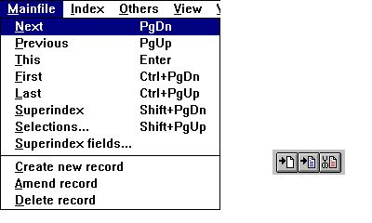

14. DATAMASTER mainfile menu and the function icons

3.2.1. Create a new record
When you select 'create new record' the input field changes from the search key to the first key field defined in your file (no.).
You must enter the key where after DATAMASTER makes a check that this key is not present in the file already. Hereafter you enter the data for each field.
You may use
- TAB or just ENTER to move to next field,
- SHIFT+TAB to go to previous field,
- CURSOR UP/DOWN to move straight up/down in the fields
- click on any field with the mouse to jump directly to this

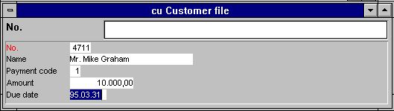

15. Dataentry

3.2.1.1. Input validation and date fields
During your input each field is validated so it will not exceed the field length you have specified, numeric fields must contain digits and date fields must contain a valid date or zero. If not you will get an error message box like:

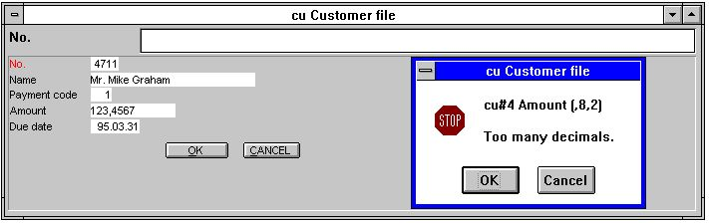

16. Input validation error message box
Date fields may be entered as DDMMYY, YYMMDD or YYYYMMDD and will automatically be turned according to the date specification by installation. You may also enter just a part of the date as DD or DDMM - the missing part will be taken from the current system date.
When you have finished the input for this record you may select the 'Create new record' function once more or just press ESC. You will be asked to confirm writing the record to you file:

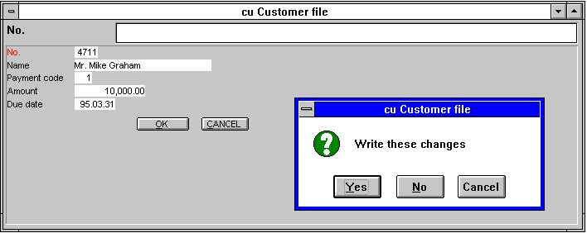

17. Confirmation of file update

3.2.2. Amending a record
To amend a record you can first look this up by entering a value in the search key and using the IQ search functions and then choose the AMEND icon or just press TAB to jump from the keyfield to the first non-key field in your file.
You may change all fields including the key fields. You finish the amend function by use of ESC to jump to the keyfield or any of the functions to select another record as PAGE DOWN for next record. Also here you will be asked to confirm writing the changes for each record.

3.2.3. Deleting a record
When you have looked up a record just choose the DELETE icon. You will be asked to confirm the removal of the record from the file.

3.3. Dataentry on list form
As in IQ you can make a list of records by placing the letter l after the fields.

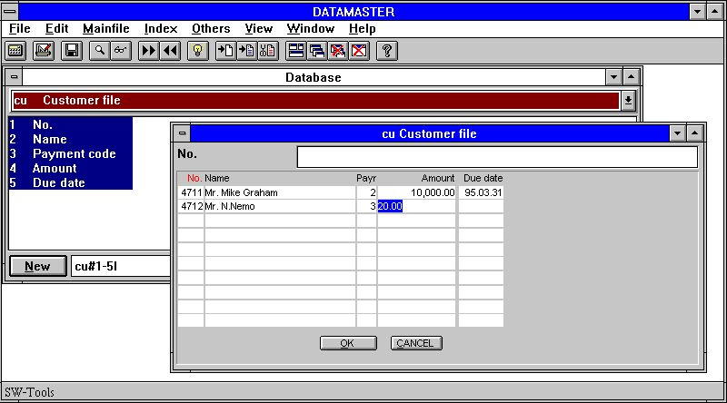

18. Dataentry on list form.
In this way you will be able to search/select a bunch of records, amend these or insert/delete records among these.
The records in such a list is kept in an internal buffer and all your amendments goes to this until you finishes the page by PAGE DOWN for next page or by ESC to jump to the keyfield. At that moment you will be asked to confirm all the updates.

3.3.1. Create a new record
Just click on a blank line and type your data. You may also choose the 'create new record' icon when positioned on a line. This causes a new empty line to be inserted ready for new input.

3.3.2. Amending a record
Just click on a line containing data and type your the new values.

3.3.3. Deleting a record
When you are positioned on a line containing data click on the 'delete' icon and the line are removed completely from the screen.

4. Altering and extending a table definition

When you modify a DATAMASTER table you can change all informations in the definition except the to letter FILE ID identifying the file.
After the modifications when you confirm your changes the new definition will be stored not overwriting the present definition but in a file prefixed NEW. The old and the new file definition will both be present at this time.
DATAMASTER now compares the old and the new definition to see if your modifications requires changes in the file itself. If so a NEW file is build and a conversion program generated and run copying all data from the old file to the new file.
If everything goes ok the old definition and the old file will be deleted and the new file renamed (activated). If something goes wrong the old definition and the old file will be kept as if no changes had occurred. Also your NEW definition with the modifications will be kept - next time you try to modify the definition possible after freeing disk space for the new file on the server you will be asked whether the new definitions should be activated.
To amend the definition for a file open the box with FILE ID and select the table you want to modify.

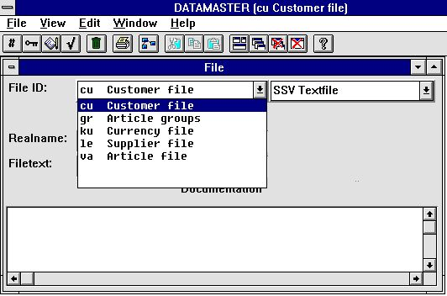

19. Selecting the table to amend
Note the listbox contains DATAMASTER files only - you cannot alter other tables in your system due to security reasons.

4.1. Changing the database interface (file type)
If you change the file type the table will be converted from one database system to another. In this way a file created e.g. with the fast SSV interface can be converted into any other database system as ACCESS.

4.2. Modifying the field informations.
You may freely modify the field names and the field formats.

4.2.1. Field name
If the database driver uses SQL names a conversion from old SQL name to new will be done when you finishes your modifications.

4.2.2. Field format
A field can be extended to hold more characters or digits without problems. If you shorten a field to hold fewer characters it will be your own responsibility that the present data can fit into the new field, if not the values will be truncated.
Numeric fields may be changed to textfields and textfields may be changed to numeric also. DATAMASTER will do its best to convert your values.

4.2.3. Inserting/deleting fields
In the EDIT menu and on the toolbar you will find the commands/icons to insert/delete fields.

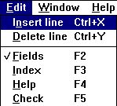

20. The EDIT menu
When you insert or delete fields the index definitions, field help documentation and check codes (see later) automatically moves with the new field numbers.
However you should be careful with these commands as the conversion program DATAMASTER generates uses the field numbers, it is
- NEW field 1 = OLD field 1,
- NEW field 2 = OLD field 2,
- NEW field 3 = OLD field 3...
Also your defined programs for dataentry, IQ or RAPGEN may refer to field numbers, these programs you must change manually afterwards.
Normally insert/delete fields should be used only for empty files with no or very few defined programs.

4.2.3.1. Free field numbers
When you define a program using DATAMASTER, IQ or RAPGEN a number of free fields, default 40, are added to the mainfile definition. If the main file has 10 fields you refer these free fields as field number 11-50.
If you extend the file to say 20 fields the free field numbers moves to 21-60.
In the calculations/layouts of the programs you have already defined the free field numbers will move automatically as these are stored not as e.g. #11 but as WW#1.

4.2.4. Marking fields as index fields
Index defines how the data is sorted in a table and how to access a specific record. You use the index e.g. when searching a record in IQ.
When you create a new table the first field is automatically named to be the main (primary) unique key (index) for the table unless you tell something else.
You see this when amending the file as the first field is shown in red and a K is added to the format (unique Key).

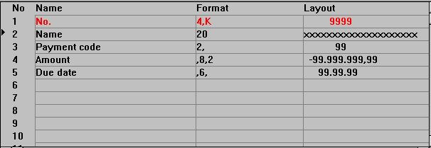

21. The field K index mark

4.2.4.1. K mark for unique Key fields
You can mark other fields with K making these unique key fields and you can remove the K mark on the first field.
The K mark is normally used only for the first field as e.g. customer number identifying the record. Two customers can not have the same number.
When the file contains data you should be careful marking fields with K as the data in the file cannot be copied unless they really holds different values for each field.

4.2.4.2. D mark for Duplicates allowed
You may also mark fields with D to allow more records with the same field value. The D mark is normally used when you wants to create a matchcode or a name index.

4.3. Index definitions
You may define other index already when creating the table or you may add / delete indexes later on. The conversion program generated will take hand of these modifications also.
A maximum of 49 index of each 128 characters length each can be defined for a table if the database driver allows this. (Basic allows only 15 index of 30 characters each).
To edit indexes for a table select the following function:

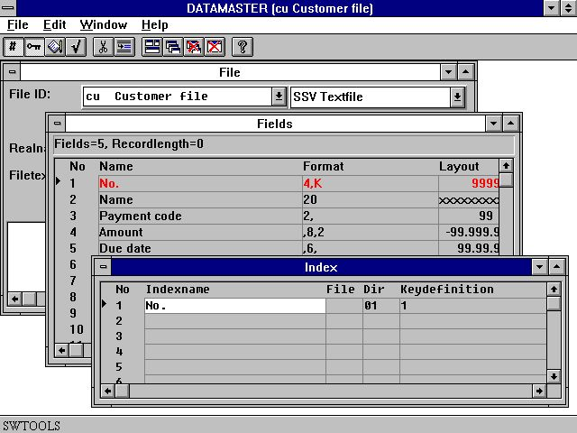

22. Editing index information
One index definition equals one line on the screen with the following informations:

4.3.1. Name
The index name may contain all letters, digits, blanks and special characters. It is used as description when e.g. IQ displays a listing of possible index selections for search.
If the database driver uses SQL names this free text name is converted into an unique SQL name also with no special characters.

4.3.2. Fileid
The fileid is only used when defining relations from this table to others, see later. Always leave this field blank when defining an index.

4.3.3. Directory (Index number)
The directory, also known as the index number, is a two-digit value. The index definitions must be numbered from 1 an upwards, you are not allowed to have to lines with the same number.

4.3.4. Keydefinition
The keydefinition is the real definition of the index telling which fields should be part of this. A few examples:

 | Keydefinition | Description
 | 1 | Field 1 is an unique key
 | #2 | Field 2 is an unique key, # can be given or omitted as desired
 | 2,1 | Field 2 is an key made unique by adding the main keyfield 1
 | 2(5,10) | Field 2 character 5 to 10 (6 characters) is a unique key
 | 2,NP | Field 2 is a key which may have duplicate values, NP indicates duplicates allowed.

4.4. Table and field documentation (Helptext)
For each of your tables you can enter a documentation text by click on the documentation field on the file page.

4.4.1. Entering the fielddocumentation
Also for each field you may enter a free text of maximum 99 lines when you open the field documentation window from the EDIT menu or by use of the icon.

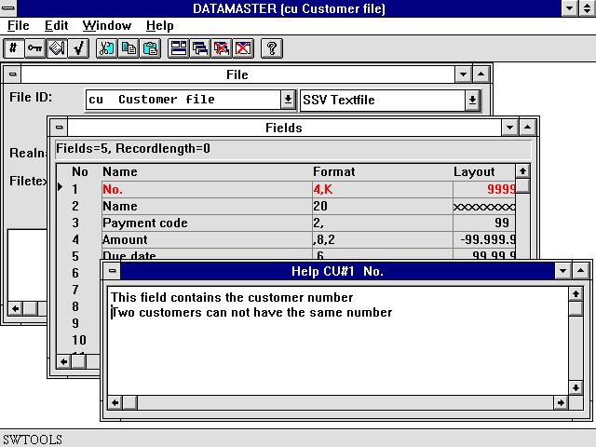

23. Editing field documentation

4.4.2. Floating on-line field help
The documentation will be printed when you print your file definitions and whenever you define a program in DATAMASTER, IQ or RAPGEN the database window for selecting fields will display floating help when the cursor is moved over the field.

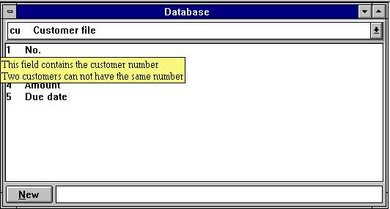

24. Floating on-line field help

4.5. Field checkcodes
Field checkcodes are used to define allowed values for fields. You can associate each field with 499 different ranges of values each connected to a description text. The checkcodes are designed for 'reasonable' small number of codes - if you need more you should create a DATAMASTER table holding the codes instead.

4.5.1. Defining the check
You open the check window from the EDIT menu or by click on the toolbar icon where after you enters the range value from-to and the text associated with that range.

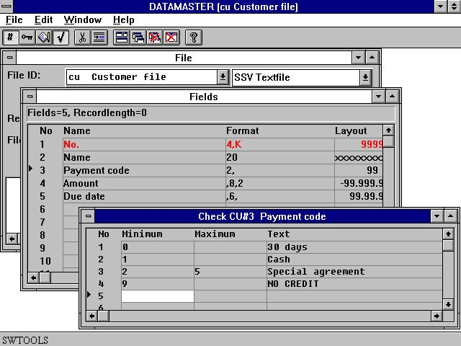

25. Defining check for a field

4.5.2. Field validation
When you define a DATAMASTER dataentry or IQ query program (as cu#1-5) an additional field is place behind all fields with associated check defined with room for the text. The length of this textfield is taken as the maximum length of any text you have defined.

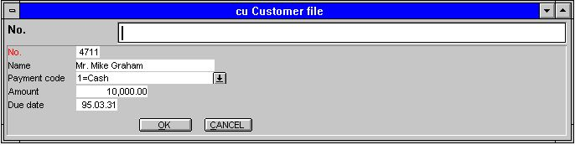

26. Field validation
The field will be validated so only the ranges you defined can be entered.
If you have created data in the file before defining the check the associated text will also be shown for these records but there may occur values which are not longer valid. These are displayed without text.

4.6. The view menu
Using the VIEW menu you can replace the layout column for each field with either the first documentation line or check code line. This gives you a fast overview of which fields have got/have not got any definitions.

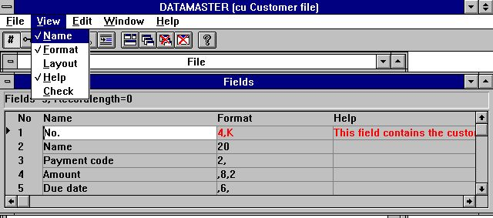

27. Overview of field documentation

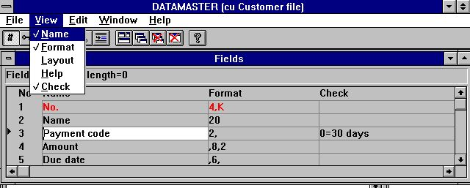

28. Overview of field check

4.7. Ending the redefinition
When you finishes your modifications of the definition the table will be converted to the new record layout if needed and you will get a message like:

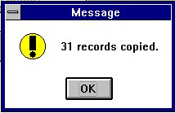

29. Confirmation of table conversion
If something goes wrong like the server runs out of disk space or you have defined an unique index where the same value of the keyfield occurs you will get a message like:

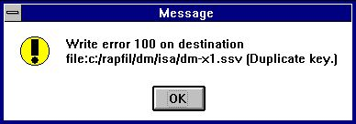

30. Error message from the conversion program
followed by:

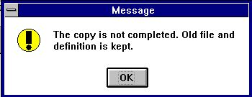

31. End message from the conversion
Next time you try to modify the table you have the possibility to activate or ignore your modifications and try again:

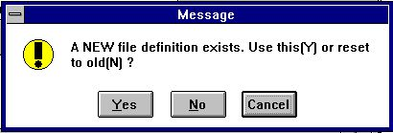

32. Try again
If you answer Y your modified definition will be used, N causes the modifications to be ignored. The following table conversion will always be done based on the original definition and table.

5. Copying, deleting and printing the definitions

5.1. Copying a table
To copy a table select NEW from the file menu and in the listbox shown:

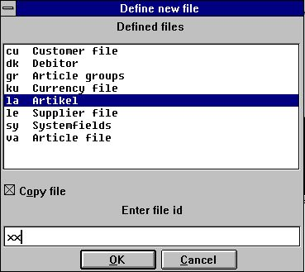

33. Marking a table for copy
select the source table by click on this, mark the copy box and enter a new ID.
The complete table definition will be copied and you can modify this. When you end your modifications all data in the original table will be copied to the new DATAMASTER table.

5.1.1. Copying a definition only
To copy a definition but not data do exactly as above but check also the option 'Zero file contents' in the file menu (see below).

5.1.2. Data conversion between systems
As the listbox above does not only contain DATAMASTER files you can select any file in the system as source file - in the above example the COMET article file from X-Basic is selected as input.
If you for the new DATAMASTER table selects another file type, e.g. ACCESS, and then just ends the definition, all data in the input file is converted into an ACCESS database table.

5.1.3. Using RAPGEN to copy data
The file you define in DATAMASTER may have a quite different set of fields than in the original file. In this case you should not choose the copy function but just define a new - empty - DATAMASTER file and then a report with the source file (la) as main file inserting records in the DATAMASTER file using calculations like:

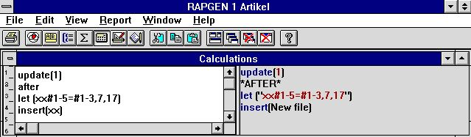

34. RAPGEN calculations for data conversion

5.2. Deleting tables
Deleting defined tables is done by selecting the following function:

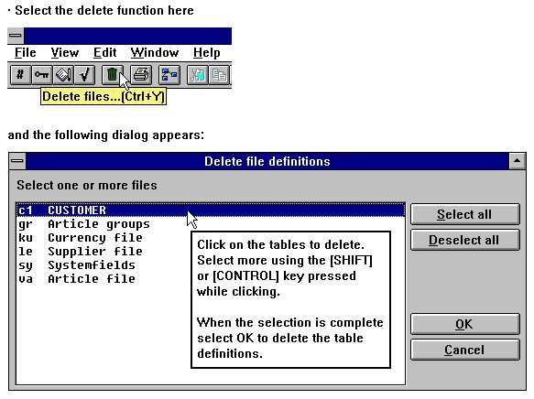

35. Deleting tables
Note that in DATAMASTER not only the table definition but also
THE TABLE AND ALL DATA WITHIN THIS is deleted !

5.2.1. Zero file contents (All data)
This function is normally used to remove test data from the table. The function is activated when you check the line in the file menu:

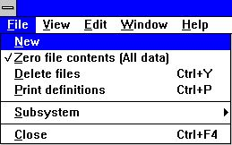

36. Zero file contents selection
where after you modify a table definition just as normal. When you finishes the modifications you will be asked to confirm:

37. Zero file contents confirmation

5.3. Printing documentation
To print documentation on table definitions use the following function and select one or more tables:

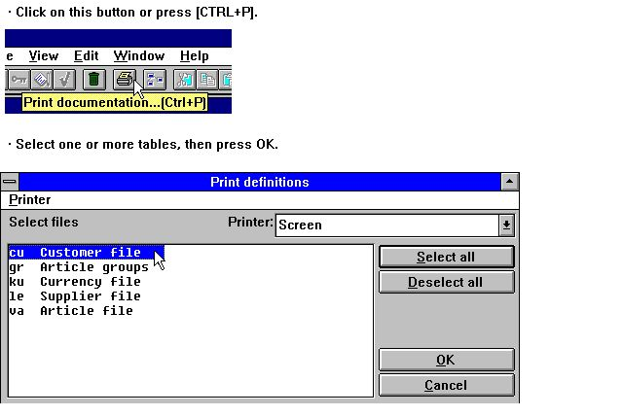

38. Printing documentation

5.3.1. Options
When printing the documentation it is possible to control what to print. A table documentation consists of the following:
- Table documentation
- Table information
- Relation diagram
- Index descriptions
- Field descriptions
- SQL descriptions (printed only for tables using an ODBC driver)
- Field documentation
The options can be switched on or off from the following menu:

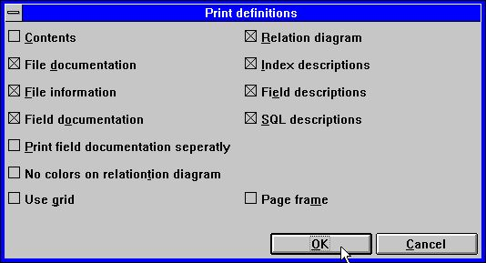

39. Documentation options

5.3.2. Printer
The documentation can be printed on any Windows installed printer. It can also be printed on a screen printer. In order to select the printer select the following:

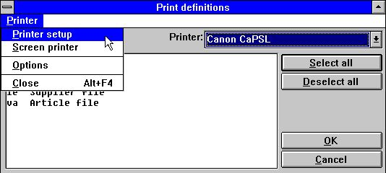

40. Selecting printer
This is an example of printed documentation on the table 'cu':

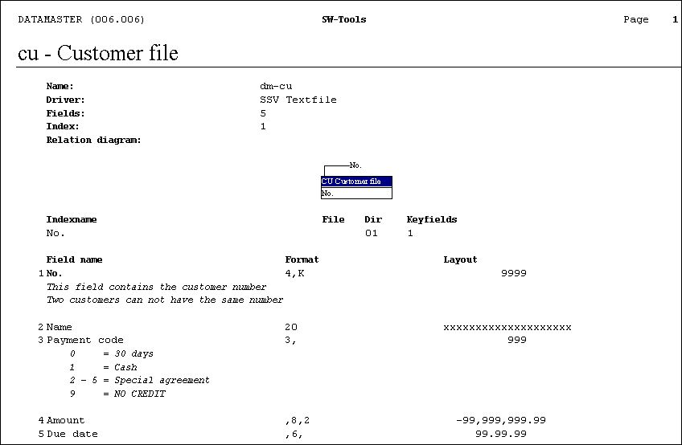

41. Example of table Documentation

6. Working with multiple tables

In DATAMASTER you can structure a complete database system with relations between your different tables. Also relations to non-DATAMASTER files can be established and these files can be mixed with your own files in DATAMASTER, IQ or RAPGEN programs.

6.1. Defining relations between tables
This is done using the INDEX window in the table definition. If we look at the standard article file:

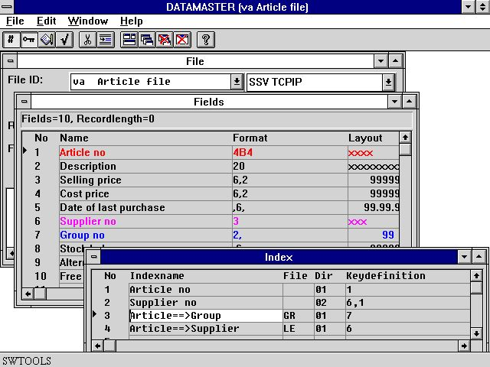

42. Relations between tables
The two first lines defines real index as article number and supplier number as described above.
Line 3 defines relation to the GR table using field 7 to search in the index (directory) 1 and read the article group record.
Line 4 defines relation to the LE table using field 6 to search in the index (directory) 1 and read the supplier informations.
Even if you are able to join two tables without having defined a relation between these by stating the relation in READ(xx),..... in you programs we strongly recommend that you define the relations in your Data Dictionary as the use of multiple files then becomes much easier and the documentation will be able to supply you with a relation diagram as shown below.

6.2. Database relations inquiry
When relations between tables exists it can be displayed graphically on screen and printed. To view relations from one table to others select:

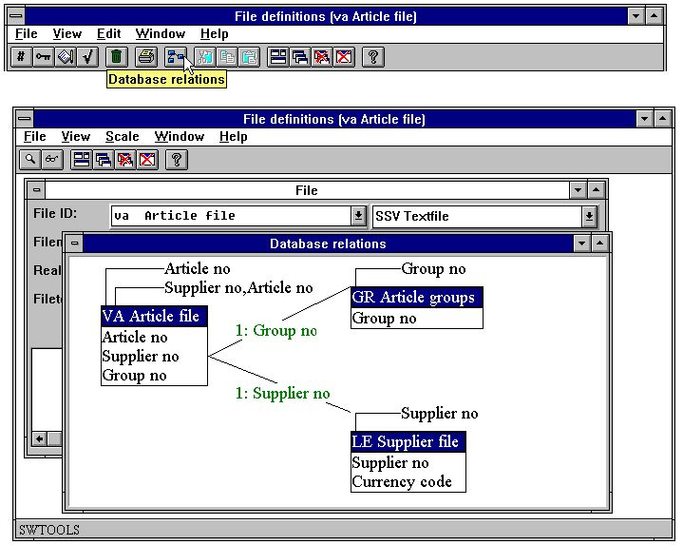

43. Database relations inquiry
The function can be scaled and generate the diagram in one or more levels.

6.3. Dataentry programs using multiple files
As described in the IQ manual you can make query programs for 2 files just by entering fields as:
va#1-10,le#1-6
IQ will read the supplier using the defined connection between the two tables. You can connect as many files in this way as you desire.
If the same is made as a DATAMASTER dataentry program you will get a program where you can create/amend/delete records in the main table (va) by standard the secondary table(s), here le, is just being read.
However DATAMASTER makes the dataentry program based on a standard program. When you save this program you are able to amend the calculations placed here for file update and extend these to update not only one file but as many as needed. How to amend calculations is described in the next chapter.

6.4. Transaction registration programs
You may even make transaction programs as shown below:

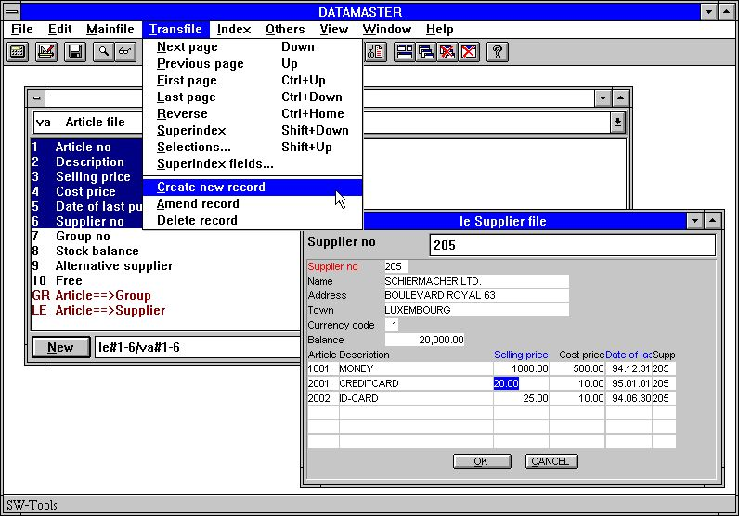

44. Transaction registration
In such program you will have the DATAMASTER functions for insert/amend/delete in both the main and the transaction menu enabling you to create new records in the main file and to insert/modify transaction lines also.
The function of the insert/amend/delete buttons on the toolbar will vary between main and transaction file functions dependent on which field you have currently selected.

7. Saving and modifying the dataentry program

Just like in IQ you can save up to 999 DATAMASTER programs. The menu used for DATAMASTER and IQ will in fact be the same which means you can build up a registration / query system with interaction between different program types. A saved program can be selected from either DATAMASTER or IQ - the program will work in the same way as dataentry or just query.
Modifications of the screen layout follows the same rules as in IQ and you can use all the fancy functions described in the IQ manual for setting colors, drawing circle's and placing pictures on the form:

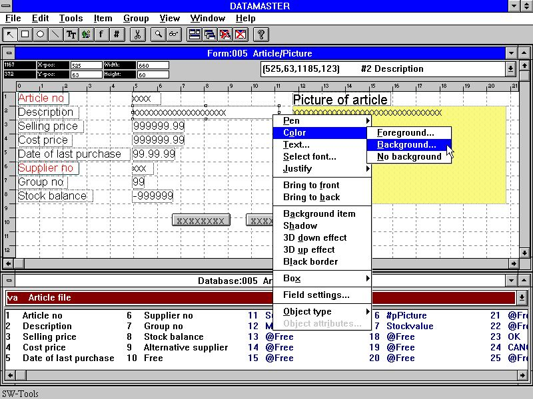

45. Amending a form
In this chapter we will discuss some principles of calculations in different types of dataentry programs. As we will do file update we will need some more entry points for calculations than for just a query program.
The user interface for calculation input is exactly the same as for IQ - for details on this you should refer to the IQ manual.
The various functions you can use are all described in part 2 - CALCULATIONS and SUBFUNCTIONS.

7.1. OK/CANCEL buttons
When a DATAMASTER program is defined these buttons will be added to ease the use. The OK/CANCEL buttons are examples of the use of DOFUNCTION as these invokes DOFUNCTION(998) and (997) causing the corresponding action to be taken.

7.1.1. Button shortcuts
When you define a button the name of the field is shown inside this. You may enter a freefield name as:
PRESS &ME
whereas the character just after & becomes a shortcut for this button which then may be activated by ALT+M

7.2. The simple dataentry program
If we define a program like:
cu#1-5
and selects the 'change parameter' function from the file menu we will get the following screen after the program has been saved:

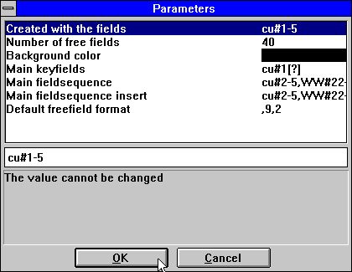

46. Parameters of program cu#1-5
where we notice some additional DATAMASTER parameters has been placed after the 3 standard IQ parameters fields, free fields and colour.

7.2.1. Field sequence parameters
Here we can amend the input sequence of the fields. The input sequence is used when you just press TAB or ENTER to go to next field, you may always override this by the CURSOR UP/DOWN or by a mouse click or abort from the sequence using ESC or PAGE DOWN.
If a field is not mentioned in the sequence you cannot position to it with a mouse click and you cannot make input to this. The field is displayed only.
There are different field sequences for amending a record and creating a new which DATAMASTER sets equal by default to all used fields except the main key field. By changing these you can define fields which can be entered on create only and not later modified.
The keyfield is kept as a separate field sequence as DATAMASTER needs to know when you are positioned here.

7.2.1.1. Specifying the input sequences
When a new program is builded the sequences will be stated something like:
le#2-6[?]
which means the actual sequence used is le#2-6 the [?] marks that DATAMASTER is allowed to update this if you add new fields to the screen layout. If you want to control the sequence yourself you should remove the [?] and just state le#2-6

7.2.2. Calculation entry points
When choosing calculations on this saved program we notice that these are separated into different parts which can be selected from the listbox:

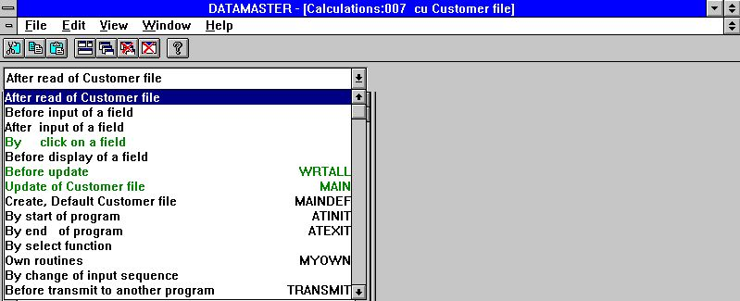

47. Calculation entry points
The lines marked in green in the box contains calculation lines.
By choosing between these entry points we are able to 'stick in' calculations on different places in the DATAMASTER standard program. Let us first have a look at what DATAMASTER itself has placed for us:

7.2.2.1. Before update
The section named 'before update' is activated in the dataentry program when you have made modifications to a record and finishes these.

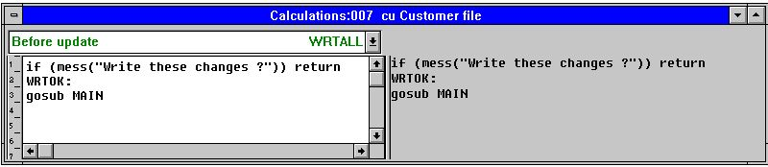

48. Before update
The purpose of these calculations is to decide if update should be made, ready the record for update and then call the actual write routine.

7.2.2.1.1. The MESS function
In the first line we find the confirmation for write. The MESS function displays a message box with the given text asking you for Y/N. If you answer Y MESS returns 0, N causes MESS to return 1.
As the calculations makes: IF (MESS(...)) RETURN a non-zero value returned from MESS will execute the RETURN from this routine and the next lines are not executed. It is answering N skips the oncoming update of the files.
If you delete this line you will get a program where you do not have to confirm writing of each record.

7.2.2.1.2. The GOSUB statement
The next line contains GOSUB MAIN which activates the function named MAIN. Each entry point in the calculations has a name. What you see on screen as 'update of customer file' is named MAIN in the calculations.
You can define your own names or labels also by a line like
MYNAME:
in the calculations and use GOTO/GOSUB for this routine also.
If you delete the GOSUB MAIN line you will get a query program, DATAMASTER does not make any updates besides the calculations.

7.2.2.2. Update of main file
This is the real writing of the modified data. Dependent on what you selected in the dataentry program (insert/amend/delete) the record will be new inserted, modified or deleted.

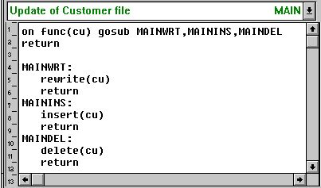

49. The update itself

7.2.2.2.1. The FUNC function
FUNC(fileid) returns 0,1,2 or 3 giving the selected function of this file:
0 No update needed
1 Amend existing record
2 Insert new record
3 Delete record

7.2.2.2.2. The ON statement
The ON FUNC(cu) GOSUB activates different routines dependent on the value of FUNC, 1 causes MAINWRT to be used, 2 MAININS and 3 MAINDEL.

7.2.2.2.3. REWRITE, INSERT and DELETE functions
The functions makes the physical update of the file. In the standard program only the main file is written but you may extend these routines with write of other files also.

7.2.2.3. Create, Default record
When you choose to create a new record these calculations are done before you enter your data. The block is by standard left blank.
Here you may set default values as #3=7 or even read a complete default record from the file.

7.2.2.4. Calculations after input
For each field you can make calculations which are executed after you have made input to the field. These may make additional validation of the field or update other fields on screen/in the file.

7.2.2.4.1. The DISP function
If you after input modifies any other field on screen than the current input field you will have to place a DISP() line in the calculation causing the display to be updated with the new value(s).

7.2.2.5. Calculations before input
You may also define calculations which are done when you select the field for input but before the input is actually done.

7.2.2.5.1. The NEXTFLD function
You may use NEXTFLD("#3") to jump to field 3 when following the standard input sequence. In this way one or more fields may be skipped or completely blocked out dependent on calculations both before and after the input.

7.2.2.6. By change of input sequence
The PARAMETERS page defines input sequences and whenever the user enters or leaves such sequence a calculation is invoked

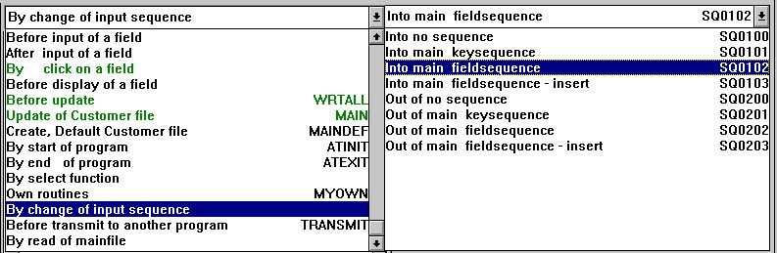

50. Calculations by change of sequence
These may e.g. be used to check/read a file when the key sequence is left.

7.3. The list dataentry program
The DATAMASTER parameters and calculation entry points are the same for a dataentry program on list form (cu#1-5l) the only difference is in the calculation for 'before update' which makes a loop over all lines on screen.

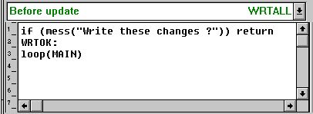

51. The loop update in a list program

7.3.1. The LOOP function
The LOOP function is the same as a GOSUB but is executed not only for one record but once for each line in the DATAMASTER line buffer. The MAIN function then decides for each record, dependent on FUNC, what must be done.

7.4. The transaction registration program
If we define a program like:
le#1-6/va#1-4
and selects the 'change parameter' function from the file menu we will get the following screen after the program has been saved:

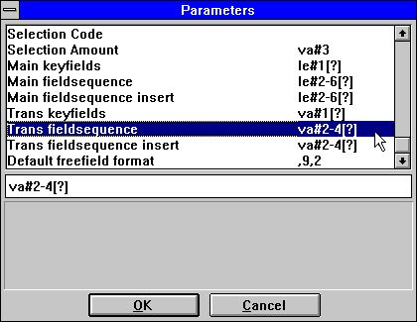

52. Parameters for the transaction dataentry program
We notice that not only the field input sequence for the main file can be altered but also for each of the transaction lines.

7.4.1. Calculation entry points
When choosing calculations on this saved program we get not only the entry points as described above, the UPDATE and DEFAULT has been spilt into main/transaction file and a SUM routine has been added:

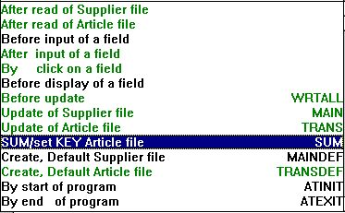

53. Entry points for the transaction program

7.4.1.1. Before update
This function now performs a mix of what we have seen in the list and the simple dataentry program:

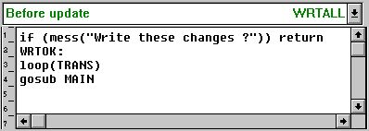

54. The transaction loop update
First a loop is done over all transaction in the transaction buffer updating these and then the main file is updated.

7.4.1.2. Transaction update
This routine named TRANS makes exactly the same as the main file update but is called for each transaction line.

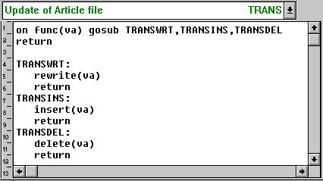

55. The transaction update
As for the main file update routine you may extend this to update more files.

7.4.2. SUM of transactions
On a transaction query program like this IQ will generate SUM routines to totalize the transactions when these are being read from the file:

56. IQ Initializing SUM with brought forward amount

57. IQ adding up SUM
In a DATAMASTER dataentry program you may amend the fields from which this sum is calculated. This must then cause a new calculation of the sum why DATAMASTER also places:

58. Calculation when changing the brought forward field

59. Calculation when changing the transaction amount
with reference to a SUM routine recalculating the sum all over:

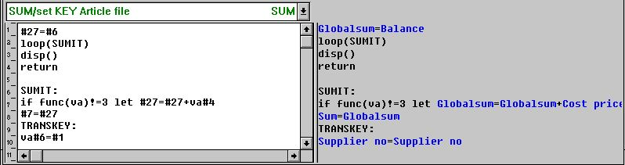

60. The SUM routine calculating transaction total
This SUM routine consist of 2 parts, the first part initialising the sum and looping over all transactions, the 2 part actually calculating the sum for each transaction. The IF FUNC.. ensures that deleted transaction lines are not taken into the total.
The last 2 lines labelled TRANSKEY: ensures the transaction key matches the main file key and is used in the following.

7.4.3. Set KEY on transaction file (SUM)
In a transaction dataentry program we normally have some 'critical' fields in the main file. A change of such a field must cause all transactions to be updated. We have looked at the 'brought forward' field already (le#6) which triggers the recalculation of SUM.
The connection between the main file and the transactions are based on one or more key fields held in the transaction matching the main file key. If the main file key is changed all transactions should be moved also.
To do this DATAMASTER makes a calculation triggered when you changes any field in the main file key:

61. Calculation when changing the supplier number
calling the routine TRANSDEF for each transaction setting the key:

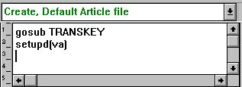

62. Calculation when creating a new transaction

7.4.3.1. The SETUPD function
In the calculations for update of the files we made a check on FUNC whether a specific record was changed.
SETUPD(xx) marks a line as modified and is used when the main file key is modified to tell all transaction lines must now be written.

7.5. Other calculation functions
Some other functions specific for DATAMASTER should be mentioned here:

7.5.1. The SEQ function
The SEQ function can be used to change the input sequence. Placed in a calculation it changes the value of the parameter given on the parameter page.

7.5.2. The MENUS function
This function can be used to deactivate menus which means you can make programs that can only amend records the insert/delete functions being blocked.

Figure list
1. DATAMASTER icons 4
2. Licence screen 5
3. The main window 11
4. Accessing the functions using menus or the toolbar 11
5. The toolbar during field input 12
6. Generel menus and buttons 12
7. Defining a new table 13
8. ID of new table 14
9. Database interface (File type) selection 16
10. Disk (lu) and number of records 18
11. The field window 20
12. Ending the definition 25
13. The first dataentry program 26
14. DATAMASTER mainfile menu and the function icons 28
15. Dataentry 29
16. Input validation error message box 30
17. Confirmation of file update 30
18. Dataentry on list form. 33
19. Selecting the table to amend 37
20. The EDIT menu 42
21. The field K index mark 44
22. Editing index information 47
23. Editing field documentation 53
24. Floating on-line field help 54
25. Defining check for a field 56
26. Field validation 57
27. Overview of field documentation 58
28. Overview of field check 58
29. Confirmation of table conversion 59
30. Error message from the conversion program 59
31. End message from the conversion 59
32. Try again 60
33. Marking a table for copy 62
34. RAPGEN calculations for data conversion 65
35. Deleting tables 66
36. Zero file contents selection 67
37. Zero file contents confirmation 67
38. Printing documentation 68
39. Documentation options 69
40. Selecting printer 70
41. Example of table Documentation 70
42. Relations between tables 72
43. Database relations inquiry 73
44. Transaction registration 75
45. Amending a form 76
46. Parameters of program cu#1-5 79
47. Calculation entry points 82
48. Before update 83
49. The update itself 86
50. Calculations by change of sequence 95
51. The loop update in a list program 96
52. Parameters for the transaction dataentry program 98
53. Entry points for the transaction program 99
54. The transaction loop update 100
55. The transaction update 101
56. IQ Initializing SUM with brought forward amount 102
57. IQ adding up SUM 102
58. Calculation when changing the brought forward field 102
59. Calculation when changing the transaction amount 102
60. The SUM routine calculating transaction total 102
61. Calculation when changing the supplier number 103
62. Calculation when creating a new transaction 103

Index

A
ACCESS 9;38;64
Amending 31;35;76;108
AND 66
B
BASIC 17;18;19
C
Calculations 8;91;93;95;108
CALCULATIONS 76
Changing 9;38
COMET 64
Copying 61;62;63
CTRAS 9
D
Data-Dictionary 11;12
DATAMASTER 1;3;4;5;6;7;8;9;10;14;16;17;20;22;26;27;28;29;37;41;42;43;54;55;57;62;64;65;66;71;74;75;76;77;79;80;81;82;85;96;97;102;103;105;108
DELETE 32;89
Deleting 32;36;66;108
Dictionary 4;6;10;26;72
DISP 92
Documentation 69;70;108
E
EDIT 42;53;56;108
Editing 24;47;53;108
EXCEL 9
F
Fileid 49
FUNC 87;88;97;102;104
G
GOSUB 85;88;97
GOTO 85
H
Helptext 52
I
IF 84;102
INDEX 72
Informix 9
INGRESS 9
Input 30;108
INSERT 89
Inserting 42
IQ 3;6;8;26;27;31;33;42;43;44;48;54;57;71;74;76;79;102;109
K
Keydefinition 51
L
Licence 5;108
LOOP 97
M
MAIN 85;97
MAINDEL 88
MAININS 88
MAINWRT 88
MENUS 107
MESS 84
Modifying 39
N
NEXTFLD 94
O
ODBC 9;69
ON 88
P
Preferences 24
Printing 68;108
R
RAPGEN 3;6;42;43;54;65;71;108
READ 72
Relations 72;108
RETURN 84
REWRITE 89
S
Saving 76
Selecting 37;70;108
Selections 27
SEQ 106
SETUPD 104
SQL 9;22;40;48;69
SUBFUNCTIONS 76
Superindex 27
T
TRANS 101
Transaction 8;75;101;108
TRANSDEF 103
TRANSKEY 102
U
UNIX 9;17
UPDATE 99
X
X-Basic 9;64

