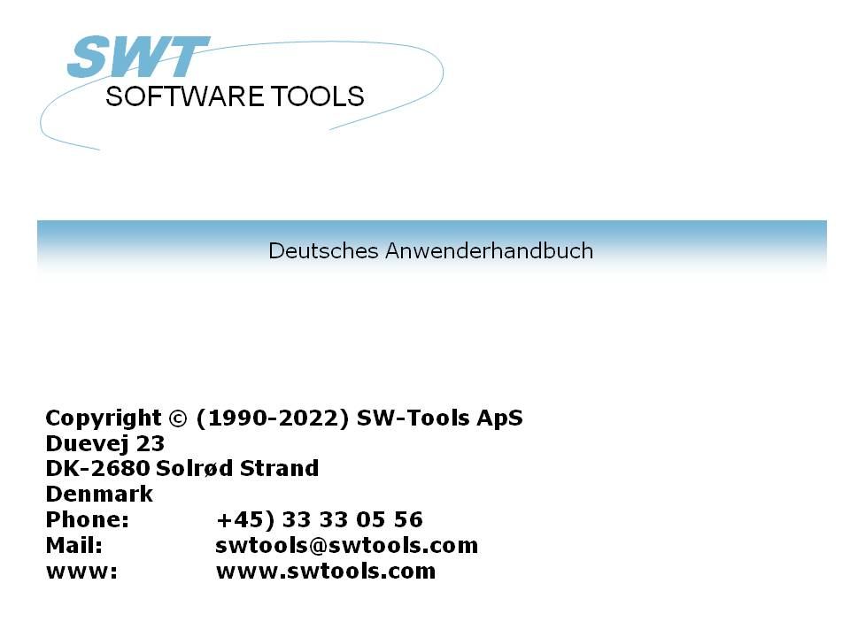

Cube Viewer

22/11/01 / 2022-09-01 008.384

Contents
Contents 2
1. Preface 4
1.1. Requirements 5
1.2. Video 6
2. The user interface 7
2.1. The controlpanel 8
2.1.1. Controlpanel items 9
2.1.1.1. Favorites 10
2.1.1.2. Options 11
2.1.1.3. Measures 12
2.1.1.4. Dimensions 13
2.1.1.4.1. Dimension axis 14
2.1.1.4.2. Dimension values 17
2.1.1.5. Reports 18
2.2. The view area 19
3. Chart view 20
3.1. View angle 27
3.2. Legend 28
3.3. 2D instead of 3D 29
4. Table view 30
4.1. Styles 31
4.2. Pivot function 32
5. Information view 35
6. Color control 36
6.1. Automatic color 37
6.2. Color according to average 38
6.3. Color according to calculation 39
7. Drill-down 40
7.1. How to drill-down 41
7.2. Single click drill-down 42
7.3. How to drill-up 43
8. Geomarketing 44
8.1. World map 45
8.2. Other country specific maps 46
8.3. Support and license 47
9. User defined visualization using Microsoft PowerPoint 48
9.1. Rules for the slide definition 51
9.1.1. Fill color rule 52
9.1.2. Textbox rule 53
9.2. How to save the slide as a map file 54
10. Labels 55
11. Sorting and view settings 56
11.1. Maximum number of elements 57
11.2. Sorting 58
12. Selections 60
12.1. All values - no selection 61
12.2. Individual values 62
12.3. Advanced selection dialog 63
13. Favorites 64
13.1. Add a favorite 65
13.2. Favorite information 66
13.3. List of favorites 67
14. Lowlevel data 68
15. Comparing multiple measures 70
16. Multiple interactive views 71
16.1. Duplicating a view 72
16.2. Inserting a new view 73
16.3. Interaction between views 74
16.4. Rotating windows 75
16.5. Deleting a view 76
17. Reports 77
17.1. New report 78
17.2. Add view to report 80
17.3. Delete report 82
17.4. Rename report 83
17.5. Printing 84
18. Extend with IQ queries 87
19. Export and Publish 88
19.1. Export a view 89
19.2. Predefined publishing to Microsoft Products 90
19.2.1. Microsoft Excel 91
19.2.2. Microsoft Word 92
19.2.3. Microsoft PowerPoint 93
19.2.4. Microsoft MapPoint 94
19.2.4.1. Postal information 95
19.2.4.2. Address information 96
20. Keyboard control 97
20.1. Generel keyboard settings 98
20.2. Ctrl keys 99
20.3. Shift+Ctrl keys 100
20.4. Special for map view 101
Figure list 102
Index 104

1. Preface

SW-Tools Cube Viewer provide you with a simple to use user interface to analyse data stored in a cube.
It is integrated in the SW-Tools IQ environment because of the following advantages:
- IQ is optimal for online queries
- IQ runs in the NET-TRIO environment for intra/internet solutions
- IQ provides the link back to the real database information for complete drill-down capabilities

1.1. Requirements
The Cube Viewer requires SW-Tools TRIO version 008.036 or higher. It also requires a separate license.

1.2. Video
This manual is based on the BI demosystem and all screenshots is automatically generated in connection with the video. The video is present at the SW-Tools webpage
http://www.swtools.com
The video is intended to be an assistant for presentations and on-line training sessions.

2. The user interface

The cube viewer consist of two areas
- A controlpanel
- A view area

2.1. The controlpanel
The controlpanel is a tree view like the windows explorer, where you as user are able to define analytic views of the data stored in the cube. The definition of a view is done by selecting one of the measures and one or more of the dimensions.
The controlpanel may be shown or hidden by selecting the Show function on the toolbar or press F11.

1. The show/hide controlpanel toolbar item
The controlpanel normally use 20% of the entire with of the window, but you may set this to 20, 30, 40 or 50% using the menu

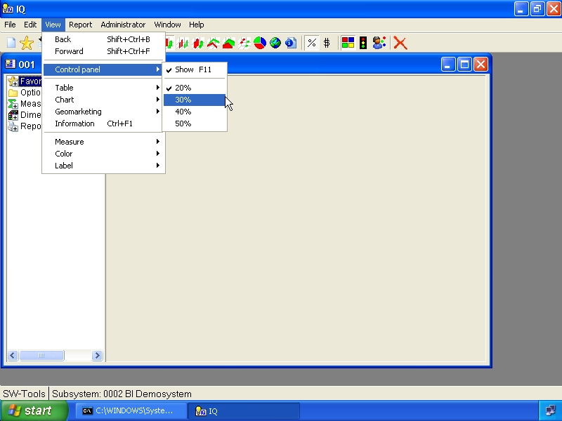

2. Menu for controlpanel size

2.1.1. Controlpanel items
The controlpanel contain the following items:

3. The controlpanel items
Any item within the controlpanel may be selected using the keyboard, that is if the controlpanel have focus. You may use the arrow keys up/down to position youself in the panel and the Enter key to select or deselect an item.
If you prefer to use the mouse you may single-click on the symbol left of the item name or double-click on the name to select or deselect the item.
Some of the items, normally those who have a + symbol in it are items that contain subitems. Therefore when you select such an item the item will be opened and the + symbol will change to a - and display all subitems underneath it. If the symbol does not change, it is because there are no subitems present for the selected item.

2.1.1.1. Favorites
This item may be opened/closed and contain subitems of every saved view. Please refer to the chapter Favorites later in this manual.

2.1.1.2. Options
This item may be opened/closed and contain entries for you to control how any axis on a chart should be. For example, you may control how it should be sorted and how many items should be displayed.
Please refer to the chapter Sorting and view settings later in this manual.

2.1.1.3. Measures
This item may be opened/closed and contain all available measures in the cube.
Normally you should only select one measure at a time. The manual will however describe how you may work with multiple measure later on.

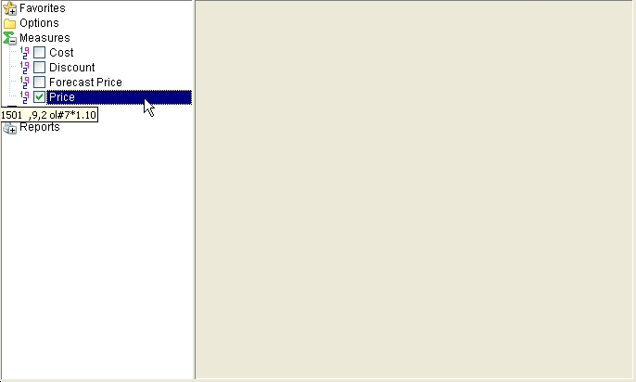

4. Selecting a measure

2.1.1.4. Dimensions
This item may be opened/closed and contain all available dimensions in the cube.
A dimension may be selected into one of 4 axis.
There is two ways you can select a dimension into an axis. By opening the dimension item and checkmark the axis or by right click on the dimension item and select the axis via a menu.

2.1.1.4.1. Dimension axis
The measure selected will always be show vertically on a chart. Therefore the dimension can only be used on X, X1, Y or Z.
The X axis is the main horisontal axis. It is divided into marks, where each mark dislays the dimension value.
The X1 axis os the secondary horisontal axis, or a subaxis on the X axis. This axis will not display any marker and dimension value.
The Y axis may be used to stack values vertically. Please be aware that the sums retrieved from the cube is summed up according to this selection, so that each dimension selected on the X, X1 or Z axis is grouped by the dimension selected in the Y axis.
A dimension can only be selected on one if the mentioned axis.

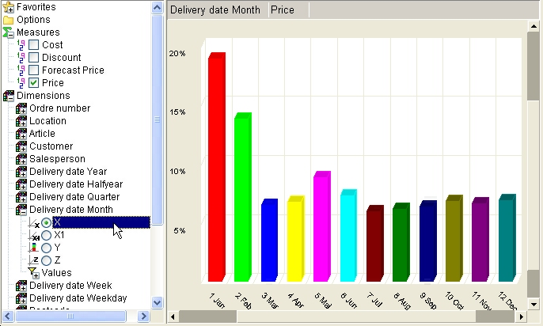

5. Dimension axis X

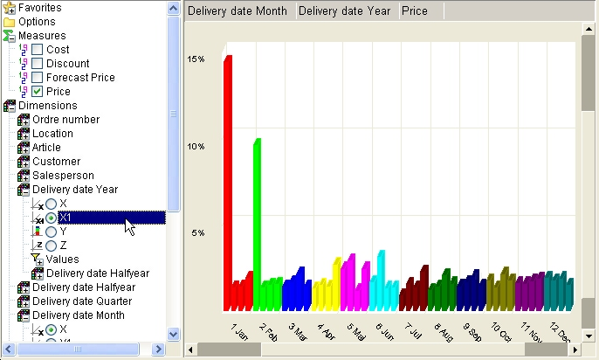

6. Dimension axis X1

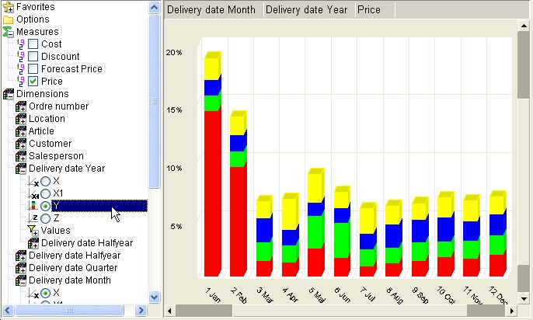

7. Dimension axis Y

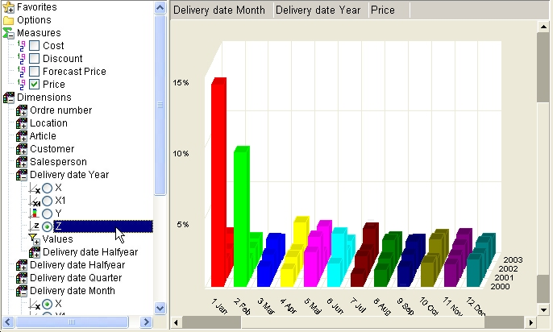

8. Dimension axis Z

2.1.1.4.2. Dimension values
The subitem dimension values contain a listing of all collected values within the cube. Also, it always contain a first item named All.
This section is used to make selections for a dimension, e.g. selecting to view data from a specific year or country.
Selections on dimension values may be done even if the dimension is not selected into an axis on the view.
Please refer to the chapter Selections later in this manual.

2.1.1.5. Reports
This item can be opened/closed and contain subitems of every saved report. Please refer to the chapter Reports later in this manual.

2.2. The view area
The view area is used to display the information selected. The view is initially not containing anything until you select at least a dimension.
The width of the view is always dependent on the size of the controlpanel as described in the previous section.

3. Chart view

The default view of any analysis is a bar chart, but the view can any of the charts shown below. You select the chart type as shown here from the toolbar or using one of the function keys as listed in the chapter Keyboard control.

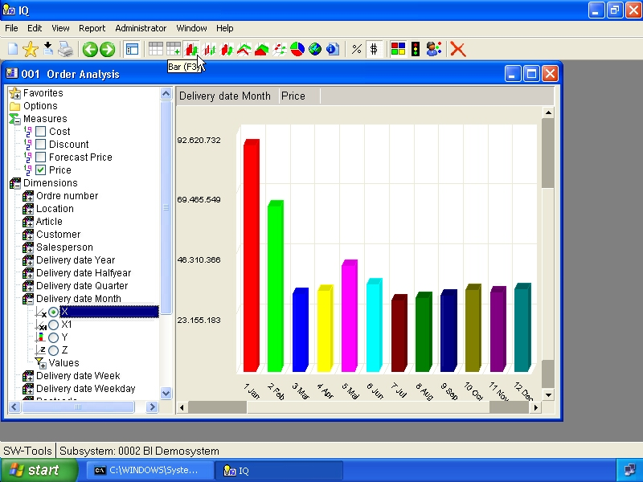

9. Bar chart

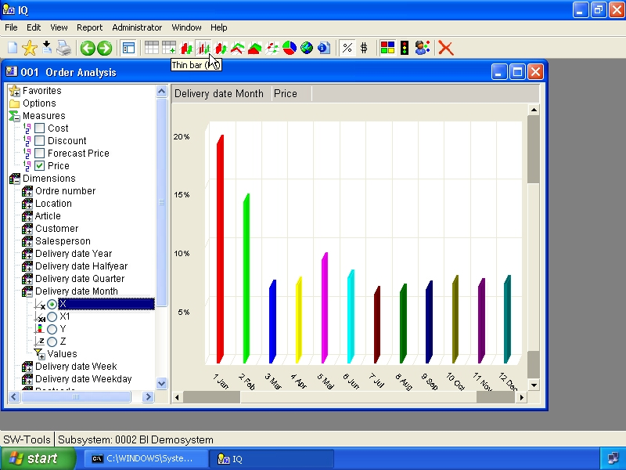

10. Thin bar chart

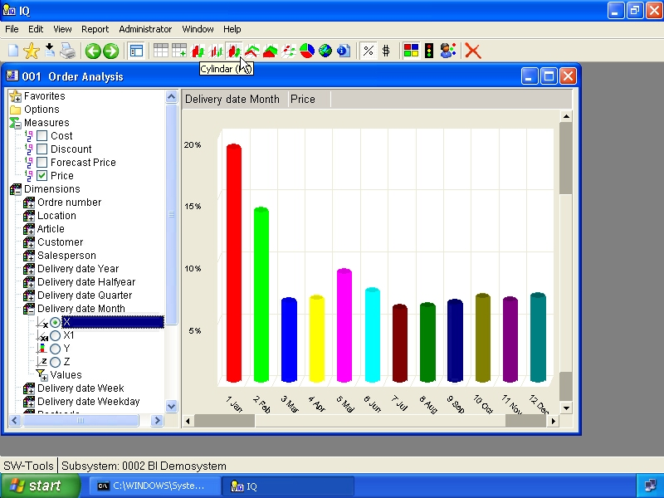

11. Cylindar chart

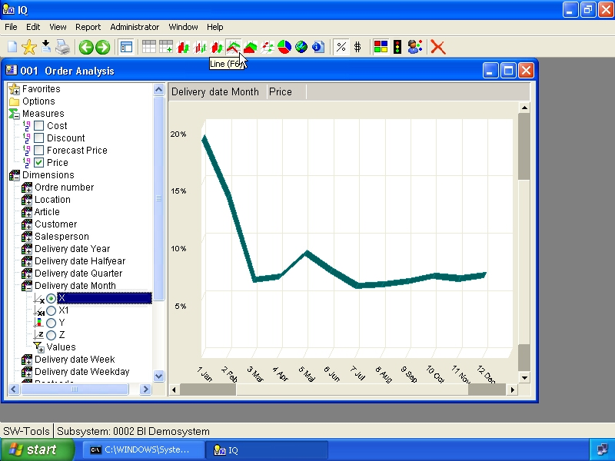

12. Line chart

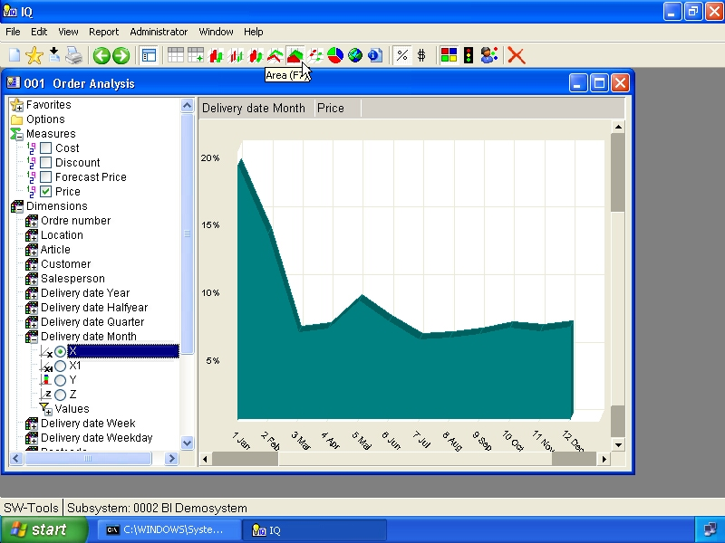

13. Area chart

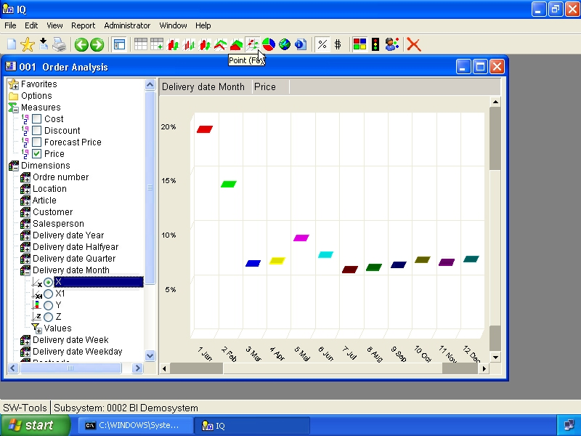

14. Point chart

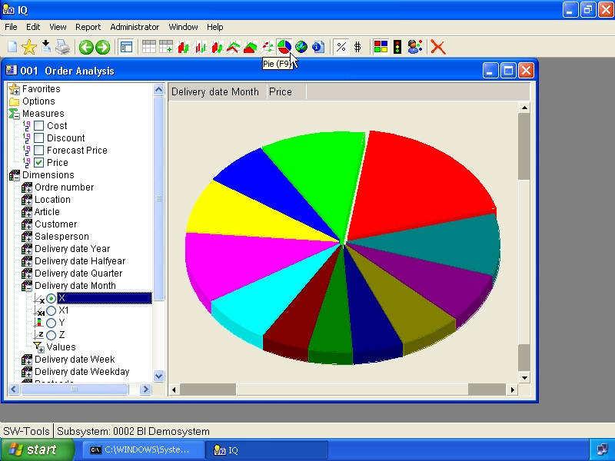

15. Pie chart

3.1. View angle
The view angle of a chart may be controlled by the two scrollbars located in the view area.

3.2. Legend
The legend of a chart may be shown/hidden using the menu
- View, Chart, Legend

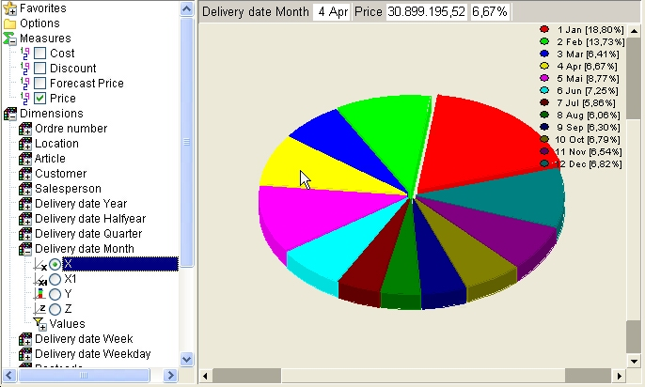

16. Display of legend

3.3. 2D instead of 3D
The chart may be displayed as 3D or 2D. You may control this with the menu
- View, Chart, 2D

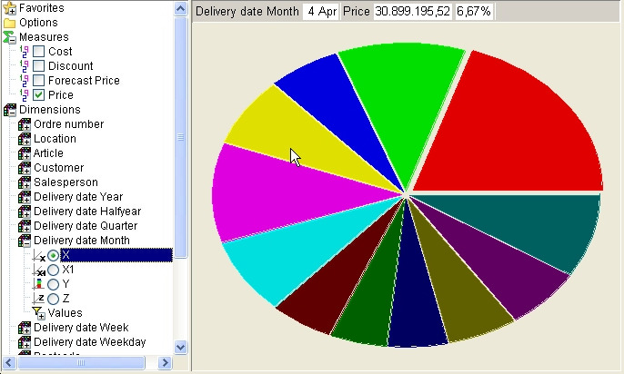

17. Display 2D chart
Please note that 2D chart will not be able to display the Z axis.

4. Table view

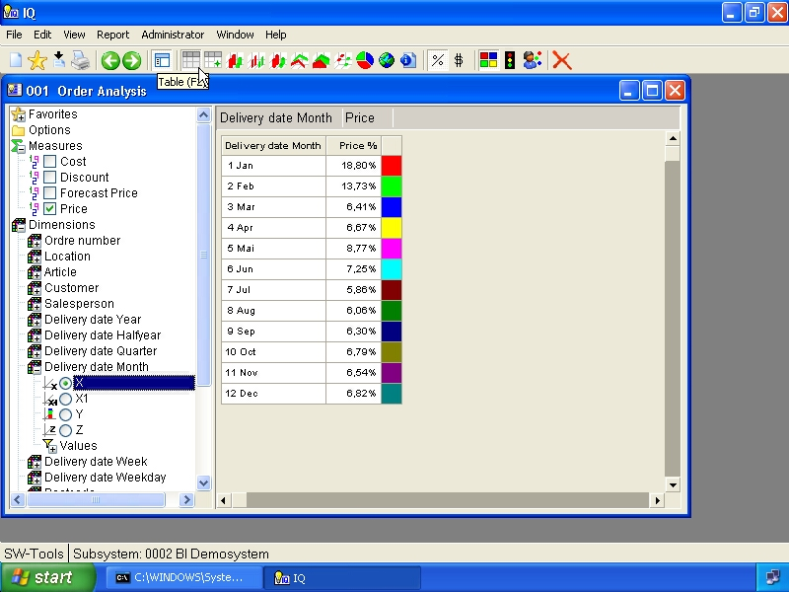

18. Table view

4.1. Styles
The following styles may be selected

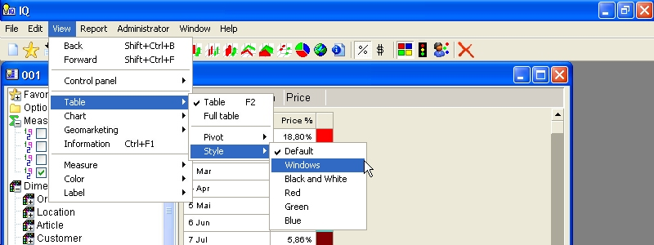

19. Selecting table style

4.2. Pivot function
THe pivot function allows you to control if a table view should be dislayed in rows or columns. This may be controlled for each axis X, X1, Y, Z.
For example, if we have selected the following dimensions into a view

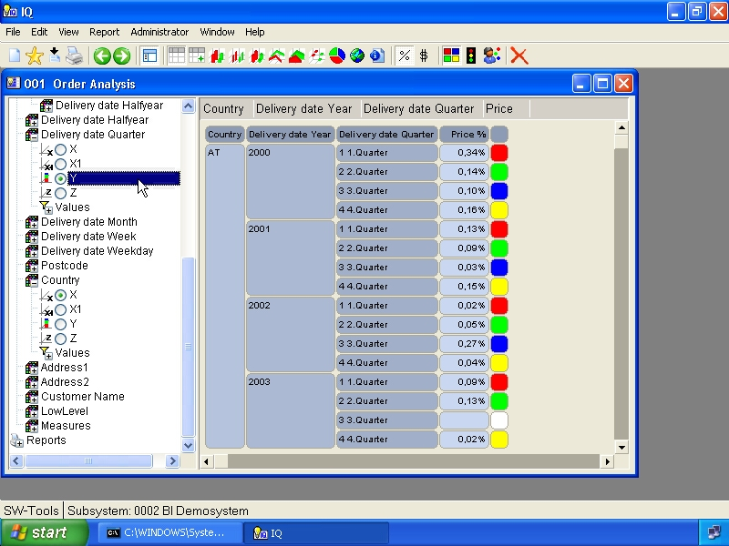

20. Table view of 3 dimensions as rows
and select the the menu

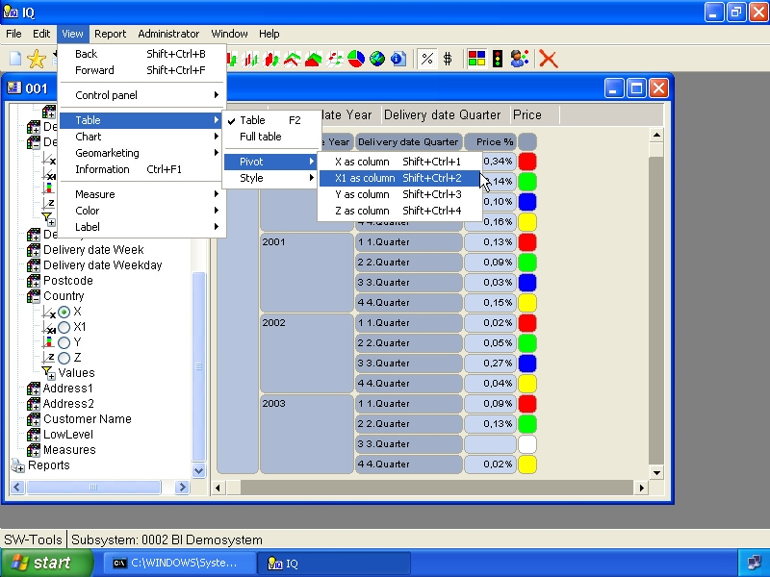

21. Selecting pivot function X1 as column
and in the same manner select the Y axis as column

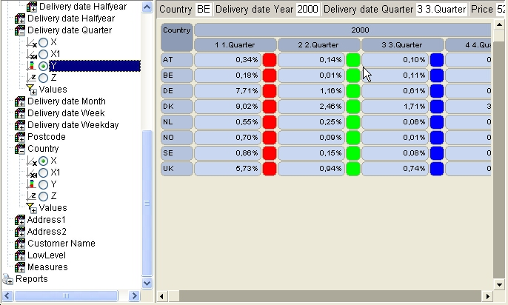

22. Pivot table with X1 and Y as column
The pivot function delivers a better visual overview of the values in the table view.

5. Information view

The information view may at all times be used just like a chart, table or map view.
The information will at all times show the following values according to the measure selected:

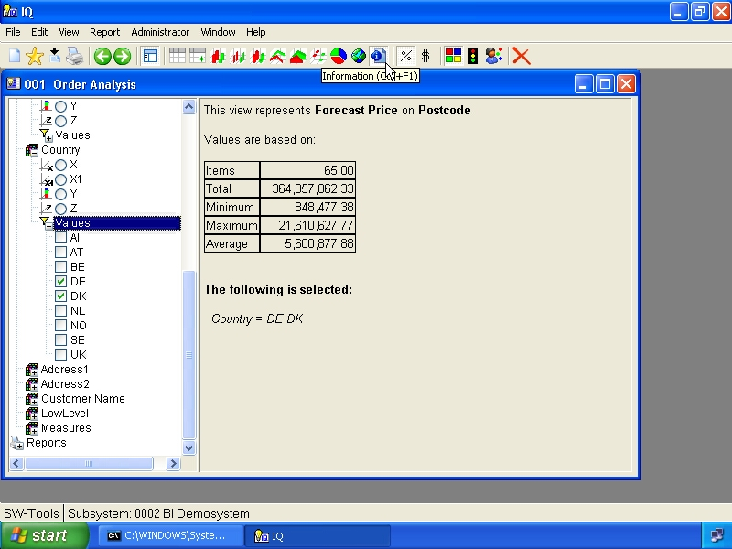

23. Information view
All selections, on any dimension, and global selections for multiple views will be listed here.
This provides the detail description of the analysis.

6. Color control

The color function is intended to make the charts to look nice for a presentation, visually be able to locate items that are below/above the average, or even according to a user defined calculation.

6.1. Automatic color
This color function has a predefined color table which cannot be modified. It is intended to make the chart look nice and to have a unique color for each item.

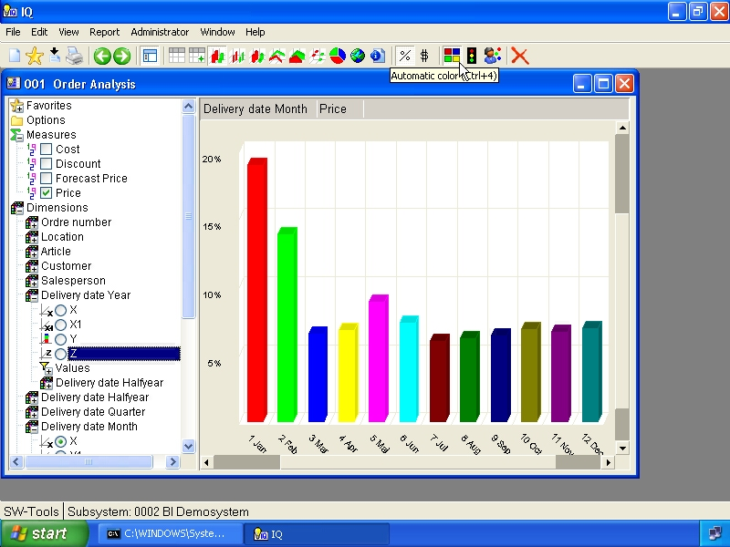

24. Automatic color

6.2. Color according to average
This color function will display a
- Red color if the item is below the average value of the entire view
- Yellow color if the item is equal to the average value of the entire view
- Green color if the item is above the average value of the entire view

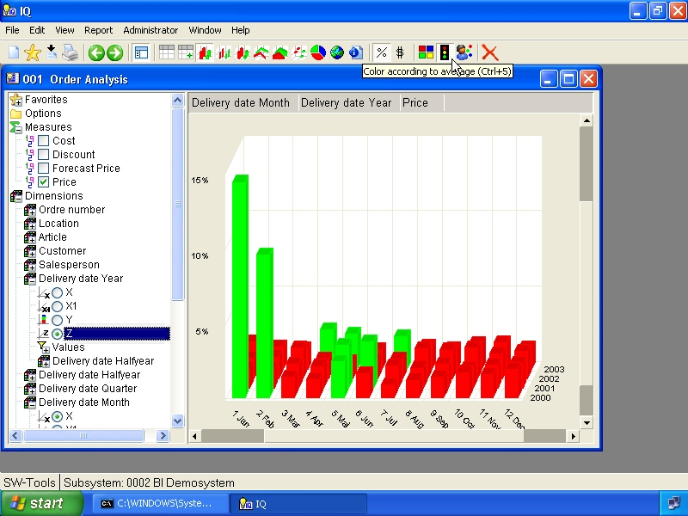

25. Color according to average
In order to know the exact values used for this please refer to the chapter Information view.

6.3. Color according to calculation
This color function may be modified by means of the calculation module. By default it provides a calculated color for an item but also a tooltip showing the
- Percentage of the average value for the view

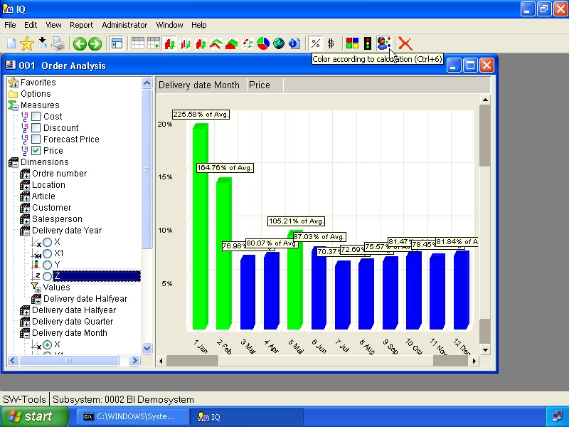

26. Color according to calculation
The calculated color is normally setup by the one who maintain the cube definition.

7. Drill-down

7.1. How to drill-down
You may click on the chart item and select the menu item

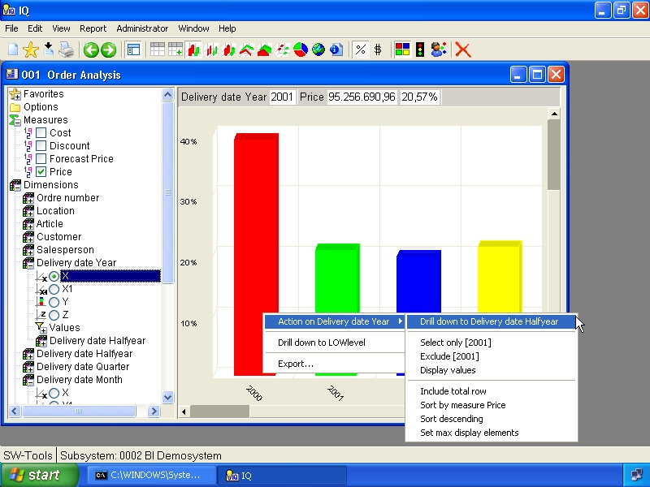

27. Drill-down in date dimension

7.2. Single click drill-down
The menu File, Settings, Single click drill-down will make a single click on a chart item drill-down to the next level if and only if the item is designed for drill-down and not a the lowest level.

7.3. How to drill-up
The drill-up function may be done in two ways.
- Selecting the tollbar item Back
- Right click on the item and select menu item Drill-up to ...

8. Geomarketing

The cube viewer may not only analyse information using the chart or table view, but according to geographic information such as
- Country
- State
- City
- Region
- Postalcode
SW-Tools offers predefined maps for the geomarketing.

8.1. World map
The world map is delivered with the SW-Tools Business Intelligence package. It is free of charge.

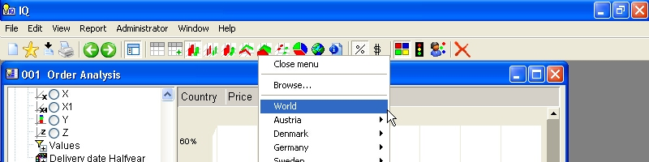

28. Selecting geomarketing map

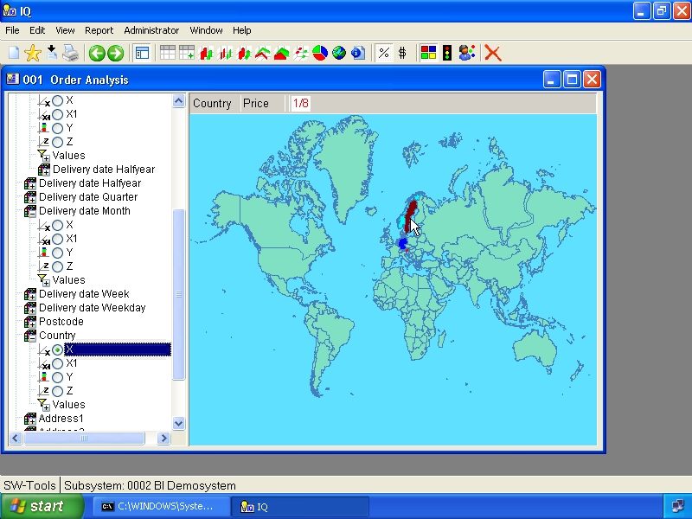

29. Worldmap

8.2. Other country specific maps
Currently SW-Tools offer the following country specific maps:
- Austria, Regions
- Denmark, Country, State and Zipcode
- Germany, Regions, Tow & Country sectors, Zipcode 1 & 2 digit
- Sweden, Regions
- England, Postalcode Area ID
- United States of America, States
If this does not satisfy your need, please read chapter User defined visualization using Microsoft PowerPoint and the chapter Export and Publish where you have easy integration with the Microsoft MapPoint application.

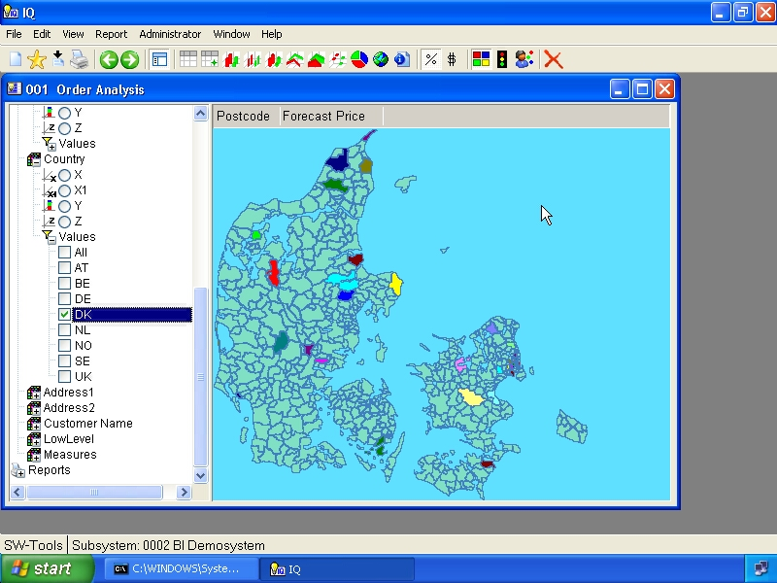

30. Danish Postalcode map

8.3. Support and license
The world map is delivered with the SW-Tools Business Intelligence package. It is free of charge.
Please contact your SW-Tools partner for prices on other geomarketing maps provided by SW-Tools.
SW-Tools will maintain the maps and provide updates when nessessary.

9. User defined visualization using Microsoft PowerPoint

Apart from the geomarketing feature described in the previous chapter, you are able to define your own visual maps using Microsoft PowerPoint.
Allthough it is impossible to describe what you may use this for, the possibilities are unendless and most importantly it is easy for you to use.
Even though SW-Tools or Microsoft MapPoint can provide maps for Postalcodes, States and Regions, most customers have their own
- Sales regions
- Stock locations
- Office locations
- Customer areas
- Organizational diagrams
- etc.
which almost certainly makes it an impossible task for SW-Tools to provide any imaginable map.
A perfect example if this is the cube used in this manual. Here we have a dimension names Location build from the two first digits of the article number. Nevertheless, this dimension represents the location of each article all over the world. Now to visualize this we have setup and saved a user defined map using PowerPoint.
The user doing the analysis may now select this map by selecting the Map item on the toolbar

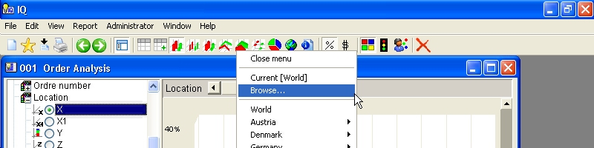

31. Selecting browse map
The browse function allows the user to load a user specific map file, in the format Windows Meta File (.WMF). This format comes from how we have saved the slide in PowerPoint.

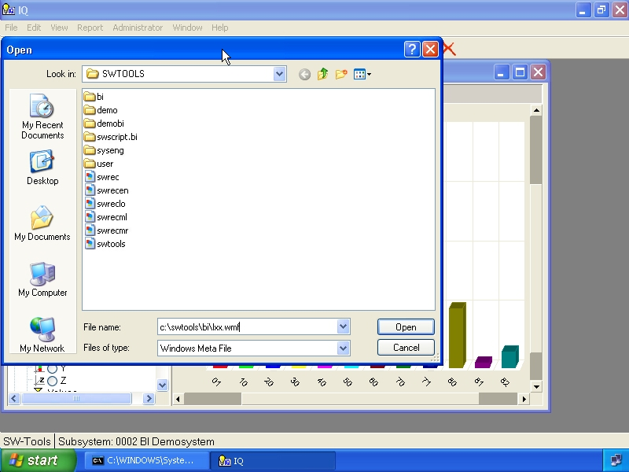

32. Browse for map file dialog
The result will be a view of the user defined map, but with the same functionality as for the normal chart, table or SW-Tools geomarketing map view, e.g. color, label and mouse over functions.

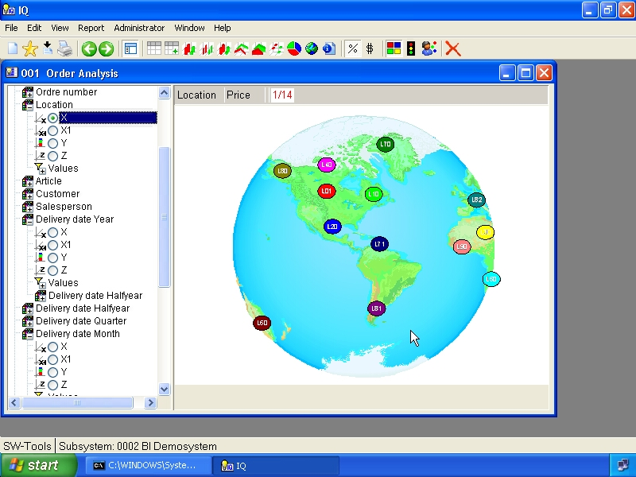

33. Powerpoint map view

9.1. Rules for the slide definition
The rules for defining a PowerPoint slide is simple. You insert any kind of item that PowerPoint can, such as symbols, pictures, etc.
Please refer to the sample map in the file
c:\swtools\bi\maps2.ppt
Now, to represent a value of a dimension in the slide you need to insert some kind of symbol, clipart where you are able to control the fill color. On the sample map for the article location we have chosen to use the circle symbol.
Once the symbol have been inserted on the slide you need to follow the rules describes here.

9.1.1. Fill color rule
The fill color must be set according to a specific RGB (Red, Green, Blue) color.
- Red may be set to a value from 0 to 255
- Green may be set to a value from 0 to 255
- Blue MUST ALWAYS BE SET TO 1
This allows you to make a possible 65536 different items on one map.

9.1.2. Textbox rule
So that the map can link the color of the item to a dimension value you need to insert a textbox somewhere on the slide. The textbox should then contain one line of text for each symbol inserted in the slide
SWMAP;8;70
where the 3 columns are separated by a semicolon.
The first column is fixed to the text SWMAP.
The second column is the reference to the color set on the symbol. In this example the symbol must have been set to a fill color, where Red=8, Green=0 and Blue=1.
The third column contain the actal value if the dimension, e.g. 70 is the article location.

9.2. How to save the slide as a map file
First of all you need to save the PowerPoint file as you would normally do. This is then the master file of your defined map(s).
Secondly, it is important to remember that the SW-Tools Business Intelligence cannot read the PowerPoint file directly, it need to have the map as a Windows Meta File (.WMF).
To save a slide in such a format you need to select the PowerPoint menu
- File, Save as...
enter a filename, e.g.
c:\swtools\bi\lxx.wmf
and select the filetype
Windows Meta File
press OK and answer Current slide when asked.

10. Labels

The following labels may be shown/hidden.
- ID
- Value
- Percentage
By default all labels are hidden. If you need to know the value of a specific item on the chart or in the table move the mouse over the item and the values will be displayed in the top left part of the view area.
When you have selected label ID and Value and is about to select label Percentage the view will look like this:

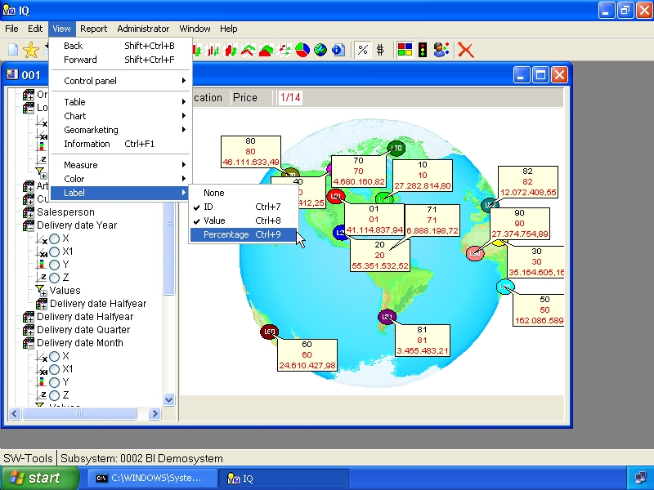

34. Selecting labels

11. Sorting and view settings

Sorting and maximum number of elements may be controlled for a view. This is done within the section Options in the controlpanel or by right click on the view area using. If you right click a menu is displayed from where you may select what you want to do.

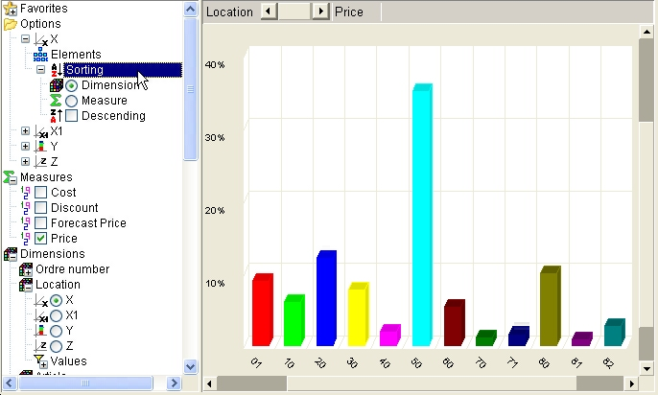

35. Options for the X axis

11.1. Maximum number of elements
The options section in the control panel may be used to set the maximum number of elements displayed in a view. The default number of elements is

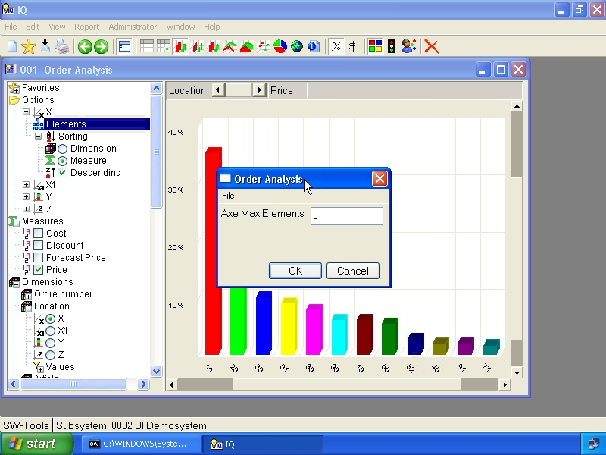

36. Setting maximum number of elements in a view

11.2. Sorting
The sorting may be done according to one or more of the axis X, X1, Y and Z. You may sort according to the dimension value, which is the default behavior, or according to the value, e.g. measure selected.

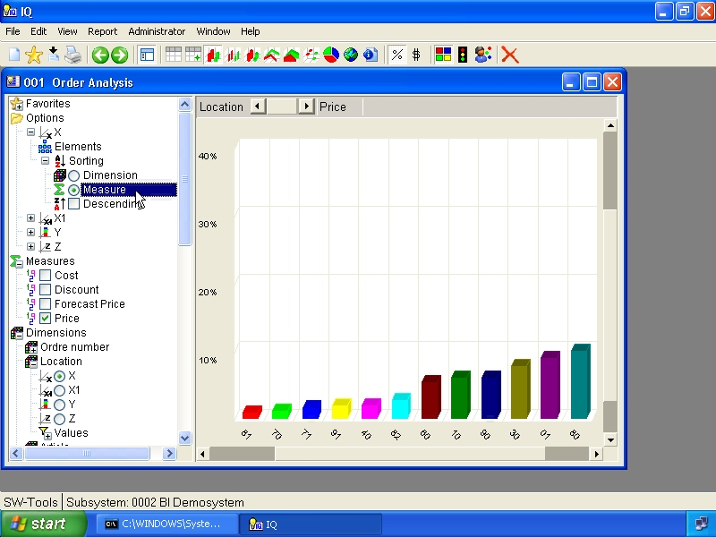

37. Sorting according to measure
Also, the sorting is by default in ascending order, but may be checkmarked to be in descending order instead.

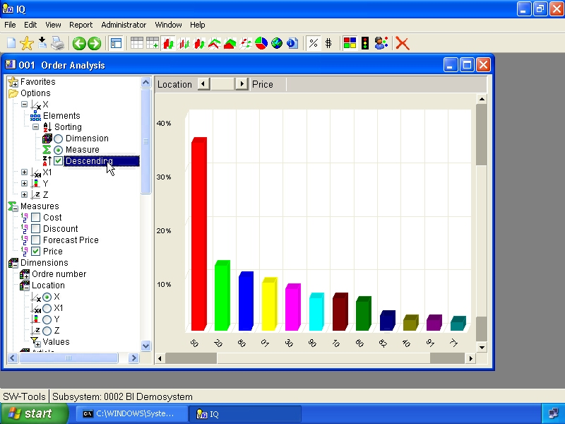

38. Sorting in descending order

12. Selections

Selections allow you to limit the view of any analysis. The selection is made within any dimension in the controlpanel in the section

12.1. All values - no selection
This option will include all values of a dimension, e.g. no selection is made.

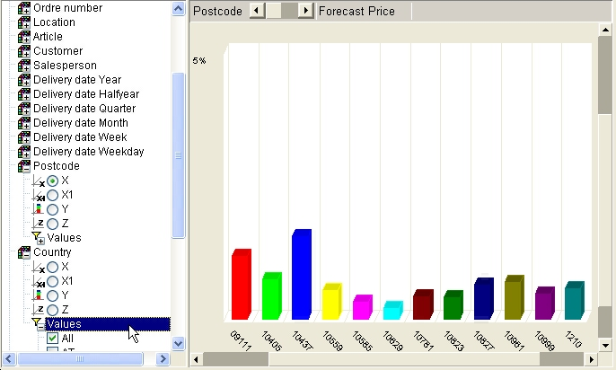

39. Selecting all dimension values

12.2. Individual values
Individual values may be checkmarked one by one.

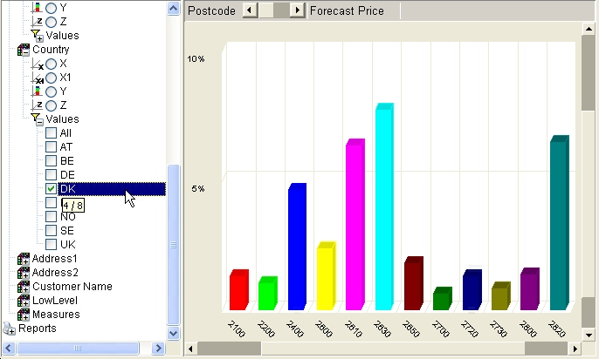

40. Selecting one dimension value

12.3. Advanced selection dialog
Instead of having to checkmark dimension values one by one you may right click on Values and choose the menuitem Selection.... The dialog allows you to enter a search criteria for text or numeric values.
For the text search you may use * and ? to include values, e.g.
D*
searches for all values begining with D.
For numeric values you may enter multiple values separated by comma and a range of values using the minus sign between the first and last value, e.g.
1-7,17
searches for the numeric values 1 to 7 and 17.

41. Advanced selection dialog

13. Favorites

The favorite section is used to store view. A view may be defined with all settings described in this manual, such as sorting, chart type etc. and hereafter saved as a favorite.

13.1. Add a favorite
To add a favorite you need to select the following toolbar item:

42. How to add a favorite

13.2. Favorite information
The favorite dialog look like this. The name will be listed in the controlpanel view.

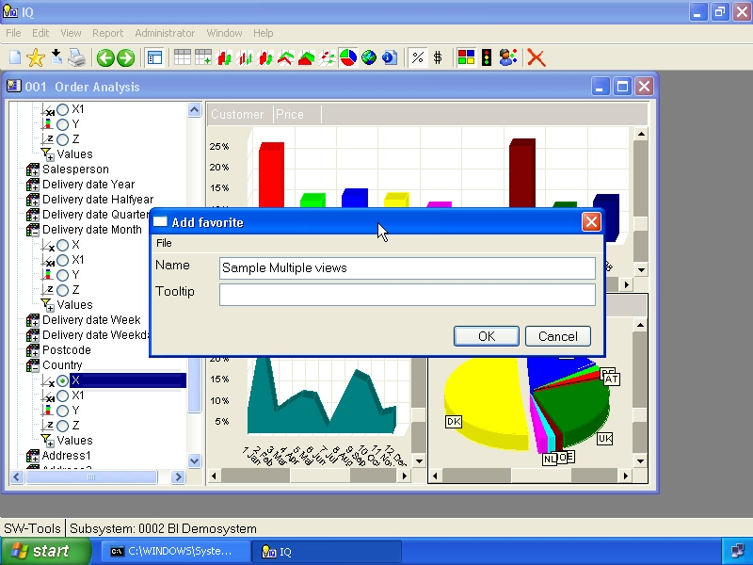

43. Dialog for favorite information

13.3. List of favorites
Once a favorite have been added the controlpanel will list it like this:

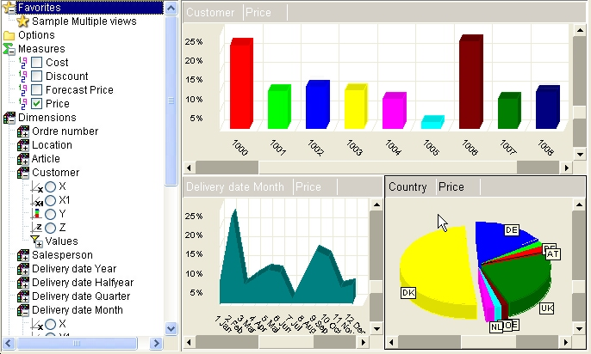

44. Control panel view of added favorites

14. Lowlevel data

In order to drill-down to low level data the cube must have been build with lowlevel data.
The lowlevel data may be selected when you click on an item with in the chart or table. The menu that is presented contain a menu item

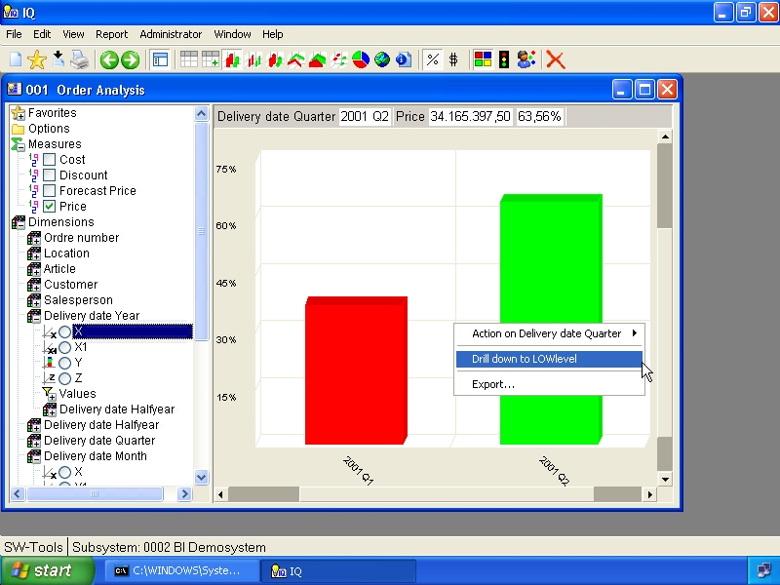

45. Menu for lowlevel drill-down
When selected the view area will change to a table view that shows all colected records for the particular item selected.

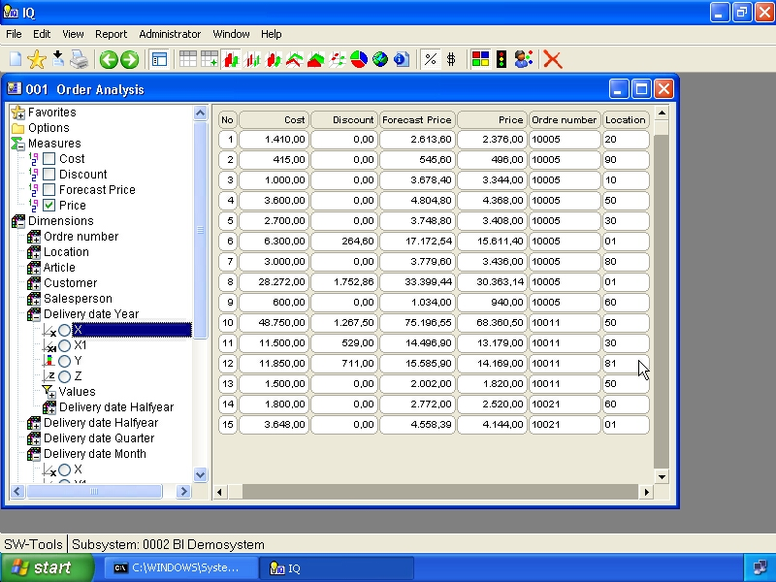

46. Drill-down data view
In order to go back from the drill-down table view you need to select a chart or table type.

15. Comparing multiple measures

If the control panel contain a dimension item named Measures it is possible to compare multiple measures in the analysis. Because the measures is treated as a dimension it can be selected into a view on any axis.

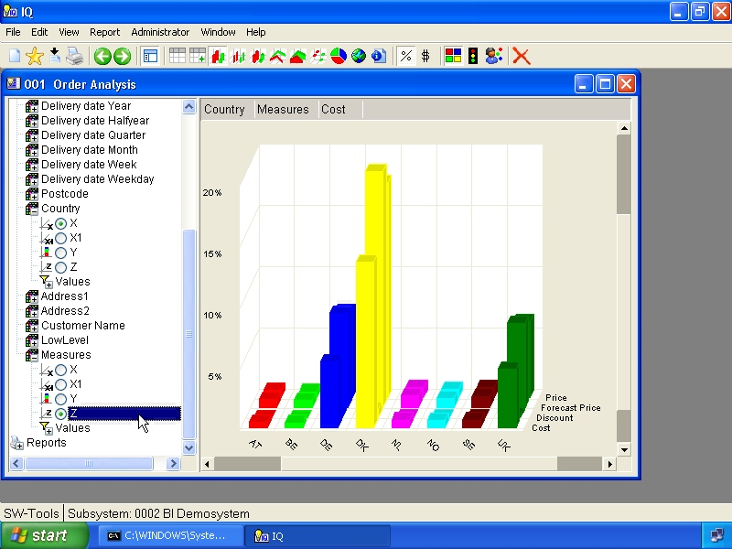

47. Multile measures in a view
The values item under the dimension Measures allows you to select all measures or just those you want to compare.
Please refer to the chapter Selections for a description of how to make a selection.

16. Multiple interactive views

The concept of multiple views that can interact provides the analyst with a powerful way to drill into the data in the cube.
You are able to use the functions New, Duplicate and Clear in order to make multiple views. The number of views is limited to a maximum of 4.

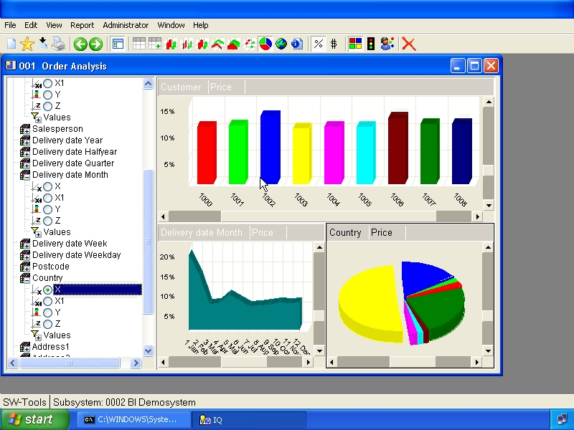

48. Multiple views on one screen
As you can see the active view is dislayed with a black border. To active another view just click once on the view. The controlpanel will only match the active view.

16.1. Duplicating a view
Use the menu Edit, Duplicate to copy the current view into a new view.

16.2. Inserting a new view
Use the menu File, New to insert a new empty view.

16.3. Interaction between views
Interaction between views are done by means of selections. Not as described earlier but by clicking an item and select

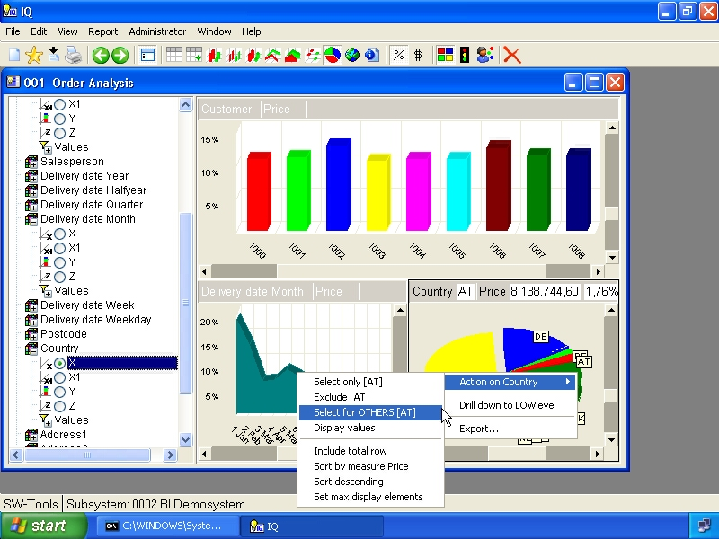

49. Global selection for other views
The selection made is not done for the current view but for all other views present. The active view will however show the chart item with a black border.
You may select multiple values and from multiple views.

16.4. Rotating windows
Use the menu Window, Rotate windows to rotate the order of the views.

16.5. Deleting a view
Use the menu Edit, Delete to delete the current view.

17. Reports

The report section is an extension of the favorite section. Within the report section you may define subreports and within each subreport you may add views as you would add to favorites.

17.1. New report
In order to define a new report folder select

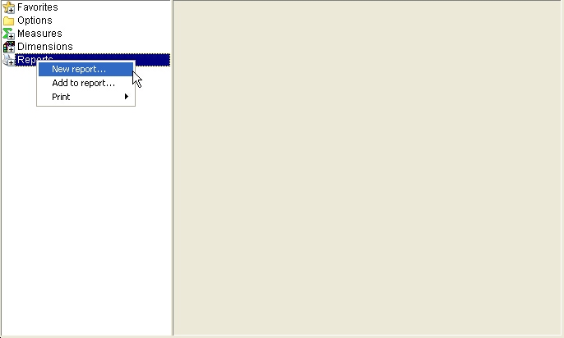

50. New report menu
In the dialog you may enter

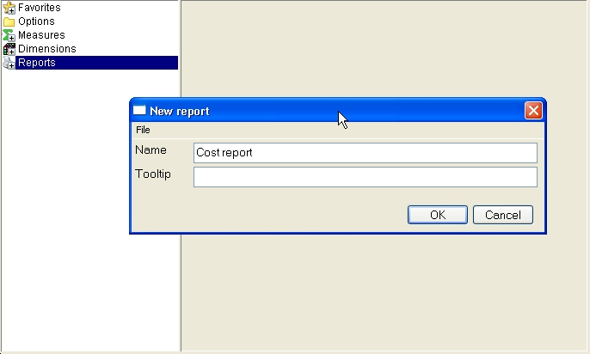

51. New report properties

17.2. Add view to report
You do not need to create a new report in order to add a view to the report section. The report section must be understood as the main report where views may be added.
If you have created a report and want to add the current view to it, be sure that the report folder is selected before adding the view. If you fail to do so the view will be added to the main report section.
A fullproof way of adding a view to a specific report folder is to right click the report folder and select

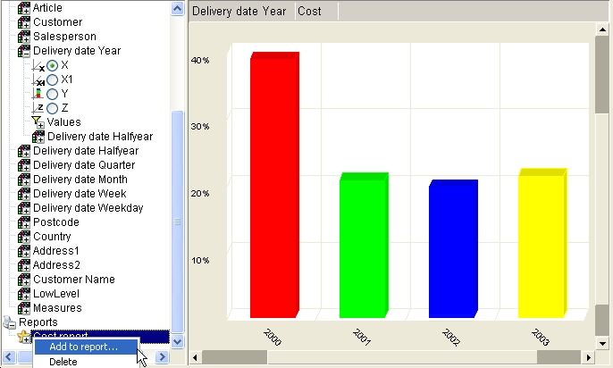

52. Add to report menu
In the dialog you may enter

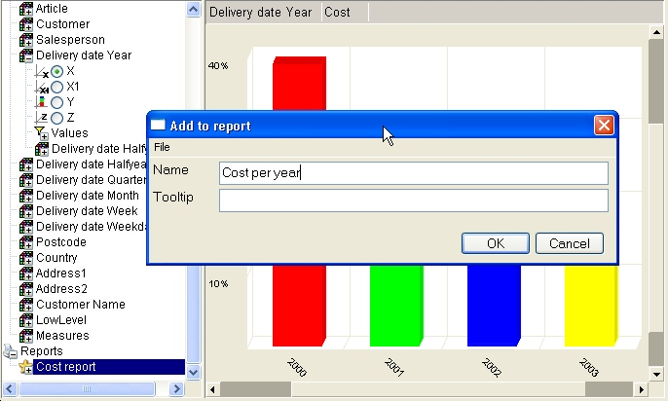

53. Add to report properties

17.3. Delete report
To delete a report or view you must right click the report folder or view and select the menuitem Delete.
The delete function will ask for confirmation first. The deleting includes all subitems within the selected section.

17.4. Rename report
To rename a report or view you must right click the report folder or view and select the menuitem Rename.

17.5. Printing
When you need to print a report defined you must right click the report folder and select the menuitem Print and hereafter the printer.

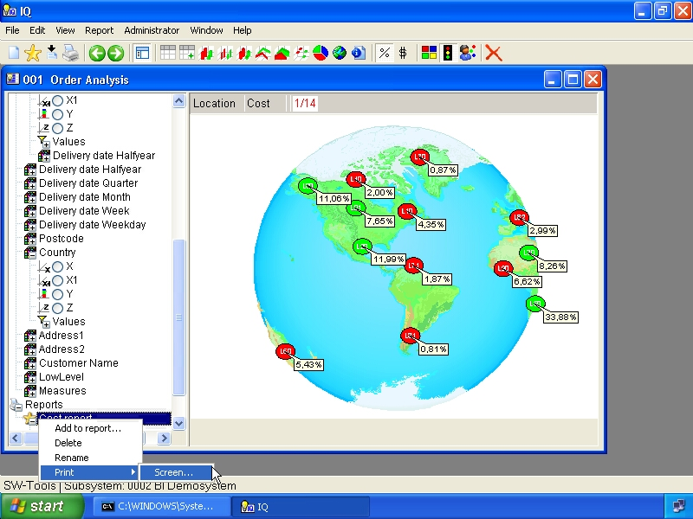

54. Print report menu
The selection of printer depends on the printers you have setup for TRIO.
If you want to print all reports, subreports etc. just right click the main report section as you would do on a report folder.
If you just want to print a view you may right click on the view as you would do on a report folder.

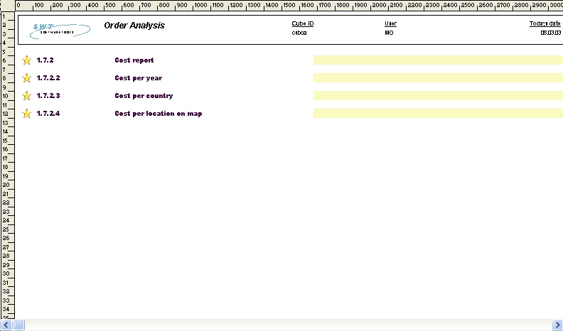

55. Sample report content

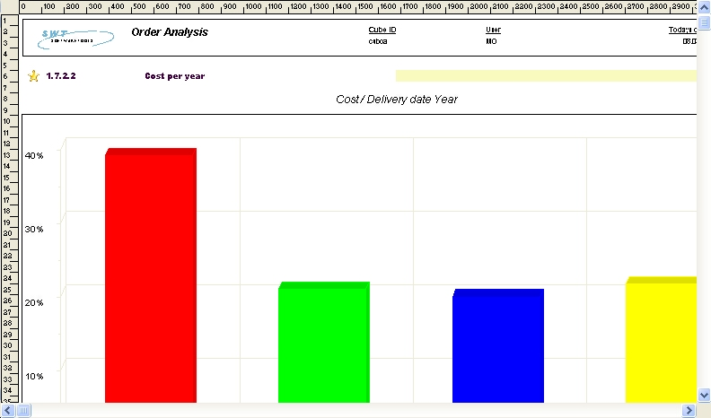

56. Sample report chart

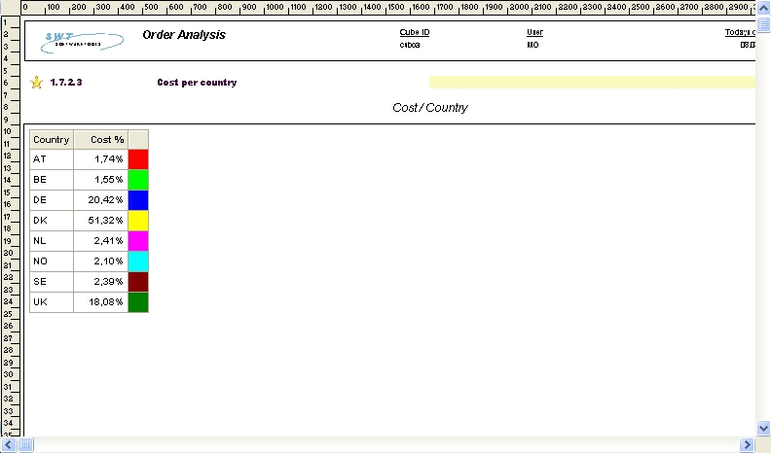

57. Sample report table

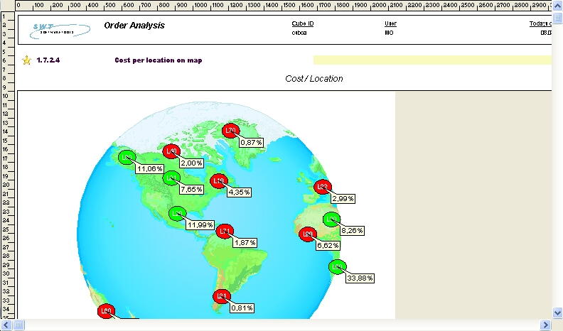

58. Sample report geomarketing

18. Extend with IQ queries

19. Export and Publish

19.1. Export a view

19.2. Predefined publishing to Microsoft Products

19.2.1. Microsoft Excel

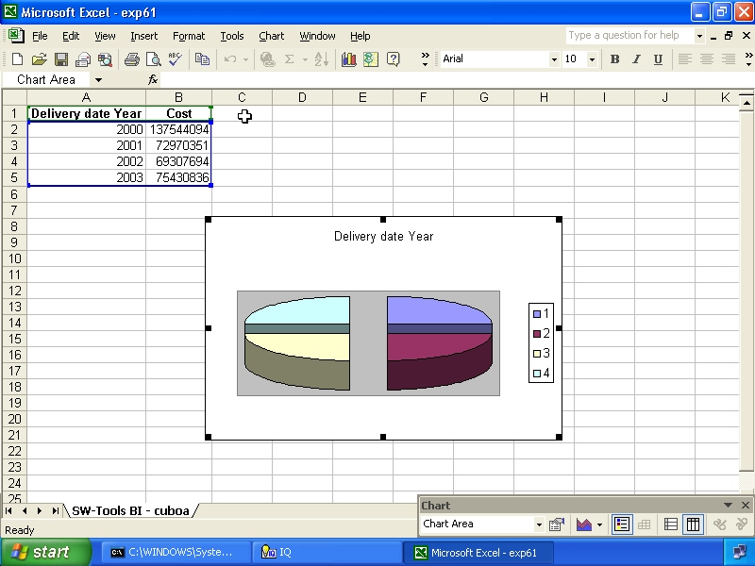

59. Sample published to Excel

19.2.2. Microsoft Word

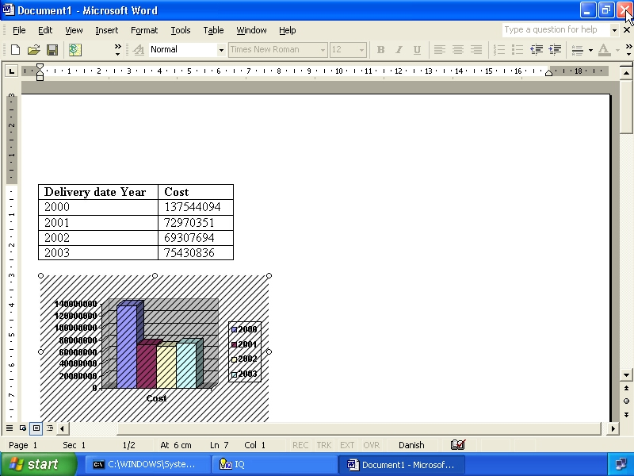

60. Sample published to Word

19.2.3. Microsoft PowerPoint

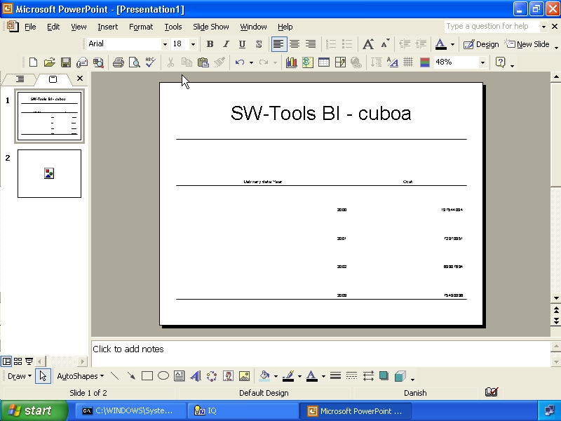

61. Sample published to PowerPoint

19.2.4. Microsoft MapPoint

19.2.4.1. Postal information

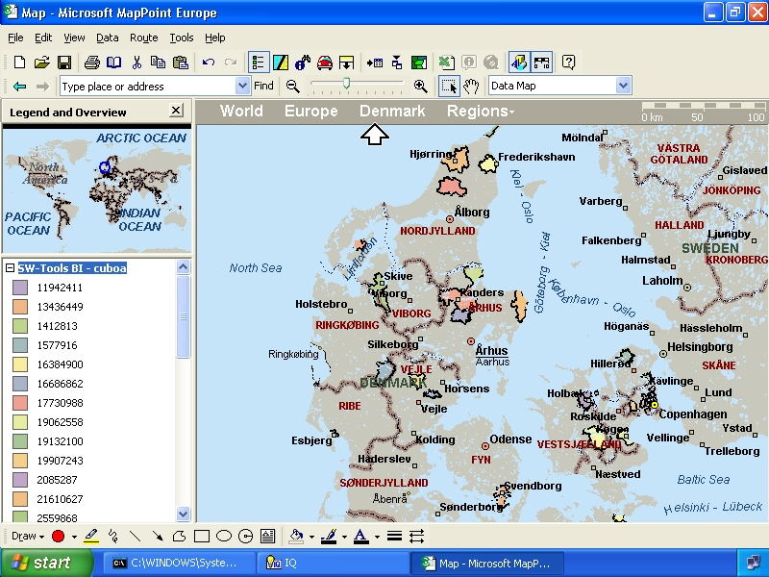

62. Sample published to MapPoint - Denmark Postalcodes

19.2.4.2. Address information

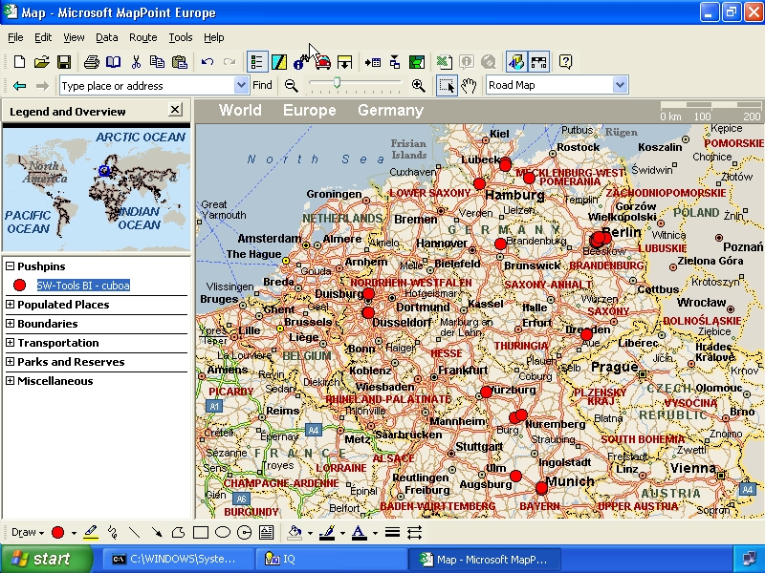

63. Sample published to MapPoint - Germany Addresses

20. Keyboard control

20.1. Generel keyboard settings

 | Key | Description
 | Delete | Clear all and close all levels in controlpanel
 | F2 | Table view
 | F3 | Bar chart view
 | F4 | Thin bar chart view
 | F5 | Cylindar chart view
 | F6 | Line chart view
 | F7 | Area chart view
 | F8 | Point chart view
 | F9 | Pie chart view
 | F11 | Show/hide controlpanel
 | F12 | Map selection

20.2. Ctrl keys

 | Key | Description
 | 0 | Rotate views
 | 1 | View percentage
 | 2 | View value
 | 3 | Include subtotals
 | 4 | Automatic color
 | 5 | Color according to average
 | 6 | Coloraccording to calculation
 | 7 | Show/hide label id
 | 8 | Show/hide label value
 | 9 | Show/hide label percentage
 | W | New view
 | S | Add to favorites
 | P | Hardcopy
 | C | Duplicate current view
 | X | Delete current view
 | F1 | Information view

20.3. Shift+Ctrl keys

 | Key | Description
 | B | Back in history
 | F | Forward in history
 | 1 | Pivot table X as column
 | 2 | Pivot table X1 as column
 | 3 | Pivot table Y as column
 | 4 | Pivot table Z as column

20.4. Special for map view

 | Key | Description
 | + | Zoom in
 | - | Zoom out
 | * | Zoom all

Figure list
1. The show/hide controlpanel toolbar item 7
2. Menu for controlpanel size 7
3. The controlpanel items 8
4. Selecting a measure 11
5. Dimension axis X 13
6. Dimension axis X1 14
7. Dimension axis Y 14
8. Dimension axis Z 15
9. Bar chart 19
10. Thin bar chart 20
11. Cylindar chart 21
12. Line chart 22
13. Area chart 23
14. Point chart 24
15. Pie chart 25
16. Display of legend 27
17. Display 2D chart 28
18. Table view 29
19. Selecting table style 30
20. Table view of 3 dimensions as rows 31
21. Selecting pivot function X1 as column 32
22. Pivot table with X1 and Y as column 33
23. Information view 34
24. Automatic color 36
25. Color according to average 37
26. Color according to calculation 38
27. Drill-down in date dimension 40
28. Selecting geomarketing map 44
29. Worldmap 44
30. Danish Postalcode map 45
31. Selecting browse map 47
32. Browse for map file dialog 48
33. Powerpoint map view 49
34. Selecting labels 54
35. Options for the X axis 55
36. Setting maximum number of elements in a view 56
37. Sorting according to measure 57
38. Sorting in descending order 58
39. Selecting all dimension values 60
40. Selecting one dimension value 61
41. Advanced selection dialog 62
42. How to add a favorite 64
43. Dialog for favorite information 65
44. Control panel view of added favorites 66
45. Menu for lowlevel drill-down 67
46. Drill-down data view 68
47. Multile measures in a view 69
48. Multiple views on one screen 70
49. Global selection for other views 73
50. New report menu 77
51. New report properties 78
52. Add to report menu 79
53. Add to report properties 80
54. Print report menu 83
55. Sample report content 84
56. Sample report chart 84
57. Sample report table 85
58. Sample report geomarketing 85
59. Sample published to Excel 90
60. Sample published to Word 91
61. Sample published to PowerPoint 92
62. Sample published to MapPoint - Denmark Postalcodes 94
63. Sample published to MapPoint - Germany Addresses 95

Index

B
Back 42;99
Bar 19;97;101
C
Chart 19;27;28
Color 35;37;38;98;101
Controlpanel 8
Cube 1;3;4
D
Dimension 13;14;15;16;101
Drill-down 39;40;68;101
E
Export 45;87;88
F
Favorites 9;63
G
Geomarketing 43
I
Information 34;37;98;101
IQ 3;86
K
Keyboard 19;96
L
Legend 27
M
Map 47;97
MapPoint 45;47;93;94;95;102
Microsoft 45;47;89;90;91;92;93
N
NET-TRIO 3
O
Office 47
Options 10;55;101
P
Percentage 38;54
Postalcode 43;45;101
PowerPoint 45;47;50;53;92;102
Publish 45;87
R
RGB 51
S
Selection 62
Sorting 10;55;57;58;101
Styles 30
T
TRIO 4;83
V
View 26;27;28;98
Z
Zipcode 45

