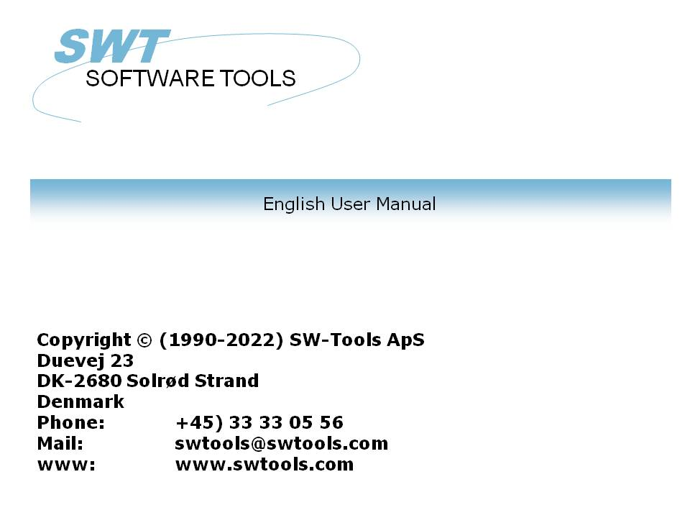

Charts

22/11/01 / 2022-09-01 008.384

Contents
Contents 2
1. Preface 4
1.1. Release notes 5
2. Charts in RAPGEN 6
2.1. The chart setup dialog 7
2.1.1. Chart 8
2.1.2. Sort by 9
2.1.3. Key value 10
2.1.3.1. Part of a field as key value 11
2.1.4. Total field 12
2.1.5. Align 13
2.1.6. Width and height 14
2.1.7. Max items 15
2.1.8. Titles 16
2.1.9. Print 17
2.1.10. Advanced 18
2.1.10.1. Print of items 19
2.1.10.2. Print of chart 20
2.1.10.3. Limits 21
2.2. Sample - TOP 10 selling price 22
2.2.1. Step 1 - Creating the report 23
2.2.2. Step 2 - Selecting fields for the layout 24
2.2.3. Step 3 & 4 - Adding the chart to the automatically generated total 25
2.2.4. The final report 27
2.3. Sample - Report with chart field in layout 28
2.3.1. Chart definition generates new work fields 29
2.3.2. How to insert the chart field in layout 30
2.3.3. The final report with chart field in layout 32
2.4. Sample report with manually calculated chart 33
3. Charts in IQ/DATAMASTER 35
3.1. Creating a simple query 36
3.2. Adding the chart step by step 37
3.3. Functions for special chart handling 38
3.3.1. Tagging an item in the chart 39
3.3.2. Performing calculations when user click on a chart item 40
4. Chart functions 41
4.1. ChartAllocate - Allocate a new chart 42
4.2. ChartFree - Free the chart 43
4.3. ChartClear - Clear content of the Chart 44
4.4. ChartOptions - Set options for the chart 45
4.5. ChartValue - Add an item value 46
4.6. ChartSet - Add an item value and description 47
4.7. ChartText - Set chart titles or items description and tag 48
4.8. ChartSave - Save a chart to a file 49
4.9. ChartLoad - Load a chart from a file 50
4.10. ChartClicked - Retrieve chart item last clicked 51
4.11. ChartTag - Tag one item in the chart 52
4.12. ChartFlags - Set special chart flags 53
4.13. ChartSetLimit - Set limits for chart 54
5. Technical specifications 55
5.1. Requirements 56
5.2. Files installed 57
Figure list 58
Index 59

1. Preface

SW-Tools Charts provide you with a simple way to produce a chart according to the report or query defined in a SW-Tools TRIO application. It may be defined on any type of total defined on a report, without using calculations.
Additionally, the user who define IQ or DATAMASTER programs or wish to control the chart by means of calculations, is fully supported by a collection of functions.

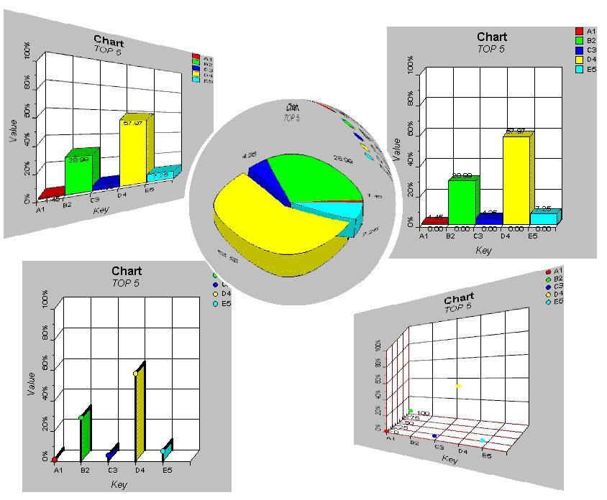

1. SW-Tools Charts

1.1. Release notes
The following enhancements has been made to the user interface in SW-Tools RAPGEN:
- A chart button has been added to the sub total/group total dialog
- A new dialog for chart setup
Please refer to the samples made in this manual to see the interface changes.

2. Charts in RAPGEN

This chapter will step by step describe how you may simply define a report with a sub total and hereby print the total including a chart.

2.1. The chart setup dialog
The chart setup dialog is activated when the chart button is selected for sub and group totals. This section will only describe each parameter in the setup dialog of the chart, so please refer to the step by step guide in the following sample sections to see where and how it is activated.

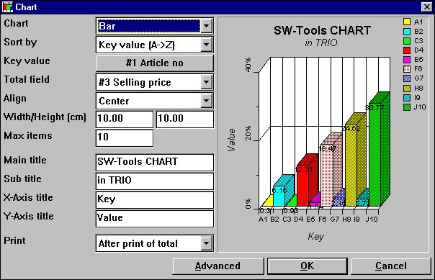

2. The chart setup dialog

2.1.1. Chart
The chart type may be one of the following:
- None
- Bar
- Pie
- Line
- High/Low/Open/Close
- XYZ point
If the type is set to 'None' no chart will be printed on the report, but the definition will be saved if the chart is activated later on.

2.1.2. Sort by
You may sort a chart in ascending order by
- Key value, e.g. sorting from A to Z
- Total value, e.g. sorting from lowest to highest value
and in descending order also.
It is also possible to sort the chart according to the item description, but can only be done by calculations, because the description of the item is equal to the key value when using the setup dialog. Please refer to the sample calculations later in this documentation.

2.1.3. Key value
The key value determine how the total value is added to the chart.
Let us assume that you define a report with print of article number, Supplier number and a calculated field Stock value. RAPGEN automatically generates a grand total with number of records, total name and in this case the total Stock value. This leaves the chart with a problem of locating the key value of each value to add for the report. Is it the Article number, the supplier number or perhaps a field not printed out, the article group number.
Because the chart setup cannot determine the key value for a grand total definition it will initially disable you from using the chart. You first have to click on the button to the left of the text 'Key value' and hereby key in the required field number in the field dialog window.
The key value is limited to 32 characters.

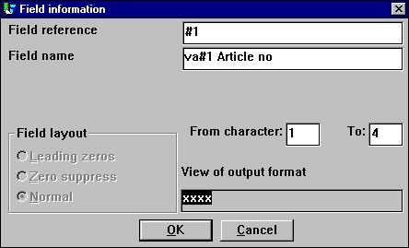

3. Selecting the key value field
By default on all other total definitions the setup of the key value will initially be the total definition field.

2.1.3.1. Part of a field as key value
In RAPGEN it is possible to work with part of fields, for example from character 1 to character 2 of the article number, which might indicate a logical definition of the article group.
This kind of 'sub field' can also be used in charts when selecting the key value field.

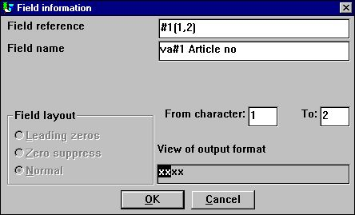

4. Selecting the key value field

2.1.4. Total field
The total field determine which total field value should be added to the chart.
Let us assume that you want to generate a chart on the article stock value. You define a report with print of article number, description, Cost price, Stock balance and a calculated field - Stock value. RAPGEN then automatically generate total fields on Cost price, Stock balance and Stock value, leaving you with 3 options on the total value. Here you need only to select the total field.
It is only possible to select a field marked as total fields on a report in the setup dialog. If you should require a chart on a total value not defined as a total field, you can only use calculations to generate the chart.

2.1.5. Align
You may align the chart on the report page as
- Left
- Centred
- Right

2.1.6. Width and height
The width and height of a chart can be given in centimetres (cm). By default it is set to zero, which will set the width to the page width and the height will be the remaining of the page. If left to zero, it means the align option has no effect because the entire page width is used.
Normally you will set the width and height to some size, also because using the remaining of the page may result in a very wide but not so high chart.
The width of a chart has influence on how wide each item in the chart can be, and if you for example print a bar chart, each item will contain the percentage text on the item. Now this printed text may exceed the bar item width, which can only be avoided by increasing the chart width or decrease the maximum number of items.
The two fields simplifies the use of the chart in a report, because you do not need to insert the chart in the layout and adjust the print control. However, if you want to setup the exact location and size of a chart field, add a border or shadow effect, you must insert the chart field manually in the layout. Please refer to the sample hereof.

2.1.7. Max items
The max. number of items determine how many items are to be shown on the final chart. For example, if the report adds 1000 articles during the print to the chart and the max. items is set to 10 the chart will only display the first 10 items according to the sorting order selected for the chart.

2.1.8. Titles
The titles on a chart amounts to 4. A main, sub, x-axis and y-axis title.
The maximal length of any title is 64 characters.

2.1.9. Print
The following print options may be used:
- After print of total (default)
- Before print of total
- Only chart
The print option can, as for normal total definitions, control when to print the chart. Before or after the print of the normal total lines.
Furthermore, you may set the option 'Only chart' which will suppress the normal print of total lines, e.g. only printing the chart.

2.1.10. Advanced
The advanced options for a chart allows you to modify how the chart is generated. If you want to control the advanced options by calculations you may refer to the functions ChartFlags() and ChartSetLimit()

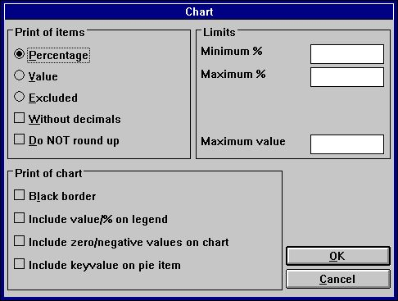

5. Advanced chart options

2.1.10.1. Print of items
In this section you can determine what should be displayed for each item in a chart. The following options are available:
- Percentage (default)
- Value
- Excluded (Do NOT display anything on the chart item)
The percentage or value displayed will by default be with 2 decimals rounded, it is a percentage which is actually 1.235 is rounded and displayed as 1.24. The following options may change the default generation:
- Without decimals
- Do NOT round

2.1.10.2. Print of chart
The print of chart options include:
- Black border
- Include value/% on legend
- Include zero/negative values on chart
- Include keyvalue on pie item (Only valid for Pie Chart)
Normally the chart displays a color list with the key value as text. If you want to include the actual value displayed for each item in this legend box, mark the "Include value/% on legend"
When working with pie charts the standard generation will NOT include zero and negative values. To include such values mark the "Include zero/negative values on chart".
For pie charts no axis descriptions are displayed. You only have the keyvalue displayed in the legend box. However, if you mark "Include keyvalue on pie item" the pie pieces will be marked as
keyvalue (value/percentage)

2.1.10.3. Limits
A chart is normally limited to a percentage from -100 to 100. When the chart is generated it calculates the lowest and highest percentage to display, which will optimise the use of the chart axis. This means if 5 items are displayed and the highest percentage is 55 the Y-axis will display a maximum percentage of 60 %. These limits may be changed in the
Minimum and Maximum % fields
Each chart represents the items as a percentage of the total chart value. If having the item values of 20, 30 and 50 the total chart value is 100. However, the goal could have been to reach a total of 200 which means that the items have NOT reached a percent of 20, 30, and 50 %, but only 10, 15, and 25 %. To get this result enter the maximum value, which will then be used when generating the chart.

2.2. Sample - TOP 10 selling price
The sample will guide you step by step through the definition of a simple report with a chart of the TOP 10 selling prices on articles from the TRIO demo system database.

2.2.1. Step 1 - Creating the report
The report is in this sample created in the demo system on RAPGEN. If you do not have access to this, please use one of your own files as main file, e.g. your article master file. Now select the function 'New report...' from the 'File' menu and select the main file and change the report name followed by OK.

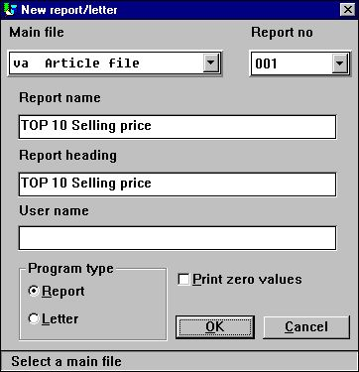

6. Step 1 : Creating the report - TOP 10 Selling price

2.2.2. Step 2 - Selecting fields for the layout
Select for example the article number, Description and Selling price for the report by click on the fields in the database window.

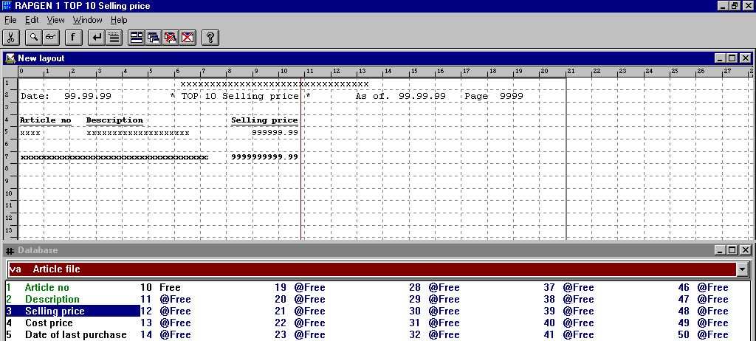

7. Step 2 : Setting up the layout of the TOP 10 Selling price report
As you can see, RAPGEN automatically generates a total field for the selling price, because the field is defined as a numeric field with more than 4 digits and/or with decimals.
Exit and save the new report layout by selecting function 'Close' in the 'File' menu.

2.2.3. Step 3 & 4 - Adding the chart to the automatically generated total
You may now activate the function 'Sorting and sub totals' from the menu 'Report'. As you can see the function window contains a list of defined sub totals, and the first line contains the grand total definition. Click on the first line, which will bring up the standard sub total dialog.
The chart setup dialog can be activated from this dialog by selecting the button called 'Chart...'.

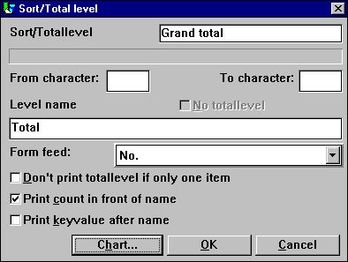

8. Step 3 : Activating the chart setup dialog
Change the options for the chart using the guidelines described earlier in the documentation.

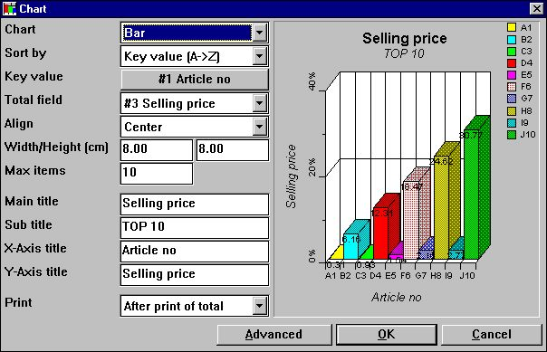

9. Step 4 : Changing the options for the chart

2.2.4. The final report

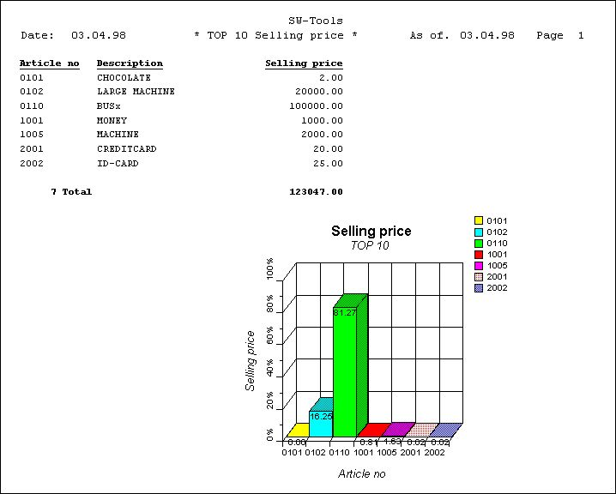

10. Print of the TOP 10 Selling price list

2.3. Sample - Report with chart field in layout
This sample is based on the previous sample report. Please read that documentation before you read this.
As described a chart is normally defined with a width and a height to avoid the manually insertion of the chart field in layout. However, it is possible to insert the chart directly in the layout and still use the normal summation made internally by RAPGEN.

2.3.1. Chart definition generates new work fields
When a total is defined including a chart definition, RAPGEN automatically generates one or more work fields, also named chart fields.
A chart field in TRIO is defined as a normal work field with the following syntax:
- Field must be marked as object '#C Chart object'

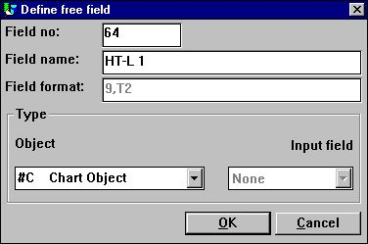

11. Chart field defined as work field
For charts setup on defined totals the name is fixed. The syntax is:
- Field name is 'HT-L a' for a sub total definition
- Field name is 'HT-G a-b' for a group total
The 'a' represents the level number and the 'b' represents the group number.

2.3.2. How to insert the chart field in layout
The chart field may be inserted in the layout function of RAPGEN. Start the function by selecting 'Layout' from the 'Report' menu.
Select the chart field named '#CHT-L 1' from the database window by one click and release the mouse button. Move the mouse arrow into the layout window and place it on the total line (should be line 7). Click once and the field is inserted.

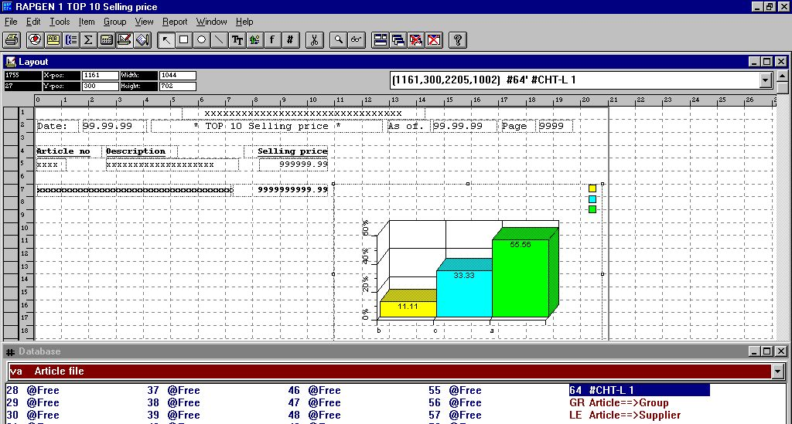

12. Chart field insert in layout
As shown in the figure, the chart has been enlarged in box size, so that it will fit the page and be able to display the desired items.
Please note, the chart will always show a bar chart with 3 items when in design mode.
Finally, remember to change the print control, because the chart item box size has changed, e.g. using multiple lines. Select 'File', 'Page Layout', 'Control...' to amend the total print lines to 7-16 (dependent on the inserted chart field size).

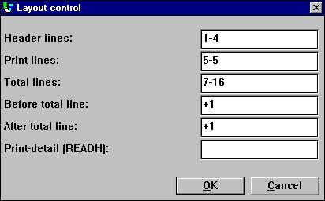

13. Amending the layout control

2.3.3. The final report with chart field in layout

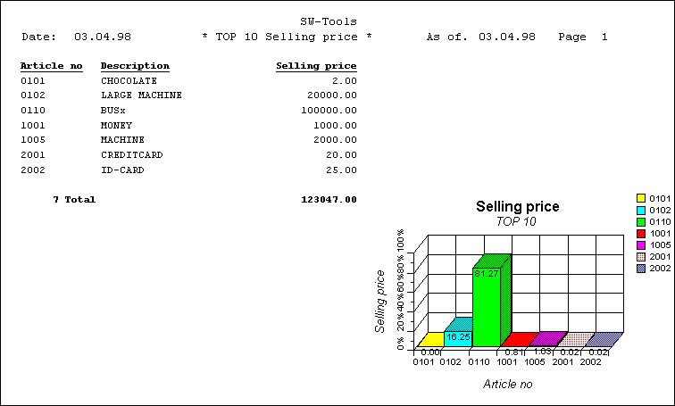

14. The final report with chart field in layout
The insertion of the chart field disabled the automatic print of the chart. The alignment, width and height of the chart setup is not used.

2.4. Sample report with manually calculated chart
This step by step guidelines for a report with manually calculated and printed charts relies on the set of functions available for the chart interface. The set of functions is listed later on in this manual.
How to generate the sample report:

Define a report with print of Article number, Description and Stock value, where stock value is free field #11 defined with name 'Stock value' and format ',9,2'.
Make the calculation of Stock value with the calculations line '#11 = #4 * #8'.
Try the report to make sure you get correct values.

Define a free field #12 in the layout function with the name 'My chart' and marked as object '#C Chart Object'.

Insert the free field #12 at the desired position in the layout and size the box accordingly. In this sample we have adjusted the box to fit from line 9 to 22.Please note, if inserting the field on a normal / total print line, the chart will be printed for each normal / total line.

Add the following calculations to the report (you may leave out all comments).

The final result of this sample is:

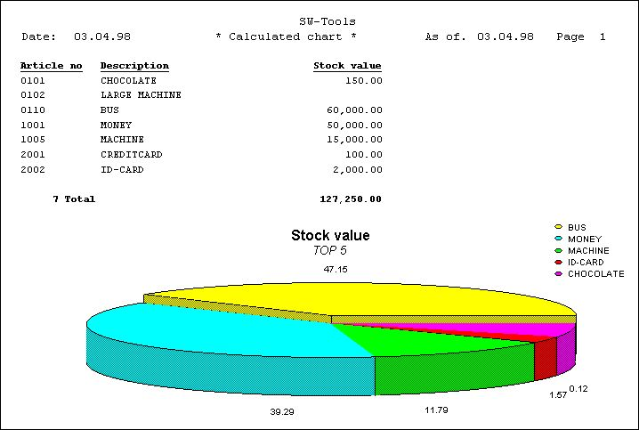

15. Calculated chart report

3. Charts in IQ/DATAMASTER

This chapter will describe how you may simply add chart functionality to any type of IQ/DATAMASTER programs. This section only illustrates the use in IQ because its the same when working with DATAMASTER.

3.1. Creating a simple query
This sample is based on a simple supplier query
le#1-6
which has been saved as program 1 in IQ.

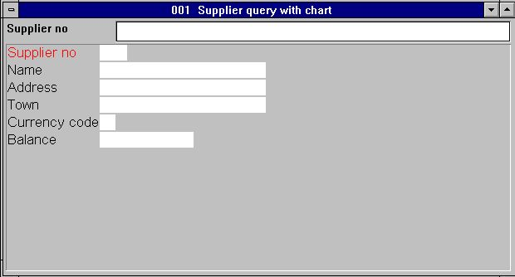

16. Simple supplier query in IQ

3.2. Adding the chart step by step

Define a free field #8 in the form function with the name 'My chart' and marked as object '#C Chart Object'.

Insert the free field #8 at the desired position in the form and size the box accordingly. In this sample we have adjusted the box to fit the query window.

Add the following calculations to the query in the section 'By start of program' (you may leave out all comments).

Because the chart is generated by start of program only, you need to restart the query program before the chart is shown.

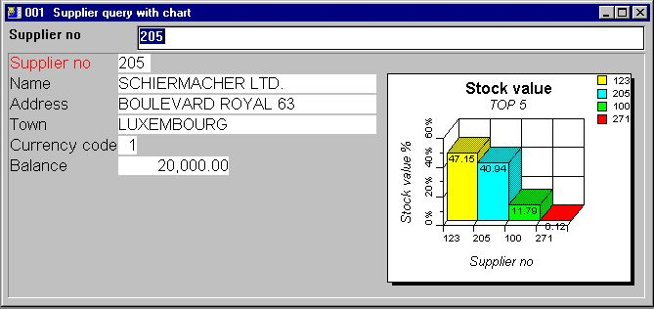

17. The final query including the chart

3.3. Functions for special chart handling
The chart interface provides two interesting function for use in IQ.
- Setting a tag on a specific item
- Retrieving the last item clicked from the chart
Please refer to the function documentation for the detailed description on the two functions.

3.3.1. Tagging an item in the chart
To tag a chart item you may use the function
ChartTag()
For example the query defined earlier can be extended with the following calculations in the section 'After read of supplier file':
ChartTag(#8,#1,#2)
which will produce the following result when query is made on supplier 123.

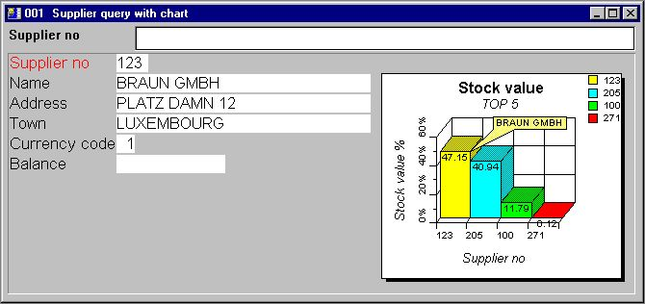

18. Query with tag on current supplier

3.3.2. Performing calculations when user click on a chart item
IQ provides the ability to make calculations when the user click on a field. However, a chart is a field, but the interesting parts are the items in the chart. Therefore, the chart interface provides you with an additional function to retrieve the last clicked item of a chart
ChartClicked()
For example the query defined earlier can be extended with the following calculations in the section 'By click on field' field '#8 #cMyChart':
if ChartClicked(#8,#9) <> 0 dofunction(505,#9)
When the user clicks on a chart item the function retrieves the key value of that item, which is the supplier number, and calls the dofunction(505,#9) to display that particular supplier.

4. Chart functions

The collection of chart functions are installed from a Windows DLL (Dynamic Linked Library). All the functions are described and implemented as sub functions in TRIO in the 09.xxx file, where xxx is the language code, located in the TRIO installation directory.
The on-line description of the chart function may be viewed directly from the database window. Select the file names 'Chart functions', which is file id 09.

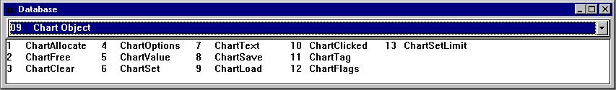

19. On-line documentation of functions

4.1. ChartAllocate - Allocate a new chart

The functions allocates a new chart object. The return value is used as first parameter for all other chart functions.
When the chart object is no longer needed it should free the memory used by calling the function ChartFree().
Please note, a chart field inserted in the layout of a report or in a form on a query/data entry program is automatically allocated by start and will free memory by termination.

ChartFree(#50) /* Free used memory

4.2. ChartFree - Free the chart

The functions will free the memory allocated by the ChartAllocate() function.
Please note, a chart field inserted in the layout of a report or in a form on a query/data entry program is automatically allocated by start and will free memory by termination.

See ChartAllocate

4.3. ChartClear - Clear content of the Chart

The functions will clear all items and options on the chart. It will NOT free the memory allocated by ChartAllocate().

None.

4.4. ChartOptions - Set options for the chart

The function allows you to set a number of options for the chart. As shown in the parameter descriptions you may select between 5 chart types, 6 different sort orders and also limit the chart to contain a specific number of items, which may be used for TOP 10 charts.
The sort order may be of 3 different types, but all of these may be sorted ascending or descending. This means, that if the sorting of the chart is requested to be by value in descending order, the par3 should be 11.

See ChartAllocate

4.5. ChartValue - Add an item value

With this function new items are inserted into the chart or values are added to existing items. All chart items are based on a unique id, which may be a text of max. 32 characters.
When the function is to insert or amend an item it will do so according to the id in par2.
Please note, the test on id is case sensitive, meaning that OLE, Ole and OLe are 3 different id's. If you need to make the comparison not case sensitive, please use the UPPER() or LOWER() subfunction (Refer to TRIO calculations and subfunctions manual).
The value parameters may be as many as 4, but the function will not always require all to be filled. If the chart is of type bar, pie, or line only the first value (par3) is used and the rest may be 0. If the chart is of type high/low/open/close you may also just use one value, which then makes it equal to a bar chart.
For high/Low/Open/Close chart the Value1 is the high value, Value2 the low value, Value 3 the Open value and Value4 the close value.
For XYZ point charts, The Value1 is the X value, Value2 is the Y value and Value3 is the Z value.
The description of an item cannot be given as parameter to this function, which means that the chart automatically uses the id as description, but you may optionally set the description with the function ChartText() or use the simplified function ChartSet() to combine the two.

ChartText(#50,1,"Michael","Michael Olsen","","") /* Set the description of id Michael

4.6. ChartSet - Add an item value and description

The function is a simplified combination of the ChartValue() and ChartText() function. Hereby you can only pass one value for chart, but at the same time pass the description of the item.

ChartValue()

4.7. ChartText - Set chart titles or items description and tag

The function allows you to set the titles for a chart or the description / tag of an item. When the par2 is 0 the par3-6 represents the possible chart titles, Main/Sub/X-Axis/Y-Axis.
When the par2 is 1 only the par3-5 is used. The par3 must then represent the unique item id and par4 the description of the item. Optionally the par5 may contain an item tag text, which will produce a special tag of the item when the chart is shown. This can be useful to make a special marking of a particular item on the chart.

See ChartValue

4.8. ChartSave - Save a chart to a file

With this function you can save a generated chart into a file. The filename may be of any valid length including the full path (Operating system dependent). The saved chart can later be loaded using the function ChartLoad().
Please note, a saved chart only contains the items that would be shown, which is dependent on the max. number of items set by the ChartOptions() function.

See ChartAllocate

4.9. ChartLoad - Load a chart from a file

With this function you can load a chart from a file. The filename may be of any valid length including the full path (Operating system dependent). The loaded chart will only contain the items that was present when it was saved, which is dependent on the max. number of items set with the ChartOptions() function.

print(9-20) /* Print layout line 9 to 20 containing the chart

4.10. ChartClicked - Retrieve chart item last clicked

The function will return the last item clicked with the left mouse button. It can for example be used in IQ queries to retrieve the item id of the clicked chart piece. With this id you may perform further calculations.
An example would be, if you have a chart with the total stockvalue of the TOP 10 suppliers, and the user of the query clicks one of the chart pieces the query will retrieve the supplier number using this function and hereafter pass it to another query, listing all the articles which makes the suppliers total stockvalue.

repeat(va)

4.11. ChartTag - Tag one item in the chart

The function will set the tag description for one item only. If any other item was tagged before it will be removed.
If par2 is "" all tags will be removed from the chart.

ChartTag(#50,#1,"Current article") /* TAG current article in the chart

4.12. ChartFlags - Set special chart flags

The function allows you to set special flags for the chart. When setting the flags you may add the flag values together.

ChartFlags(#50,1) /* Display item values instead of percent

4.13. ChartSetLimit - Set limits for chart

This function may set different types of limits for the chart. The limit to set is dependent on the type given in par2.
Normally the chart automatically calculates the maximum value as the sum of all items inserted. Based on this maximum value, each item percent is calculated. However, if you want to print a chart based on a budget, you may want to set the maximum value required to calculate the correct percentage. For example, if having 3 partners which really ougth to sell for 50.000 each, but the partners have sold only the following:
Partner 1 : 50.000
Partner 2 : 20.000
Partner 3 : 30.000
the normal chart would calculate the maximum as 100.000 and hereby displaying the percentage 50, 20 and 30. This would give an "incorrect" view of the situation, because the percentage should actually be 100, 40, and 60 of the budget amount of 50.000. By setting the maximum value with this function you may generate such a chart "correctly".
The margin settings on a chart determines how titles, legends and the actual chart is displayed. Assuming the legend text is so wide that it overlaps the chart, it is possible to increase the right margin, which will make the chart smaller in width, and hereby leaving more space for the legend to be displayed.
The standard margins used is 15 millimetres for left, top, right and bottom. If you want a smaller margin set a negative value for the margin, e.g. to get a right margin of only 10 millimetres par3 should be -5.

ChartSetLimit(#50,4,50000) /* Set the maximum value to 50.000

5. Technical specifications

5.1. Requirements
The chart interface requires SW-Tools TRIO version 007.001 or higher. It will be supported in 16 and 32-bit versions.

5.2. Files installed

 | 09.eng | Subfunction descriptions and interface for SW-Tools TRIO calculations
 | cht-eng.hlp | Window on-line manual
 | swc999xx.dll | Dynamic Link Library, where 999 is the major version number and xx is 16/32 bit

Figure list
1. SW-Tools Charts 3
2. The chart setup dialog 6
3. Selecting the key value field 9
4. Selecting the key value field 10
5. Advanced chart options 17
6. Step 1 : Creating the report - TOP 10 Selling price 22
7. Step 2 : Setting up the layout of the TOP 10 Selling price report 23
8. Step 3 : Activating the chart setup dialog 24
9. Step 4 : Changing the options for the chart 25
10. Print of the TOP 10 Selling price list 26
11. Chart field defined as work field 28
12. Chart field insert in layout 29
13. Amending the layout control 30
14. The final report with chart field in layout 31
15. Calculated chart report 33
16. Simple supplier query in IQ 35
17. The final query including the chart 36
18. Query with tag on current supplier 38
19. On-line documentation of functions 40

Index

A
Align 12
B
Bar 7
D
DATAMASTER 3;34
I
IQ 3;34;35;37;39;50;57
L
Layout 29
Line 7
P
Pie 7;19
R
RAPGEN 4;5;9;10;11;22;23;27;28;29
S
Sort 8
Sorting 24
T
TRIO 3;21;28;40;45;55;56
X
XYZ 7;45
Y
Y-axis 20

